Practical No: 1

Aim: Write a Python/Java code to perform pairwise alignment. Take 2 sequences from user and calculate the score.

Code:

se1=input("Enter the first sequence::") se2=input("Enter the second sequence::") seq1=list(se1) seq2=list(se2) score=[]

def Pairwise_alignment(a,b): gap(a,b) print(a)

print(b) value=0 length=len(a) for i in range(0,length): if(a[i]==b[i]): score.append('1') value=value+1 else:

score.append('0')

print(score)

print(value)

def gap(a,b):

if(len(a)==len(b)):

print()

else: k=int(input("enter the position to insert::")) if (len(a)<len(b)):

1. insert(k,'-')

else:

1. insert(k,'-')

return(a,b)

Pairwise_alignment(seq1,seq2)

Output:

Practical No: 2

Aim: Write a Python/Java code to find the identity value of a given sequences. Take the sequence fromuser.

Code:

se1=input("Enter the first sequence::") se2=input("Enter the second sequence::")

seq1=list(se1) seq2=list(se2) def find_identity(a,b): gap(a,b) print(a) print(b) score=0 length=len(a) total_elements=len(a)*len(b) for i in range(0,length):

for j in range(0,length): if(a[i]==b[j]):

score=score+1

identity=(score/total_elements)*100 print("Matching Score::",score) print("Identity of the sequences::",identity)

def gap(a,b):

if(len(a)==len(b)):

print()

else: k=int(input("enter the position to insert gap ::")) if (len(a)<len(b)):

1. insert(k,'-')

else:

1. insert(k,'-')

return(a,b) find_identity(seq1,seq2) Output:

Practical No: 3

Aim: Write a Python/Java code to find the Similarity value of a given sequences. Take the sequence fromuser.

Code: sequence_one=input("Enter the first sequence: ") sequence_two=input("Enter the second sequence: ")

how_many=int(input("How many elements for similarity condition?")) similarities=[] for i in range(0,how_many): a=input("Enter an element: ")

c=int(input("How many elements is it similar to? ")) similarities.append([]) similarities[i].append(a)

for j in range(0,c): b=input("What is it similar to? ") similarities[i].append(b)

def compare(o,t,s):

print(o) print(t) print(s)

#checking if similar score=0 for i in range(len(o)):

for j in range(len(s)):

if o[i] in s[j] and t[i] in s[j] and o[i] != t[i]: score+=1 #calculating similarity similarity= (score*100)/len(o)

return similarity

print(compare(list(sequence_one),list(sequence_two),similarities),"%")

Output:

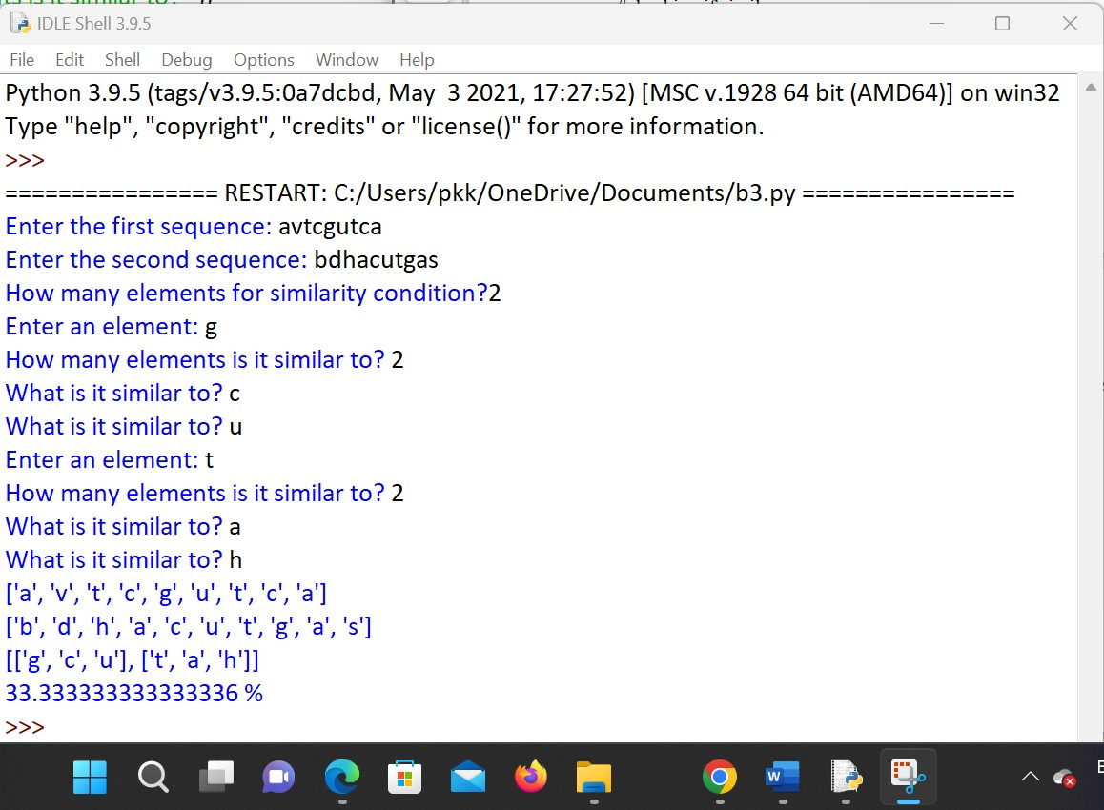

Practical No: 4

Aim: Enter genome of five different organism and write a python/java program to find consensus sequence using Multiple Sequence Alignment (MSA) technique.

Code:

import java.io.*; import java.util.*; public class Consensus

{ public static void main(String str[]) throws IOException

{ int n, i,j,k,count;

String seq[],cons[];

ArrayList<Integer> a = new ArrayList<Integer>();

ArrayList s = new ArrayList();

BufferedReader br=new BufferedReader(new InputStreamReader(System.in)); System.out.println("Enter the no of Sequences"); n=Integer.parseInt(br.readLine()); seq=new String[n];

System.out.println("Enter sequences"); for(i=0;i<n;i++)

seq[i]=br.readLine();

cons=new String[seq[0].length()]; for(j=0;j<seq[0].length();j++) cons[j]=" "; for(j=0;j<seq[0].length();j++)

{

a.clear();

s.clear(); for(i=0;i<n;i++)

{ count=1; for(k=i+1;k<n;k++)

{

if(seq[i].charAt(j)==seq[k].charAt(j)) count++;

}

System.out.println("count="+count);

a.add(count);

s.add(seq[i].charAt(j));

}

/**Updated Snippet 1**/

Set<String> set = new HashSet<>(s);

ArrayList setlist = new ArrayList(set);

Collections.sort(setlist); if (setlist.contains('-') &&setlist.size()==2){ cons[j]+="-"+setlist.get(1);

} else if (setlist.size()==1){ cons[j]+="-"+setlist.get(0);

} else{ int m = Collections.max(a); int index=a.indexOf(m); System.out.println("Max="+m); cons[j]+=s.get(index); System.out.println("index="+index); for(i=index+1;i<a.size();i++)

{ if(a.get(i)==m) cons[j]+="/"+s.get(i);

}

} }

System.out.println("Consensus="); for(j=0;j<seq[0].length();j++){

/**Updated Snippet 2**/ if(cons[j].length()==2) System.out.print(cons[j].toLowerCase()); else if(cons[j].length()==3) System.out.print(cons[j].replace("-","")); else

System.out.print(cons[j]);

}

}

}

Output:

Practical No: 5

Aim: Perform a BLAST search on a specific gene sequence of a specify organism.

Steps:

Go to the National Center for Biotechnology Information Site https://[www.ncbi.nlm.nih.gov/](http://www.ncbi.nlm.nih.gov/)

Select Nucleotide from All Databases and find any organism in a search bar.

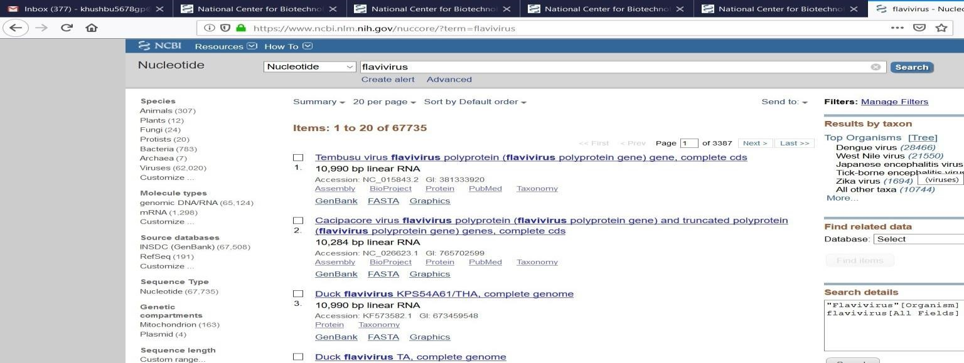

Run BLAST option we have to select

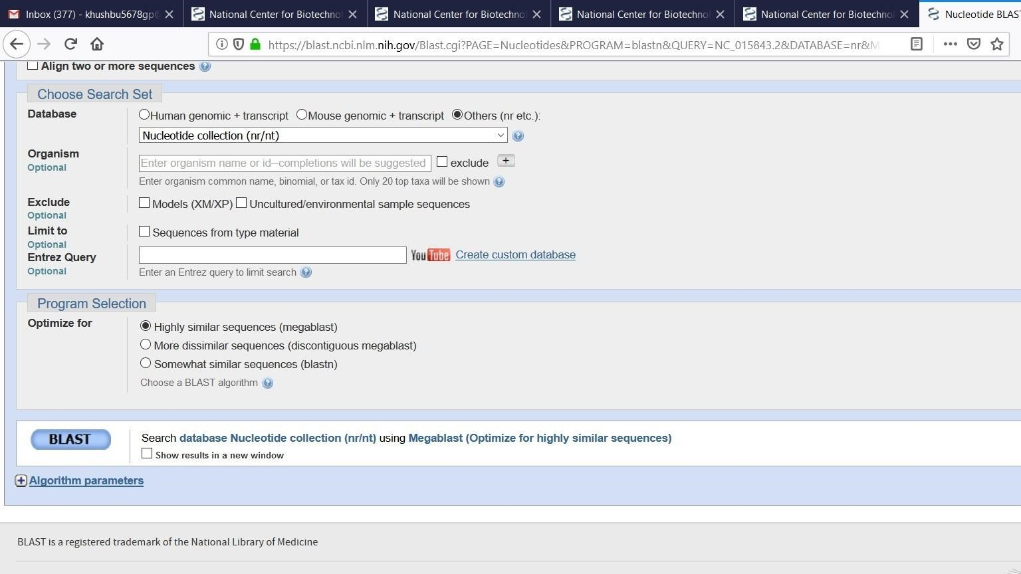

BLAST

Here the result will be display

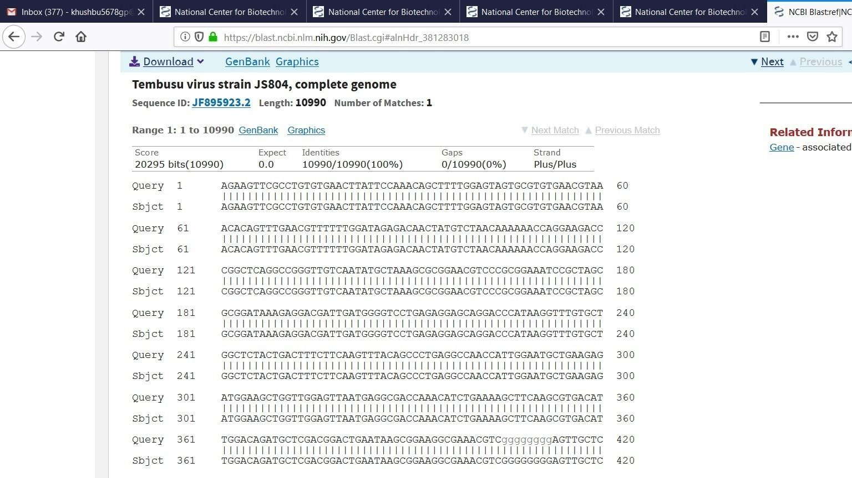

Practical No: 6

Aim: Write a Python/Java code to find motif in a given sequence.

Code:

import random

l=int(input("Enter the length of motif")) file=open("mot.txt","r") r=file.read() print("Sequence",r) size=len(r) print("Size of the sequence",size) pos=random.randint(0,len(r)-5)

#pos=1 print("Position",pos) motif=r[pos:pos+l] print("Motif",motif) i=pos+1 while(i<=size-1):

if(motif==r[i:i+1]): str1=r[i:i+1] print("Match motif",str1) file1=open("motoutput.txt","a") file1.write(str1+" ")

i+=1

Output:

Enter the length of motif4

Sequence AGAAGTTCGAGAAGCCGTAGT

Size of the sequence 21

Position 0

Motif AGAA

import random

l=int(input("Enter the length of motif")) file=open("mot.txt","r") r=file.read() print("Sequence",r) size=len(r) print("Size of the sequence",size) pos=random.randint(0,len(r)-5)

#pos=1

print("Position",pos) motif=r[pos:pos+l] print("Motif",motif) i=pos+1 while(i<=size-1):

if(motif==r[i:i+1]): str1=r[i:i+1] print("Match motif",str1) file1=open("motoutput.txt","a") file1.write(str1+" ")

i+=1

Output:

Enter the length of motif4

Sequence AGAAGTTCGAGAAGCCGTAGT

Size of the sequence 21

Position 0

Motif AGAA

Practical No: 7

Aim: Perform a BLAST search on any genes sequence and writer a java/python code to count the no of repetition of each nucleotide in the sequence.

Code:

file=open("genes.txt","r") r=file.read() size=len(r)

score_A=0 score_C=0 score_T=0 score_G=0

for i in range(size): if(r[i]=='A'):

score_A+=1

elif (r[i]=='C'):

score_C+=1

elif (r[i]=='T'):

score_T+=1

elif (r[i]=='G'):

score_G+=1 print("score of A is ",score_A) print("score of C is ",score_C) print("score of T is ",score_T) print("score of G is ",score_G) Output: score of A is 6

score of C is 4

score of T is 7 score of G is 6

Practical No: 8

Aim: Generate a regular expression enter three protein sequence of three different organism. Write Python/Java code to find regular expression for this sequences.

Code:

def gen_reg_exp(seq_list, no_of_col):

final_list=[] for colnum in range(no_of_col):

collist=[]

for colseq in seq_list:

collist.append(colseq[colnum]) if len(set(collist))==len(collist):

#print(final_list) final_list.append('x')

else:

if len(set(collist))==1:

final_list.append(collist[0])

else:

final_list.append(''.join(set(collist))) display_output(final_list)

def display_output(final_list): print(*final_list, sep='-')

no_of_seq=int(input("Enter the number of sequence: ")) print("Enter all the sequences")

seq_list=[]

for _ in range(no_of_seq):

seq_list.append(list(map(str, input("").split())))

gen_reg_exp(seq_list, len(seq_list[0]))

Output:

Enter the number of sequence: 4

Enter all the sequences

A D L G A V F A L C D R Y F Q

S D V G P R S C F C E R F Y Q

A D L G R T Q L R C D R Y Y Q

A D I G Q P H S L C E R Y F Q

SA-D-IVL-G-x-x-x-x-FRL-C-ED-R-YF-YF-Q

Practical No: 9

Aim: Enter six protein sequence of different organism and write a program to find a fingerprint of sequence.

Code:

def solve_fingerprint(seq_list, no_of_col):

seq_dict=dict() for colnum in range(no_of_col):

counta,countc,countt,countg=0,0,0,0 for colseq in seq_list:

if colseq[colnum]=='A': counta+=1 elif colseq[colnum]=='T': countt+=1 elif colseq[colnum]=='C': countc+=1 elif colseq[colnum]=='G':

countg+=1 seq_dict[colnum]=[counta,countc,countt,countg]

display_results(seq_dict)

def display_results(seq_dict): print("\tA \tC \tT \tG") for key in seq_dict:

print("\n",*seq_dict[key],sep="\t")

no_of_seq=int(input("Enter the number of sequence: ")) print("Enter all the sequences")

seq_list=[]

for _ in range(no_of_seq):

seq_list.append(list(map(str, input("").split())))

solve_fingerprint(seq_list,len(seq_list[0]))

Output:

Enter the number of sequence: 4

Enter all the sequences

A C T G A T G

A T C A G A A

A T A A G C A

A G T T A G C

A C T G

4 0 0 0

1. 1 2 1

1. 1 2 0

1. 0 1 1

2 0 0 2

1. 1 1 1

1. 1 0 1