# *Report On*

# *Machine Learning Project*

***Project Name : Rate of Road Accidents.***

***Project Done By :***

1. ***Ayusha Sandeep Bhola.***
2. ***Akshata Shriniwas Machal.***
3. ***Shrutika Sunil Chendake.***

## 1. Introduction

There is a huge impact on the society due to traffic accidents where there is a great costs of fatalities and injuries. In recent years, there is a increase in the researches attention to determine the significantly affect the severity of the drivers injuries which is caused due to the road accidents. Accurate and comprehensive accident records are the basis of accident analysis. the effective use of accident records depends on some factors, like the accuracy of the data, record retention, and data analysis. There is many approaches applied to this scenario to study this problem.

A recent study illustrated that the residential and shopping sites are more hazardous than village areas.as might have been predicted , the frequencies of the casualties were higher near the zones of residence possibly because of the higher exposure.A study revealed that the casualty rates among the residential areas are classified as relatively deprived and significantly higher than those from relatively affluent areas.

## ***2. My approach***

## ***2.1 Data Collection***

Dataset for this project has been taken from Government website. It consists of 16 columns and nearly 2500 rows. This dataset contains the details about the Road Accidents in Year 2014. It includes the details related to the accidents example wheather conditions , road surface, casuality , number of vehicles and this are also considered as inputs to the algorithm . The output is rate of number of casuality.

## ***3. Experimental results and discussion***

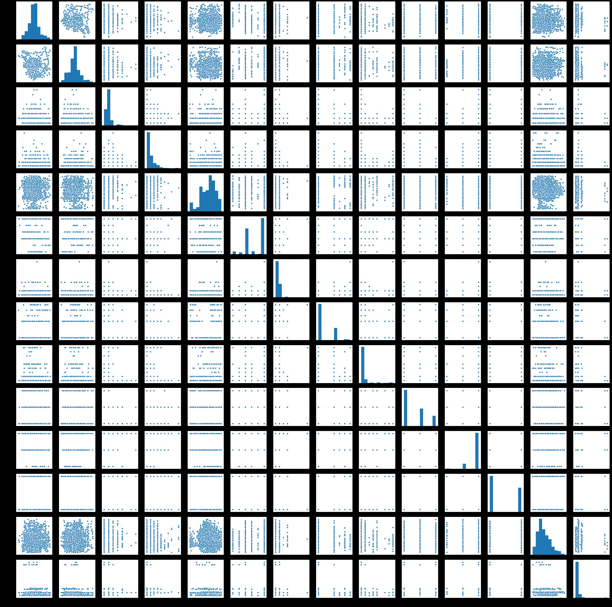

After getting the dataset we performed the Data Preprocessing. And then plotted the Graph and based on the Graph we were not able to choose the correct Algorithm . So we applied all the Algorithm of Regression to the dataset and compared all the accuracy and we found the best accuracy with Decision Tree Regression. 

We plotted Pairplot for the dataset to get the clear idea of how the variables are dependent on each other and how they vary among themselves.

## ***5. Conclusions and future work***

Rate of the number of Casualties can be predicted using Machine Learning using Regression Type.

Decision Tree Algorithm gives better results as compared to Multi-Linear Regression Algorithm or Polynomial Regression Algorithm

## ***6. References***

**Dataset References:- https://github.com/damianoc90/Road-accidents-analysis/blob/master/dataset.csv**