–––––Server & APIs Assignment

1. Assume that the sales tax program is now a web app, From the server the app asks for all the rates of different countries:

#Create a Json structure of the countries and their corresponding sales tax which you would return from the server.

#Similar to this create other API response structures

1. **If the Sales Tax system were to be a web application**

**#What type of web application would it be?**

Answer : - It would be a **Dynamic Web applictaion** because When the web server receives a request for a dynamic page, the page is passed to a software called the application server.

Databases are used at the server end , so the user gets the updated content. The application server reads the code ,customizes the page and passes it to the web server which then sends it to the browser.

They are used when the information changes often.And are much more complex to construct and design.

and this web application can be a **single page web application** also because it has some features like:-

**Fast:** Most HTML/CSS/Scripts resources are only loaded once throughout the lifespan of an application. The content updates dynamically .And the page never reloads completely.

**Caching:** An SPA sends only one request to a server and then stores all the data it receives.And then is able to work offline

.

**#What would be its architecture?**

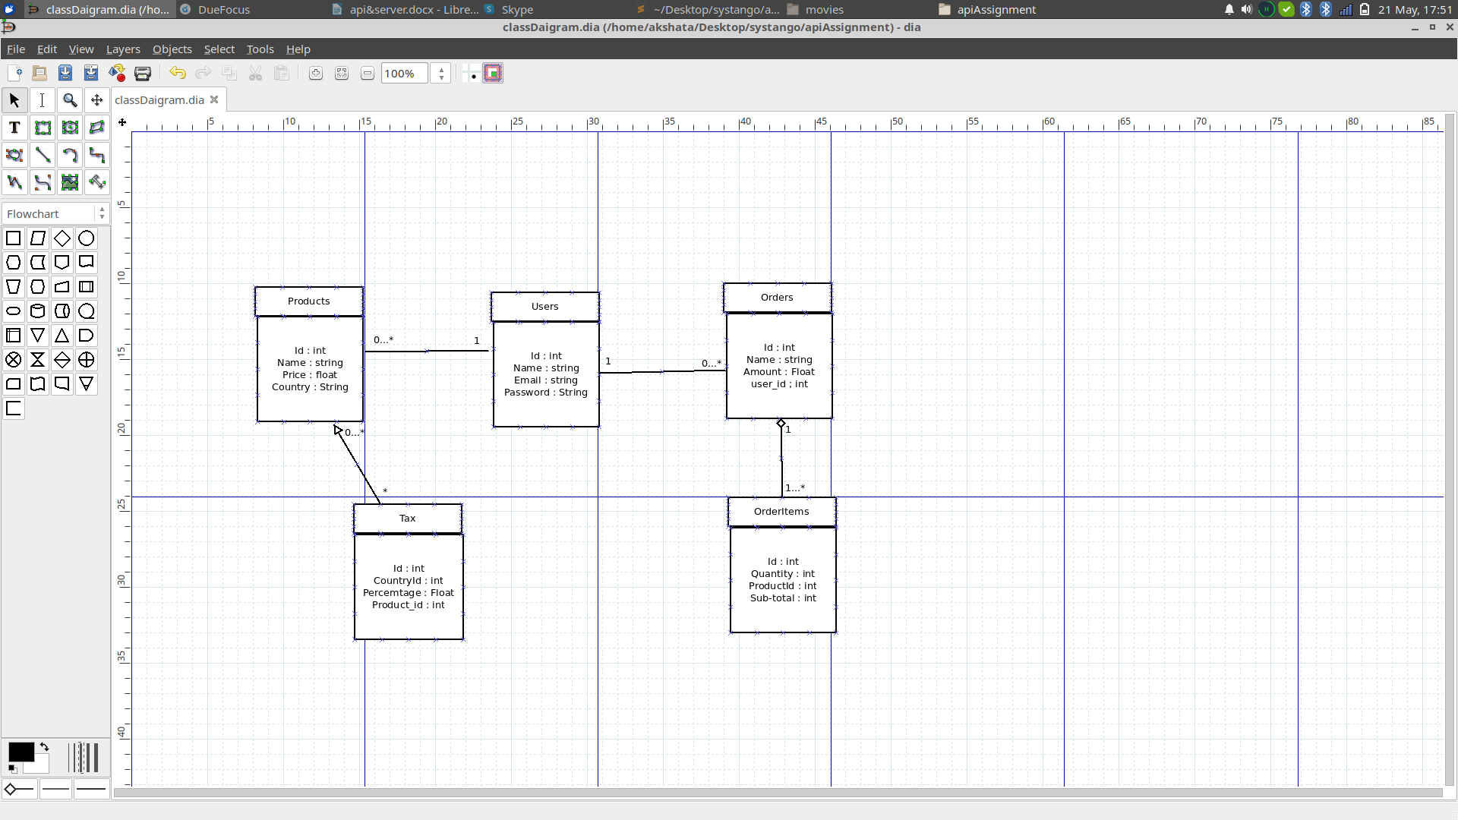Answer :-

**#What would be the components of client and server involved in this?**

Answer:-

