**METHODOLOGY**

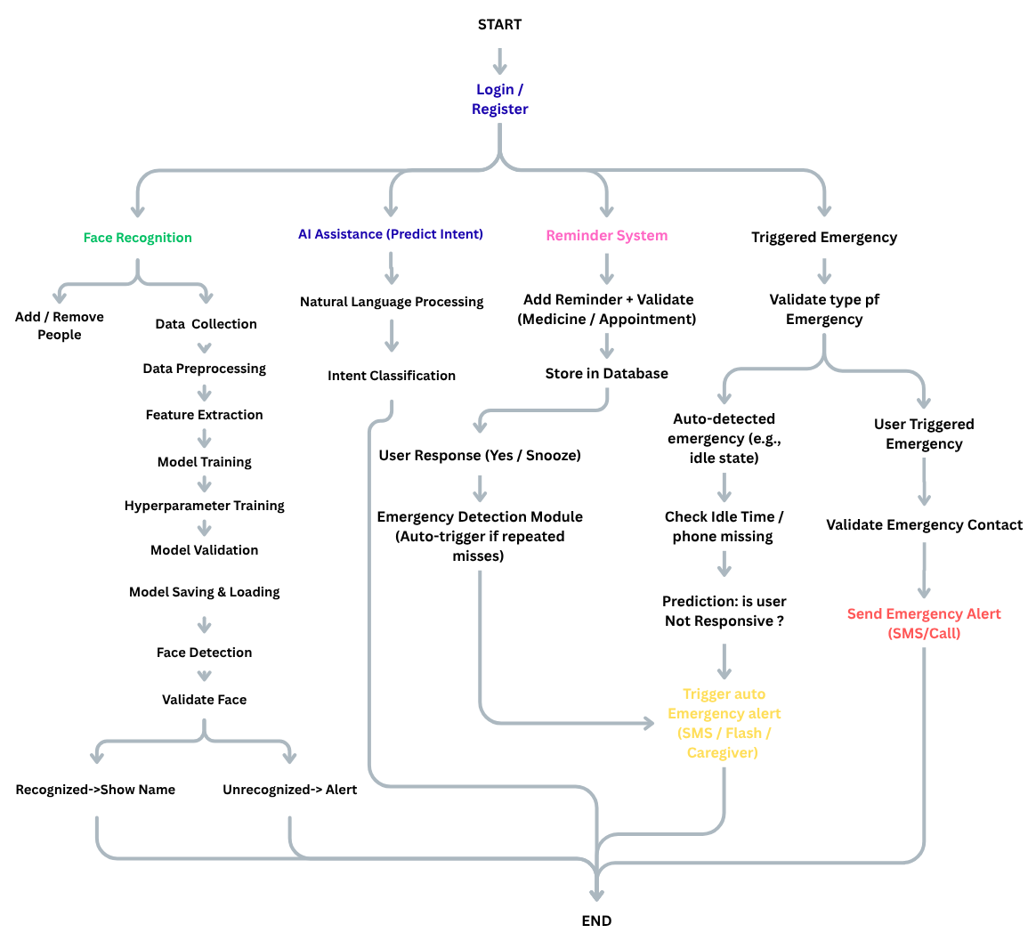

**A. Research Design**

This study follows a **prototype-based applied research design**, focused on developing and testing a smart assistive app called *NeuroMate* for dementia patients. The goal is to explore how technologies like face recognition, voice interaction, and smart reminders can support memory assistance in a user-friendly way.

**Type of Study:**

It is a **technical implementation study**, centered on building a functional prototype to demonstrate core features and usability rather than conducting formal clinical trials.

**Data Collection Methods:**

* **Secondary research** was conducted by reviewing existing dementia-related apps, scholarly articles, and official health resources to identify common challenges and required features.
* Development was guided by **feature comparisons**, and improvements were made based on **informal feedback** from peers and mentors.

**Sample:**

As this is a prototype-driven research project, there was **no formal participant sample** involved. However, the app design was guided by insights from:

* Publicly available information on dementia symptoms and caregiving needs.
* Comparative analysis of **3–5 existing assistive apps** in the domain.

**B. Data Analysis**

Since this project is centered on a **technical prototype**, the data analysis primarily focuses on **qualitative and observational evaluation** of the application's features, performance, and user interaction. No formal statistical testing is required, but the effectiveness of the system is measured through:

* **Feature-wise testing**: Each major feature (face recognition, voice assistant, reminders, emergency alerts) is tested for functionality, accuracy, and response time.
* **Error rate analysis**: For example, in face recognition, misidentification or failure to detect a known person is noted and calculated as a **percentage error rate**.
* **User interaction feedback**: Informal feedback from peers or mentors is summarized to identify usability issues or confusion during navigation.
* **System logs and behavior tracking**: Logs are used to observe how consistently the reminders trigger or how the voice assistant responds under different conditions.

No advanced statistical methods are applied, as the research does not involve numerical data from human subjects. However, **basic metrics** such as success/failure counts, accuracy percentages, and feature usage frequency are used for evaluation.

**C. Ethical Considerations**

Although this research is based on building a technical prototype and does not involve direct patient testing, several ethical principles were taken into account during the design and development of the Neuromate application.

**1. Data Privacy and Confidentiality**

* The app is designed to handle sensitive information like user photos, relationships, and reminders. In future real-world use, this data would be securely stored using encrypted databases or trusted platforms like Firebase.
* User data is not shared or transmitted without permission, and strong access controls are planned for deployment scenarios.

**2. Informed Consent (Future Scope)**

* While no real patient data was used during the prototype phase, future testing or deployment would require **informed consent** from patients and caregivers.
* Users must be clearly informed about what data the app collects (e.g., face images, voice inputs) and how it will be used.

**3. Ethical Use of AI**

* Face recognition and voice interaction features are used **only to assist the user** in daily activities, not for surveillance or any intrusive purpose.
* Recognized people can be added or removed manually by caregivers to avoid misidentification.

**4. Accessibility and User Safety**

* The app design follows a **user-friendly and elderly-friendly approach**, using simple layouts, large buttons, and audio support where needed.
* The **emergency alert feature** is designed to promote safety without causing confusion or accidental misuse.

**5. Non-Misleading Claims**

* The app does not present itself as a medical tool or diagnosis system. It is strictly a supportive memory aid and reminder assistant for day-to-day use.