Analysis of highly concentrated financial service in Chicago

Akshata Hegde

Published on
7 Feb 2020

Table of Contents

Introduction/ Business Problem ................................................................................. 3
Data ............................................................................................................................ 4
Section 1: Data Sources..............................................................................................4
Section 2 : Data Cleaning ...........................................................................................4
Section 3 : Data Analysis............................................................................................ 5
Methodology............................................................................................................... 5
Results and Observations.............................................................................................8
Conclusions..................................................................................................................8

Introduction / Business Problem

Background on financial centres

Financial centres are locations with large concentration of banking institutions, asset management companies , insurance companies and other financial market players. They are catalyst for global growth with economic influence.

Chicago is leading financial hub in derivatives market. The Chicago Mercantile Exchange is the oldest futures trading exchange in the world and is known for global derivative trading. The city is home to the Chicago Stock Exchange, the Federal Reserve Bank of Chicago, The Chicago Mercantile Exchange and the Chicago Board of Trade. With dozens of major banks, it remains seconds national financial hub after New York City.

Business Problem

Chicago is prominent financial centres, providing wide range of financial services. They have numerous leading banks and financial intuitions which are headquartered in Chicago. Hence the question is - Which financial services is highly concentrated in Chicago ?

Interest

Prospective job seekers looking for roles in finance would be interested in knowing which financial services is highly demanded. Financial consultant firms who are keen in expanding their services in Chicago would be interested.

Data

Section 1 - Sources of data

The following is list of data which will used to solve the problem - - Which financial services is highly concentrated in Chicago ?

1) List of Chicago neighborhoods had been sourced from Wikipedia site. The website contained a table of different neighborhoods along with community areas . There are 246 Chicago neighborhoods.

2) I have used the Geopy package to generate latitude and longitude values for Chicago neighborhoods.

3) I have used Foursquare API to find the financial institutions/banks around the neighborhoods of Chicago within 800 meter radius.

Section 2 - Data Cleaning and Analysis

There was one neighborhoods which had missing values. Hence the row was dropped, making number of neighborhoods total as 245. From Geopy package, latitude, longitude, altitude, point and location were generated. Columns such as point, altitude and location had been dropped. Latitude and longitude columns were renamed by making their first letter uppercase.

With help of Foursquare API, I used search query to generate JSON file containing raw list of financial institutions and other institutions within radius of 500 meter. I assigned relevant part of JSON file to obtain results containing details of financial institutions like location address, latitude, longitude , category and etc. After normalizing JSON file, I obtained unfiltered data frame of financial institution. I only took necessary columns like name of the institution, latitude , longitude and category which institution belongs to and stored in different data frame.

This data frame contained 30 venues located in Chicago within radius of 800 meters.

Section 3- Analysis of Data

With help of this data, I was able to generate a map showing the location of thirty financial institutions located in Chicago.

Based on the data frame containing 30 financial institutions, I got the distinct count of categories. There were 14 distinct categories in which I removed the categories that didn't belong to financial services criteria. Finally I had 8 distinct categories. From this information, I was able to generate Bar Graph to represent which was highly concentrated financial service in Chicago.

Methodology

I used GitHub repository for storing my data. As mentioned above in Data sources, I used Geopy package to generate latitude and longitude for each Chicago neighborhoods. Following is representation of first five rows of my dataframe containing columns

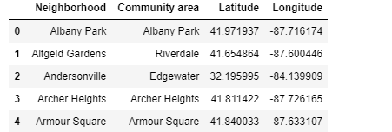
fig -1 - Dataframe representing the list of neighborhood in Chicago

I used Folium library with the geographic details like the neighborhood ,community areas, latitude and longitudes to generate the following map which represents the locations of different neighborhoods and community areas in Chicago.

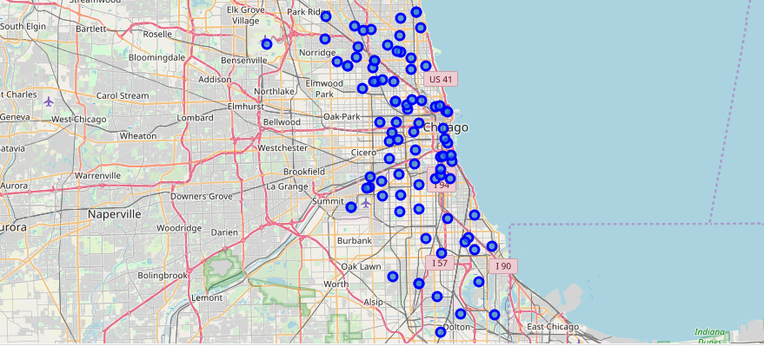
fig -2 - Map representing the neighborhood and community areas of Chicago

I used Foursquare API to generate financial institutions within radius of 800 meters . As search query, I used the term 'financial' to generate the list. After cleaning the raw data , I obtained the below list of financial intuitions located in the city with details of name of the institutions , categories, latitude and longitude.

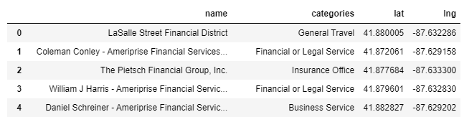
fig -3 - Dataframe representing the list of financial institutions located in Chicago within 800 meters radius.

Again I used Folium library to generate a map representing the locations of financial institutions with help of latitude and longitude details.

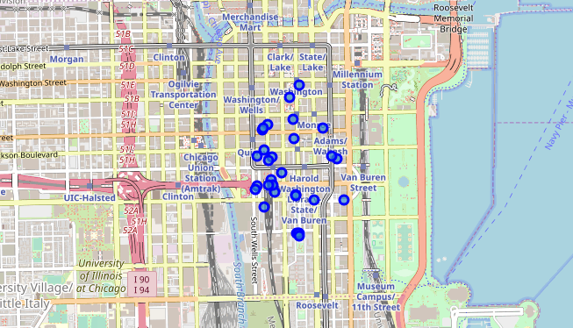
fig 4 - Map representing the locations of financial institutions

Based on dataframe that contained 30 financial institutions, I obtained number of financial institutions for each distinct category. I stored the same in different dataset after removing those categories which didn't fit the financial institution criteria.

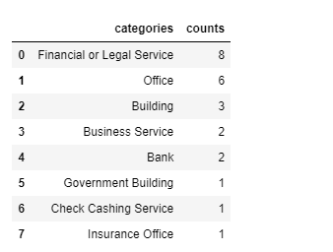
fig 5 : dataframe representing the number of financial service providers in each category.

I used bar chart to represent the number of financial services providers in each category.

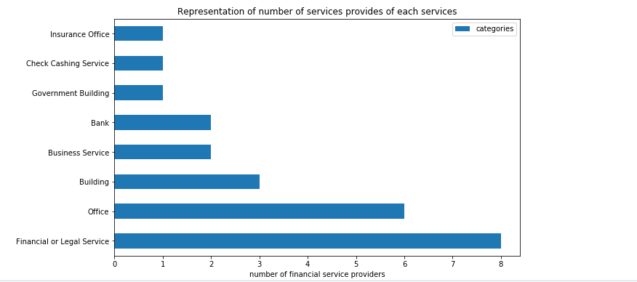
fig 6 : bar graphs representing the number of financial service providers in each category.

Results and Observations

As per the above bar graph, we can note that the financial or legal services are most highly concentrated financial service sector. These financial or legal service firms are regulatory firms that provide services related to anti money laundering and compliance. They checks suspicious transactions as well monitor any money laundering activities. They also make sure their regulatory measures are compiled. The second highly concentrated financial service sector are asset management offices which comprises the building ,business services and office. The least concentrated is the insurance companies.

Conclusion

Hence the question - Which financial services is highly concentrated in Chicago ? has been solved. With the help of Foursquare API, I was able to generate financial institution with 500 meters. A bar graph was plotted based on number of financial services providers within each category. The highly concentrated financial service sector is financial or legal firms which are regulatory firms that provide services related to anti money laundering and compliance.

These findings may help prospective job seekers looking out for roles in finance sector. The financial consultancy firms can also make decisions regarding whether to expand their services in Chicago.

