1. Click on the article that you want to view. ( "Critical": "🔴", "High Risk": "🟠", "Caution": "🟡", "Moderate": "🟡" , "Low Risk": "🟢", "Neutral": "🔵")

1. Displays below

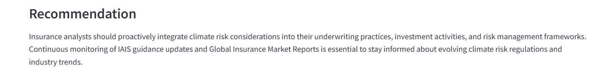

1. Click on analytical overview to get this:

