**New Interface for Attendance and Administration**

**A PROJECT REPORT**

**Submitted by**

|  |  |
| --- | --- |
| 1RVU23CSE056 | Aniketh Bhargav |
| 1RVU23CSE035 | Akshata Athreya |
| 1RVU23CSE031 | Ahaan R |
| 1RVU23CSE076 | Arnav Jain |

*in partial fulfillment for the award of the degree*

*of*

**B.Tech (Hons.)**

*in*

**Computer Science and Engineering**



**School of Computer Science and Engineering**

**RV University**

**RV Vidyaniketan,8th Mile, Mysuru Road, Bengaluru, Karnataka, India - 562112**

**MAY 2024**

**DECLARATION**

I, Aniketh Bhargav (1RVU23CSE056)**,** Ahaan R (1RVU23CSE031)**,** Arnav Jain (1RVU23CSE076)andAkshata Athreya (1RVU23CSE035) students of second semester B. Tech in **Computer Science & Engineering,** at School of Computer Science and Engineering, **RV University,** hereby declare that the project work titled“New Interface for Attendance and Administration” has been carried out by us and submitted in partial fulfillment for the award of degree in **Bachelor of Technology in Computer Science & Engineering** during the academic year **2023-2024**. Further, the matter presented in the project has not been submitted previously by anybody for the award of any degree or any diploma to any other University, to the best of our knowledge and faith.

Name: Aniketh Bhargav Signature

USN: 1RVU23CSE056

Name: Ahaan R Signature

USN: 1RVU23CSE031

Name: Arnav Jain Signature

USN: 1RVU23CSE076

Name: Akshata Athreya Signature

USN: 1RVU23CSE035

Place: BENGALURU

Date: 04-06-2024



**School of Computer Science and Engineering**

RV University

RV Vidyaniketan,8th Mile, Mysuru Road, Bengaluru, Karnataka, India - 562112

**CERTIFICATE**

This is to certify that the project work titled **“**New Interface for Attendance and Administration**”** is performed by Aniketh Bhargav (1RVU23CSE056)**,** Ahaan R (1RVU23CSE031)**,** Arnav Jain (1RVU23CSE076)andAkshata Athreya (1RVU23CSE035)**,** a debonair students of Bachelor of Technology at the School of Computer Science and Engineering, RV university, Bengaluru in partial fulfillment for the award of degree Bachelor of Technology in Computer Science & Engineering , during the Academic year **2023-2024**.

**Prof. Dr.Mydhili Nair Dr. G Shobha**

**Guide**

Assistant Professor Head of the Department Dean

SOCSE SOCSE SOCSE

RV University RV University RV University

Date: Date: Date:

Name of the Examiner Signature of Examiner

1.

2.

**ACKNOWLEDGEMENT**

It is a great pleasure for us to acknowledge the assistance and support of a large number of individuals who have been responsible for the successful completion of this project work.

First, we take this opportunity to express our sincere gratitude to the School of Computer Science and Engineering, RV University, for providing us with a great opportunity to pursue our Bachelor’s Degree in this institution.

In particular we would like to thank Dr. Sanjay R. Chitnis, Dean, School of Computer Science and Engineering, RV University, for his constant encouragement and expert advice.

It is a matter of immense pleasure to express our sincere thanks to Dr.Mydhili Nair, Head of the department, Computer Science & Engineering University, for providing right academic guidance that made our task possible.

We would like to thank our guide Prof. , Designation, Dept. of Computer Science & Engineering, RV University, for sparing his/her valuable time to extend help in every step of our project work, which paved the way for smooth progress and fruitful culmination of the project.

We are also grateful to our family and friends who provided us with every requirement throughout the course.

We would like to thank one and all who directly or indirectly helped us in completing the Project work successfully.

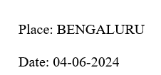

Name: Aniketh Bhargav

USN: 1RVU23CSE056

Name: Ahaan R USN: 1RVU23CSE031

Name: Arnav Jain USN: 1RVU23CSE076

Name: Akshata Athreya

USN: 1RVU23CSE035

**TABLE OF CONTENTS**

|  |  |  |
| --- | --- | --- |
|  | **TITLE** |  |
|  | **ABSTRACT** | **v** |
| **1.0** | **INTRODUCTION** | **6** |
| **2.0** | **TOOLS AND TECHNOLOGY USED** | **7** |
|  | 2.1 Software Requirements |  |
| **3.0** | **IMPLEMENTATION** | **8** |
|  | 3.1 Announcements |  |
|  | 3.2 Student Records  3.3 Attendance |  |
| **4.0** | **RESULT AND DISCUSSION** | **13** |
| **5.0** | **CONCLUSION** | **15** |
|  | **REFERENCES** |  |
|  | **APPENDIX** |  |

**ABSTRACT**

This project introduces a new, user-friendly platform designed to make announcements, student management and tracking attendance easier. The main purpose of this project is to simplify and automate routine tasks carried out by administrations on a daily basis.

This platform helps teachers conveniently track students’ academic progress, attendance as well as send the latest announcements to the students.

This platform can easily be adapted to the various needs of multiple institutes thus catering to their requirements. Therefore, schools of all sizes can benefit from this interface.

This interface enhances efficiency, accuracy, and organization in your educational environment with this innovative solution.

1. **INTRODUCTION**

This interface is designed to make grading, attendance, and administrative tasks easier and more efficient for teachers and school administrators. Our system is used to simplify and automate many repetitive educational tasks, therefore improving productivity and user experience.

Traditional methods are time-consuming, error-prone, and are a burden on teachers and administrative staff. In order to optimize their operations, schools and colleges have a high demand for such a platform which can address their issues efficiently.

Manual attendance systems are prone to cause errors and utilize valued class time. Therefore, an automatic attendance system will ensure efficient usage of time. Maintaining schedules, announcements, and student records manually or with outdated systems creates inefficiencies and data management issues.

The tools used for managing schedules, announcements, and records restructure administrative tasks, making all relevant information easily accessible in one place.

This user-friendly platform centralizes all data and grading with automated calculations, simplifying attendance with real-time updates, and easing administrative tasks with in-built tools and secure storage.

1. **TOOLS AND TECHNOLOGY USED**

HARDWARE & SOFTWARE REQUIREMENTS

Software Requirements

Programming Languages:

Python, JavaScript, HTML, Flask, SQLite

Libraries:

Flask- Flask, render_template, request and redirect

1. **IMPLEMENTATION** 
   1. Announcements

Flask:

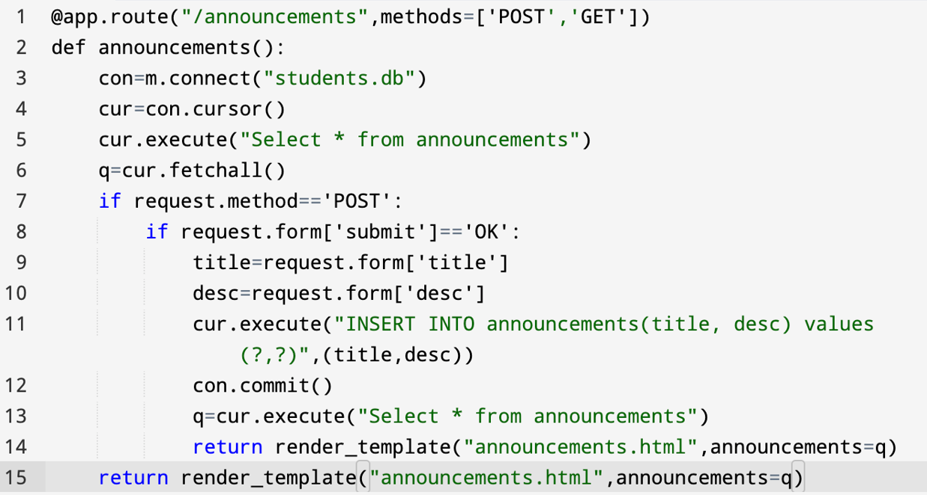

@app.route is a decorator function which directs the website to the “announcements” page.

GET request fetches the information from the URL and displays the same.

POST request adds a new announcement to the database and displays the updated list of announcements.

An SQLite database “students.db” is connected which stores data such as “title” and “description”.

To this database, operations such as submit and display can be performed.

HTML:

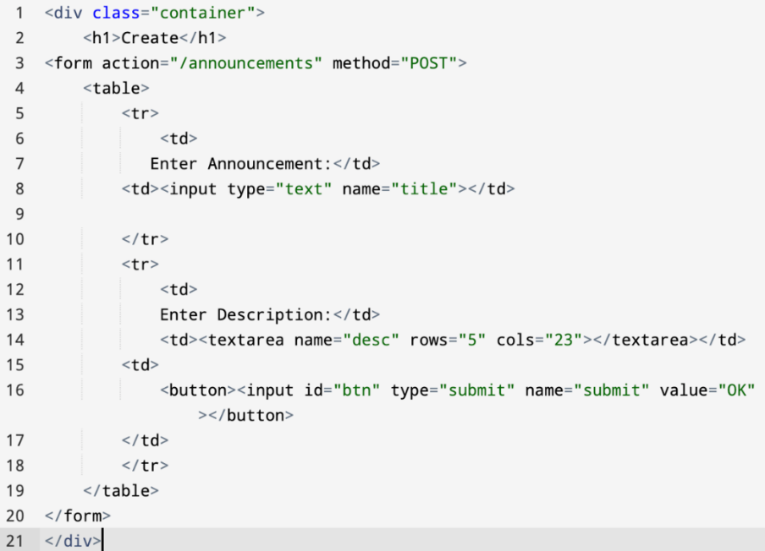

3.2 Student Records

Flask:

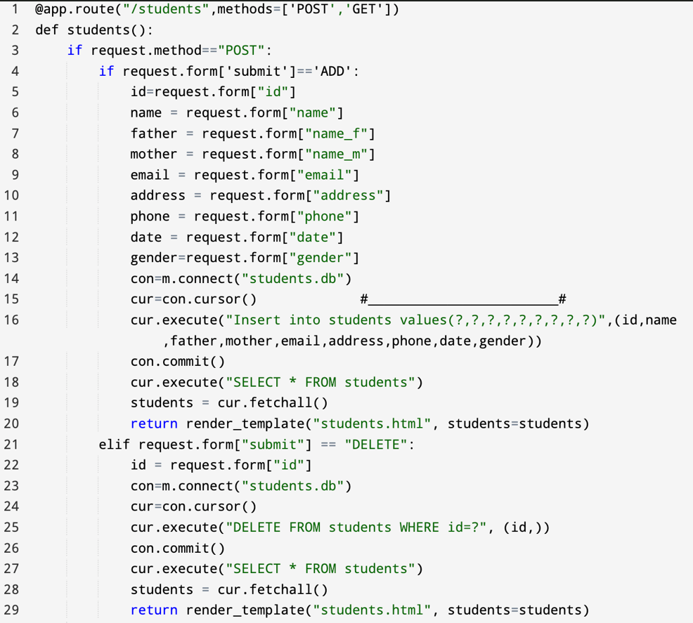

@app.route is a decorator function which directs the website to the “students” page.

GET request fetches the information from the URL and displays the same.

POST request adds a new announcement to the database and displays the updated list of announcements.

An SQLite database “students.db” is connected. It takes information such as “name”, “email”, “address”, etc. from the user. Various operations such as “Delete”, “Update”, “Add”, “Display” and “Search” can be performed.

On performing any of the above operations, the render_template returns the updated database file.

HTML:

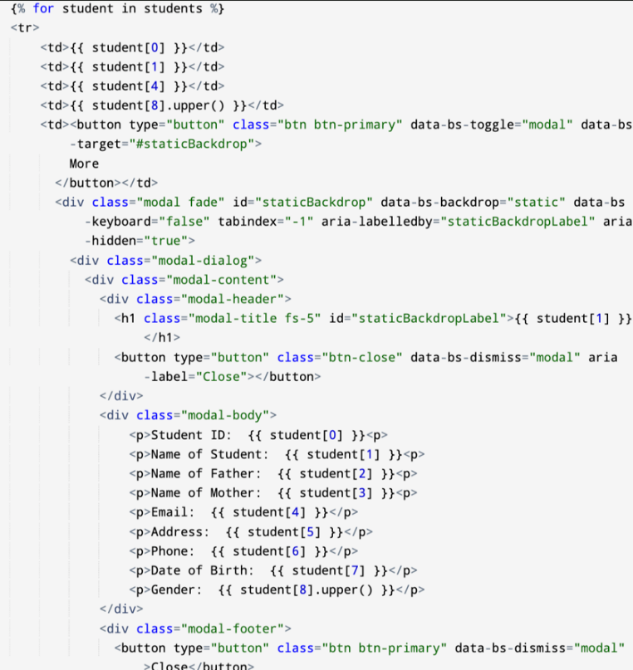

3.3 Attendance

Flask:

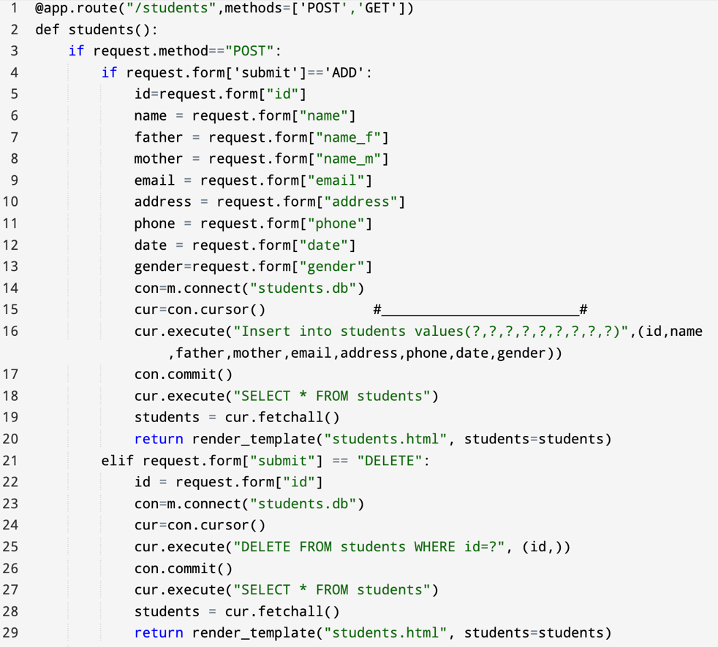

@app.route is a decorator function which directs the website to the “students” page.

GET request fetches the information from the URL and displays the same.

POST request adds a new announcement to the database and displays the updated list of announcements.

Each time the attendance is taken, a new table is formed for that date using the elif condition.

HTML:

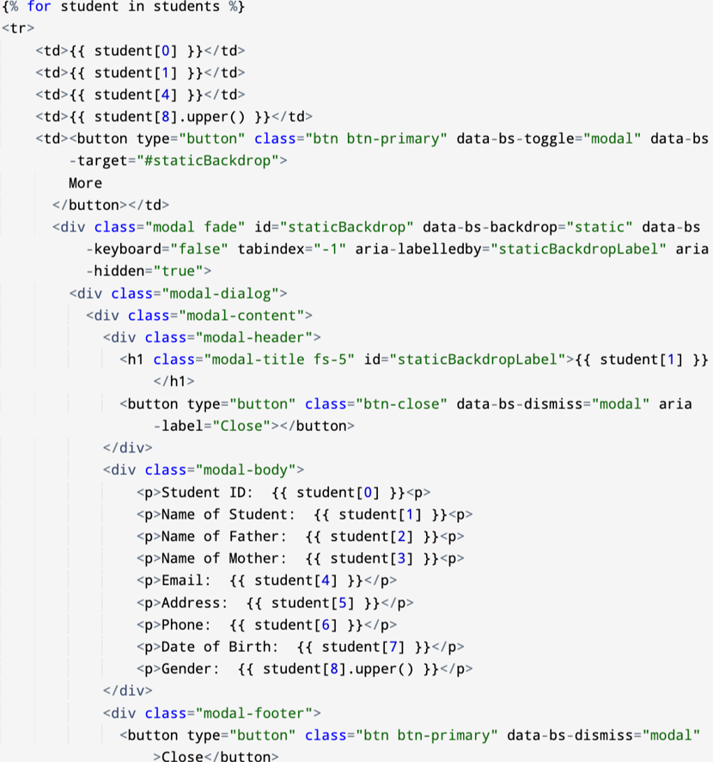

1. **RESULT AND DISCUSSION**



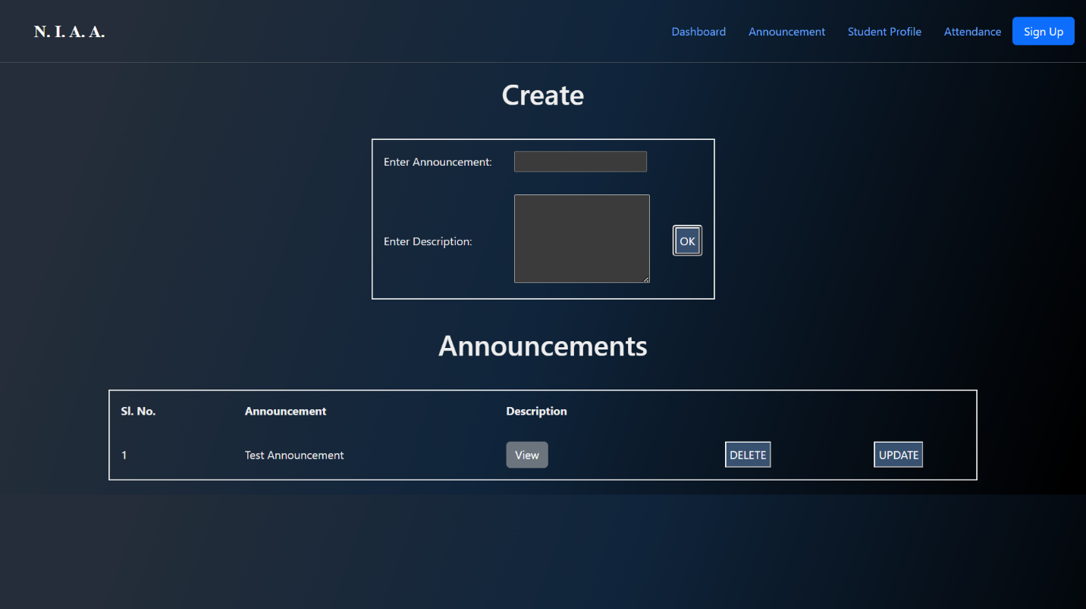

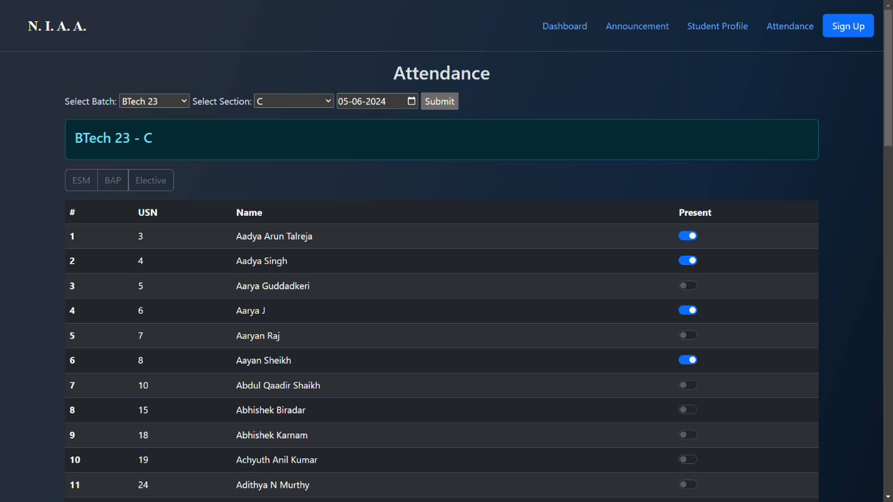

1. **CONCLUSION**

This new, user-friendly interface is intended to make grading, attendance, and administrative tasks easier and more resourceful for schools. We tackled common problems such as time-consuming manual attendance tracking, complex grading methods, and long administrative tasks.

This platform introduces a flexible grading system that supports various types of valuations, and all-inclusive tools for managing schedules and student records.

Administrators can find school operations easier to manage, thus improving the overall accuracy of data significantly. The system’s design is adaptable, making it appropriate for various school sizes and technological systems.

The key goal of this project is to update school administrations, making it more efficient and effective. Future enhancements can include better compatibility, more features like grading assessments, real-time analytics and reporting which can help identify students who may need extra support early on.

This platform can be used to create a more organized and responsive educational environment.

**APPENDIX**

GitHub Link:

https://github.com/arnavj1903/New-Interface-for-Grading-Attendance-and-Administration