**Exercise on GitHub and Git**

**Part 2:**

Installation completed successfully.

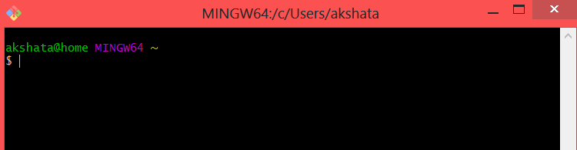

**Part 3:**

Answer the following questions.

* What is GitHub?

Git is a free and open source software which is designed to handle simple to complex projects with efficiency. It is used to maintain revision control system to keep a track of all the changes, maintaining work remotely. **GitHub** is a hosting service for **git** repositories. **Git** is the tool, while **GitHub** is the service to use **git**.

* When was it created?

It was created 10 years ago on April 10, 2008

* Why?

Provides facility enabling multiple people to work on the same project at any given time.

* By who?

**Founders** of GitHub are

1. Tom Preston-Werner
2. Chris Wanstrath
3. P. J. Hyett
4. Scott Chocon

* What similar platforms exist?

1. GitLab
2. BitBucket
3. SourceForge
4. GitKraken
5. LaunchPad

* Why would you use such a platform? (Answer between 5 and 10 lines)

GitHub is publicly available, free service that provides access control and collaboration features like bug tracking and task managements for every project. It provides a centralized, cloud based location to store, share, publish, test and collaborate on web development projects. A remotely based development team can work on the same project, editing and building upon each other’s code without any confusion of multiple people working on the same project.

**Part 4:**

Went through the Git tutorial: <https://try.github.io>.

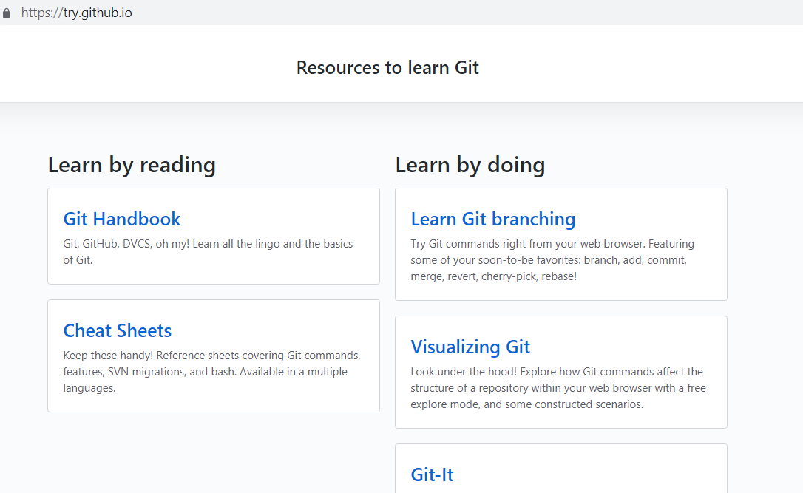

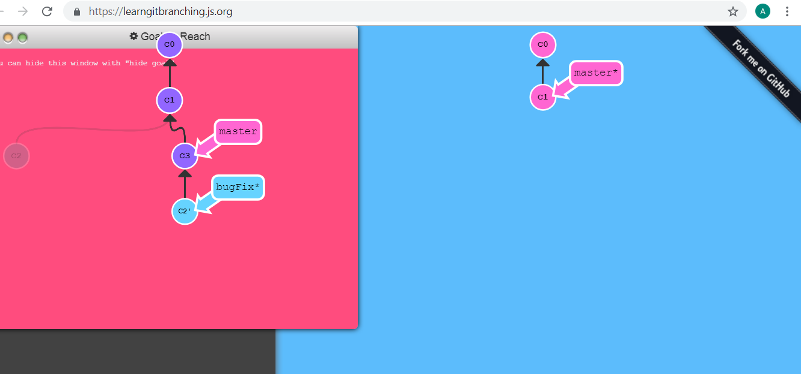

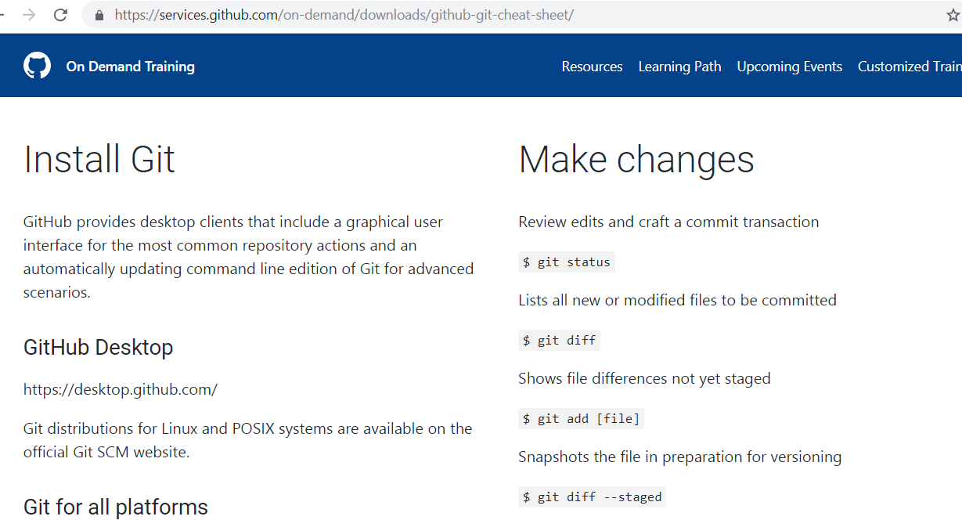

**Part 5:**

Define the Git terms

* Repository
  + It is a digital storage space that is used to store your project and all the versions of its file.
* Commit
  + It is used to save individual changes to a file. A new unique ID is created everytime changes are saved, tracking the name and time of person who made the change.
* Push
  + Push is uploading local repository content to remote repository.
* Branch
  + Branch is a lightweight movable pointer. When you create a new project a new pointer is created for you to move around.
* Fork
  + This term refers to the case when the developer creates a copy of a project in local repository to start working on it.
* Merge
  + Merging a pull request into the upstream branch when work is completed. Anyone with push access to the repository can complete the merge.
* Clone
  + Cloning a git repository means that you create a local copy of the code provided by developer.
* Pull
  + Used to pull the project/file/code from the remote location.
* Pull request
  + Pull requests let you tell others about changes you've pushed to a GitHub repository so that they can review the changes for any modification.

**Part 6:**

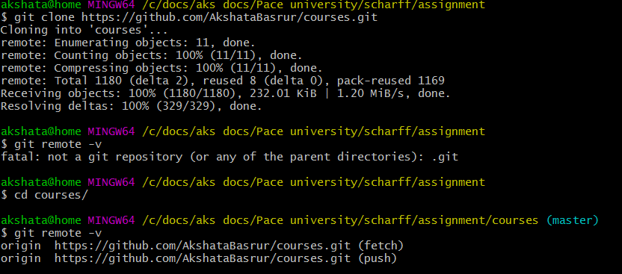

After Git remote add upstream

