Book Recommendation System

Akshata Deo
department of Computer Engineering
San Jose State University
San Jose, California
akshata.deo@sjsu.edu

Abstract—The number of books in university library is increasing rapidly. How to find interesting books from a large number of books is a long tail problem that every reader is concerned about. Recommendation system is a tool which help these users find the books that they are interested in. Besides working efficiently, recommendation system has proven in increasing profits also. This paper proposes a quick and intuitive book recommendation system that helps readers to find appropriate book to read next. In this paper, content based and user based collaborative filtering approaches have been used with cosine similarity measure for recommendation. Finally, the experimental results have been provided with a detailed discussion on different approaches applied.
Keywords—content based, user based collaborative filtering, recommendation system, cosine similarity measure

Introduction
Today, people’s life is surrounded by information technology. Development of information digitization, networking and mobile technology is at a great pace. Recommendation system is an information filtering system proposed to reduce the additional cost of users in the search process[1]. Content based, collaborative filtering, associative rule mining, KNN, knowledge based are some of the recommendation system approaches. According to the preferences of groups with the same hobbies and interests, users can recommend the information they are interested in. Through cooperative mechanism, users can respond to the information to a certain extent (such as rating, borrowing times)and record it to filter it, so as to help others choose the information. Collaborative filtering can be divided into group filtering and evaluation [2]. Personalized recommendation system is a high-level business intelligence platform based on massive data mining which to help the e-commerce websites provide fully personalized decision support and information services for shopping for the customers [5]. This paper proposes a book recommendation system on the basis of user preferences by asking to rate books and choosing favourite categories and then generates the list of books user most probably would like to read.
In Section 2 literature review on related researches and the current status of recommender system is provided. Section 3 explains the detailed implementation of the proposed system. Finally in Section 4 we make some conclusions.

Related Work and Current status of Recommendation System

Related Work
Over the last 20 years there has been a considerable growth in the field of recommender systems. Every recommendation system approach has its own advantages and disadvantages. Traditionally collaborative filtering and content based filtering are used. Content based approach is item based. similarity between different items are found out Whereas, collaborative filtering is user based approach. Similarity between users are found out and most similar users’ content are recommended to each other. The data about their preferences can be collected upon ratings they give on the items. One of the successful example of collaborative filtering is Amazon. Also there is hybrid recommender system, which combine both of previously explained approaches.
There are many book recommendation systems for today [3], [4], [5], [6]. The authors of [1], [2] use social-media information to learn the preferences of users in order to make right recommendations. Kaur et. al. [4] use such an information like interest fields, number of clicks to suggest appropriate book.

Proposed System

Collecting Data
In recommendation system the amount of data plays an important role. In order to provide accurate recommendations one have to provide enough data. For that purpose we decided to collect data from existing resources. This paper refer the dataset provided by IIF(Institute for Informatik Freiburg). The dataset is originally collected by Cai-Nicolas Ziegler in a 4-week crawl from the Book-Crossing community with kind permission from Ron Hornbaker, CTO of Humankind Systems. This dataset contains 278,858 users (anonymized but with demographic information) providing 1,149,780 ratings (explicit / implicit) about 271,379 books. The dataset contains 3 tables as follows:
- users_information: It contains the users. User IDs (`User-ID`) is anonymous and map to integers. Demographic data is provided (`Location`, `Age`) if available. Otherwise, these fields contain NULL-values.
- book_information: Books are identified by their respective ISBN. Invalid ISBNs have already been removed from the dataset. Moreover, some content-based information is given (`Book-Title`, `Book-Author`, `Year-Of-Publication`, `Publisher`), obtained from Amazon Web Services. In case of several authors, only the first is provided. URLs linking to cover images are also given, appearing in three different flavours (`Image-URL-S`, `Image-URL- M`, `Image-URL-L`), i.e., small, medium, large. These URLs point to the Amazon web site.
- user_ratings: It contains the book rating information. Ratings (`Book-Rating`) are either explicit, expressed on a scale from 1-10 (higher values denoting higher appreciation), or implicit, expressed by 0.

Data Preprocessing
- Data Cleaning: Since the dataset was huge in size, all the missing values have been simply removed instead of applying some methods to address missing values. All the duplicate values have been removed. Feature selection has been performed by adding and dropping the attributes. All the unnecessary columns have been dropped. All the mandatory attributes have been added those were important for book recommendation point of view and not presented by dataset already. Normalised the whole dataset. Made it even for each attribute.
- Instances Selection and Partitioning: 80% of the total dataset has been reserved for training purpose and 20% for testing purpose.
- Representation Transformation: Label encoding has been performed for categorical values. Label encoding makes calculation comparatively easy.
After the total refinement of the dataset, two of the three files shown in Fig.1 using pandas:
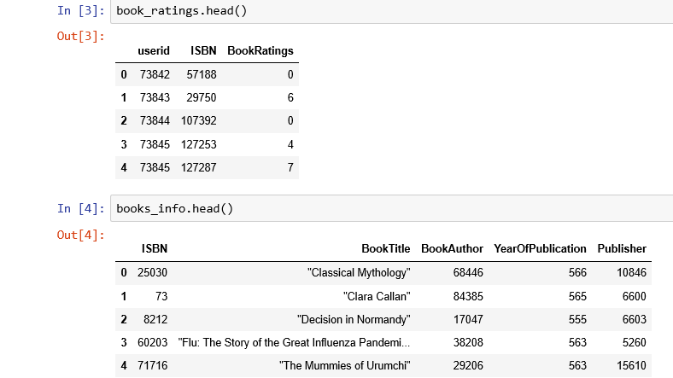
- Preprocessed dataset

User Based Collaborative Filtering Approach
In user based collaborative filtering approach, recommendation is done on the basis of user’s past behaviour. Suppose we want to recommend a book to a user. To address this problem first similarity will be calculated between the given user and rest of all the other users. This similarity can be measured by many methods like pearson correlation, cosine similarity, jaccard similarity etc. In this paper, cosine similarity measure has been used. The formula of cosine similarity is shown in Fig.2
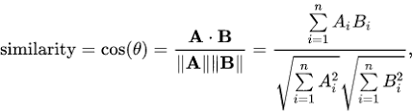
- Cosine similarity formula
Where A and B are vectors. This way nxn matrices is formed where n is the number of total users. This is shown below in Fig.3
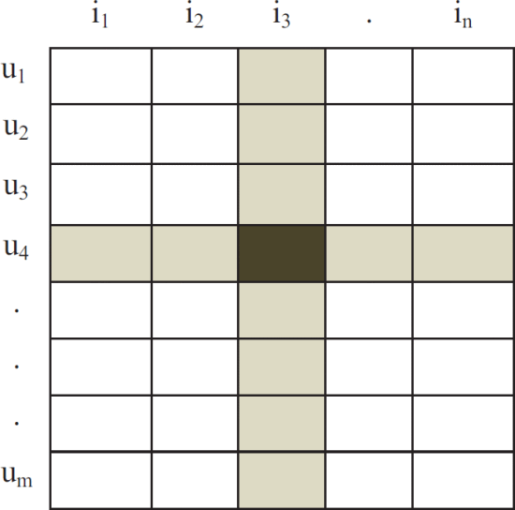
- Matrices of cosine similarity
Now after calculating the similarity of the given user with each user, top n similar users are considered for further calculation. Now we will predict the ratings for books which have not been read by given user yet but have been nicely rated by most similar users. This can be calculated by following formula:
Pui=∑vinS(u,k)∩N(i)Wuvrvi

This approach is based on the belief that an item liked by similar peer will be liked by the user belong to the same peer.

Content Based Approach
Content based approach is the item based approach. Suppose we want to recommend books to a given user. To do so first we will find out what all books have been read by given user and highly rated. Now we will find out the similarity between those highly rated books and other books, hence known as item based approach. Again, similarity can be measured by many methods like pearson correlation, cosine similarity, jaccard similarity etc. In this paper, cosine similarity measure has been used. After calculating the similarity measures between highly rated books and all other books, only top n books will be considered to recommend the given user. This is the working principle of content based approach. This approach is based on the belief that the books liked by a user in past, similar kind of books will be liked in future also.

Experiment Results
Precision and Recall are recognized as evaluating indicator about the recommendation effect of the recommended system:
Precision= Σ u∈U |R(u)∩T(u)|/ Σ u∈U |R(u)|
Recall= Σ u∈U |R(u)∩T(u)|/ Σ u∈U |T(u)|
where, R(u) is the list of recommendations based on the user's behavior in training set and T(u) is the user's behavior in testing set [5].
Although Precision and Recall is not necessarily related in the calculation formula, it is unlikely to achieve high Precision and high Recall at the same time in an actual recommendation system. Billsus and Pazzani proposed the F indicator to get an equilibrium point between Precision and Recall to evaluate the recommendation system [10]
F= (2×Recall×Precision) / (Recall+Precision)
All experimentations ran on Windows8.1 with Python3.

Results Analysis
According to the test results, conclusions can be drawn as follow:
- When the number of recommended books is the same and the number of neighbors is similar, using the Jaccard similarity can get better results
- When the recommended number of books is the same and using the same similarity calculation rule, the recommended effect is showing an upward trend with the number of neighbors increasing [6]. When the number of neighbors run up to about 100, the recommended effect achieves the best effect. After that, the effect declines slowly and then tends to stabilize
- For three different book recommending amounts, recommending 5 books can get the highest Precision but the lowest Recall. Recommending 10 books will get the medium effect. Recommending 15 books will get the highest Recall and best total effect (the highest F value).

Flow Diagram
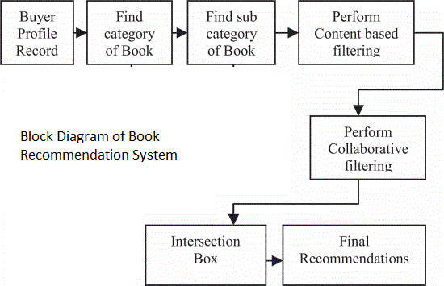
- Flow diagram of the project

Conclusion
Recommender system has become a mandatory tool in E - commerce on the web. The main job of recommender system is to help users find items they want to buy from a long tail. In this paper, we presented a book recommendation system which recommends books to the users according to their previous data, so that a user will get a relevant book. In this recommendation system we considered user based collaborative filtering and content based approach, which helped in getting the books of good quality.
For future work, the cold start problem and matrix sparsity can be addressed. These are the to problems that certain to happen in the recommendation system.

Acknowledgment
This project is completed under the supervision of Prof. Shih Yu Chang. This project is done to fulfil the requirement of CMPE256 Large Scale Analytics class.

References
- Nursultan Kurmashov, Konstantin Latuta, Abay Nussipbekov, “Online book recommendation system”, Almaty, Kazakhstan, 25 February 2016
- Yongen Liang, Shiming Wan, “Design and Implementation of Books Recommendation System”, Beijing, China, China, 11 March 2019
- Anand Shanker Tewari , Abhay Kumar , Asim Gopal Barman, “Book recommendation system based on combine features of content based filtering, collaborative filtering and association rule mining”, 27 March 2014, Gurgaon, India
- Anand Shanker Tewari , Kumari Priyanka, “Book recommendation system based on collaborative filtering and association rule mining for college students”, Mysore, India, 26 January 2015
- I. S. Jacobs and C. P. Bean, “Personalized book recommendation system based on opinion mining,”, vol. III, G. T. Rado and H. Suhl, Eds. New York: Academic, 2010, pp. 271–350.
- Y. Yorozu, M. Hirano, K. Oka, and Y. Tagawa, “Realization of Individualised Recommendation on Book Sales,” IEEE Transl. J. Magn. Japan, vol. 2, pp. 740–741, August 1987 [Digests 9th Annual Conf. Japan, p. 301, 1999].

