Online Medication & Prescription Tracker
Problem statement:
• Many patients depend on multiple medicines daily but lack a reliable system to manage dosage, timing, and duration accurately.
• Paper-based prescriptions are easy to misplace, difficult to organize, and inconvenient for long-term reference.
• Missed doses and incorrect medication intake often occur due to forgetfulness or lack of timely reminders.
• Elderly patients and individuals with chronic illnesses face additional difficulty in maintaining consistent medication routines.
• Caregivers and family members have limited visibility into whether medications are being taken as prescribed.
• There is no centralized platform for securely storing and reviewing prescription history over time.
• Existing manual methods do not provide alerts or structured tracking of ongoing and completed medications.
• A digital solution is required to simplify medication management, reduce human error, and support better adherence to prescribed treatments.

Objective of The System:
The objective of Prescripto is to develop a centralized digital platform for managing prescriptions and medication schedules efficiently. The system aims to reduce medication errors, prevent missed doses, and improve treatment adherence by providing digital prescription storage, automated medication scheduling, and tracking facilities. It also enables doctors and caregivers to monitor patient medication history, ensuring better healthcare management and improved patient safety.

SCOPE:
• The system shall allow users to create secure accounts to manage personal medication and prescription data.
• The system shall provide functionality to add, update, and remove medication details such as name, dosage, frequency, and duration.
• The system shall support uploading and viewing digital prescriptions in a structured format.
• The system shall enable users to schedule medications based on time and receive reminder notifications accordingly.
• The system shall maintain a history of active and completed medications for future reference.
• The system shall restrict access to prescription data through authentication and role-based permissions.
• The system shall allow caregivers or authorized users to view medication schedules if permission is granted.
• The system shall handle basic input validation to prevent incomplete or incorrect medication entries.
• The system shall provide a simple and accessible user interface suitable for users of different age groups.
• The system shall operate as a support tool for medication tracking and shall not provide medical advice or diagnosis.
Deliverables:
- Responsive Login and Register Page
- Reusable components
- Documentation
Roles and Responsibilities
1. Patient
The patient serves as the main user of the application and is responsible for handling their own medication and prescription records.
Duties:
- Sign up and securely access the system
- Update and maintain personal account information
- Add or upload prescription details
- Receive notifications for medication schedules
- Monitor medication usage history
- Check both current and previous prescriptions

2. Doctor
The doctor is responsible for issuing and managing patient prescriptions within the system.
Duties:
- Access the platform through secure login
- Generate and edit electronic prescriptions
- Specify dosage instructions, intake frequency, and treatment period
- Review patient prescription records
- Adjust or stop medications when necessary

3. Administrator
The administrator supervises the overall operation of the system and ensures smooth functionality and data accuracy.
Duties:
- Oversee system performance and maintain data integrity
- Evaluate reports and monitor system activities
- Control user permissions and handle configuration setting
Technology
Frontend: React (Axios , React Router Dom , Tailwind CSS)
Flowchart
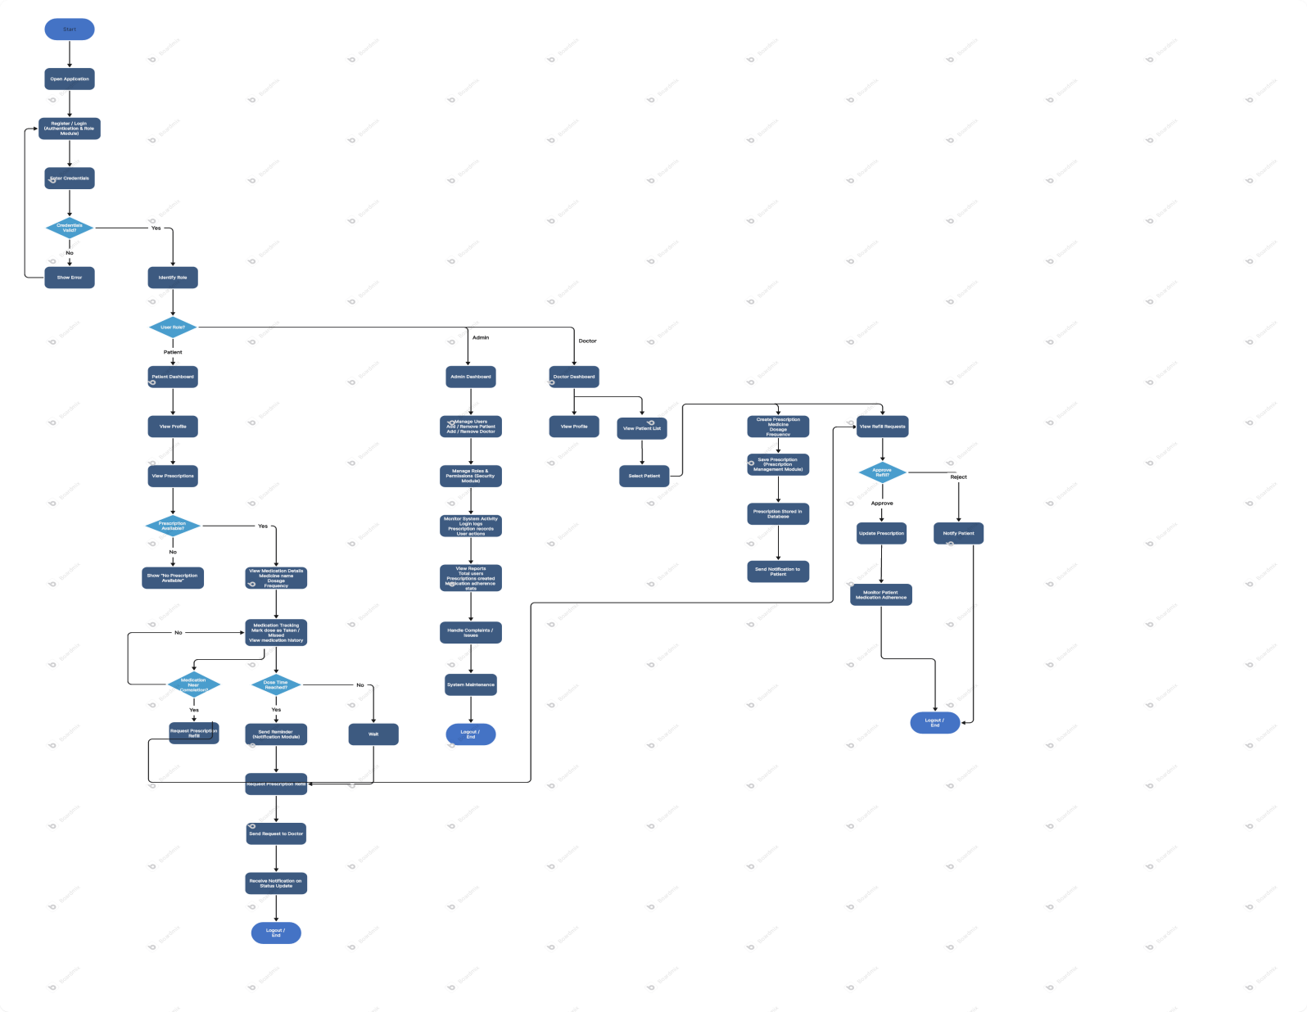
Milestone And Project Progress:
- Milestone 1:
      - Login page
      - Register page
- Form validation
- Input fields
- Buttons
- Styling

