Online Medication and Prescription Tracker

Frontend Project Plan – Dashboard & Landing Page

Problem Statement:
Patients often forget to take medicines on time or misplace prescriptions due to lack of a proper tracking system. Manual methods like paper notes and memory-based reminders are unreliable and can lead to missed doses and health risks.
This project aims to develop an online medication and prescription tracker with a simple landing page and dashboard where users can store prescriptions, set medicine reminders, and track their medication schedule easily, improving adherence and overall health management.

1. Project Overview:
Objective: Design and develop a responsive frontend including a landing page and user dashboard.
Technologies: CSS, JavaScript, React
Target Users: End users, admin users.

2. Scope of Work:
•The system shall allow users to create secure accounts to manage personal medication and prescription data.
•The system shall provide functionality to add, update, and remove medication details such as name, dosage, frequency, and duration.
•The system shall support uploading and viewing digital prescriptions in a structured format.
•The system shall enable users to schedule medications based on time and receive reminder notifications accordingly.
•The system shall maintain a history of active and completed medications for future reference.
•The system shall restrict access to prescription data through authentication and role-based permissions.
•The system shall allow caregivers or authorized users to view medication schedules if permission is granted.
•The system shall handle basic input validation to prevent incomplete or incorrect medication entries.
•The system shall provide a simple and accessible user interface suitable for users of different age groups.
•The system shall operate as a support tool for medication tracking and shall not provide medical advice or diagnosis.

3.Tools and Technologies:
- Frontend: React ,CSS,JS

4. Deliverables:
- Responsive landing page
- Functional dashboard UI
- Reusable components
- Documentation

5. Testing Plan:
- Cross‑browser testing
- Mobile responsiveness
- Performance testing
- UI/UX testing
6.Flow Chart:
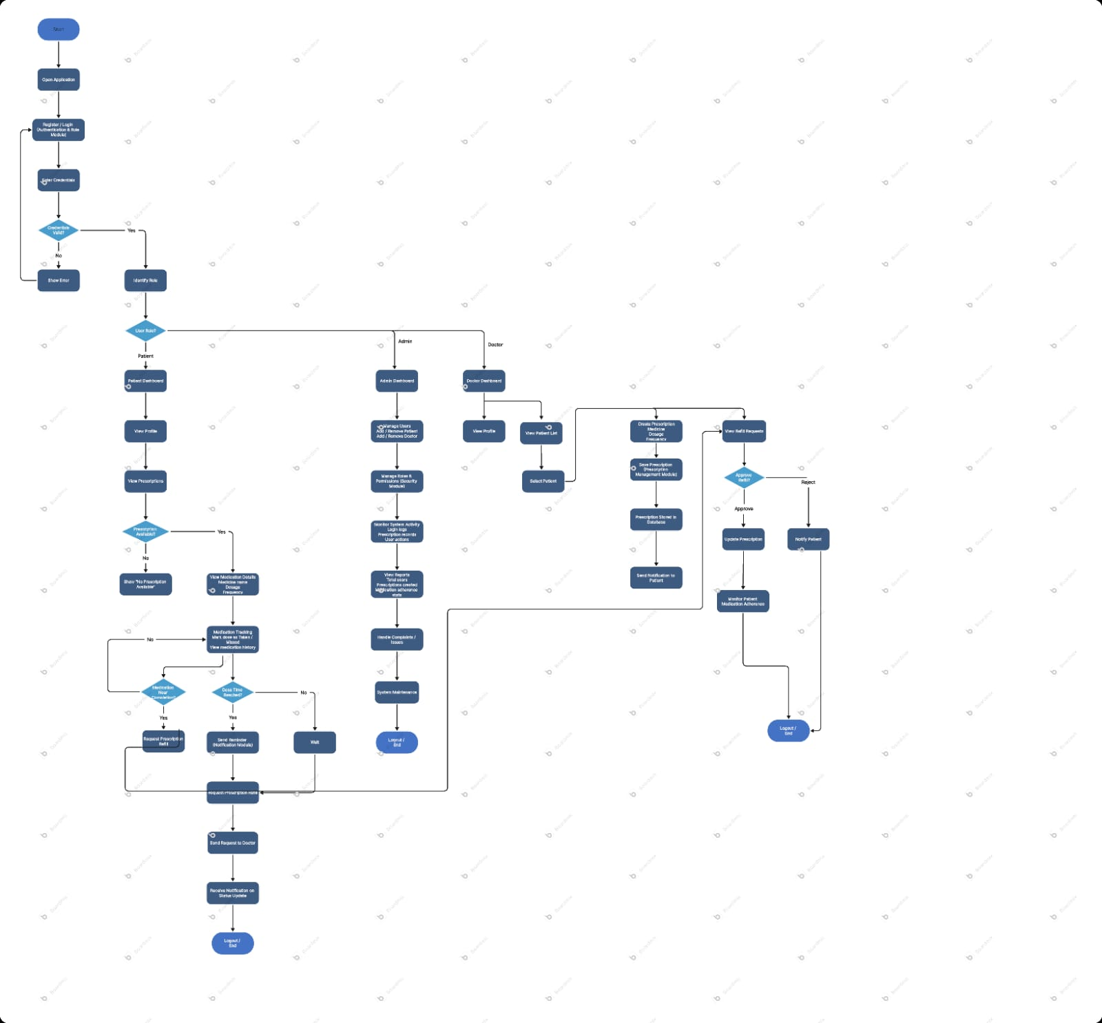

7. Milestone 1:
- Landing page
- UI design
- Responsive layout
- Navigation bar
- Features section
- Login page
- Register page
- Patient authentication UI
- Form validation
- Input fields
- Buttons
- Styling

Milestone 2:
- Patient login page
- Patient dashboard
- My prescription page
- Today's medicine page
- Medicine status in caregiver dashboard
Milestone 3:
- Patient's health report
- Patient's appointment
- APPOINTMENT schedule
- Contact doctor button in caregiver dashboard
Milestone 4:
  - AI Health Assistant
  - AI Chatbot Interface
  - Real-Time Responses
  - Health Query Suggestions
  - AI Dashboard Feature

8. Conclusion:
This plan ensures structured development of the frontend dashboard and landing page with clear milestones and deliverables.

