PRESCRIPTO - ONLINE MEDICATION AND PRESCRIPTION TRACKING

INFOSYS SPRINGBOARD VIRTUAL INTERNSHIP 6.0
JAVA BATCH 13 - TEAM A

NAME-AKSHATA KAPARE
ROLE: DOCUMENTATION, BACKEND

INDEX

- INTRODUCTION
- PROBLEM STATEMENT
- OBJECTIVES OF THE PROJECT
- SCOPE OF THE PROJECT
- DELIVERABLES
- FUNCTIONAL MODULES
- TARGET USERS
- USER ROLES AND RESPONSIBILITIES
- TECHNOLOGY STACK
- FLOWCHART
- MILESTONES AND PROJECT PROGRESS
- MILESTONE 1
- MILESTONE 2
- MILESTONE 3
- MILESTONE 4
- RESULTS AND OUTPUT
- CONCLUSION

INTRODUCTION:
Prescripto is a centralized digital platform developed to modernize prescription management and medication tracking. The system enables doctors to generate secure electronic prescriptions, allows patients to monitor medication schedules with automated reminders, and provides administrators with tools to manage and supervise system operations.
By replacing manual, paper-based processes with a secure and efficient digital solution, Prescripto enhances accuracy, improves medication adherence, and strengthens communication between healthcare stakeholders. The platform is designed with a strong focus on data security, accessibility, and operational efficiency, contributing to improved healthcare delivery and better patient outcomes.

PROBLEM STATEMENT:
Current healthcare systems heavily rely on manual prescription handling and paper-based records, which are time-consuming and error-prone. Prescriptions are often misplaced, misread, or delayed due to the lack of digital management. Communication between doctors and patients is fragmented, leading to confusion regarding medication schedules and dosage. Patients frequently miss doses due to the absence of timely reminders and proper tracking mechanisms. Doctors find it difficult to monitor patient medication adherence effectively. Additionally, maintaining and retrieving patient health data becomes inefficient and unreliable. These challenges highlight the need for a centralized digital prescription and medication tracking system.

OBJECTIVES OF PROJECT:
- Digitalize prescription management to reduce errors.
- Track patient medication adherence in real-time.
- Enable secure doctor-to-patient communication
- Send automated notifications for medication reminders.
- Ensure data security and privacy compliance.
- Provide analytics for medication trends and usage.

SCOPE OF PROJECT:
- User authentication and role-based access (Doctor, Patient, Pharmacy, Admin)
- Prescription creation, storage, and retrieval
- Patient medication tracking dashboard
- Pharmacy verification of prescriptions
- Notifications for medication reminders
- Audit logs for prescription updates
- Secure data storage and encryption

DELIVERABLES:
The Prescripto project will deliver the following tangible and measurable outcomes:

1.Production-Ready Application:
A fully functional web-based (and mobile-accessible) system with secure, role-based access for Doctors, Patients, and Administrators.

2.Digital Prescription Management System:
A centralized module enabling the creation, modification, storage, and retrieval of digital prescriptions.

3.Medication Tracking and Adherence Dashboard:
A patient-facing interface to monitor medication schedules, adherence status, and prescription history.

4.Automated Notification and Reminder System:
A comprehensive dashboard for user management, system monitoring, and audit tracking.

5.Secure Database and Data Protection Implementation:
Encrypted storage of medical records, secure authentication mechanisms, and role-based data access control.

FUNCTIONAL MODULES:
- Authentication and Authorization Module
· Secure login and registration
· Role-based access control (Doctor, Patient, Admin)
· Password encryption and session management
- Prescription Management Module
· Digital prescription creation
· Editing and updating prescriptions
· Secure storage and retrieval of records
- Medication Tracking Module
· Daily medication schedule tracking
· Adherence status monitoring
· History of completed and missed doses
- Notification and Reminder Module
· Automated medication reminders
· Real-time alerts for prescription updates
- Admin Management Module
· User management
· System monitoring dashboard
· Audit log tracking
- AI & Analytics Module
· Medication adherence analysis
· Trend visualization
· Basic predictive insights

TARGET USER:
- Doctors: Create and manage prescriptions for patients
- Patients/Users: Track medications, receive reminders, and view prescription history
- Admin: Monitor system usage, manage users, and ensure system integrity

USER ROLES AND RESPONSIBILITIES:
- Doctor
· Create and manage digital prescriptions
· Update medication details and dosage instructions
· Review patient medication adherence data
· Communicate essential instructions to patients

- Patient / User
· Register and securely log in to the system
· View and download prescriptions
· Track medication schedules
· Receive and respond to medication reminders
· Monitor personal medication history

- Administrator
· Manage user accounts and roles
· Monitor system usage and activity logs
· Ensure data security and compliance
· Handle system-level updates and issue resolution
· Maintain overall system integrity

TECHNOLOGY STACK:
· Frontend: HTML, CSS, JavaScript / React
· Backend: Java 17 SpringBoot
· Database: MySQL
· AI/Analytics: Python, Machine Learning models
· Authentication: JWT Authentication

MILESTONES AND PROJECT PROGRESS:
- MILESTONE 1:
- Requirement Analysis
- Project planning
- Role allocation
- Technology Selection
- Team GitHub Repository
- Theme Selection
- System flowchart
- JWT Based Authentication
- MILESTONE 2:
- Develop RESTful APIs for different modules
- Integrate backend with database (MySQL, MongoDB, Firebase, etc.)
- Implement user authentication and authorization
- Test APIs using tools like Postman
- MILESTONE 3:
- Implement validation and error handling
- Optimize database queries and performance
- Completed the Doctor module functionalities
- MILESTONE 4:
- Integrated Google Gemini API for AI Health Assistant

- Developed AI service layer for processing user queries

- Created REST APIs for chatbot interaction (request–response handling)

- Implemented API communication using RestTemplate

- Developed logic for medicine information and side-effect responses

- Handled error handling and API response optimization

- Coordinated with frontend for chatbot integration

RESULTS AND OUTPUT:
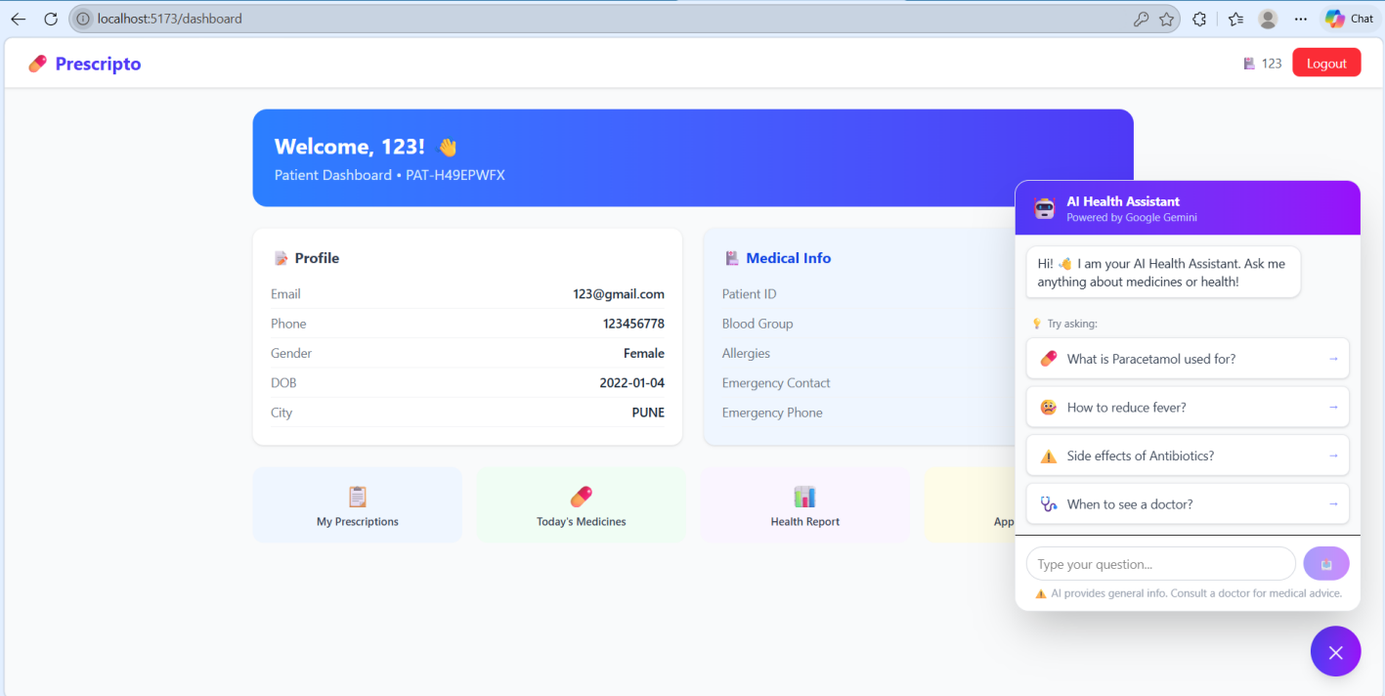

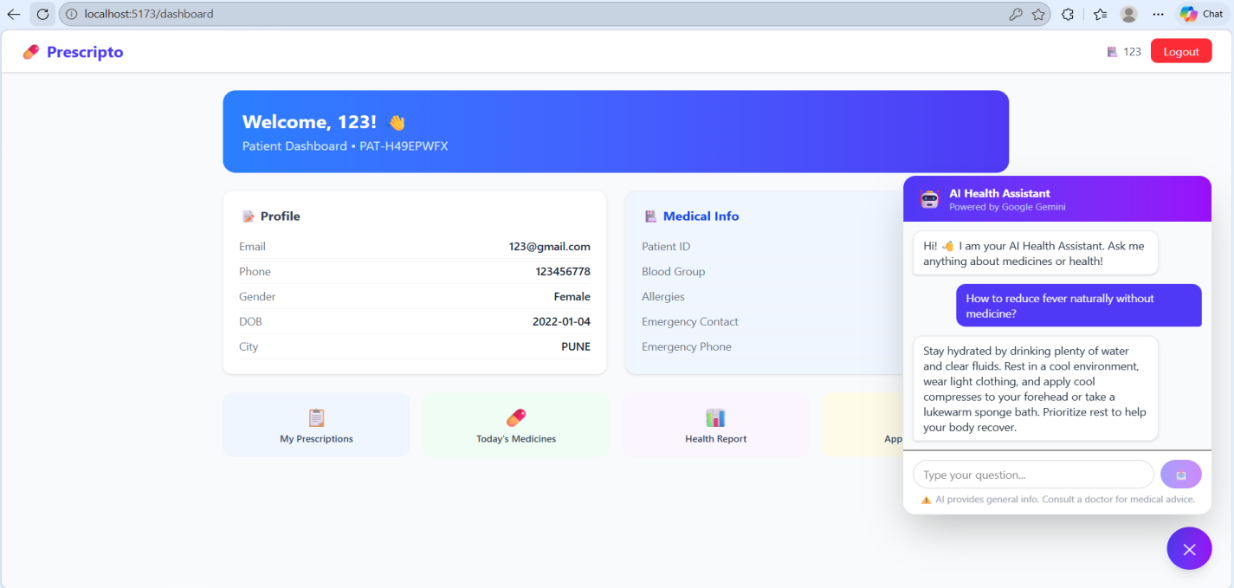
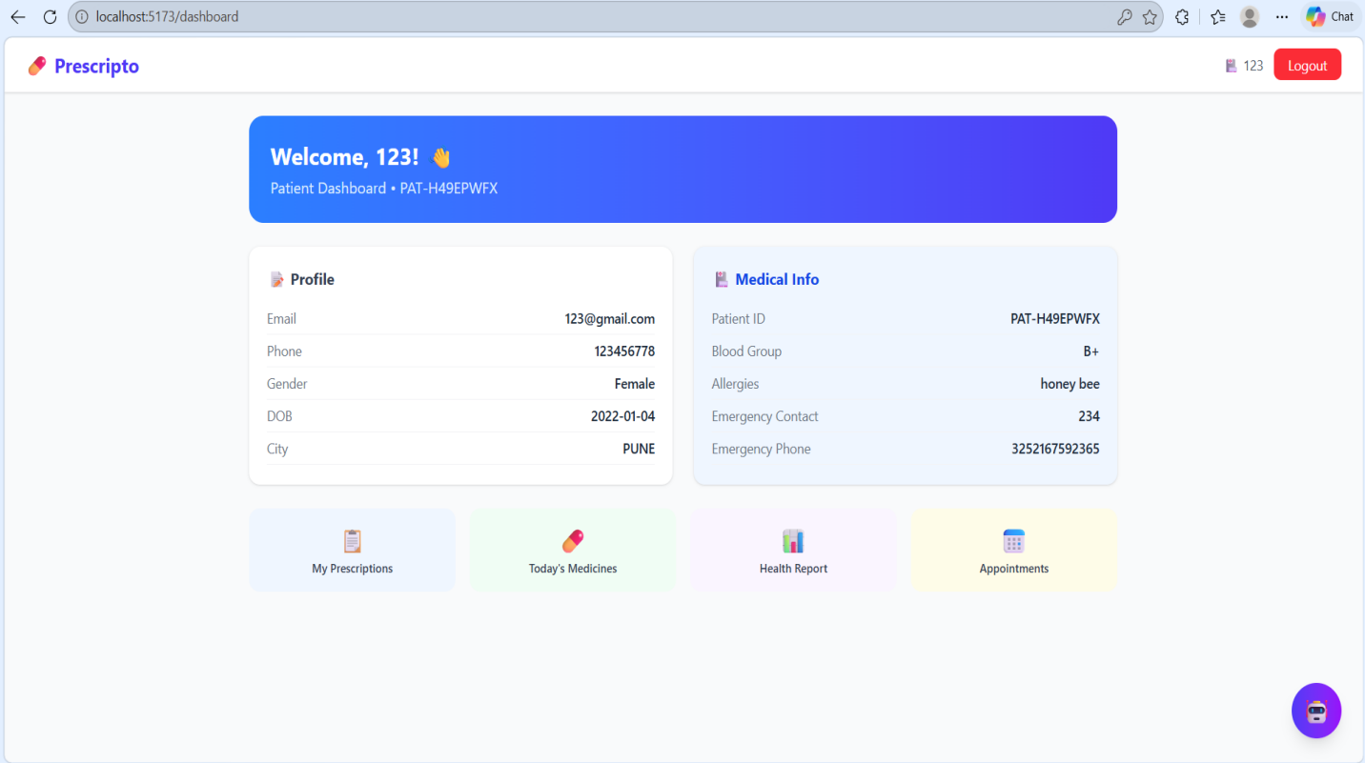

CONCLUSION:
Prescripto provides a secure and efficient digital solution for managing prescriptions and tracking medication. By replacing manual processes with a centralized system, it reduces errors, improves medication adherence, and enhances communication between doctors and patients.The implementation of a robust backend using Spring Boot and RESTful APIs ensures reliable data handling, secure authentication, and smooth system performance. The Admin module enables effective system monitoring and user management, improving overall control and security.Additionally, the integration of an AI-powered health assistant enhances user experience by providing real-time information on medicines, dosage, and general health queries.Overall, Prescripto is a scalable, user-friendly, and technology-driven platform that contributes to improved healthcare management and better patient outcomes.

