HIGH-LEVEL DESIGN
RAG-Based Customer Support Assistant
with LangGraph & Human-in-the-Loop

Internship Project | 2025

1. System Overview

1.1 Problem Definition
Customer support teams spend a significant amount of time answering the same questions repeatedly. Most of these questions already have answers buried inside product documentation, FAQs, or policy documents. The challenge is not the lack of information — it is that retrieving the right piece of information at the right moment, and presenting it clearly, is hard to do manually at scale.

This project builds a system that reads a PDF knowledge base, understands user queries, finds the most relevant information, and responds in a conversational way. When the system is not confident enough to answer, it escalates the query to a human agent rather than guessing.

1.2 Scope
- Accepts a single PDF as the knowledge base (TechCorp support FAQ)
- Handles natural language queries through a chat interface
- Retrieves relevant chunks using vector similarity search
- Generates accurate, context-bound answers using an LLM
- Routes low-confidence queries to human escalation (HITL)
- Runs entirely on Google Colab — no paid infrastructure needed

2. Architecture Diagram
The diagram below shows how data flows through the system from the moment a user types a query to the moment they receive an answer.

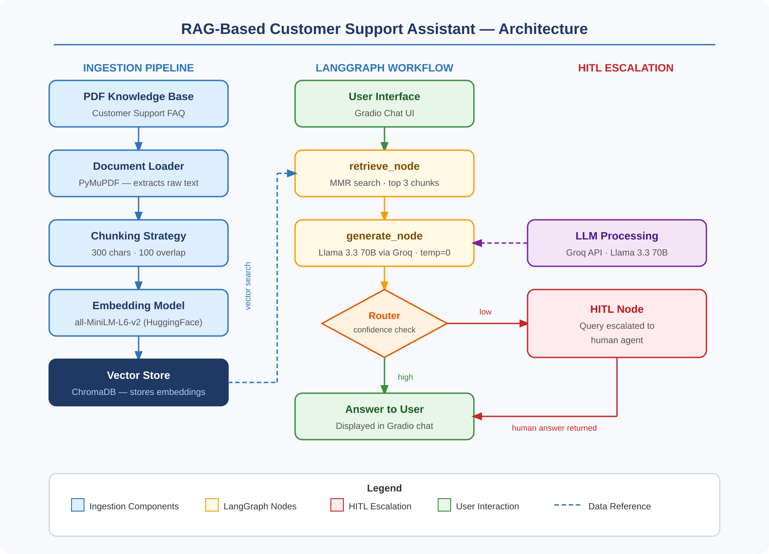

3. Component Descriptions

3.1 Document Loader
Uses PyMuPDF (fitz) to open the PDF and extract raw text page by page. PyMuPDF was chosen over alternatives like pdfplumber because it is faster and handles special characters and arrow symbols (like the ones in our FAQ) more reliably.

3.2 Chunking Strategy
The extracted text is split using LangChain's RecursiveCharacterTextSplitter with a chunk size of 300 characters and an overlap of 100 characters. The separators are tuned specifically for FAQ-style documents: double newlines, single newlines, and question markers (Q: and ?) are used as natural split points. This ensures each chunk contains a complete question-answer pair rather than cutting mid-sentence.

3.3 Embedding Model
Sentence embeddings are generated using the all-MiniLM-L6-v2 model from HuggingFace. This model converts text into 384-dimensional vectors that capture semantic meaning. It runs locally on CPU inside Colab — no API key or internet call required at query time. It was chosen for its balance of speed and accuracy on short FAQ-style text.

3.4 Vector Store
ChromaDB stores the document embeddings in memory during the Colab session. Each chunk is stored as a vector alongside its original text. At query time, ChromaDB performs similarity search to find the closest matching chunks.

3.5 Retriever
The retriever uses MMR (Maximal Marginal Relevance) search instead of plain cosine similarity. MMR fetches the top 6 candidate chunks but returns only 3, picking ones that are both relevant and different from each other. This avoids getting three chunks that say the same thing and improves answer quality.

3.6 LLM (Language Model)
The answer generation uses Llama 3.3 70B through Groq's free API. Temperature is set to 0 to make outputs deterministic and reduce hallucination. The model is constrained by a strict prompt that instructs it to answer only from the provided context and reply 'I don't know' if the answer is not present.

3.7 Graph Workflow Engine (LangGraph)
LangGraph manages the sequence of operations as a directed graph. Each step is a node, and the connections between steps are edges. This makes the control flow explicit and easy to modify. The graph has three nodes: retrieve, generate, and hitl. The routing decision after generate determines which path to take.

3.8 Routing Layer
After the LLM generates a response, a simple confidence check is applied. If the answer contains the phrase 'I don't know', confidence is marked as low and the query is routed to the HITL node. Otherwise it goes directly to the user. This rule-based approach is reliable for our constrained prompt design.

3.9 HITL Module
When a query is escalated, the system pauses and prompts for a human response via Gradio's chat interface. The human-provided answer is then returned to the user with a note indicating it was resolved by a human agent. This ensures no query goes unanswered even when the knowledge base lacks coverage.

4. Data Flow

4.1 Ingestion Pipeline (Run Once at Startup)
- PDF is loaded from disk using PyMuPDF
- Raw text is extracted page by page
- Text is split into overlapping chunks (300 chars, 100 overlap)
- Each chunk is converted to a 384-dim vector by MiniLM
- Vectors and original text are stored in ChromaDB

4.2 Query Lifecycle (Run Per User Message)
- User types a question in the Gradio chat UI
- LangGraph initializes the GraphState with the query
- retrieve_node calls MMR search on ChromaDB, fetches top 3 chunks
- Context is assembled from retrieved chunks
- generate_node sends query + context to Llama 3.3 via Groq
- LLM returns an answer strictly based on the context
- Router checks confidence — high goes to user, low goes to HITL
- Answer is displayed in the chat UI

5. Technology Choices
Component | Choice | Reason
PDF Loader | PyMuPDF (fitz) | Fast, handles special characters well
Text Splitter | RecursiveCharacterTextSplitter | FAQ-aware separators, clean Q&A chunks
Embedding Model | all-MiniLM-L6-v2 | Free, runs on CPU, good semantic accuracy
Vector Store | ChromaDB | In-memory, zero setup, works on Colab
Retrieval Strategy | MMR (k=3, fetch_k=6) | Reduces redundancy, improves answer quality
LLM | Llama 3.3 70B via Groq | Free tier, fast inference, strong reasoning
Workflow Engine | LangGraph | Explicit graph control, easy HITL integration
UI | Gradio ChatInterface | Runs inside Colab, shareable public link

6. Scalability Considerations

6.1 Handling Large Documents
The current chunk size of 300 characters works well for our 10-question FAQ. For larger documents such as a 100-page manual, the same pipeline would still work — ChromaDB handles thousands of chunks without issue. The only adjustment needed would be increasing fetch_k in MMR retrieval to maintain result diversity.

6.2 Increasing Query Load
Groq's free API handles up to 14,400 tokens per minute. For higher loads, the LLM call could be replaced with a locally hosted model using Ollama, or upgraded to a paid Groq plan. ChromaDB's in-memory store can be replaced with a persistent on-disk instance or a managed vector database like Pinecone for production use.

6.3 Latency
The main latency source is the Groq API call, which typically responds in under 2 seconds. Embedding generation at query time is fast since MiniLM is a small model. ChromaDB MMR search over a few hundred chunks is near-instant. Total end-to-end latency for a typical query is under 3 seconds.

