TECHNICAL DOCUMENTATION
RAG-Based Customer Support Assistant
with LangGraph & Human-in-the-Loop

Internship Project | 2025

1. Introduction

1.1 What is RAG
RAG stands for Retrieval-Augmented Generation. It is a technique that combines two different capabilities — the ability to search through a document and find relevant information, and the ability of a large language model to understand and generate human-readable text. Instead of relying on the model's pre-trained knowledge alone, RAG first retrieves specific pieces of text from a knowledge source and then uses those pieces as context when generating an answer.

A purely generative model might hallucinate — that is, confidently produce an answer that sounds correct but is not. RAG addresses this by grounding the model's response in actual retrieved content. The model is not inventing — it is reading and rephrasing what was already written in the document.

1.2 Why It Is Needed
Traditional keyword search retrieves documents based on exact word matches. If a user types 'how do I get back into my account', a keyword search would fail to match a document that says 'password reset instructions'. Semantic search using embeddings solves this — it understands that both phrases mean the same thing and retrieves the correct document regardless of wording differences.

At the same time, a pure LLM with no retrieval has no access to your private or domain-specific documents. It cannot answer questions about your company's return policy or support procedures unless that information was in its training data. RAG bridges this gap by combining real-time document retrieval with language generation.

1.3 Use Case Overview
This project implements a customer support assistant. The knowledge base is a PDF containing frequently asked questions and their answers. When a user submits a question through the Gradio chat interface, the system retrieves the most relevant parts of the FAQ, passes them to the language model along with the question, and generates a clear, accurate response. If the question falls outside the knowledge base, the system escalates it to a human agent rather than guessing.

Core idea: Answer from what you know. Escalate what you don't.

2. System Architecture Explanation

2.1 Detailed Explanation of HLD
The system consists of two distinct pipelines that run at different times. The ingestion pipeline runs once when the system starts. It loads the PDF, splits it into chunks, converts each chunk to an embedding, and stores everything in ChromaDB. This is a one-time setup step. The query pipeline runs every time a user asks a question. It takes the query, searches ChromaDB, retrieves the top matching chunks, builds a prompt, calls the LLM, and routes the response either directly to the user or to the HITL module.

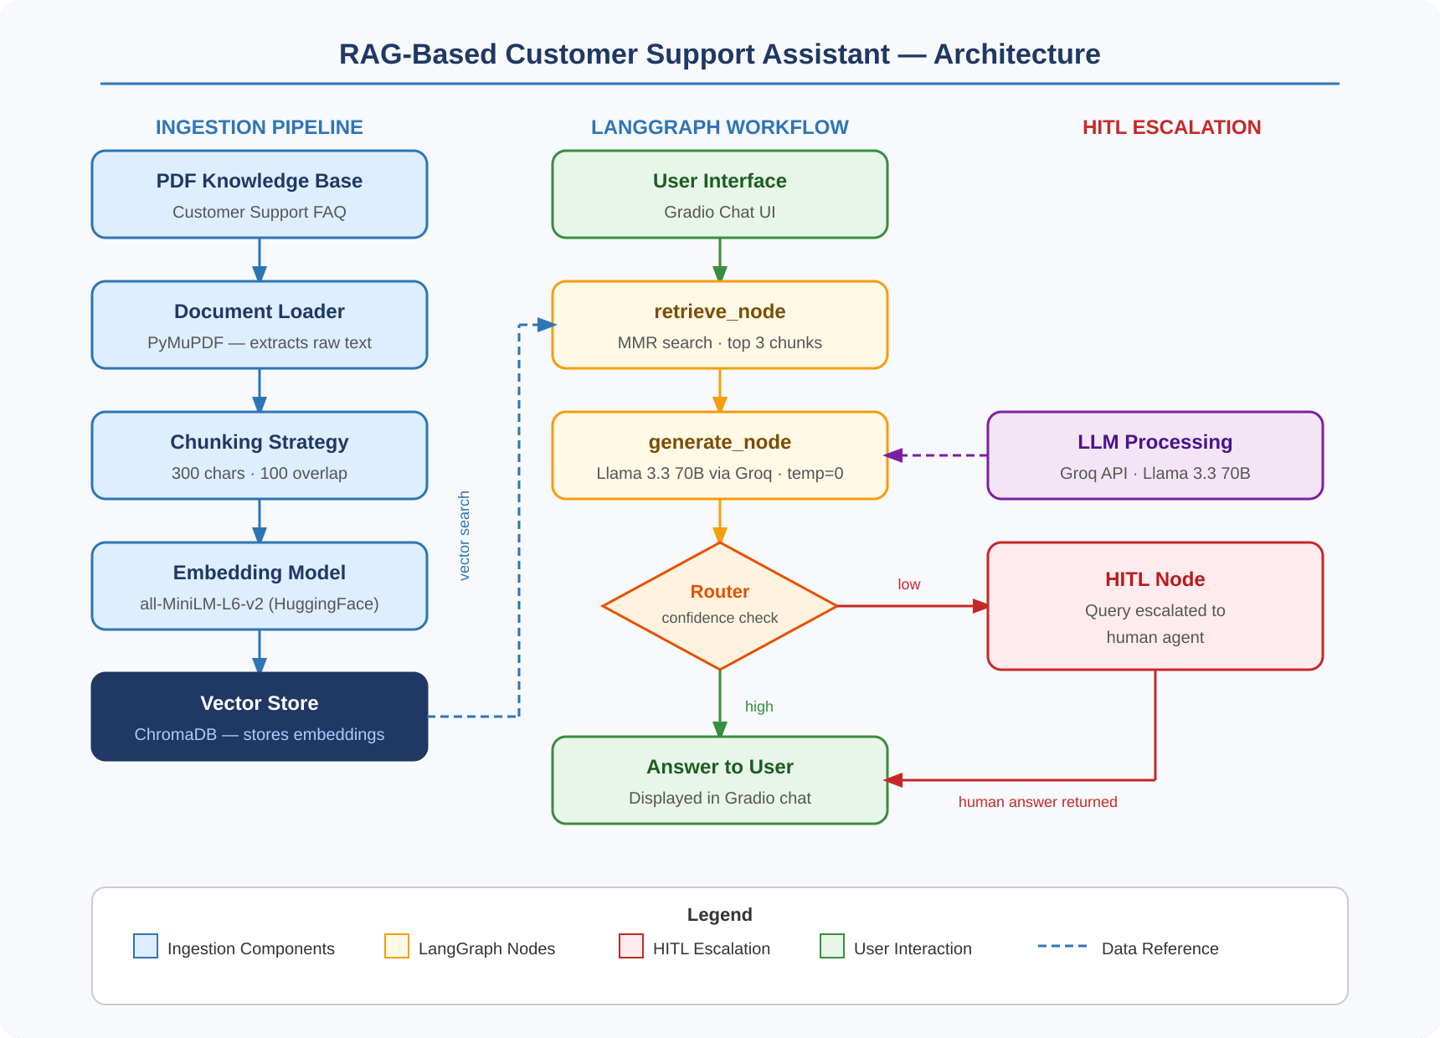
Figure 1: System Architecture Overview

2.2 Component Interactions
The PyMuPDF loader feeds raw text to the chunking module, which feeds chunks to the embedding model, which feeds vectors to ChromaDB. This chain happens once. At query time, the retriever pulls from ChromaDB and feeds context to the LangGraph workflow. Inside the workflow, the generate node calls the Groq API and the result goes to the router. The router either sends the answer to Gradio or diverts to the HITL node. Every component is connected in a single linear flow with one branching point at the router.

3. Design Decisions

3.1 Chunk Size Choice
The chunk size was set to 300 characters with 100 characters of overlap. This was chosen specifically because the knowledge base is a FAQ document where each question-answer pair is short and self-contained. A larger chunk size like 1000 characters would merge multiple Q&A pairs into one chunk, making it harder to isolate the exact answer to a specific question. A smaller size like 100 characters would cut answers in half. At 300 characters with the right separators, each chunk typically contains exactly one complete Q&A pair.

Chunk size is not a one-size-fits-all parameter. It depends on the structure of your document.

3.2 Embedding Strategy
The all-MiniLM-L6-v2 model was chosen over larger alternatives for three reasons. First, it runs on CPU without needing a GPU, making it compatible with the free tier of Google Colab. Second, it produces embeddings fast enough that the ingestion pipeline completes in a few seconds even on slow hardware. Third, despite its small size, it achieves strong semantic similarity scores on short question-answer text, which is exactly what this use case requires.

3.3 Retrieval Approach
MMR was chosen over standard cosine similarity search. The reason is that with only 6 chunks in the knowledge base, plain similarity search might return three chunks that are all minor variations of the same Q&A pair. MMR penalizes redundancy by selecting chunks that are both relevant to the query and different from each other. This gives the LLM richer, more diverse context to work with, which improves answer quality especially when the user's question is ambiguous.

3.4 Prompt Design Logic
The prompt was designed with two hard constraints. First, it explicitly tells the model to answer only from the provided context. This prevents the model from mixing its pre-trained knowledge with the retrieved content, which would be unpredictable and potentially wrong. Second, it gives the model a clear fallback instruction — reply with exactly 'I don't know' when the context is insufficient. This exact phrase is what the routing logic checks for, creating a clean handoff between the LLM and the HITL system.

Answer ONLY using the context below.
If the answer is not in the context, reply exactly: 'I don't know'

4. Workflow Explanation

4.1 LangGraph Usage
LangGraph was used instead of a plain Python function chain because it makes the control flow explicit and modifiable. In a regular Python function, adding a new step or changing routing logic means rewriting the main function. With LangGraph, each step is an independent node and the connections between steps are declared separately as edges. This makes it easy to add new nodes, change routing conditions, or insert logging without touching the existing nodes.

4.2 Node Responsibilities
Node | Responsibility | Reads From State | Writes To State
retrieve_node | Fetch relevant chunks from ChromaDB | query | context
generate_node | Call LLM and assess confidence | query, context | answer, confidence
hitl_node | Collect human response | query | answer, escalated

4.3 State Transitions
The GraphState starts with only the query field populated. After retrieve_node runs, context is filled in. After generate_node runs, answer and confidence are filled in. The router then reads confidence to decide the next step. If high, the graph ends and the state is complete. If low, hitl_node overwrites the answer field with the human response and sets escalated to True before the graph ends.

5. Conditional Logic

5.1 Intent Detection
There is no separate intent classification model in this system. Intent is inferred implicitly through the retrieval step. If the user's query is semantically similar to content in the knowledge base, the retriever will find matching chunks and the LLM will produce a confident answer. If the query is unrelated to the knowledge base, the retriever may still return some chunks but they will be irrelevant, and the LLM — constrained by the prompt — will respond with 'I don't know'. This approach avoids the complexity of maintaining a separate classifier while still achieving reliable routing.

5.2 Routing Decisions
The routing function is a single Python function that reads the confidence field from the GraphState and returns either the string 'hitl' or the END constant from LangGraph. This function is registered as a conditional edge in the graph. It is called automatically after every execution of generate_node. The simplicity of this routing logic is intentional — it is reliable, transparent, and easy to debug.

def route(state):
return 'hitl' if state['confidence'] == 'low' else END

6. HITL Implementation

6.1 Role of Human Intervention
The HITL module exists because no knowledge base is ever complete. Users will always ask questions that the system was not designed to handle. Rather than returning a wrong answer or leaving the user without a response, the system transparently escalates to a human. In the current implementation this human is simulated via a text input prompt in the Gradio interface. In a real deployment this would connect to a support ticket system or a live agent dashboard.

6.2 Benefits
- Guarantees that every query receives an answer — no silent failures
- Maintains trust by being honest about knowledge boundaries
- Provides a data collection opportunity — escalated queries reveal gaps in the knowledge base
- Easy to extend — the hitl_node can be connected to any external system

6.3 Limitations
- In the current implementation, HITL requires a human to be actively monitoring the session
- There is no queue or notification system — the chat simply waits for input
- If the human leaves the input blank, an empty answer is returned to the user
- No logging of escalated queries is implemented in the current version

7. Challenges and Trade-offs

7.1 Retrieval Accuracy vs Speed
MMR search is slightly slower than plain cosine similarity because it evaluates 6 candidates instead of 3. For a small knowledge base like ours with 6 chunks, this difference is negligible — both complete in milliseconds. For a large knowledge base with thousands of chunks, fetch_k would need to be tuned carefully to balance retrieval quality against response time.

7.2 Chunk Size vs Context Quality
Smaller chunks give more precise retrieval but risk cutting answers in half. Larger chunks preserve context but may include irrelevant content that confuses the LLM. The 300-character size with 100-character overlap was chosen after testing — it keeps each Q&A pair intact while ensuring that adjacent answers are not merged into the same chunk. For a different document type, this parameter would need to be re-evaluated.

7.3 Cost vs Performance
The Groq API free tier was chosen to keep the project accessible with no paid dependencies. The trade-off is rate limiting — Groq allows 14,400 tokens per minute on the free tier, which is sufficient for demonstration and testing but would be a bottleneck under real user load. A production deployment would either use a paid API tier or a locally hosted model via Ollama to handle higher concurrency without cost concerns.

Trade-off | Current Choice | Production Alternative
LLM API cost | Groq free tier | Paid Groq / Ollama local
Vector store persistence | ChromaDB in-memory | ChromaDB on-disk / Pinecone
Embedding compute | CPU (MiniLM) | GPU (larger model)
HITL interface | Gradio input prompt | Live agent dashboard

8. Testing Strategy

8.1 Testing Approach
Testing was done manually using a set of representative queries divided into three categories. The first category covers queries that are directly answered in the knowledge base — these should always produce a high-confidence answer. The second category covers queries that are related to the topic but not explicitly in the FAQ — these test the retriever's ability to find approximate matches. The third category covers completely out-of-scope queries — these should always trigger HITL escalation.

8.2 Sample Queries and Expected Behavior
Query | Category | Expected Outcome
How do I reset my password? | Direct match | Correct answer — high confidence
What is the refund policy? | Direct match | Correct answer — high confidence
How do I contact support? | Direct match | Correct answer — high confidence
Can I get my money back? | Approximate match | Refund policy answer — high confidence
My app is crashing | Approximate match | Troubleshooting answer — high confidence
What is the weather today? | Out of scope | I don't know — HITL triggered
Who is the CEO of the company? | Out of scope | I don't know — HITL triggered

9. Future Enhancements

9.1 Multi-Document Support
The current system loads a single PDF. A natural next step is to support multiple documents — for example, separate PDFs for billing, technical support, and account management. This would require adding source metadata to each chunk so the system can tell the user which document the answer came from. ChromaDB supports metadata filtering natively, so this enhancement would not require changing the core architecture.

9.2 Feedback Loop
Currently there is no mechanism for capturing whether the user found the answer helpful. Adding a simple thumbs up or thumbs down button in Gradio would allow collection of feedback data. Over time this data could be used to identify which queries are consistently answered poorly, guiding improvements to the knowledge base or the prompt.

9.3 Memory Integration
The current system treats every query as independent. It has no memory of previous turns in the conversation. Adding conversational memory using LangChain's ConversationBufferMemory would allow the system to handle follow-up questions like 'can you explain that in simpler terms' or 'what about for premium users'. This would make the assistant feel significantly more natural in real support conversations.

9.4 Deployment
The current setup runs inside a Google Colab notebook and generates a temporary Gradio public URL. For a production deployment, the system could be containerized using Docker and hosted on a cloud platform such as Google Cloud Run or AWS Lambda. The Gradio interface could be replaced with a custom React frontend that connects to a FastAPI backend wrapping the LangGraph workflow. ChromaDB would be replaced with a persistent managed vector database.

Enhancement | Effort | Impact
Multi-document support | Low | High — broader knowledge coverage
User feedback collection | Low | Medium — improves knowledge base over time
Conversational memory | Medium | High — more natural interactions
Production deployment | High | High — real-world usability
Automated HITL logging | Low | Medium — identifies knowledge gaps

