Linux Basics Assignment
Name: Akshatha
Email: ashwithashetty756@gmail.com
GitHub Username: Akshatha1131

1. Creating and Renaming Files/Directories
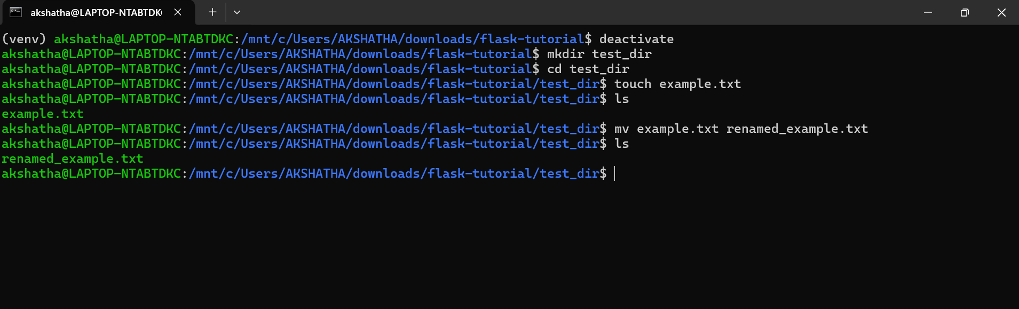
mkdir test_dir creates a new directory named test_dir
cd test_dir changes the current directory to test_dir
touch example.txt creates an empty file named example.txt
mv example.txt renamed_example.txt renames file from example.txt to renamed_example.txt
ls lists the files in the directory to verify that the file has been renamed successfully

2. Viewing File Contents
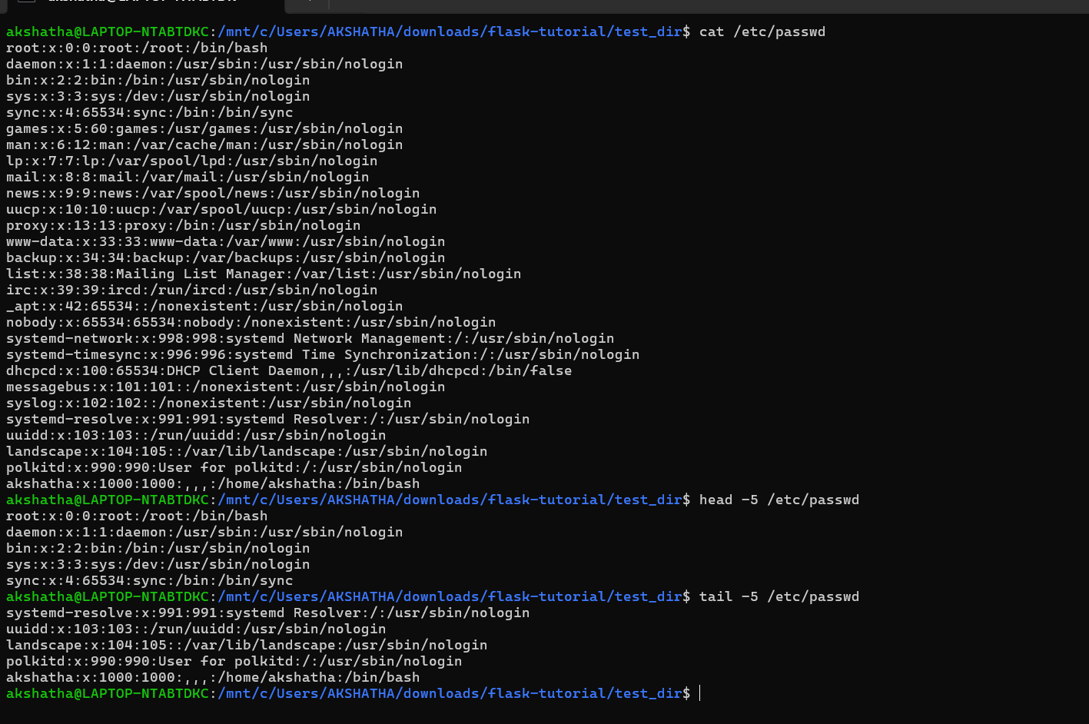
cat /etc/passwd displays the complete contents of the /etc/passwd file
head -n 5 /etc/passwd displays the first 5 lines of the file
tail -n 5 /etc/passwd displays the last 5 lines of the file

3.Searching for Patterns
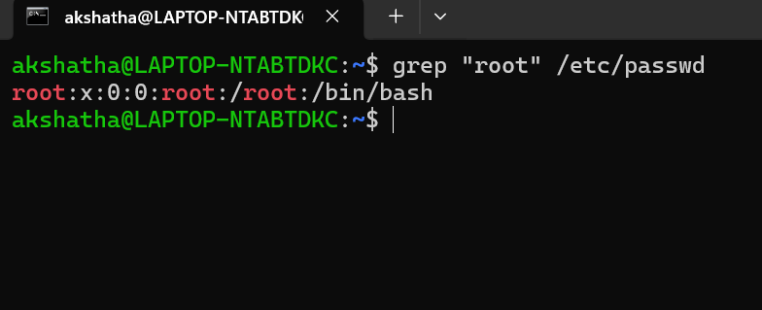
grep “root” /etc/passwd searches the /etc/passwd file for all lines containing the word “root”

4. Zipping and Unzipping
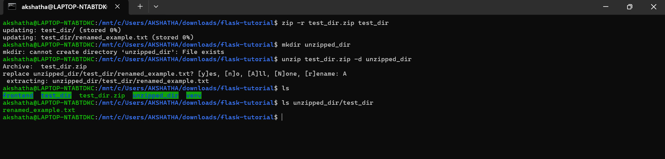
zip -r test_dir.zip test_dir compresses the test_dir directory and all its contents into a ZIP file named test_dir.zip The -r option means recursive, so it includes all files and subdirectories
unzip test_dir.zip -d unzipped_dir extracts the contents of the ZIP file into a new directory named unzipped_dir

5. Downloading Files
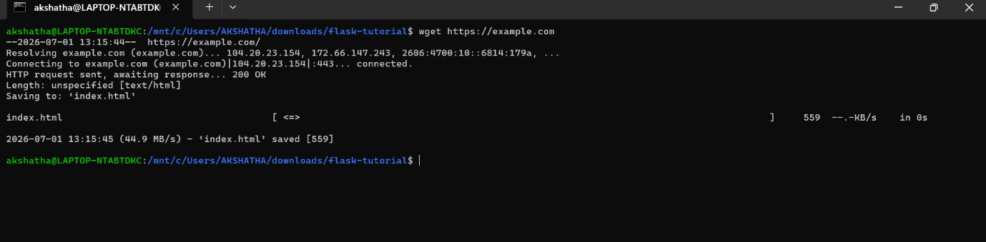
wget is a command-line utility used to download files from the internet
In this task, wget https://example.com downloads the homepage of the website example.com and saves it as index.html in the current directory

6. Changing Permissions
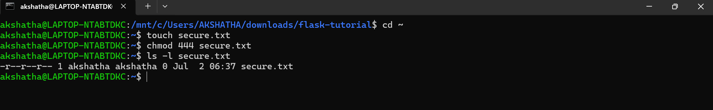
touch secure.txt creates an empty file named secure.txt.
chmod 444 secure.txt changes the file permissions to read-only for the owner, group, and others.
ls -l secure.txt displays the file permissions to verify that the changes were applied successfully.

7. Working with Environment Variables
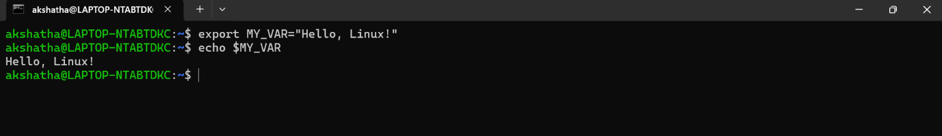
export MY_VAR="Hello, Linux!" creates an environment variable named MY_VAR and assigns it the value "Hello, Linux!".
echo $MY_VAR displays the value of the environment variable.

