Linux Basics Assignment - 3
Name: Akshatha
Email: ashwithashetty756@gmail.com
GitHub Username: Akshatha1131

1.Create a Flask application with an /api route. When this route is accessed, it should return a JSON list. The data should be stored in a backend file, read from it, and sent as a response.
Code (app.py)
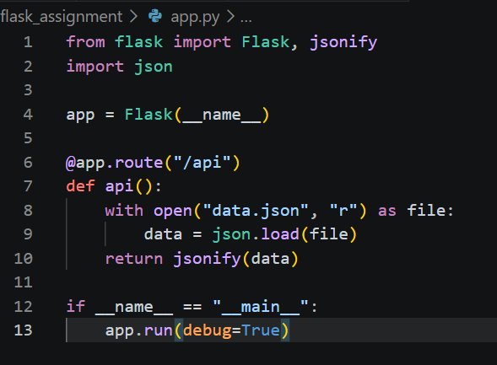

Backend File (data.json)
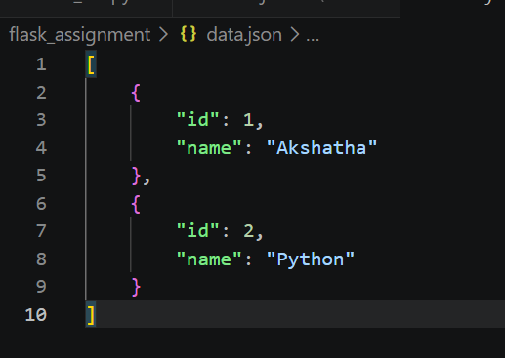
Output
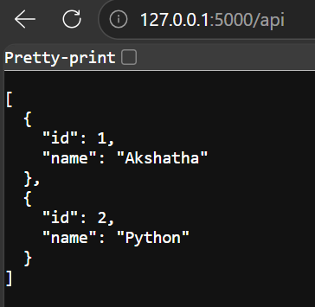
Step 1
Create a folder named flask_assignment.
Step 2
Create a file named data.json and store the required data in JSON format.
Step 3
Create a file named app.py and write the Flask code to read the data from data.json and return it as a JSON response.
Step 4
Open the terminal, go to the flask_assignment folder, activate the virtual environment (if required), and run:
python3 app.py
Step 5
The terminal displays:
Running on http://127.0.0.1:5000
Step 6
Open a web browser and visit:
http://127.0.0.1:5000/api
Step 7
The browser displays the JSON data stored in data.json.

2. Create a form on the frontend that, when submitted, inserts data into MongoDB Atlas. Upon successful submission, the user should be redirected to another page displaying the message "Data submitted successfully". If there's an error during submission, display the error on the same page without redirection.

app.py
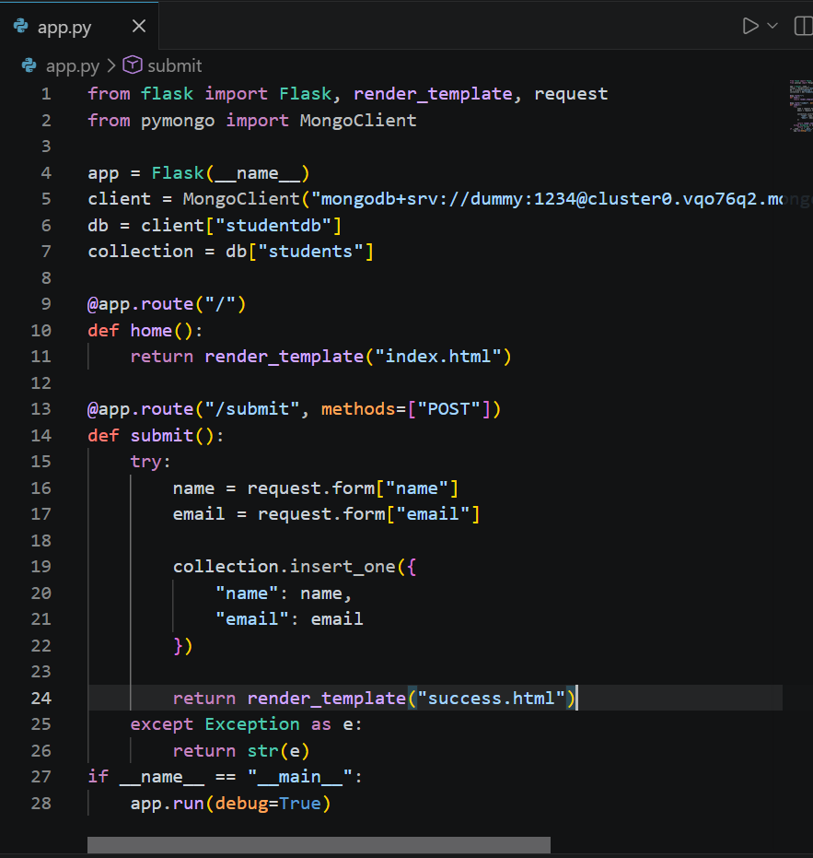

templates/index.html
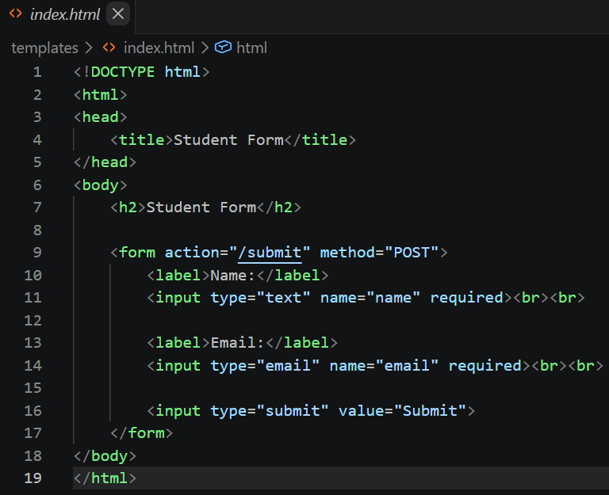

templates/success.html
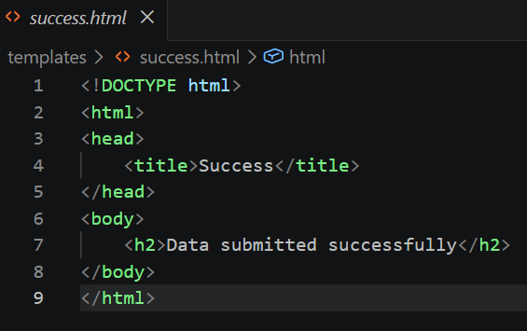

Terminal
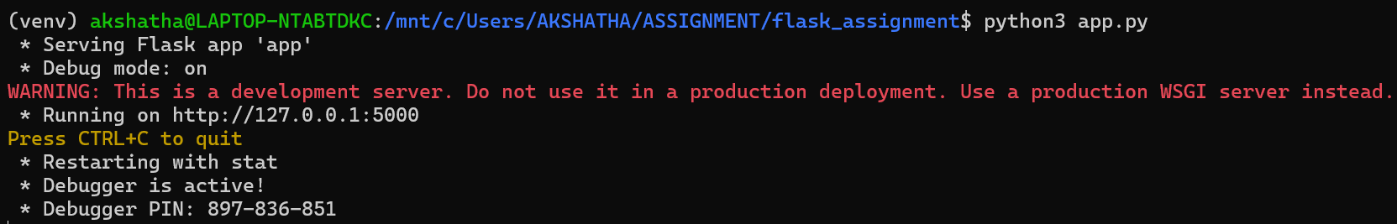

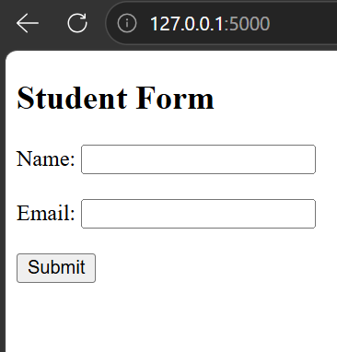

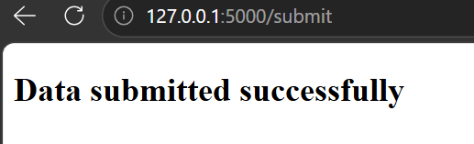

Step 1: Create a folder named flask_assignment.
Step 2: Create a templates folder.
Step 3: Create index.html and design a form with Name and Email fields.
Step 4: Create success.html to display "Data submitted successfully" after form submission.
Step 5: Install the required packages using:
pip install flask
pip install pymongo
Step 6: Create app.py and connect the Flask application to MongoDB Atlas using the connection string.
Step 7: Run the application using:
python3 app.py
Step 8: Open the browser and visit:
http://127.0.0.1:5000
Step 9: Enter the Name and Email, then click Submit.
Step 10: The data is stored in MongoDB Atlas, and the application redirects to the "Data submitted successfully" page.

