Linux Basics Assignment - 2
Name: Akshatha
Email: ashwithashetty756@gmail.com
GitHub Username: Akshatha1131

1. Grade Checker
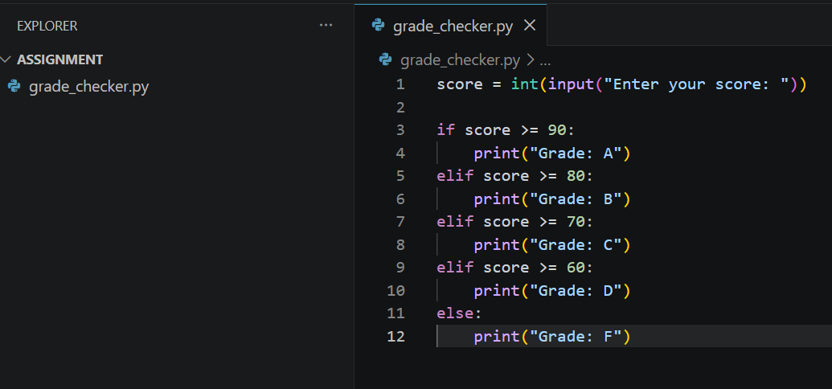

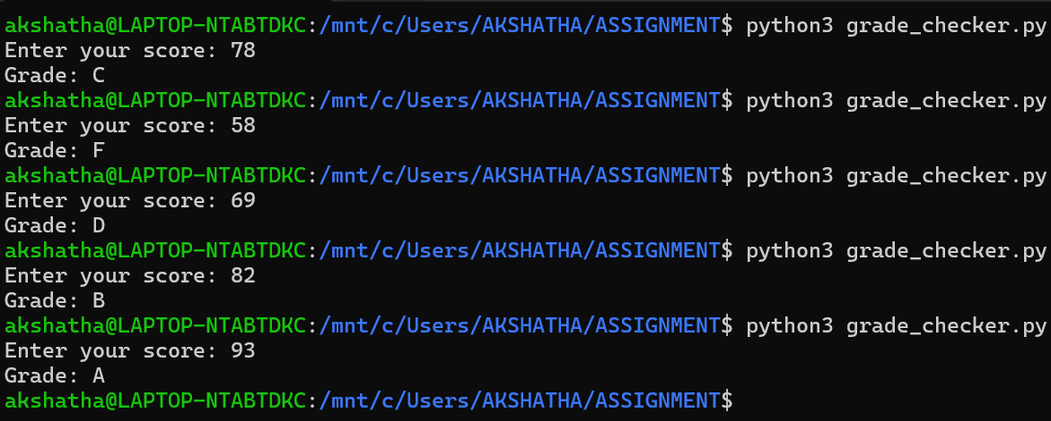

This program asks the user to enter a score. It uses if-elif-else statements to check the score and prints the correct grade.

2 Student Grades
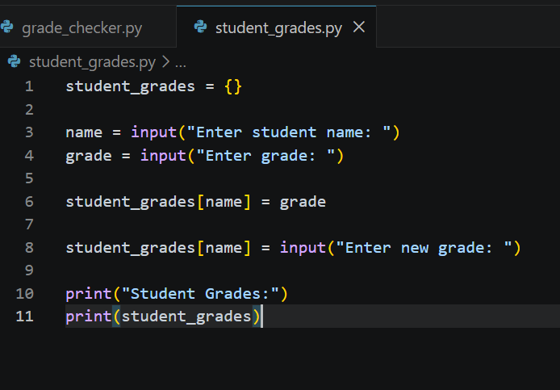
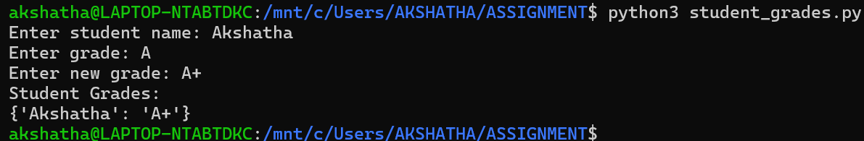

This program uses a dictionary to store student names and grades. It allows the user to add a student, update the student's grade, and display all student grades.

3.Write to a File
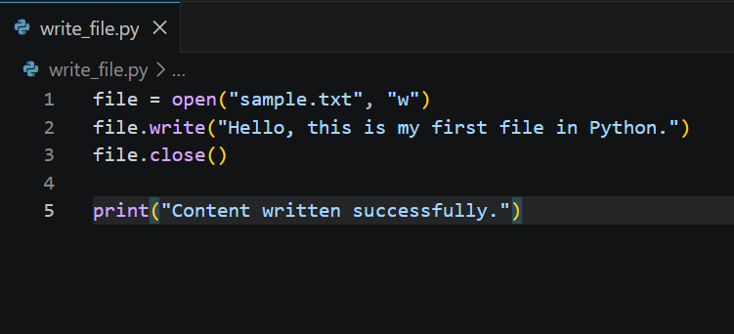
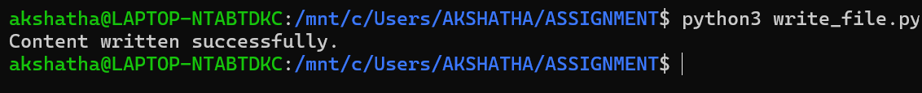
This program creates a file named sample.txt and writes the text "Hello, this is my first file in Python." into the file.

4. Read from a File
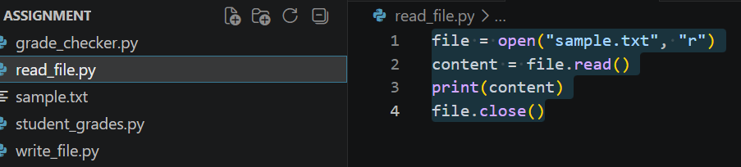

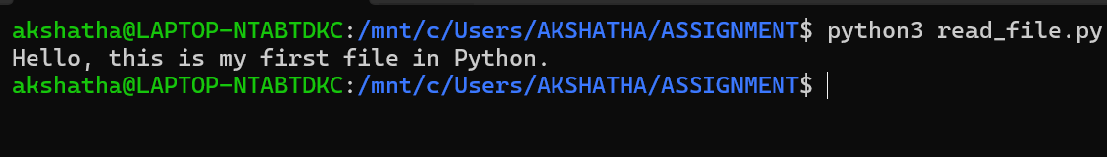

This program opens the sample.txt file, reads the content from the file, displays it on the screen, and then closes the file.

