Linux Basics Assignment - 5
Name: Akshatha
Email: ashwithashetty756@gmail.com
GitHub Username: Akshatha1131

1. Frontend (Node.js with Express):
Step 1: Create the project folder structure
Command
mkdir flaskp
cd flaskp
mkdir frontend backend
- mkdir flaskp creates a new project folder named flaskp.
- cd flaskp moves inside the newly created project folder.
- mkdir frontend backend creates two separate folders:
- frontend → will contain the Node.js + Express application.
- backend → will contain the Flask application.

Step 2: Create the Flask Backend Application
Command
cd backend
touch app.py
python3 -m venv venv
source venv/bin/activate
pip install flask flask-cors --break-system-packages
pip freeze > requirements.txt
- cd backend moves into the backend folder where the Flask application will be developed.
- touch app.py creates a new Python file named app.py. This file contains the Flask backend logic.
- python3 -m venv venv creates a Python virtual environment named venv.
  - A virtual environment keeps project dependencies separate from the system Python packages.
- source venv/bin/activate activates the virtual environment in Linux/WSL.
- pip install flask flask-cors --break-system-packages installs the required Python libraries:
  - Flask → Used to create the backend web server and handle requests.
  - Flask-CORS → Allows communication between the Node.js frontend and Flask backend.
- pip freeze > requirements.txt creates a requirements.txt file containing all required Python packages.
  - This file is used later by Docker to install dependencies inside the backend container.

Step 3: Write the Flask Backend Code (app.py)
Command
Open the Flask application file:
nano app.py
- nano opens the app.py file in the terminal text editor.
- The Flask backend code is written inside this file.
- This file handles requests received from the Node.js frontend and processes the submitted form data.
Flask Backend Code (app.py)
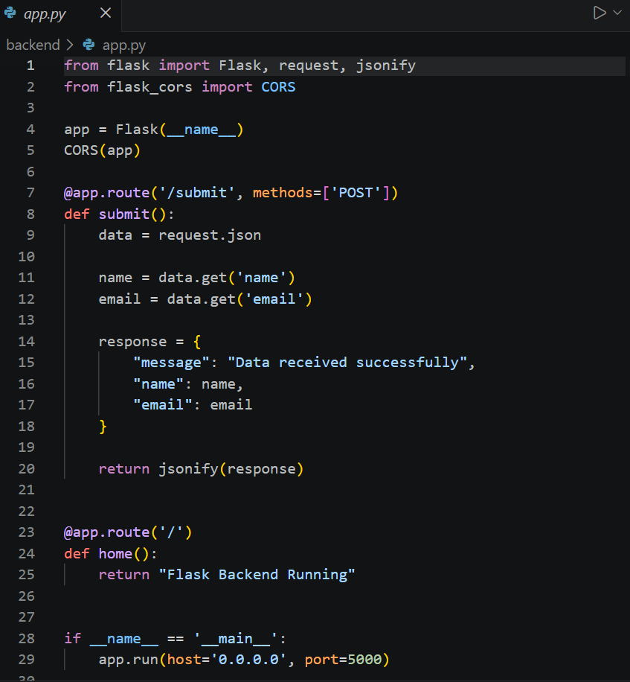
- Flask is imported to create the backend web application.
- request is used to receive data sent from the frontend.
- jsonify converts Python data into JSON format for sending responses.
- CORS(app) enables communication between the Node.js frontend and Flask backend.
- /submit is a POST API endpoint that receives form data.
- request.json reads the JSON data sent by the frontend.
- data.get() extracts the name and email values from the submitted form.
- The backend sends a JSON response containing the received data.
- The / route checks whether the Flask server is running.
- app.run() starts the Flask server on port 5000.

Run the Flask Backend
Command
python3 app.py
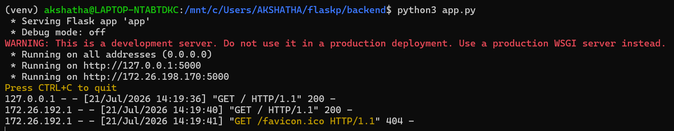

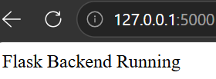

Step 4: Create the Node.js + Express Frontend
Command
Move back to the main project folder:
cd ..
Move into the frontend folder:
cd frontend
Initialize a Node.js project:
npm init -y
Install required packages:
npm install express axios
Create frontend files:
touch server.js
mkdir views
touch views/index.html
Explanation
- cd .. moves from the backend folder back to the main project folder.
- cd frontend enters the frontend directory where the Node.js application will be created.
- npm init -y creates a Node.js project and generates a package.json file.
- npm install express axios installs required dependencies:
  - Express → used to create the frontend web server.
  - Axios → used to send form data requests from Node.js frontend to Flask backend.
- touch server.js creates the main Express server file.
- mkdir views creates a folder to store HTML pages.
- touch views/index.html creates the frontend form page.

Step 5: Create the Express Frontend
Command
Move to the frontend folder:
cd ../frontend
Initialize a Node.js project:
npm init -y
Install the required packages:
npm install express axios
Create the required files:
touch server.js
mkdir views
touch views/index.html
Explanation
- cd ../frontend moves to the frontend folder.
- npm init -y initializes a new Node.js project and creates the package.json file.
- npm install express axios installs the required packages:
  - Express – Creates the frontend web server.
  - Axios – Sends HTTP requests from the frontend to the Flask backend.
- touch server.js creates the main Express server file.
- mkdir views creates a folder to store HTML pages.
- touch views/index.html creates the HTML form page.

Express Server Code (server.js)
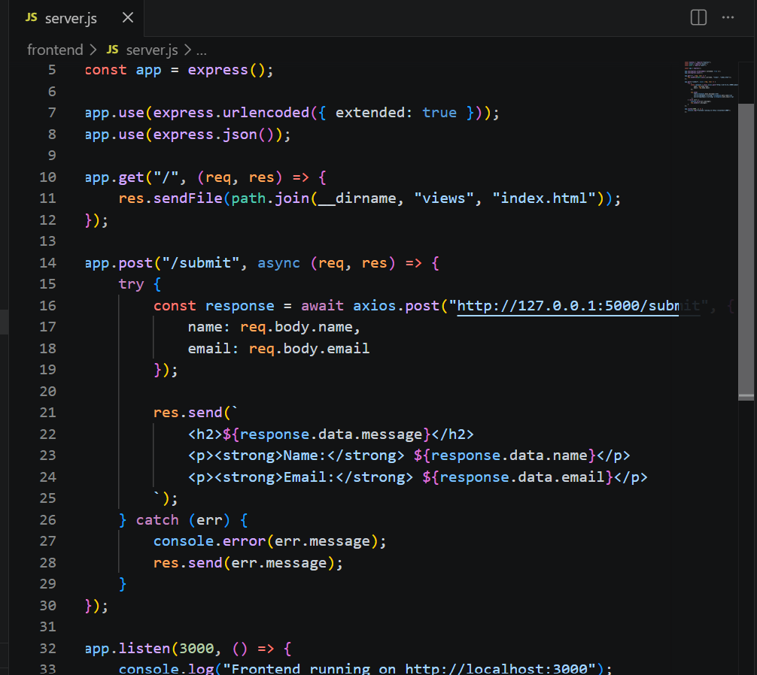

HTML Form (views/index.html)
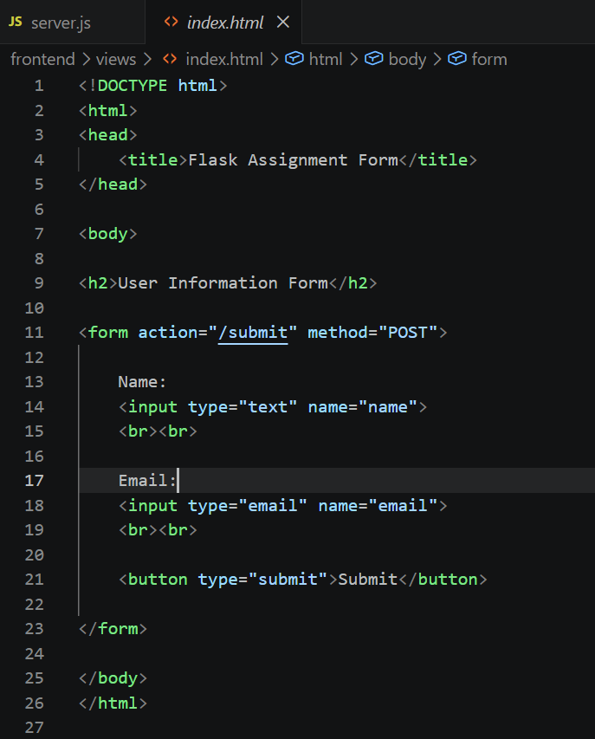
Explanation
- The Express server serves the HTML form at http://localhost:3000.
- The user enters their name and email.
- When the Submit button is clicked, the form data is sent to the Express server.
- Express uses Axios to forward the data to the Flask backend (http://127.0.0.1:5000/submit).
- The Flask backend processes the request and returns a JSON response.
- Express displays the received response in the browser.
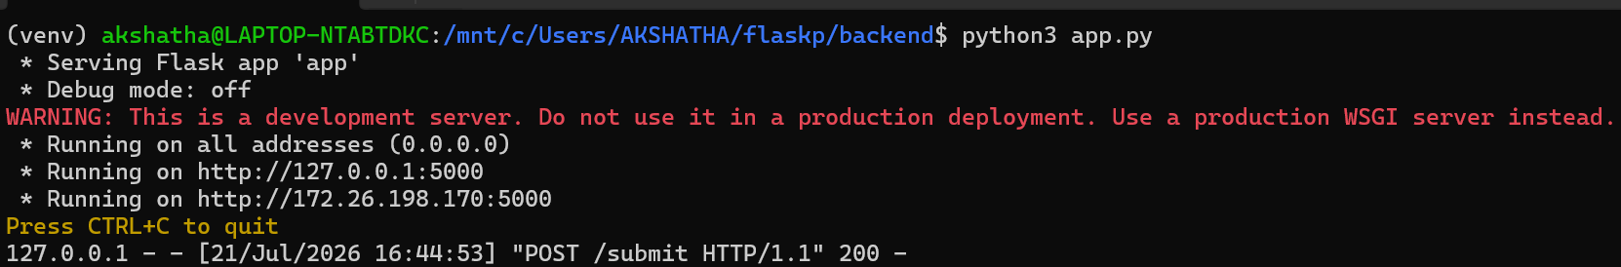

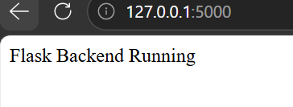

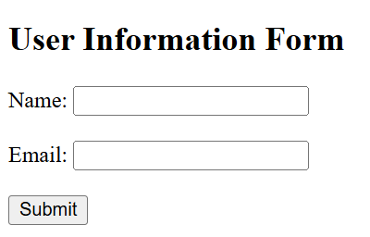

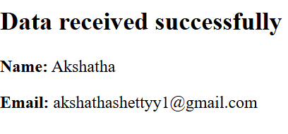

Step 6: Create a Dockerfile for the Flask Backend
Command
Move to the backend folder:
cd ../backend
Create a Dockerfile:
touch Dockerfile
Explanation
- cd ../backend moves to the Flask backend directory.
- touch Dockerfile creates a file named Dockerfile.
- The Dockerfile contains instructions to build a Docker image for the Flask backend.

backend/Dockerfile
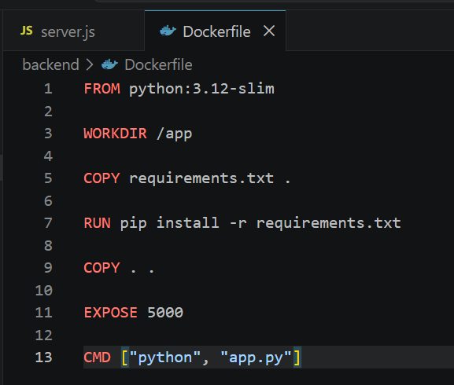

Explanation
- FROM python:3.12-slim uses the official lightweight Python 3.12 image.
- WORKDIR /app sets the working directory inside the container.
- COPY requirements.txt . copies the dependency file into the container.
- RUN pip install -r requirements.txt installs the required Python packages.
- COPY . . copies all backend files into the container.
- EXPOSE 5000 exposes port 5000 for the Flask application.
- CMD ["python", "app.py"] starts the Flask application when the container runs.

Step 7: Create a Dockerfile for the Node.js Frontend
Command
Move to the frontend folder:
cd ../frontend
Create a Dockerfile:
touch Dockerfile
Explanation
- cd ../frontend moves to the Node.js frontend directory.
- touch Dockerfile creates a new file named Dockerfile.
- This file contains the instructions to build the Docker image for the Express application.

frontend/Dockerfile
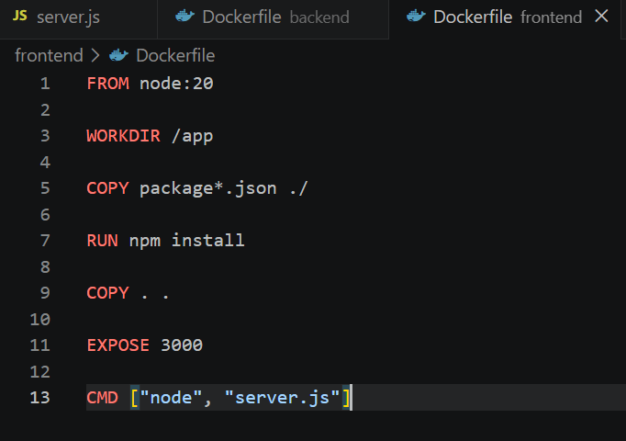

Explanation
- FROM node:20 uses the official Node.js version 20 image.
- WORKDIR /app sets the working directory inside the container.
- COPY package*.json ./ copies package.json and package-lock.json.
- RUN npm install installs all required Node.js dependencies.
- COPY . . copies the remaining frontend files into the container.
- EXPOSE 3000 exposes port 3000 for the Express server.
- CMD ["node", "server.js"] starts the Express application when the container runs.
Step 8: Create the Docker Compose File (docker-compose.yml)
Command
Move to the main project folder:
cd ..
Create the Docker Compose file:
touch docker-compose.yml
Explanation
- cd .. moves from the frontend folder to the main flaskp project folder.
- touch docker-compose.yml creates a Docker Compose configuration file.
- Docker Compose is used to run multiple containers (frontend and backend) together on the same network.

docker-compose.yml
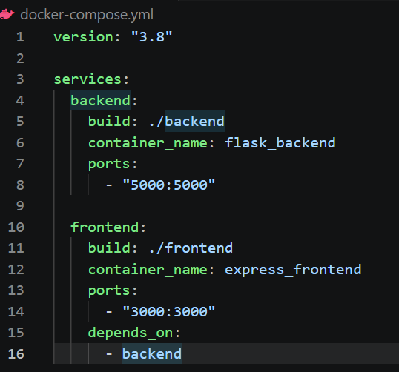
Explanation
- version: "3.8" specifies the Docker Compose file version.
- services: defines the containers to be created.
- backend:
  - build: ./backend builds the Flask image using the backend Dockerfile.
  - container_name assigns the container name.
  - ports: "5000:5000" maps port 5000 from the container to the host.
- frontend:
  - build: ./frontend builds the Node.js image using the frontend Dockerfile.
  - container_name assigns the container name.
  - ports: "3000:3000" maps port 3000 from the container to the host.
  - depends_on ensures the backend starts before the frontend.

Step 9: Create a .gitignore File
Command
Make sure you are in the main project folder:
cd ..
Create the .gitignore file:
touch .gitignore
Open the file:
nano .gitignore

Add the Following Content
# Node.js
frontend/node_modules/
# Python
backend/venv/
__pycache__/
*.pyc
# VS Code
.vscode/
# Environment files
.env
# OS files
.DS_Store
Thumbs.db
Explanation
- frontend/node_modules/ ignores the Node.js dependencies folder because it can be recreated using npm install.
- backend/venv/ ignores the Python virtual environment because it should not be uploaded to GitHub.
- __pycache__/ and *.pyc ignore Python cache files.
- .vscode/ ignores Visual Studio Code settings.
- .env ignores environment variable files.
- .DS_Store and Thumbs.db ignore operating system-generated files.
This keeps the GitHub repository clean by excluding unnecessary files.

Step 10: Build and Run the Project Using Docker Compose
Command
Move to the project folder:
cd /mnt/c/Users/AKSHATHA/flaskp
Build the Docker images:
docker compose build
Run the Docker containers:
docker compose up
Explanation
- cd /mnt/c/Users/AKSHATHA/flaskp moves to the main project folder where the docker-compose.yml file is located.
- docker compose build builds the Docker images for both the Flask backend and the Express frontend using their respective Dockerfiles.
- docker compose up creates and starts both containers and connects them on the same Docker network.
- Docker Compose automatically creates a network so the frontend can communicate with the backend using the service name backend.
Verification Command
Open the browser and visit:
http://localhost:3000
Fill in the Name and Email fields and click Submit.
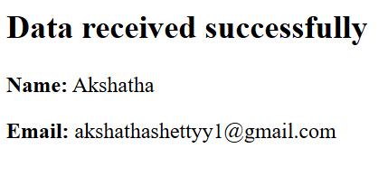
Step 11: Push the Project to GitHub
Command
Rename the default branch to main:
git branch -M main
Push the project to the GitHub repository:
git push -u origin main
Explanation
- git branch -M main renames the current branch from master to main.
- git push -u origin main uploads the local project files to the connected GitHub repository.
- The -u option sets the remote origin/main as the default upstream branch, allowing future pushes with just git push.

Step 12: Push Docker Images to Docker Hub
Command
Log in to Docker Hub:
docker login
Tag the backend image:
docker tag flaskp-backend:latest akshatha31/flask-backend:latest
Tag the frontend image:
docker tag flaskp-frontend:latest akshatha31/node-frontend:latest
Push the backend image:
docker push akshatha31/flask-backend:latest
Push the frontend image:
docker push akshatha31/node-frontend:latest

Explanation
- docker login authenticates the Docker client with the Docker Hub account.
- docker tag assigns Docker Hub repository names to the locally built backend and frontend images.
- docker push uploads the tagged Docker images to Docker Hub.
- Once uploaded, the images can be downloaded and executed on any system using Docker.
