Linux Basics Assignment - 4
Name: Akshatha
Email: ashwithashetty756@gmail.com
GitHub Username: Akshatha1131

1. Create a new GitHub repository.
- Clone the repository to your local machine using SSH (generate an SSH key if needed, add the public key to your GitHub account).
- Create a new branch named after your username (e.g., Tutedude).
- Add your Flask project files to this branch.
- Commit the changes and merge the branch into the main branch.

Step 1: Create a New GitHub Repository
Created a new repository named
Git-Flask-Assignment
A GitHub repository is used to store and manage project files online.
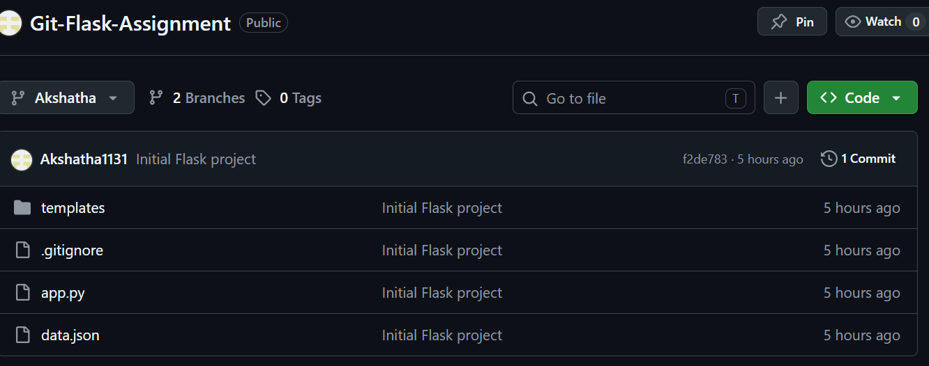

Step 2: Clone the Repository Using SSH
Command
git clone git@github.com:Akshatha1131/Git-Flask-Assignment.git
- git clone downloads a GitHub repository to the local computer.
- The SSH URL is used instead of HTTPS because authentication is handled using the SSH key.
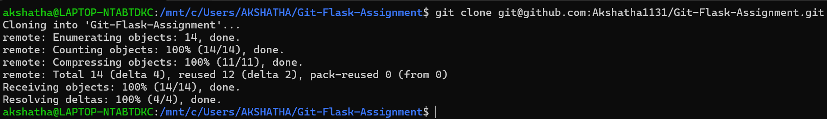

Step 3: Open the Repository
Command
cd Git-Flask-Assignment
- cd means Change Directory.
- It moves into the cloned repository folder.
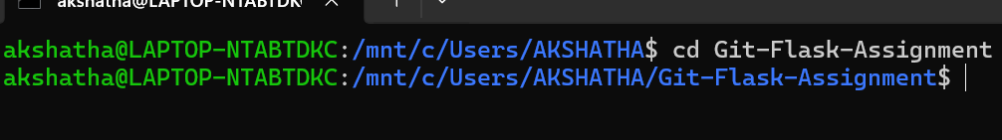

Step 4: Copy the Flask Project
Command
cp -r /mnt/c/Users/AKSHATHA/ASSIGNMENT/flask_assignment/* .
- cp copies files.
- -r means copy folders recursively.
- . represents the current directory.
This copies all Flask project files into the Git repository.

Step 5: Create a New Branch
Command
git checkout -b Akshatha
- it checkout switches branches.
- -b creates a new branch.
- Akshatha is the branch name.
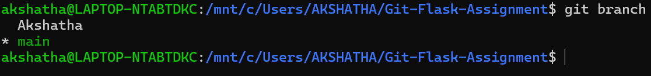

Step 6: Create a .gitignore File
Command
echo "venv/" > .gitignore
- echo "venv/" prints the text venv/.
- > redirects the output into a file.
- .gitignore is a special Git file that tells Git which files or folders to ignore.
- venv/ is ignored because it contains the Python virtual environment, which should not be uploaded to GitHub.
This command creates a .gitignore file and tells Git to ignore the venv folder.
Verification Command
ls -a
- ls lists files in the current directory.
- -a displays all files, including hidden files such as .gitignore.
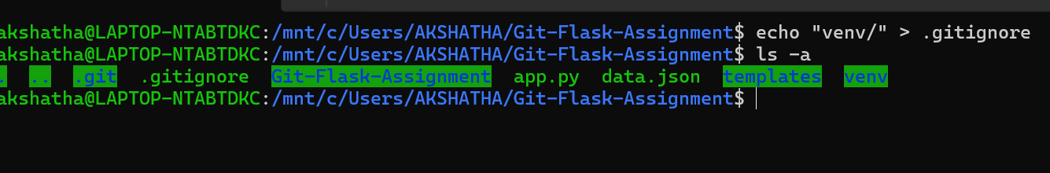

Step 7: Check the Repository Status
Command
git status
- git status displays the current state of the Git repository.
- It shows:
  - The current branch.
  - Untracked files.
  - Modified files.
  - Staged files.
  - Whether the working directory is clean.
This command helps verify which files are ready to be added or committed.
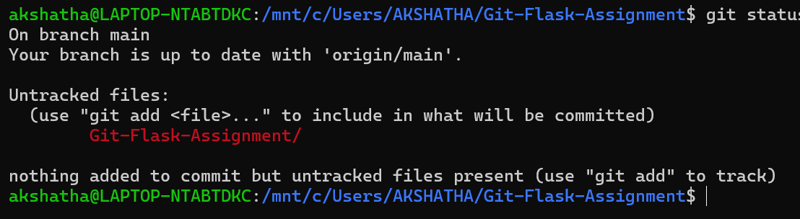

Step 8: Add Files to the Staging Area
Command
git add .
- git add moves files from the working directory to the staging area.
- . means all files in the current directory.
- After this command, Git knows which files should be included in the next commit.
Verification Command
git status
Explanation
This command checks whether the files have been successfully staged.

Step 9: Commit the Changes
Command
git commit -m "Initial Flask project"
- git commit saves the staged changes into the Git repository.
- -m is used to provide a commit message.
- "Initial Flask project" describes the changes made in this commit.
Verification Command
git log --oneline
Displays the commit history in a compact format, including:
- Commit ID
- Commit message
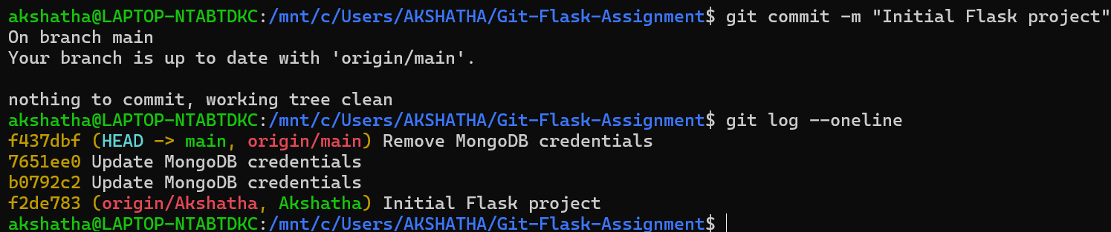

Step 10: Push the Akshatha branch to GitHub
Command:
git push -u origin Akshatha
- git push uploads your local commits to the remote GitHub repository.
- origin is the name of the remote repository.
- Akshatha is the branch being pushed.
- -u sets the upstream branch so future pushes can be done with just git push.

Step 11: Create the main Branch
Command
git branch main
- git branch creates a new branch.
- main is the name of the branch.
- Since the repository was initially empty, this command creates the main branch from the current commit.

Step 12: Switch to the main Branch
Command
git checkout main
- git checkout switches from one branch to another.
- This command changes the current working branch from Akshatha to main
Verification Command
git branch
- Displays all available branches.
- The branch with * is the currently active branch.
Step 13: Push the main Branch to GitHub
Command
git push -u origin main
- git push uploads the local main branch to GitHub.
- origin is the remote repository.
- main is the branch being uploaded.
- -u sets the upstream branch, so future pushes can be done using only git push.

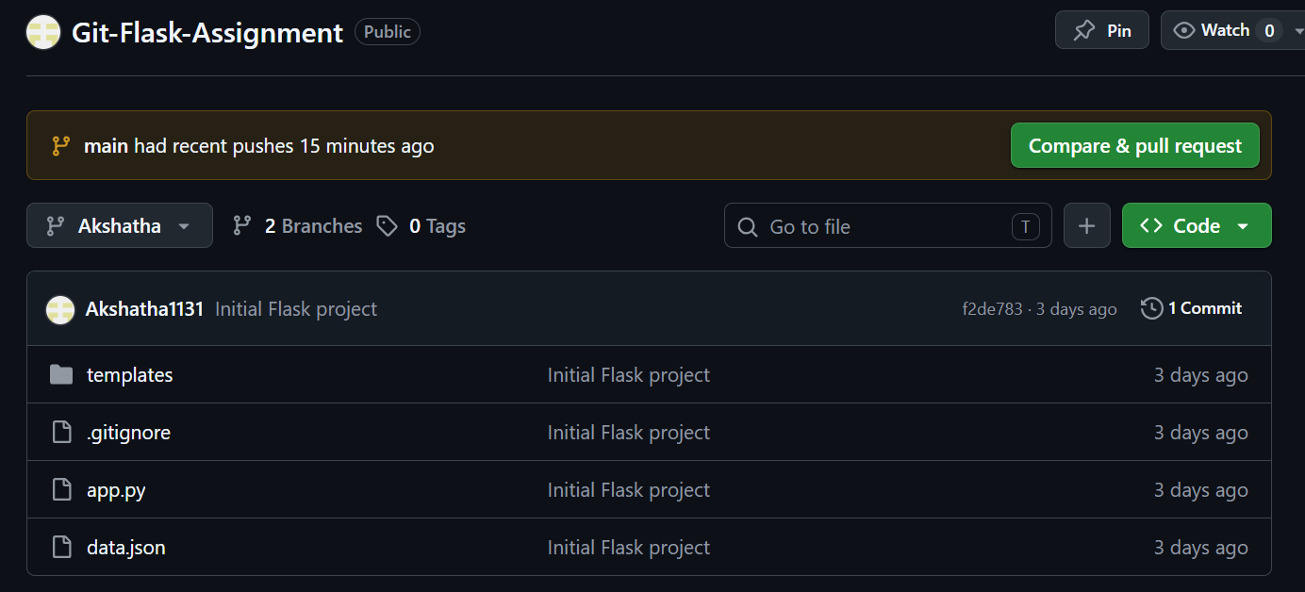

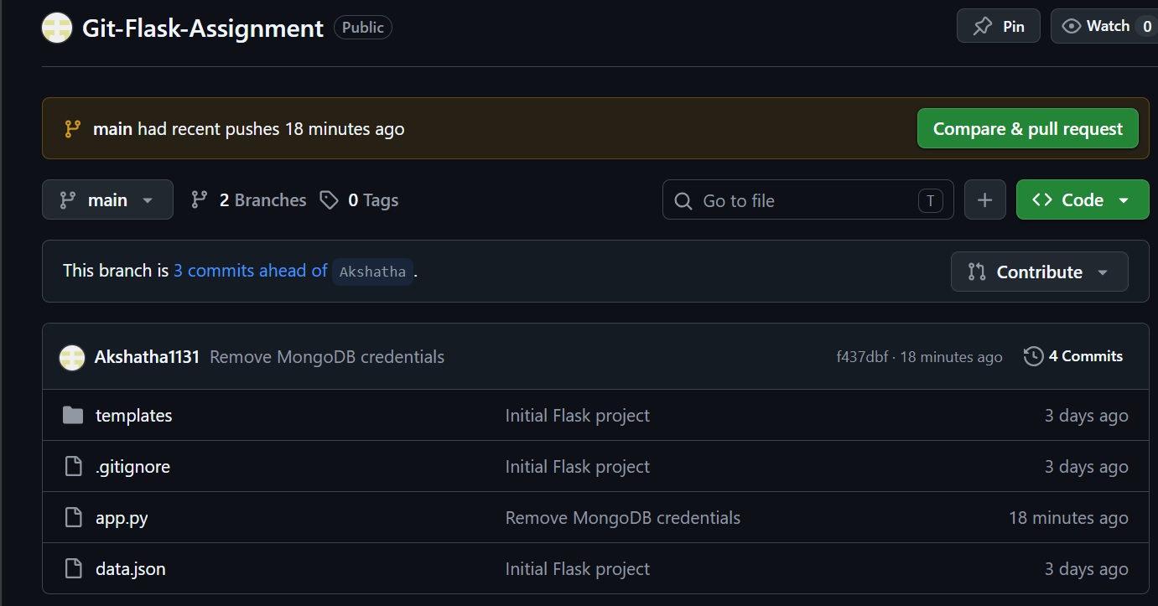

2. Create a new branch named <your_name>_new (e.g., Tutedude_new).
- Update the content of the JSON file used for the /api route in this branch.
- Merge the <your_name>_new branch into the main branch.
- If there are conflicts during the merge, resolve them by accepting the changes from the <your_name>_new branch.
- Add the resolved changes to the staging area, commit them, and push the updates to the remote repository.

Step 1: Create a New Branch Named Akshatha_new
Command
git checkout -b Akshatha_new
- git checkout is used to switch between branches.
- -b creates a new branch.
- Akshatha_new is the name of the new branch.
This command creates a new branch named Akshatha_new and automatically switches to it.
Verification Command
git branch --show-current
Displays the name of the current working branch to verify that you are on the Akshatha_new branch.
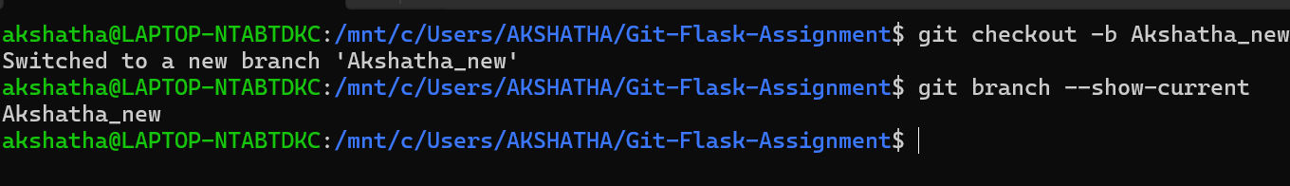

Step 2: Update the JSON File Used for the /api Route
Open the file
data.json
Replace the existing content with
[
{
"id": 1,
"name": "Akshatha",
"course": "Flask"
},
{
"id": 2,
"name": "Tutedude",
"course": "Git"
}
]
- Opens the JSON file used by the /api route.
- Updates the data with new values in the Akshatha_new branch.
- This modification will later be merged into the main branch.
Save the file
After editing, save data.json.
Verification Command
cat data.json
Displays the contents of data.json in the terminal to verify that the new JSON data has been saved correctly.
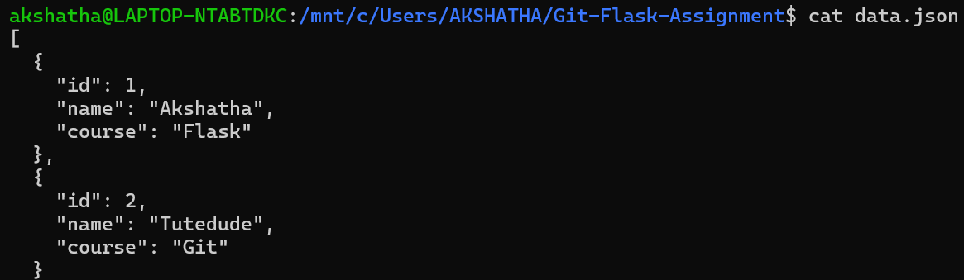

Step 3: Check the Repository Status
Command
git status
- Displays the current status of the Git repository.
- Shows that the modified data.json file is detected and is ready to be staged.

Step 4: Add the Updated JSON File to the Staging Area
Command
git add data.json
- git add moves the modified data.json file to the staging area.
- This prepares the file to be included in the next commit.

Step 5: Commit the Updated JSON File
Command
git commit -m "Updated data.json in Akshatha_new branch"
- Creates a new commit containing the updated data.json.
- Saves the changes in the Akshatha_new branch with the given commit message.

Step 6: Push the Akshatha_new Branch to GitHub
Command
git push -u origin Akshatha_new
- Uploads the Akshatha_new branch to the remote GitHub repository.
- Sets the upstream branch so future pushes can be done using git push.

Step 7: Switch to the main Branch
Command
git checkout main
- Switches from the Akshatha_new branch to the main branch.
- The merge will be performed in the main branch.
Verification Command
git branch --show-current
Verifies that the current working branch is main.

Step 8: Merge the Akshatha_new Branch into main
Command
git merge Akshatha_new
- Merges all the commits from the Akshatha_new branch into the main branch.
- If there are no conflicts, Git completes the merge automatically.
If Merge Conflicts Occur
If Git reports merge conflicts:
- Open the conflicted file.
- Accept the changes from the Akshatha_new branch.
- Save the file.
Then run:
git add .
git commit -m "Resolved merge conflict by accepting Akshatha_new changes"
- git add . stages the resolved files.
- git commit saves the merge resolution.
Note: If there is no merge conflict, you do not need to perform these commands.

Step 9: Push the Updated main Branch
Command
git push origin main
- Uploads the updated main branch, including the merged changes, to the GitHub repository.
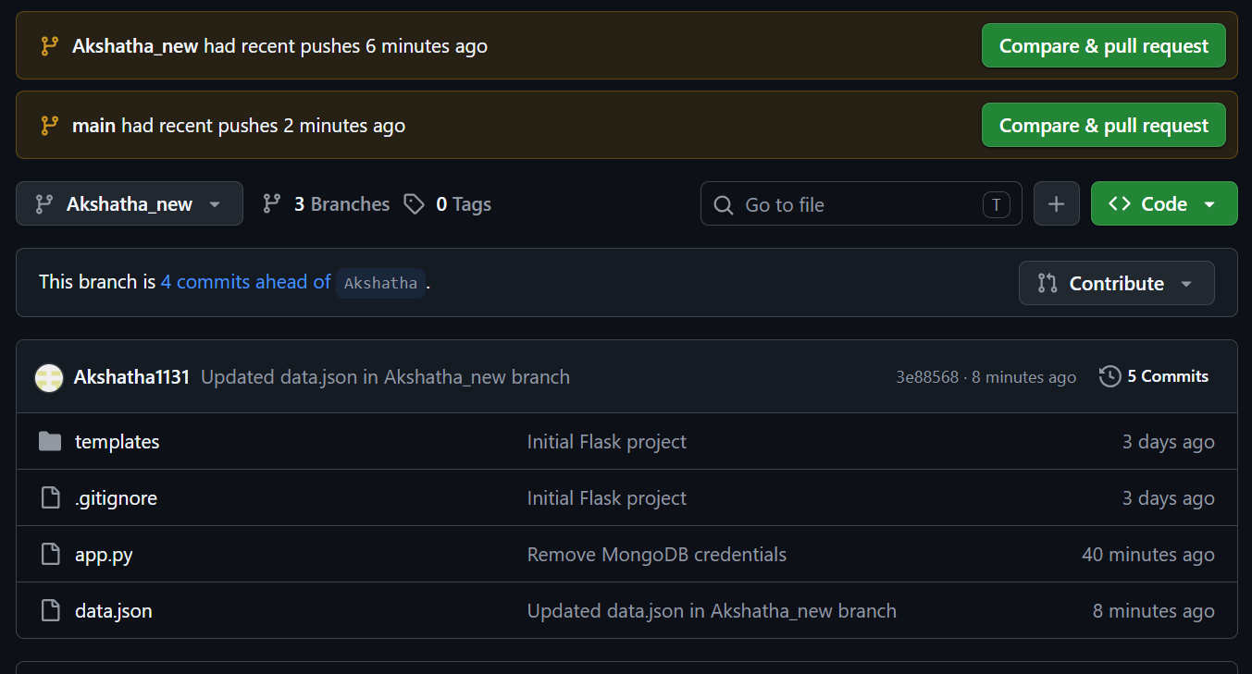

3. Branch Creation:
- Create two branches: master_1 and master_2 from the main branch.
- Feature Development in master_1:
- In the master_1 branch, create a To-Do Page in the frontend.
  - The page should contain a form with the following fields:
    - Item Name
    - Item Description
- Backend API in master_2:
- In the master_2 branch, create a backend route named /submittodoitem.
- This route will:
  - Accept itemName and itemDescription via a POST request.
  - Store these details in a MongoDB database.
- Merging Changes:
- Merge the changes from both master_1 and master_2 into the main branch.

Step 1: Switch to the main Branch
Command
git checkout main
- git checkout switches between branches.
- main is the branch from which the new branches (master_1 and master_2) will be created.

Step 2: Create the master_1 Branch
Command
git checkout -b master_1
- Creates a new branch named master_1.
- Automatically switches to the newly created branch.

Step 3: Create the master_2 Branch
Command
git checkout -b master_2
- Creates a new branch named master_2.
- Automatically switches to the master_2 branch.

Step 4: Switch to the master_1 Branch
Command
git checkout master_1
- git checkout switches between branches.
- This command switches from the master_2 branch to the master_1 branch.
- The frontend To-Do page will be developed in this branch.

Step 5: Create the To-Do Page in the Frontend
Action
Open the frontend HTML file (for example, templates/index.html) and add a form with the following fields:
- Item Name
- Item Description
Example:
<form action="/submittodoitem" method="POST">
<label>Item Name:</label>
<input type="text" name="itemName" required>

<label>Item Description:</label>
<textarea name="itemDescription" required></textarea>

<button type="submit">Submit</button>
</form>
What this step does
- Creates a frontend To-Do page.
- Adds a form for entering:
  - Item Name
  - Item Description
- Configures the form to send data to the /submittodoitem backend route using the POST method.
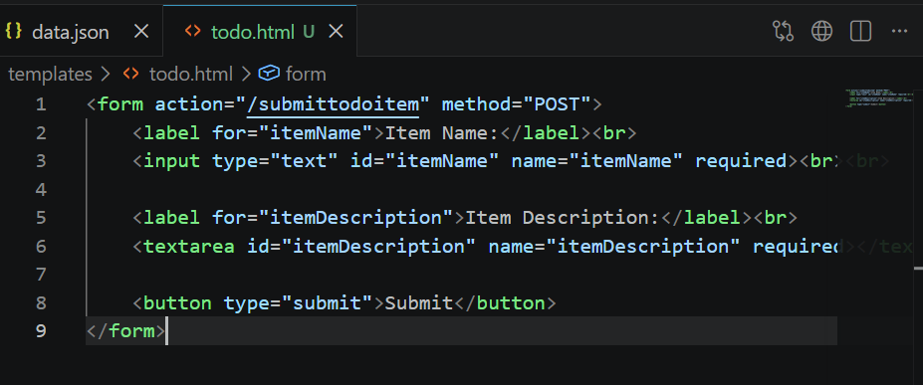

Step 6: Create a Route for the To-Do Page
Open app.py and add:
@app.route("/todo")
def todo():
return render_template("todo.html")
Place it above:
if __name__ == "__main__":
app.run(debug=True)

What this step does
- Creates a new Flask route named /todo.
- When the user visits /todo, Flask renders the todo.html page.

Step 8: Verify the To-Do Page
Run:
python app.py
Open:
http://127.0.0.1:5000/todo
You should see:
- Item Name
- Item Description
- Submit button
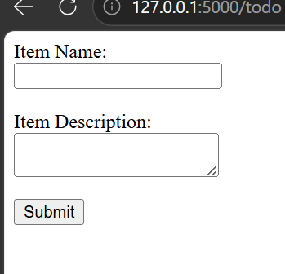

Step 9: Stage the Frontend Changes
Command
git add app.py templates/todo.html
- git add adds files to the Git staging area.
- app.py stages the updated Flask application file.
- templates/todo.html stages the newly created To-Do page.
This prepares the frontend changes to be committed.

Step 10: Commit the Frontend Changes
Command
git commit -m "Added To-Do frontend page"
- git commit saves the staged changes in the local Git repository.
- -m allows you to provide a commit message.
- "Added To-Do frontend page" describes the changes made in this commit.
This creates a new commit containing the frontend To-Do page implementation.

Step 11: Push the master_1 Branch to GitHub
Command
git push -u origin master_1
- git push uploads your local commits to the remote GitHub repository.
- origin is the remote repository name.
- master_1 is the branch being pushed.
- -u sets origin/master_1 as the upstream branch, so future pushes can be done using just git push.
This uploads the frontend To-Do page implementation to GitHub.

Step 12: Switch to the main Branch
Command
git checkout main
- git checkout switches from the current branch to another branch.
- main is the primary branch from which the new master_2 branch will be created.
This ensures that master_2 starts from the latest version of the main branch.

Step 13: Create the master_2 Branch
Command
git checkout -b master_2
- git checkout switches branches.
- -b creates a new branch and switches to it immediately.
- master_2 is the branch where you'll implement the backend API (/submittodoitem).

Step 14: Create the Backend Route /submittodoitem
Open app.py and add the following code above:
if __name__ == "__main__":
app.run(debug=True)
Paste this:
@app.route("/submittodoitem", methods=["POST"])
def submittodoitem():
try:
itemName = request.form["itemName"]
itemDescription = request.form["itemDescription"]

collection.insert_one({
"itemName": itemName,
"itemDescription": itemDescription
})

return "To-Do Item Submitted Successfully!"

except Exception as e:
return str(e)
What this code does
- Creates a new route named /submittodoitem.
- Accepts a POST request from the To-Do form.
- Reads:
  - itemName
  - itemDescription
- Stores them in the MongoDB collection.
- Returns a success message after inserting the data.
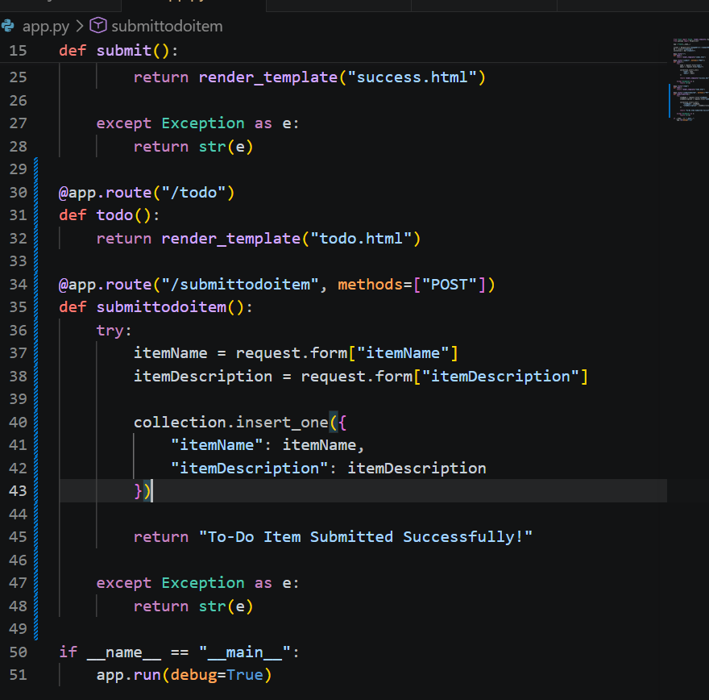
Step 15: Run and Test the Backend API
Command
python3 app.py
- Starts the Flask development server.
- Runs the application locally.
- Makes the application available at:
http://127.0.0.1:5000
Verification
- Open the browser and go to:
http://127.0.0.1:5000/todo
- Enter the following details:
  - Item Name
  - Item Description
- Click the Submit button.
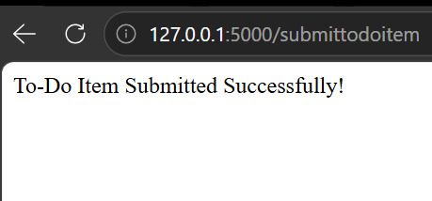

Step 16: Push the master_2 Branch to GitHub
Commands
git add app.py templates/todo.html
git commit -m "Added backend API for To-Do page"
git push -u origin master_2
What these commands do
- git add app.py templates/todo.html
  - Stages the updated app.py and todo.html for commit.
- git commit -m "Added backend API for To-Do page"
  - Creates a new commit containing the backend implementation.
- git push -u origin master_2
  - Uploads the master_2 branch to the remote GitHub repository.
  - Sets origin/master_2 as the upstream branch.

Step 17: Merge master_1 into main
1. Switch to the main branch
git checkout main
- Switches from master_2 to the main branch.
- We perform merges on the main branch.

2. Merge master_1
git merge master_1
- Merges all the frontend changes from the master_1 branch into main.

3. Verify the merge
git log --oneline --graph --all
- Displays the commit history as a graph.
- Confirms that master_1 has been merged into main.

Step 19: Merge master_2 into main
git merge master_2
- Merges all the backend changes from the master_2 branch into the main branch.
- Combines the /submittodoitem backend route with the existing project.
If Git reports a merge conflict, resolve it first. If there are no conflicts, Git will complete the merge automatically.

Step 20: Resolve Merge Conflicts and Complete the Merge
Commands
git add app.py templates/todo.html
git commit -m "Resolved merge conflicts and merged master_2 into main"
- git add app.py templates/todo.html
  - Stages the files after resolving the merge conflicts.
- git commit -m "Resolved merge conflicts and merged master_2 into main"
  - Completes the merge by creating a merge commit.
  - Saves the resolved changes in the local Git repository.

Step 21: Push the Updated main Branch to GitHub
Command
git push origin main
- Pushes the latest commits from the local main branch to the remote GitHub repository.
- Updates the remote repository with:
  - The merged master_1 branch (frontend changes).
  - The merged master_2 branch (backend changes).
  - The resolved merge conflicts.
  - All final project updates.
