**Akshatha**

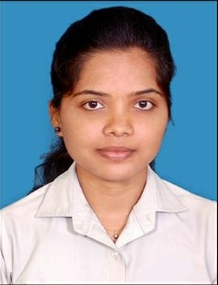

**Junior Software Developer**

**Mobile:** 7026747205

**Email ID:** [naikakshatha744@gmail.com](mailto:naikakshatha744@gmail.com)

**Profile Summary**

A versatile, hardworking individual, driven to meet or exceed a company’s expectations to deliver high-quality software products. An effective listener that can communicate technical information in an easily understandable way. Offers a strong background in creative problem-solving and a proven ability to multi-task.

**Work Experience**

Working as a **Junior** **software developer** at **Cognizant Technology Solutions**, Bangalore, from **28 Dec 2021 to present**.

**Key Responsibilities**

* Developing and maintaining features using Spring Boot, Microservice architecture, and Java.
* Collaborating with teams to understand requirements and deliver solutions.
* Writing clean and efficient code, adhering to coding standards.
* Testing and ensuring the reliability of features through unit test.
* Documenting technical designs and procedures for knowledge sharing.
* Contributing to continuous improvement efforts and optimizing application performance.
* Responsible for interacting with the client and taking clarification regarding application.

**Skills**

* Java, C programming skills.
* Spring Boot with Java 8, REST API and JPA.
* MySQLs writing ability.
* Knowledge in HTML, CSS.
* Knowledge in Git, Kafka, and AWS.

**Education**

2017-20 **B. Tech Information Technology** from Manipal Institute of Technology, Manipal.

**Certification**

AWS Certified Cloud Practitioner – AWS