Ransomware detection: project report
Base Paper: XRan
XRan (Explainable Deep Learning-based Ransomware Detection using Dynamic Analysis) is a ransomware detection framework that combines dynamic behavioral analysis, deep learning, and explainable AI. The system executes samples in a Cuckoo Sandbox and extracts three types of behavioral sequences: API calls, Dynamic Link Libraries (DLLs), and Mutual Exclusions (Mutexes). These sequences are combined to capture relationships between different aspects of an executable’s behavior and are then processed using a two-layer Convolutional Neural Network (CNN) for ransomware detection. The paper evaluates XRan for both ransomware-versus-benign and ransomware-versus-general-malware detection, rather than identifying individual ransomware families or variants. To improve interpretability, the framework uses LIME and SHAP to explain the features influencing its predictions.
Experiments across multiple ransomware datasets demonstrate that combining different dynamic features can achieve high detection performance, with the combined model achieving a 99.0% accuracy and 99.4% true positive rate on the combined ransomware-benign dataset.
Item | Detail
Input | API call, DLL and mutex sequences from Cuckoo reports
Model | Two-layer CNN with dropout and max pooling
Tasks | Ransomware vs benign and ransomware vs other malware, as two separate models
Explanations | LIME per sample, SHAP for global importance
Headline result | 99.4% TPR on the combined ransomware/benign set
Ransomware vs malware | 94.7% TPR on the combined set
Stated future work | Static pre-filter, hierarchical ransomware typing, family identification

What is Ransomware?
Ransomware is a type of malicious software (malware) that prevents users from accessing their files or systems, by encrypting important data, and demands a ransom in exchange for restoring access. It can enter a system through methods such as phishing emails, malicious downloads, software vulnerabilities, or social engineering.
Ransomware Stages:
The first stage i.e. initialisation stage comprises the methodologies adopted to send ransomware malware via attachments through emails which are malicious, electronic devices like infected pen drives and malicious websites. The next stage comprises of target stage where the attacker victimizes the gullible users by making them download malicious attachments or inserting infected pen drives and directing them towards malicious websites. The third stage consists of encryption stage where the confidential data of users available on network and personal devices are encrypted using various methods leading to blocking of its usage for intended users. The final stage consists of demanding heavy ransomware to decrypt the files intended for specific users, forcing the users to pay hefty money and denying the data accessibility till the ransome is paid in full. If the organisations deny paying the ransome, the attackers are prone to leak the data on dark web

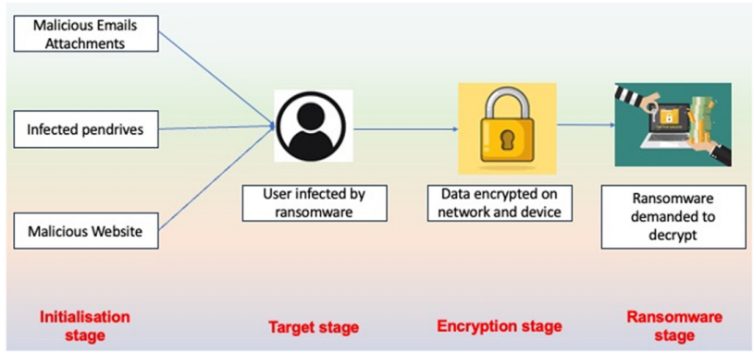
XRan Architecture flow:
- Collect ransomware, other malware and benign executables.
- Run each sample in a Cuckoo sandbox on a Windows 7 virtual machine, for up to 60 minutes. The weighted average run was 155.3 seconds.
- From each Cuckoo report, extract three chronologically ordered sequences: API calls, DLLs and mutexes.
- Cut each sequence to a fixed length of 500 API calls, 10 DLLs and 10 mutexes, and concatenate them into one 520-element vector. The average API sequence in the data was about 10,500 calls, so the model sees roughly the first 5%.
- Train two parallel models, one for ransomware vs benign and one for ransomware vs malware. Each is a two-layer CNN with dropout, max pooling, a dense output, binary cross-entropy loss and the Adam optimiser. Training used 10 epochs, chosen because validation loss rose after about 40.
- Output the label for each model.
- Explain the result with LIME for single samples and SHAP for global feature and position importance.
The split was 80% training, 10% validation and 10% test, with 10-fold cross-validation. Experiments ran on a Core i7 9700K with 64 GB of memory.

Datasets used in XRan
Name | Source | Year | Type | Samples | Average analysis time
RD1 | VirusShare | 2016 | Ransomware executables | 6,263 | 217.4 s
RD2 | SOREL-20M | 2020 | Ransomware binaries | 7,703 | 135.7 s
RD3 | ISOT | 2020 | Cuckoo JSON reports, 21 families | 668 | 1,504.4 s
MD | VX Heaven | 2010 | Non-ransomware malware | 6,263 | 86.5 s
BD | Download.com, Software Informer, PortableFreeware, Windows system files | 2019 to 2020 | Benign executables | 14,797 | 107.5 s
The authors chose the RD2 samples by their SOREL tags, keeping those with relatively more ransomware tags. RD3 contains reports only, so XRan could not run those samples itself. Models were trained on RD1, RD2 and RD3 separately, then on the combination. To balance classes, BD and MD were randomly undersampled (for RD3, 668 benign samples were drawn). The authors also computed a coverage percentage to show how much of the benign or malware feature space each ransomware set covers. RD1 overlapped most with BD and MD, and RD2 least.

Gaps in XRan
S.No | Gap | Evidence
1 | No family classification | Both models are binary. The authors list family identification as future work.
2 | Delayed detection | It classifies a finished Cuckoo run (155.3 s average, 60 min cap) and reports no detection time. Its conclusion admits dynamic analysis is resource heavy.
3 | No handling of new families | Training is batch and offline. Ispahany et al. say retraining from scratch leaves a window for new variants. XRan has no family-held-out or time-ordered test.
5 | Narrow views | Only API, DLL and mutex sequences. No file I/O, entropy, registry or network data.
6 | Sandbox and evasion | Windows 7 VM, no evasion test, only the encryptor is analysed. Ispahany et al. note that ransomware can detect VMs and that API monitoring can be fooled by dummy calls.

How the gaps can be solved
The proposed flow is: streaming detector, alert, family classifier, novelty check, labelling, incremental update.

