# Performance Test Results - 16 Users, 120s

## Test Setup

This performance test was executed on JPetStore application using Apache JMeter and monitored via AppDynamics.  
Load Details:  
- Users: 16 concurrent virtual users  
- Duration: 120 seconds  
- Test Tool: Apache JMeter 5.6.3  
- Monitoring Tool: AppDynamics SaaS Controller  
- Test Type: Load Test

## JMeter Aggregate Report

Below is the JMeter aggregate report showing key performance metrics for each transaction/scenario.

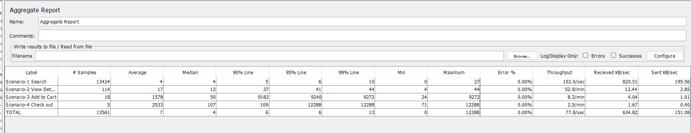

## AppDynamics Monitoring Results

The AppDynamics dashboard provided application-level performance metrics during the test run.  
- Average Response Time: 3 ms  
- Total Calls: 452  
- Transaction Health: 100% normal

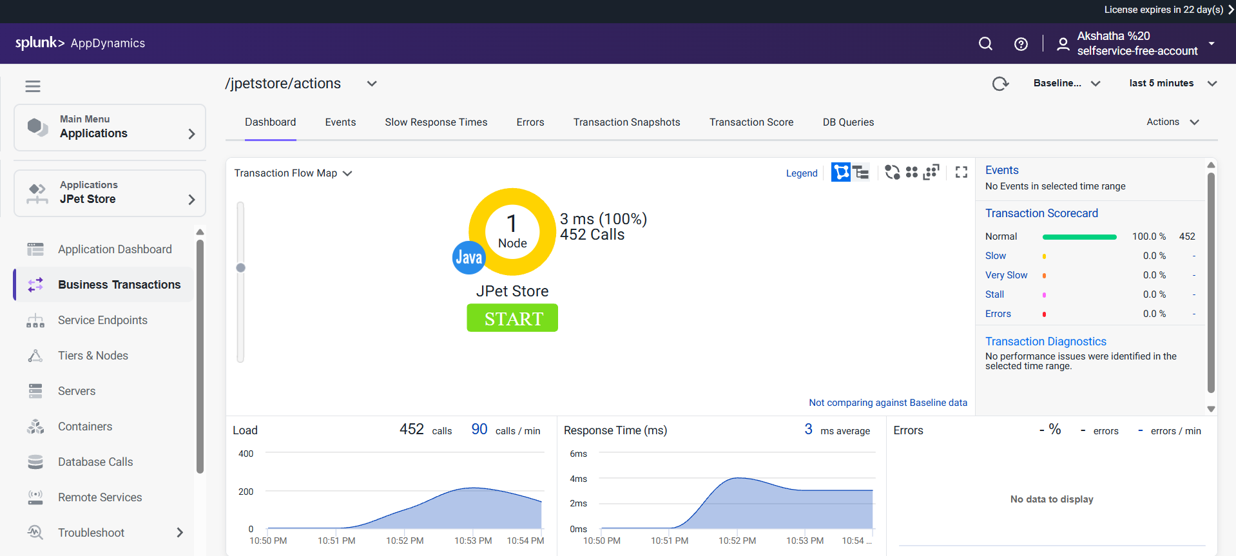

## Observations & Analysis

1. The application handled the 16-user load for 120 seconds with stable response times.  
2. AppDynamics reported very low average latency (3 ms), indicating strong backend performance.  
3. No slow transactions or errors were detected.  
4. Throughput and transaction counts were consistent across the test duration.  
5. This scenario indicates the application can handle small concurrent loads efficiently.