

Safety Plan Lane Assistance

**Document Version: [Version]**

**Template Version 1.0, Released on 2017-06-21**



# Document history

|  |  |  |  |
| --- | --- | --- | --- |
| Date | Version | Editor | Description |
| 15-05-2018 | 1.0 | Akshatha Holla | Initial Version |
|  |  |  |  |
|  |  |  |  |
|  |  |  |  |
|  |  |  |  |

# Table of Contents

Document history

Table of Contents

Introduction

Purpose of the Safety Plan

Scope of the Project

Deliverables of the Project

Item Definition

Goals and Measures

Goals

Measures

Safety Culture

Safety Lifecycle Tailoring

Roles

Development Interface Agreement

Confirmation Measures

# Introduction

## Purpose of the Safety Plan

A Safety plan outlines the steps taken to achieve functional safety. It includes defining the system under consideration, the goal of the project, the steps taken to ensure safety. It also defines the different roles of individuals and the project schedule plan. Further to this it also ensures confirmation measures such as reports that are prepared to confirm that safety has been achieved.

## Scope of the Project

For the lane assistance project, the following safety lifecycle phases are in scope:

Concept phase

Product Development at the System Level

Product Development at the Software Level

The following phases are out of scope:

Product Development at the Hardware Level

Production and Operation

## Deliverables of the Project

The deliverables of the project are:

Safety Plan

Hazard Analysis and Risk Assessment

Functional Safety Concept

Technical Safety Concept

Software Safety Requirements and Architecture

# Item Definition

The item under consideration here is a simple Lane assistance system. The two major functionalities of the lane assistance system are:

1. Lane departure warning
2. Lane keeping assistance

The lane departure warning system identifies lanes using the camera sensors and vibrates the steering wheel to warn the driver if the change in lane was unintentional (ie. Happens suddenly without any signals).

The Lane keeping assistance functionality assists the driver by turning the steering wheel to turn towards the center of the lane to ensure that the vehicle stays in the ego lane.

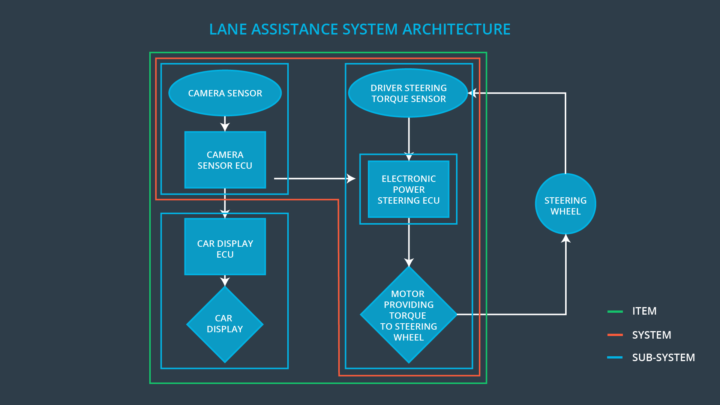

The visualization of the various systems, subsystems and their boundaries can be seen in the image shown above.

The system consists of 3 subsystems:

* The Camera subsystem:

1. The Camera sensor- Detects lane departures
2. The camera ECU- has the hardware and software required for deep learning or for computer vision techniques like the Hough transform.

* The Car display subsystem:

1. The Car display ECU- Contains software that controls the car display used to relay information to the driver.
2. The Car display – Displays warnings when there is unplanned or sudden lane change and other such information.

* The Electronic power steering subsystem:

1. Driver steering torque system
2. Electronic power steering ECU- Supplies signals to the motor to add torque to the steering wheel to ensure turns towards the center of the lane.
3. Motor- provides calculated torque to the steering wheel.

# Goals and Measures

## Goals

The goal of this project is to check whether the lane assistance system under consideration adheres to the ISO 26262 standard. Here we perform situational analysis and hazard identification to identify and classify all possible risks at system and subsystem level and come up with safety goals based on the hazard analysis and risk assessment. This is further translated to engineering requirements which are applied to reduce the risks at all levels of the system.

## Measures

|  |  |  |
| --- | --- | --- |
| Measures and Activities | Responsibility | Timeline |
| Follow safety processes | All Team Members | Constantly |
| Create and sustain a safety culture | All Team Members | Constantly |
| Coordinate and document the planned safety activities | Safety Manager | Constantly |
| Allocate resources with adequate functional safety competency | Project Manager | Within 2 weeks of start of project |
| Tailor the safety lifecycle | Safety Manager | Within 4 weeks of start of project |
| Plan the safety activities of the safety lifecycle | Safety Manager | Within 4 weeks of start of project |
| Perform regular functional safety audits | Safety Auditor | Once every 2 months |
| Perform functional safety pre-assessment prior to audit by external functional safety assessor | Safety Manager | 3 months prior to main assessment |
| Perform functional safety assessment | Safety Assessor | Conclusion of functional safety activities |

# Safety Culture

These are few of the characteristics of a good safety culture for a company:

* High priority: safety has the highest priority among competing constraints like cost and productivity
* Accountability: processes ensure accountability such that design decisions are traceable back to the people and teams who made the decisions
* Rewards: the organization motivates and supports the achievement of functional safety
* Penalties: the organization penalizes shortcuts that jeopardize safety or quality
* Independence: teams who design and develop a product should be independent from the teams who audit the work
* Well defined processes: company design and management processes should be clearly defined
* Resources: projects have necessary resources including people with appropriate skills
* Diversity: intellectual diversity is sought after, valued and integrated into processes
* Communication: communication channels encourage disclosure of problems

# Safety Lifecycle Tailoring

For the lane assistance project, the following safety lifecycle phases are in scope:

Concept phase

Product Development at the System Level

Product Development at the Software Level

The following phases are out of scope:

Product Development at the Hardware Level

Production and Operation

# Roles

|  |  |
| --- | --- |
| Role | Org |
| Functional Safety Manager- Item Level | OEM |
| Functional Safety Engineer- Item Level | OEM |
| Project Manager - Item Level | OEM |
| Functional Safety Manager- Component Level | Tier-1 |
| Functional Safety Engineer- Component Level | Tier-1 |
| Functional Safety Auditor | OEM or external |
| Functional Safety Assessor | OEM or external |

# Development Interface Agreement

A DIA (development interface agreement) defines the roles and responsibilities between companies involved in developing a product which in this case would be the OEM which provides the lane assistance system and our company (Tier 1) which would analyze the system from functional safety viewpoint. All involved parties need to agree on the contents of the DIA before the project begins.

The DIA also specifies what evidence and work products each party will provide to prove that work was done according to the agreement.

The ultimate goal is to ensure that all parties are developing safe vehicles in compliance with ISO 26262.

The Responsibilities of the OEM would be:

* Overall project management
* Acquiring and allocation of resources needed for the functional safety activities
* Appoints safety manager, auditor and assessor and system level safety engineer
* Does product development, safety management for the entire lane assistance system
* Ensures that the design and production implementation conform to the safety plan and ISO 26262.
* Independent judgement as to whether functional safety is being achieved via a functional safety assessment

The Responsibilities of our (Tier 1) company would be

* Planning, coordinating and documenting of the development phase of the safety lifecycle for the particular component which is modified.
* Tailoring the safety lifecycle according to the changes in the component
* Maintaining the safety plan
* Product development and subsystem change implementation
* Monitoring progress against the safety plan
* Integration
* Testing at the hardware, software and system levels
* Performing pre-audits before the safety auditor

# Confirmation Measures

Confirmation measures serve two purposes:

* that a functional safety project conforms to ISO 26262, and
* that the project really does make the vehicle safer.

**Confirmation review**

Ensures that the project complies with ISO 26262. As the product is designed and developed, an independent person would review the work to make sure ISO 26262 is being followed.

**Functional safety audit**

Checking to make sure that the actual implementation of the project conforms to the safety plan is called a functional safety audit.

**Functional safety assessment**

Confirming that plans, designs and developed products actually achieve functional safety is called a functional safety assessment.

A safety plan could have other sections that we are not including here. For example, a safety plan would probably contain a complete project schedule.

There might also be a "Supporting Process Management" section that would cover "Part 8: Supporting Processes" of the ISO 26262 functional safety standard. This would include descriptions of how the company handles requirements management, change management, configuration management, documentation management, and software tool usage and confidence.

Similarly, a confirmation measures section would go into more detail about how each confirmation will be carried out.