

Functional Safety Concept Lane Assistance

**Document Version: [Version]**

**Template Version 1.0, Released on 2017-06-21**



# 

# Document history

|  |  |  |  |
| --- | --- | --- | --- |
| Date | Version | Editor | Description |
| 22-05-2018 | 1.0 | Akshatha Holla | Functional Safety Concep |
|  |  |  |  |
|  |  |  |  |
|  |  |  |  |
|  |  |  |  |

# Table of Contents

Document history

Table of Contents

Purpose of the Functional Safety Concept

Inputs to the Functional Safety Analysis

Safety goals from the Hazard Analysis and Risk Assessment

Preliminary Architecture

Description of architecture elements

Functional Safety Concept

Functional Safety Analysis

Functional Safety Requirements

Refinement of the System Architecture

Allocation of Functional Safety Requirements to Architecture Elements

Warning and Degradation Concept

# 

# Purpose of the Functional Safety Concept

The purpose of functional safety is avoiding accidents by reducing risk to acceptable levels. In order to achieve this a functional safety concept document is created by identifying the elements and subsystems that can be used to meet the safety goals, then the safety goals are refined to functional safety requirements which are further allocated to relevant parts of item architecture.

Then the system architecture is refined to handle the new requirements.

# Inputs to the Functional Safety Concept

## Safety goals from the Hazard Analysis and Risk Assessment

|  |  |
| --- | --- |
| **ID** | **Safety Goal** |
| Safety_Goal_01 | The oscillating steering torque from the Lane Departure Warning function shall be limited. |
| Safety_Goal_02 | The lane keeping assistance function shall be time limited and the additional steering torque shall end after a given time interval so that the driver cannot misuse the system for autonomous driving. |

## Preliminary Architecture

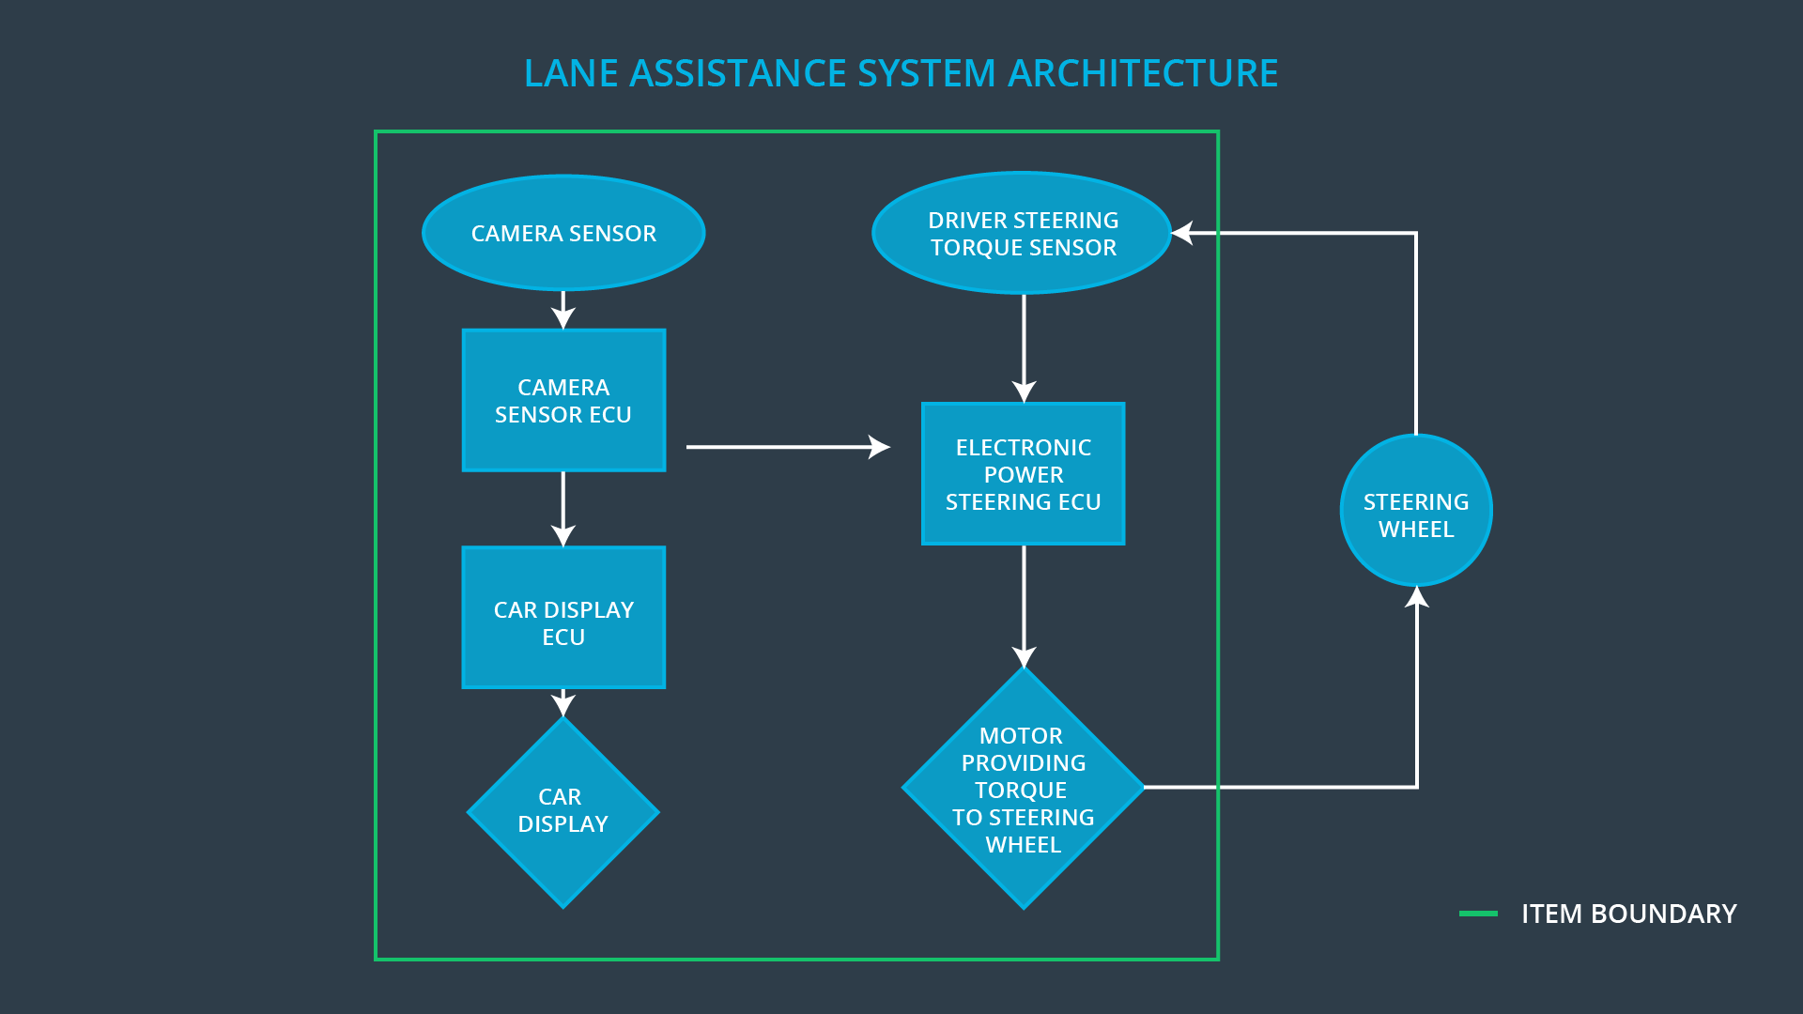

The preliminary architecture of the Lane assistance system can be seen above.

### 

### Description of architecture elements

|  |  |
| --- | --- |
| **Element** | **Description** |
| Camera Sensor | The camera sensor is used to capture images of the road and provides them as an input to the Camera sensor ECU. |
| Camera Sensor ECU | The Camera sensor ECU takes the input from the camera sensor and calculates the position of the car with respect to the lane lines that are detected by it. |
| Car Display | Provides visual warnings in cases of lane departure and other issues. |
| Car Display ECU | The car display ECU takes input from the Camera sensor ECU and processes the warnings to be provided to the car display. |
| Driver Steering Torque Sensor | Driver Steering Torque Sensor measures the amount of torque applied by the driver to the steering wheel. |
| Electronic Power Steering ECU | Takes the steering wheel torque input applied by the driver and the torque necessary to adjust the car to drive at the center of the expected lane from the camera ECU and provides appropriate input torque value to the motor. |
| Motor | Takes appropriate torque input from Electronic Power steering ECU and applies it to the steering wheel. |

# Functional Safety Concept

The functional safety concept consists of:

* Functional safety analysis
* Functional safety requirements
* Functional safety architecture
* Warning and degradation concept

## Functional Safety Analysis

|  |  |  |  |
| --- | --- | --- | --- |
| **Malfunction ID** | **Main Function of the Item Related to Safety Goal Violations** | **Guidewords (NO, WRONG, EARLY, LATE, MORE, LESS)** | **Resulting Malfunction** |
| Malfunction_01 | Lane Departure Warning (LDW) function shall apply an oscillating steering torque to provide the driver a haptic feedback | MORE | The lane departure warning function applies an oscillating torque with very high torque amplitude (above limit) |
| Malfunction_02 | Lane Departure Warning (LDW) function shall apply an oscillating steering torque to provide the driver a haptic feedback | MORE | The lane departure warning function applies an oscillating torque with very high torque frequency (above limit) |
| Malfunction_03 | Lane Keeping Assistance (LKA) function shall apply the steering torque when active in order to stay in ego lane | NO | The lane keeping assistance function is not limited in time duration which leads to misuse as an autonomous driving function |

## Functional Safety Requirements

Lane Departure Warning (LDW) Requirements:

|  |  |  |  |  |
| --- | --- | --- | --- | --- |
| **ID** | **Functional Safety Requirement** | **ASIL** | **Fault Tolerant Time Interval** | **Safe State** |
| Functional  Safety  Requirement  01-01 | The lane keeping item shall ensure that the lane departure oscillating torque amplitude is below Max_Torque_Amplitude | C | 50ms | Ensuring that the torque amplitude is below Max_Torque_Amplitude |
| Functional  Safety  Requirement  01-02 | The lane keeping item shall ensure that the lane departure oscillating torque frequency is below Max_Torque_Frequency | C | 50ms | Ensuring that the torque frequency is below  Max_Torque_Frequency |

Lane Departure Warning (LDW) Verification and Validation Acceptance Criteria:

|  |  |  |
| --- | --- | --- |
| **ID** | **Validation Acceptance**  **Criteria and Method** | **Verification Acceptance**  **Criteria and Method** |
| Functional  Safety  Requirement  01-01 | The Max_Torque_Amplitude value should be a value that can be handled by the driver | Verify that when the torque amplitude crosses the Max_Torque_Amplitude limit, the lane assistance output is set to zero within the 50 ms fault tolerant time interval. |
| Functional  Safety  Requirement  01-02 | The Max_Torque_Frequency value should be a value that can be handled by the driver | Verify that when the torque frequency crosses the Max_Torque_Frequency limit, the lane assistance output is set to zero within the 50 ms fault tolerant time interval |

Lane Keeping Assistance (LKA) Requirements:

|  |  |  |  |  |
| --- | --- | --- | --- | --- |
| **ID** | **Functional Safety Requirement** | **ASIL** | **Fault Tolerant Time Interval** | **Safe State** |
| Functional  Safety  Requirement  02-01 | The Lane keeping assistance function shall be time limited and the additional steering torque shall end after a given timer interval so that the driver cannot misuse the system for autonomous driving | B | 500ms | Turn off the Lane keeping assistance function |

Lane Keeping Assistance (LKA) Verification and Validation Acceptance Criteria:

|  |  |  |
| --- | --- | --- |
| **ID** | **Validation Acceptance**  **Criteria and Method** | **Verification Acceptance**  **Criteria and Method** |
| Functional  Safety  Requirement  02-01 | The Max_duration should be a value which ensures that the driver does not take his hands off the wheel entirely | Test that the Lane keeping assistance turns off after Max_duration |

## Refinement of the System Architecture

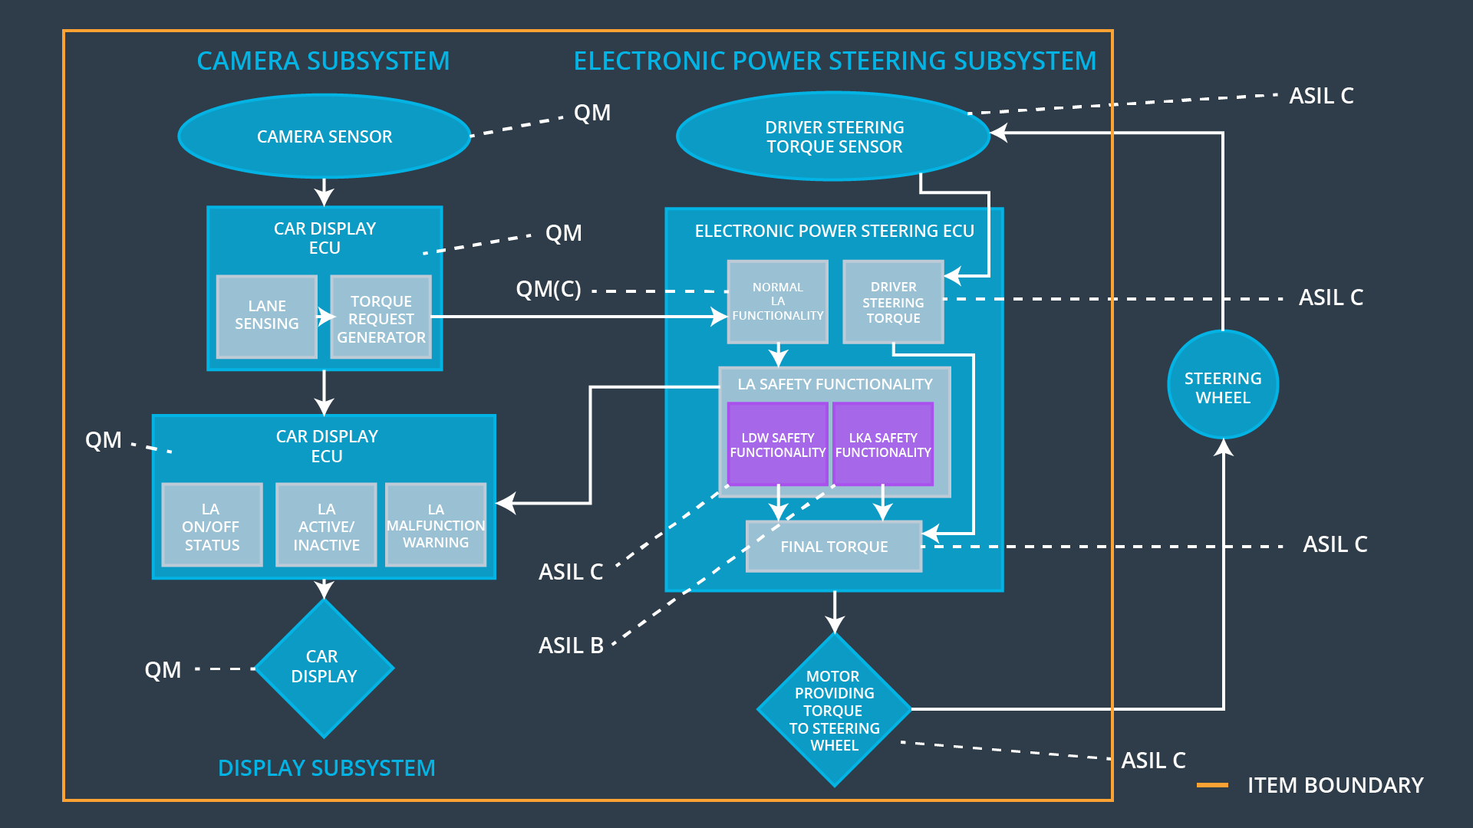

## Allocation of Functional Safety Requirements to Architecture Elements

|  |  |  |  |  |
| --- | --- | --- | --- | --- |
| **ID** | **Functional Safety Requirement** | **Electronic Power Steering ECU** | **Camera ECU** | **Car Display ECU** |
| Functional  Safety  Requirement  01-01 | The Electronic Power Steering ECU shall ensure that the lane departure oscillating torque amplitude is below Max_Torque_Amplitude | **x** |  |  |
| Functional  Safety  Requirement  01-02 | The Electronic Power Steering ECU shall ensure that the lane departure oscillating torque frequency is below Max_Torque_Frequency | **x** |  |  |
| Functional  Safety  Requirement  02-01 | The electronic power steering ECU shall ensure that the lane keeping assistance torque is applied for only Max_Duration | **x** |  |  |

## Warning and Degradation Concept

|  |  |  |  |  |
| --- | --- | --- | --- | --- |
| **ID** | **Degradation Mode** | **Trigger for Degradation Mode** | **Safe State invoked?** | **Driver Warning** |
| WDC-01 | Turn off LDW functionality | Malfunction_01  Malfunction_02 | Yes | Lane departure Warning on car display |
| WDC-02 | Turn off LKA functionality | Malfunction_03 | Yes | LKA Warning on display |