

Technical Safety Concept Lane Assistance

**Document Version: [Version]**

**Template Version 1.0, Released on 2017-06-21**



# Document history

|  |  |  |  |
| --- | --- | --- | --- |
| Date | Version | Editor | Description |
| 22-05-18 | 1.0 | Akshatha Holla | Technical Safety Concept |
|  |  |  |  |
|  |  |  |  |
|  |  |  |  |
|  |  |  |  |

# 

# Table of Contents

Document history

Table of Contents

Purpose of the Technical Safety Concept

Inputs to the Technical Safety Concept

Functional Safety Requirements

Refined System Architecture from Functional Safety Concept

Functional overview of architecture elements

Technical Safety Concept

Technical Safety Requirements

Refinement of the System Architecture

Allocation of Technical Safety Requirements to Architecture Elements

Warning and Degradation Concept

# 

# Purpose of the Technical Safety Concept

The purpose of the technical safety concept is to convert functional requirements into technical requirements and is more concrete since it gets into the details of the item’s technology. As opposed to the functional safety concept which was a part of the concept phase the technical safety concept is a part of the Product development phase.

# Inputs to the Technical Safety Concept

## Functional Safety Requirements

|  |  |  |  |  |
| --- | --- | --- | --- | --- |
| **ID** | **Functional Safety Requirement** | **ASIL** | **Fault Tolerant Time Interval** | **Safe State** |
| Functional  Safety  Requirement  01-01 | The lane keeping item shall ensure that the lane departure oscillating torque amplitude is below Max_Torque_Amplitude | C | 50ms | Ensuring that the torque amplitude is below Max_Torque_Amplitude |
| Functional  Safety  Requirement  01-02 | The lane keeping item shall ensure that the lane departure oscillating torque frequency is below Max_Torque_Frequency | C | 50ms | Ensuring that the torque frequency is below  Max_Torque_Frequency |
| Functional  Safety  Requirement  02-01 | The Lane keeping assistance function shall be time limited and the additional steering torque shall end after a given timer interval so that the driver cannot misuse the system for autonomous driving | B | 500ms | Turn off the Lane keeping assistance function |

## Refined System Architecture from Functional Safety Concept

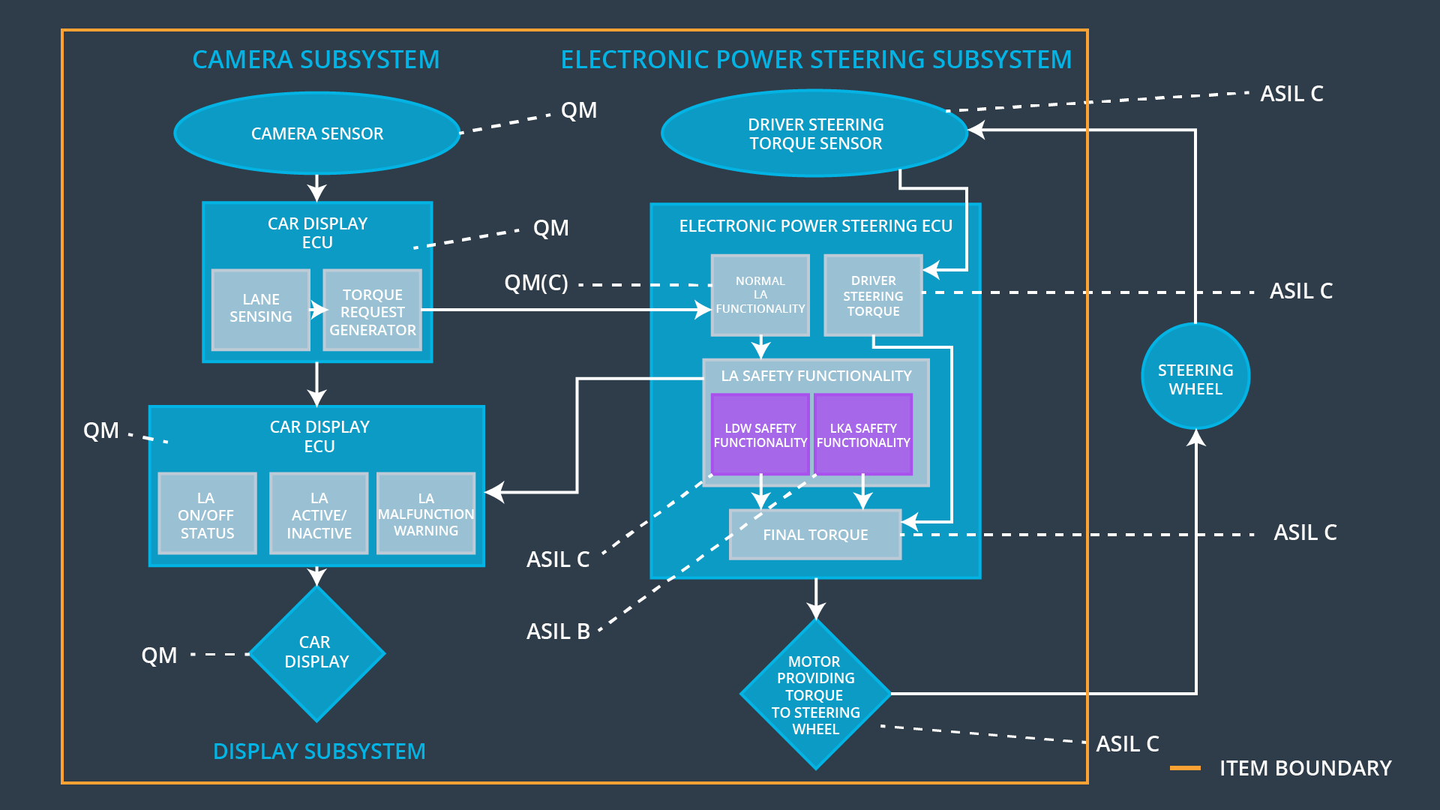

### 

### Functional overview of architecture elements

|  |  |
| --- | --- |
| **Element** | **Description** |
| Camera Sensor | The camera sensor is used to capture images of the road and provides them as an input to the Camera sensor ECU. |
| Camera Sensor ECU - Lane Sensing | The Camera sensor ECU takes the input from the camera sensor and calculates the position of the car with respect to the lane lines that are detected by it. |
| Camera Sensor ECU - Torque request generator | The Camera sensor ECU –torque generator calculates the torque required to re-center the vehicle according to the lane |
| Car Display | Provides visual warnings in cases of lane departure and other issues. |
| Car Display ECU - Lane Assistance On/Off Status | The information about the On/Off status of the Lane Assistance system is  provided to the car display by the Car Display ECU - Lane Assistance On/Off Status |
| Car Display ECU - Lane Assistant Active/Inactive | The information about the active/inactive status of the Lane assistance system is provided to the car display by the Car Display ECU - Lane Assistant Active/Inactive |
| Car Display ECU - Lane Assistance malfunction warning | The information about possible malfunctions in the Lane assistance system is provided to the car display by the Car Display ECU - Lane Assistance malfunction warning |
| Driver Steering Torque Sensor | Driver Steering Torque Sensor measures the amount of torque applied by the driver to the steering wheel. |
| Electronic Power Steering (EPS) ECU - Driver Steering Torque | Processes the driver steering torque measured by the driver steering torque sensor. |
| EPS ECU - Normal Lane Assistance Functionality | Performs Lane assistance functions like Lane departure warning and Lane keeping assistance. Takes necessary torque inputs from camera sensor ECU and generates necessary final torque. |
| EPS ECU - Lane Departure Warning Safety Functionality | Ensures that the applied torque amplitude and frequency are minimum. |
| EPS ECU - Lane Keeping Assistant Safety Functionality | Ensures that the Lane Keeping assistance function is not activated longer than Max_Duration. |
| EPS ECU - Final Torque | Combine the outputs of Lane Departure Warning Safety Functionality, Lane Keeping Assistant Safety Functionality and Electronic Power Steering (EPS) ECU - Driver Steering Torque to calculate final torque |
| Motor | Takes appropriate torque input from Electronic Power steering ECU and applies it to the steering wheel. |

# 

# Technical Safety Concept

## Technical Safety Requirements

**Lane Departure Warning (LDW) Requirements:**

Functional Safety Requirement 01-01 with its associated system elements

(derived in the functional safety concept)

|  |  |  |  |  |
| --- | --- | --- | --- | --- |
| **ID** | **Functional Safety Requirement** | **Electronic Power Steering ECU** | **Camera ECU** | **Car Display ECU** |
| Functional  Safety  Requirement  01-01 | The lane keeping item shall ensure that the lane departure oscillating torque amplitude is below Max_Torque_Amplitude | X |  |  |

Technical Safety Requirements related to Functional Safety Requirement 01-01 are:

|  |  |  |  |  |  |
| --- | --- | --- | --- | --- | --- |
| **ID** | **Technical Safety Requirement** | **ASIL** | **Fault Tolerant Time Interval** | **Architecture Allocation** | **Safe State** |
| Technical  Safety  Requirement  01 | The LDW safety component shall ensure that the amplitude of the LDW_Torque _Request sent to the Final Electronic Power Steering Torque component is below Max_torque_Amplitude | C | 50ms | LDW_safety | LDW_Torque_Request is set to zero |
| Technical  Safety  Requirement  02 | As soon as the failure is detected by the LDW function, it shall de activate the LDW feature and the LDW_torque_Request shall be set to zero. | C | 50ms | LDW_safety | LDW_Torque_Request is set to zero |
| Technical  Safety  Requirement  03 | As soon as the LDW function deactivates the LDW feature , the ‘LDW safety’ software block shall send a signal to the car display ECU to turn on a warning light. | C | 50ms | LDW_safety | LDW_Torque_Request is set to zero |
| Technical  Safety  Requirement  04 | Memory test shall be conducted at the start up of the EPS ECU to check for any faults in memory | A | Ignition cycle | Safety start up | LDW_Torque_Request is set to zero |
| Technical  Safety  Requirement  05 | The validity and Integrity of the data transmission for LDW_Torque_Request signal shall be ensured | C | 50ms | Data Transmission Integrity check | LDW_Torque_Request is set to zero |

Functional Safety Requirement 01-2 with its associated system elements

(derived in the functional safety concept)

|  |  |  |  |  |
| --- | --- | --- | --- | --- |
| **ID** | **Functional Safety Requirement** | **Electronic Power Steering ECU** | **Camera ECU** | **Car Display ECU** |
| Functional  Safety  Requirement  01-02 | The lane keeping item shall ensure that the lane departure oscillating torque frequency is below Max_Torque_Frequency | X |  |  |

Technical Safety Requirements related to Functional Safety Requirement 01-02 are:

|  |  |  |  |  |  |
| --- | --- | --- | --- | --- | --- |
| **ID** | **Technical Safety Requirement** | **ASIL** | **Fault Tolerant Time Interval** | **Architecture Allocation** | **Safe State** |
| Technical  Safety  Requirement  01 | The LDW safety component shall ensure that the frequency of the LDW_Torque _Request sent to the Final Electronic Power Steering Torque component is below Max_torque_Frequency | C | 50ms | LDW_safety | LDW_Torque_Request is set to zero |
| Technical  Safety  Requirement  02 | As soon as the failure is detected by the LDW function, it shall de activate the LDW feature and the LDW_torque_Request shall be set to zero. | C | 50ms | LDW_safety | LDW_Torque_Request is set to zero |
| Technical  Safety  Requirement  03 | As soon as the LDW function deactivates the LDW feature , the ‘LDW safety’ software block shall send a signal to the car display ECU to turn on a warning light. | C | 50ms | LDW_safety | LDW_Torque_Request is set to zero |
| Technical  Safety  Requirement  04 | Memory test shall be conducted at the start up of the EPS ECU to check for any faults in memory | A | Ignition cycle | Safety start up | LDW_Torque_Request is set to zero |
| Technical  Safety  Requirement  05 | The validity and Integrity of the data transmission for LDW_Torque_Request signal shall be ensured | C | 50ms | Data Transmission Integrity check | LDW_Torque_Request is set to zero |

**Lane Keeping Assistance (LKA) Requirements:**

Functional Safety Requirement 02-1 with its associated system elements

(derived in the functional safety concept)

|  |  |  |  |  |
| --- | --- | --- | --- | --- |
| **ID** | **Functional Safety Requirement** | **Electronic Power Steering ECU** | **Camera ECU** | **Car Display ECU** |
| Functional  Safety  Requirement  02-01 | The lane keeping item shall ensure that the lane keeping assistance torque is applied for only Max_Duration | X |  |  |

Technical Safety Requirements related to Functional Safety Requirement 02-01 are:

|  |  |  |  |  |  |
| --- | --- | --- | --- | --- | --- |
| **ID** | **Technical Safety Requirement** | **ASIL** | **Fault Tolerant Time Interval** | **Allocation to Architecture** | **Safe State** |
| Technical  Safety  Requirement  01 | The LKA safety component shall ensure that the duration of the LKA_Torque_Request sent to the Final Electronic Power Steering Torque component is below Max_Duration | B | 500ms | LKA_safety | LKA_Torque_Request is set to zero |
| Technical  Safety  Requirement  02 | Memory test shall be conducted at the start up of the EPS ECU to check for any faults in memory | A | Ignition cycle | Safety start up | LKA_Torque_Request is set to zero |
| Technical  Safety  Requirement  03 | The validity and Integrity of the data transmission for LKA_Torque_Request signal shall be ensured | B | 500ms | Data Transmission Integrity check | LKA_Torque_Request is set to zero |
| Technical  Safety  Requirement  04 | As soon as the LKA function deactivates the LKA feature , the ‘LKA safety’ software block shall send a signal to the car display ECU to turn on a warning light. | B | 500ms | LKA_safety | LKA_Torque_Request is set to zero |
| Technical  Safety  Requirement  05 | As soon as the failure is detected by the LKA function, it shall de activate the LKA feature and the LKA_torque_Request shall be set to zero. | B | 500ms | LKA_safety | LKA_Torque_Request is set to zero |

## Refinement of the System Architecture

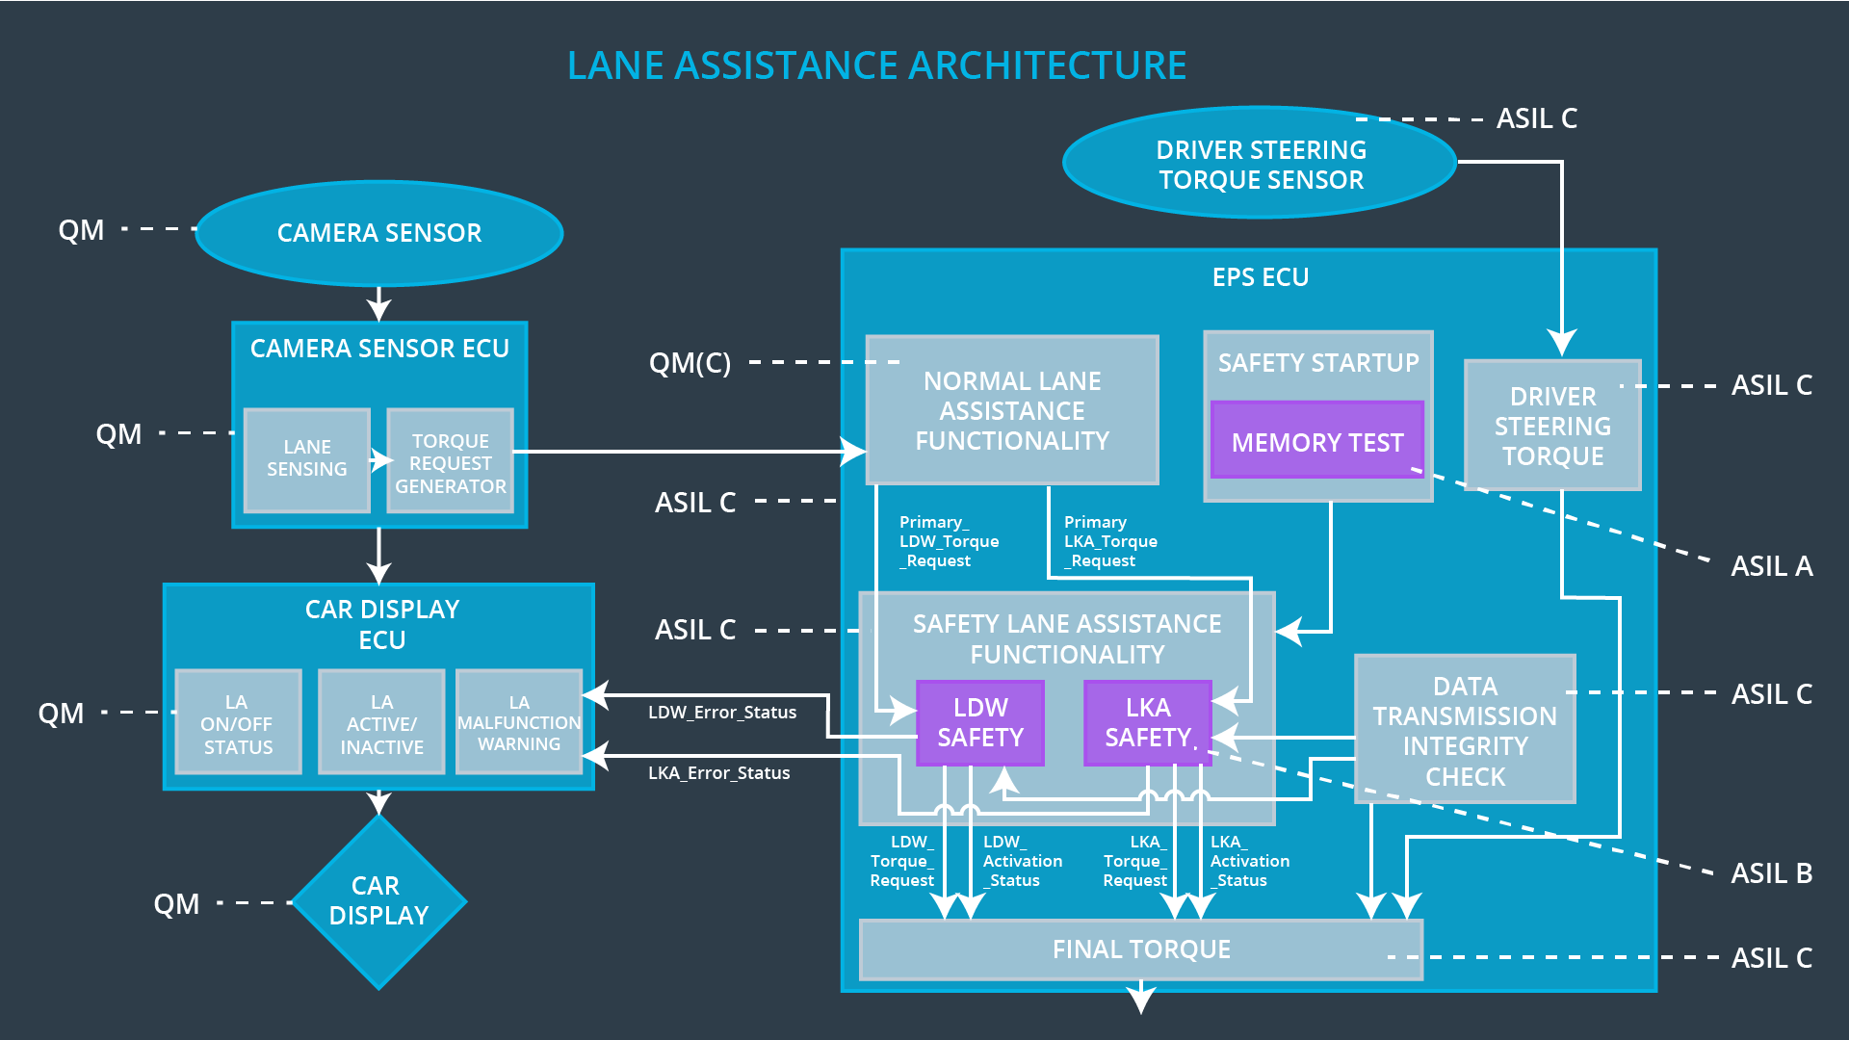

## 

## Allocation of Technical Safety Requirements to Architecture Elements

Here you can state that for this particular item, all technical safety requirements are allocated to the Electronic Power Steering ECU

## 

## Warning and Degradation Concept

|  |  |  |  |  |
| --- | --- | --- | --- | --- |
| **ID** | **Degradation Mode** | **Trigger for Degradation Mode** | **Safe State invoked?** | **Driver Warning** |
| WDC-01 | Turn off LDW functionality | Malfunction_01  Malfunction_02 | Yes | Lane departure Warning on car display |
| WDC-02 | Turn off LKA functionality | Malfunction_03 | Yes | LKA Warning on display |