Ingress-controller

Github link

<https://github.com/AkshathaMR/python-reach-sample>

1.Need to build the Docker image and push it to the docker hub

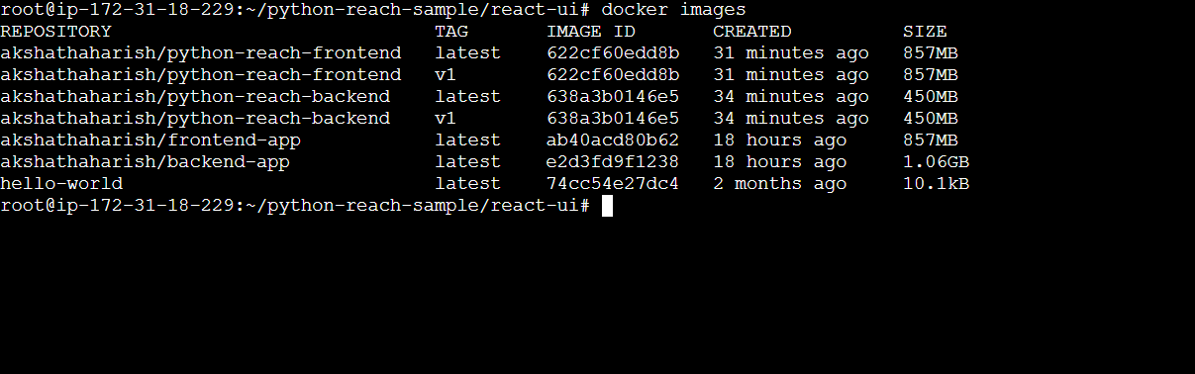

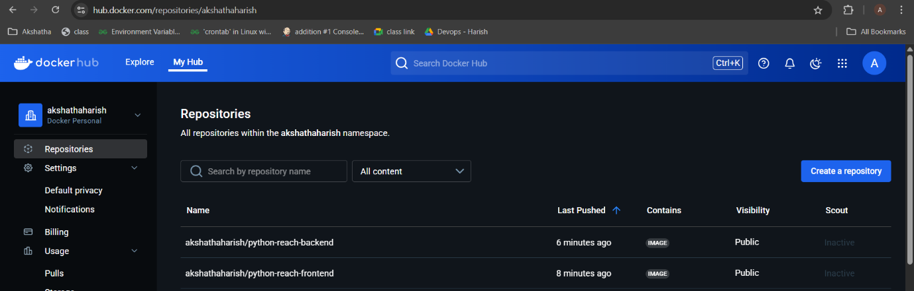

2. Need to create deployment.yml , ingress-loadbalancer.yml and route.yml

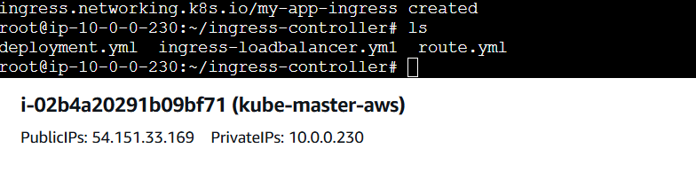

3.Install the ingress

kubectl apply -f <https://raw.githubusercontent.com/kubernetes/ingress-nginx/controller-v1.10.0/deploy/static/provider/cloud/deploy.yaml>

4. kubectl apply -f ingress-loadbalancer.yml

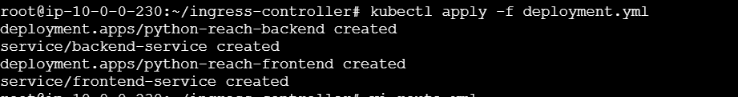

kubectl get svc -n ingress-nginx

load balancer created

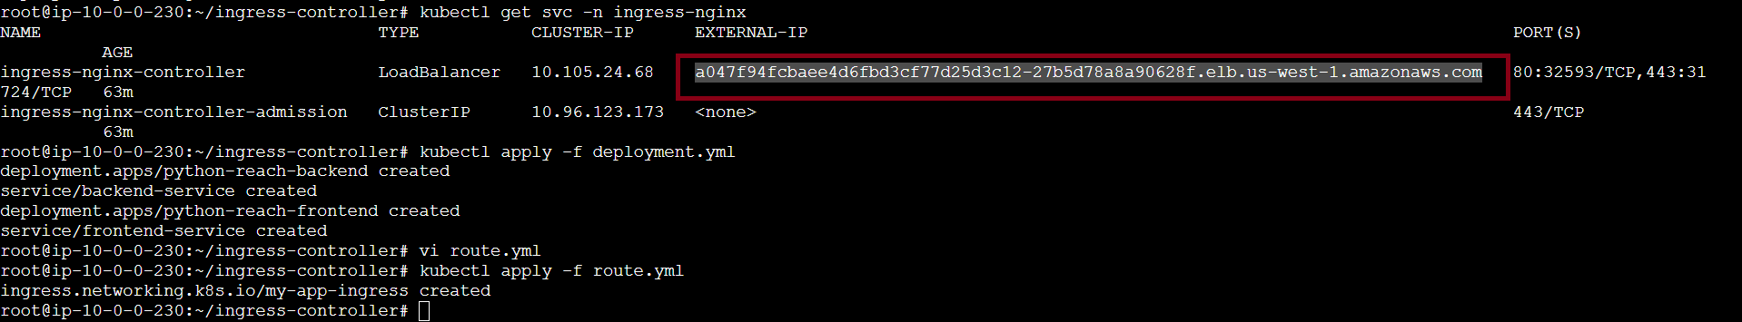

Need to add this load balancer in deployment.yml

kubectl get pods -n ingress-nginx

