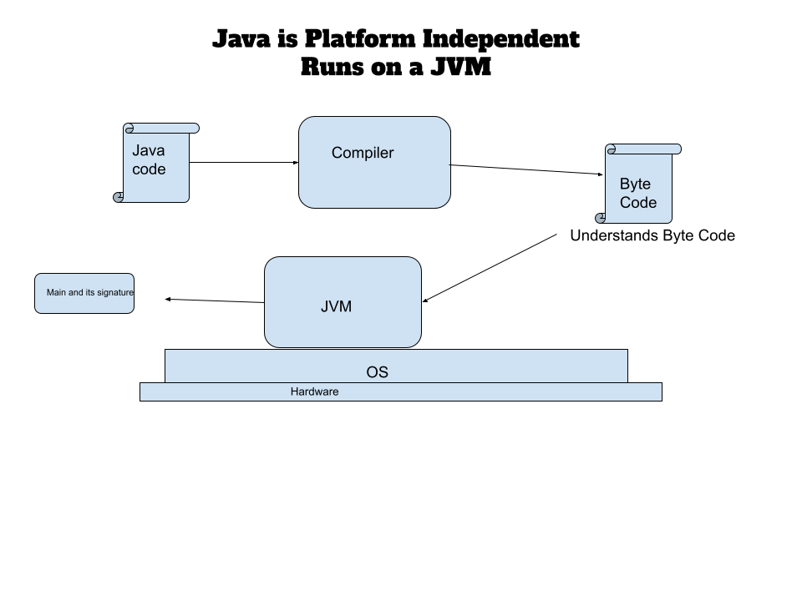

The signature for the main function is

|  |
| --- |
| public static void main(String args) |

Java Code has extension .java

Byte Code after Compilation has .class extension

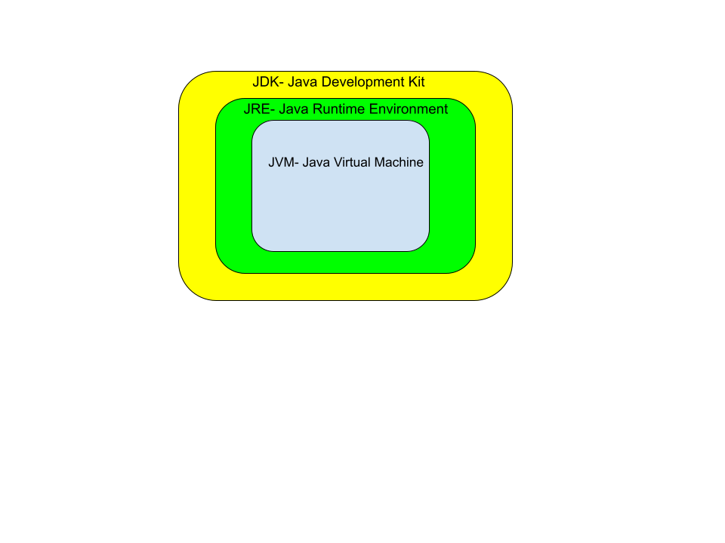

Java is WORA -> Write once run Anywhere

Java is a Strongly Typed Language

Every variable should be given a datatype

Java is a object-oriented programming language.

Everything the programming world is an object.

Object has two things: Properties and behaviour.