Workflow of docker Architecture

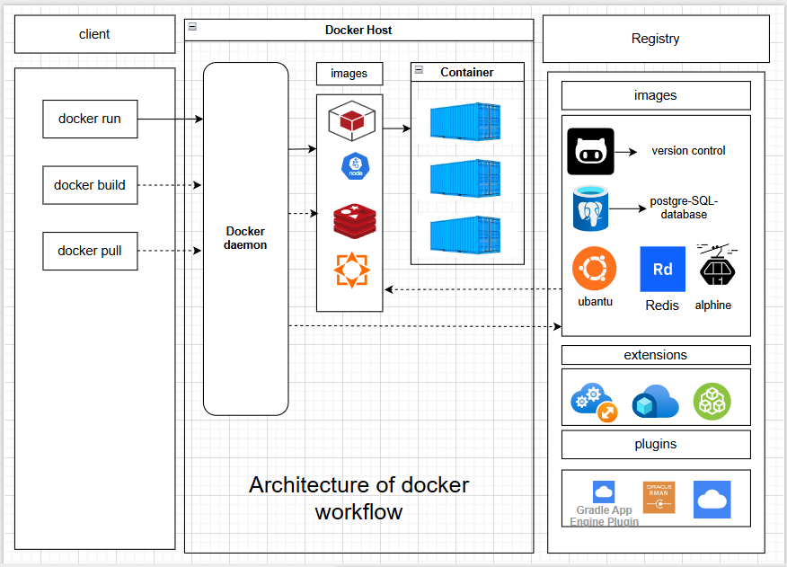

1)- Docker Daemon: It is a background service that listens to Docker API requests from clients and manages Docker objects such as images, containers, networks, and volumes. It also communicates with registries to pull or push images.
2)- Rest API: - (Representational State Transfer) REST API is to enable communication and data exchange between different software applications over a network, most commonly the internet, using standard HTTP methods.

3)- Docker Registry or docker Hub: - Docker Registry is the service that stores and distributes Docker images. Docker Hub is the default public registry, while companies often use private registries like AWS ECR or Azure ACR. In Docker’s architecture, the client communicates with the Docker daemon, which then pulls or pushes images to the registry.

4)- docker images: - A Docker Image is a lightweight, read-only template that contains everything needed to run an application, including the code, libraries, dependencies, and configurations.

5)- docker extensions: - Docker Extensions are add-ons (plugins) that integrate with Docker Desktop to extend its functionality. They allow developers to add new tools, workflows, or third-party integrations directly inside Docker Desktop.

6)- docker Containers: - A Docker Container is a lightweight, isolated, and executable unit of software that runs from a Docker Image. It packages the application and all its dependencies together so it runs the same way on any system.
7)- docker client: - client usually interact with server with the help of operating system with the help of Internet gateway-(REST API).

8)- docker plugins: - Docker plugins are out-of-process extensions designed to enhance the core functionality of the Docker Engine. They allow for the integration of third-party tools and services, extending capabilities in areas such as storage, networking, logging, and authorization.

