Project-1 – conduct of my Jira ProjectTask – create a Jira Automation rule which include the triggers and action for assigning QA rule  
  
Steps for creating the project in jira account   
  
  
Steps:- 1:- Create a project in the jira account select the scrum dashboard to view the project Add the name of project file name :- Devops_project-1 and key automatically create as file mentioned.  
  
Screenshot of the conduct:-

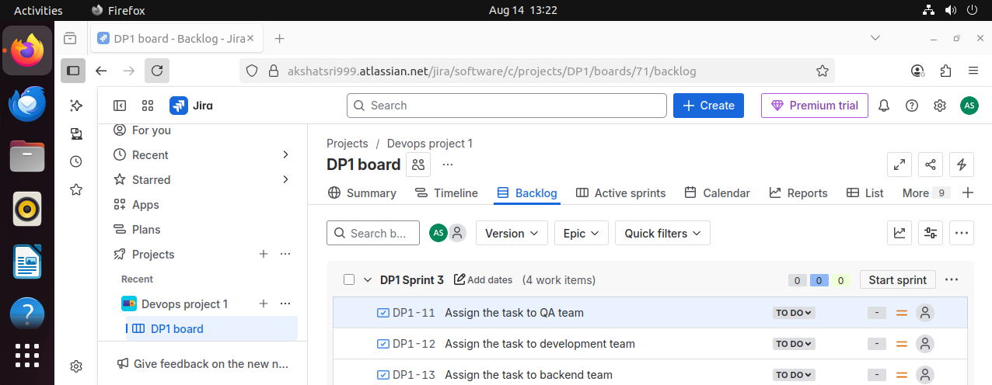  
  
  
Step-2 create a sprint in backlog section and write the task to be assign to QA team and push to sprint which i have created.

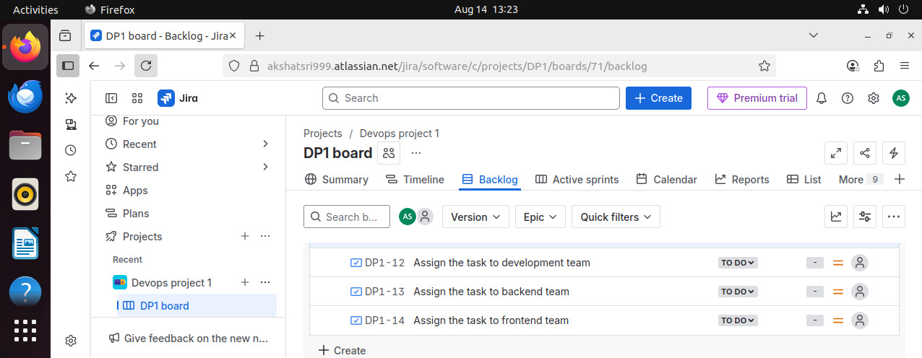Step-3 create the task that is assigned in the question as assign the automation task to QA team lead and add the bugs if it have do comment the bugs propery and respectifully that manage or team lead can esay understand it

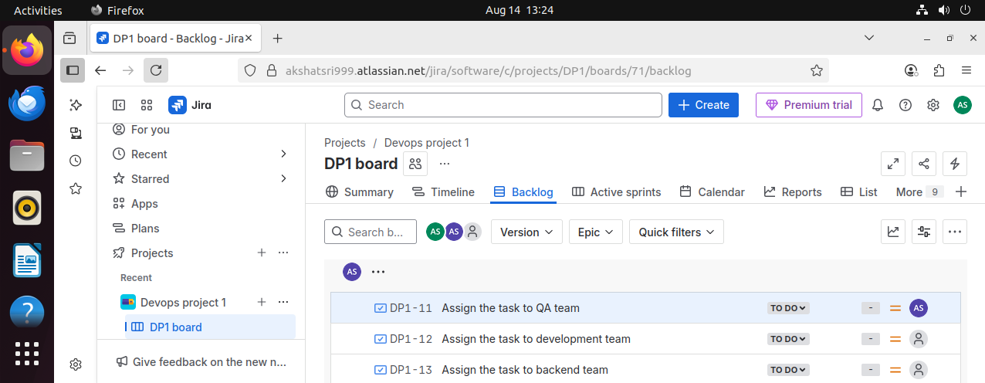  
  
step-4 :- if one done you you can start with the sprint and and track the record and add the invites or the specific leaders that is been assigned in question it’s mentioned to a QA leader here my my another id thet i have added to assign the task of QA lead and assigned to QA team as well.





steps -5 :- In above screenshoot we can easily se that AS in purple colour is assigned the task successfully and check and create sprint : ----- start sprint as well we can easy monitor our work and easily track the assigne tasks.  
  
Step-6 :- in above screenshot sprint started and assign the task is under process once done the team lead will push the sprint task to done or completed and notifies to the manager once confirm it’s done the task

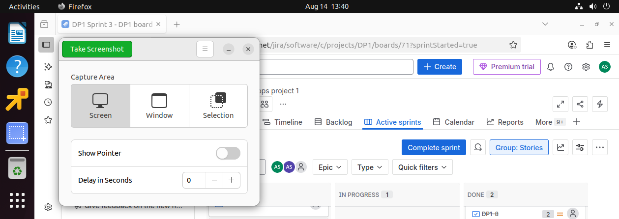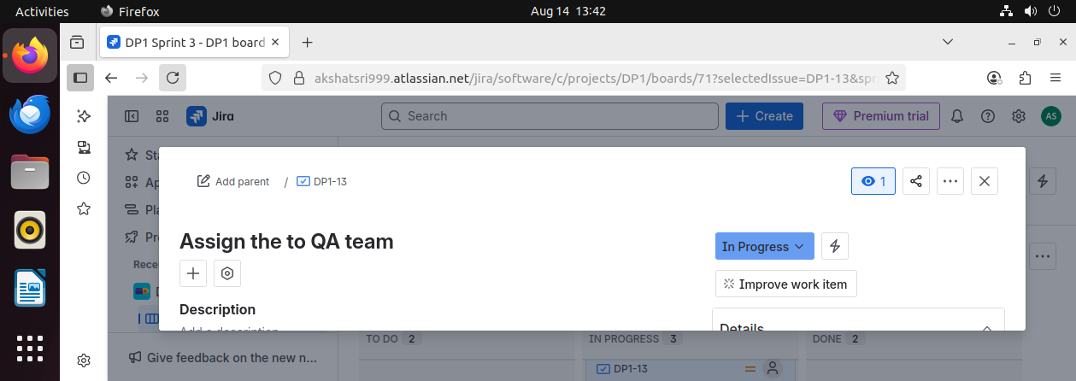

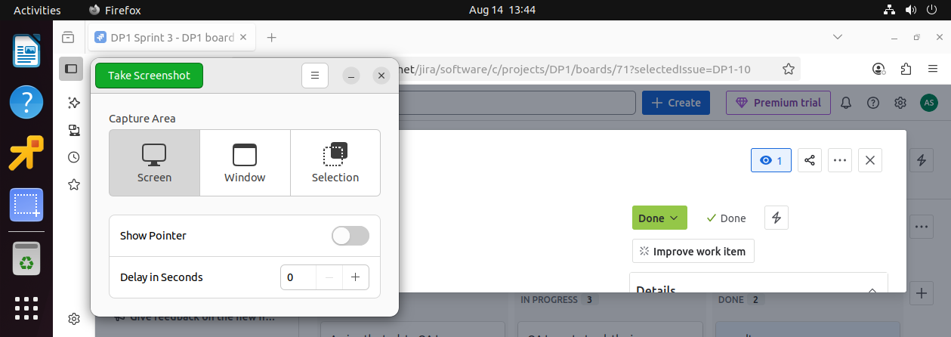  
  
step-7 :- task succesfully completed and sprint will be marked as mark completed.