2.
SELECT ebh.DepartmentID, ebh.Name,YEAR(e.HireDate) as hire_year, count(*) as number_of_employees_hired FROM AdventureWorks2019.HumanResources.Employee e
JOIN (SELECT edh.BusinessEntityID, D.Name, D.DepartmentID FROM AdventureWorks2019.HumanResources.EmployeeDepartmentHistory AS EDH
JOIN AdventureWorks2019.HumanResources.Department AS D ON EDH.DepartmentID = d.DepartmentID) as ebh ON ebh.BusinessEntityID = e.BusinessEntityID
GROUP BY ebh.DepartmentID, ebh.Name, YEAR(e.HireDate)

Output
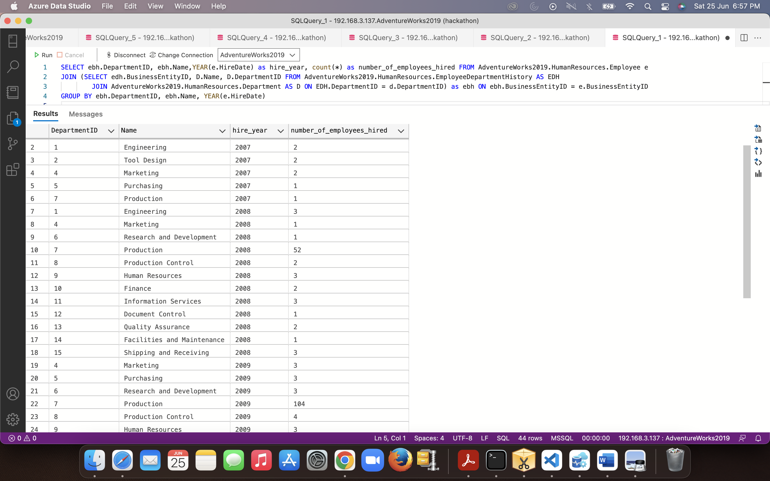

3.
SELECT pcr.FirstName, pcr.Name from AdventureWorks2019.HumanResources.Employee as e
JOIN(SELECT p.BusinessEntityID, bear.Name, p.PersonType, p.FirstName from AdventureWorks2019.Person.Person as p
JOIN(SELECT adcr.Name, adcr.AddressID, bea.BusinessEntityID FROM AdventureWorks2019.Person.BusinessEntityAddress as bea
JOIN (SELECT ad.AddressID, CSP.Name, CSP.StateProvinceID from AdventureWorks2019.Person.Address as ad
JOIN (SELECT sp.StateProvinceID, sp.CountryRegionCode, cr.Name from AdventureWorks2019.Person.StateProvince as sp
JOIN AdventureWorks2019.Person.CountryRegion as cr on cr.CountryRegionCode = sp.CountryRegionCode) as CSP ON ad.StateProvinceID = csp.StateProvinceID) as adcr
ON adcr.AddressID = bea.AddressID) as bear ON bear.BusinessEntityID = p.BusinessEntityID) as pcr
on e.BusinessEntityID = pcr.BusinessEntityID
where pcr.PersonType <> 'EM' and pcr.FirstName LIKE 'S%'

