Hostel Management System
A Project Based Learning Report Submitted in partial fulfilment of the requirements for the award of the degree

of

Bachelor of Technology
in The Department of AI & DS
Project Based Learning (PBL) – Group 6

Submitted by
2510080055: AKSHAY CHANDRA
2510080052: MANOJ
2510080053: SAI CHARAN
2510080051: PRANITH REDDY

Under the guidance of
Laiphangbam Melinda



Department of AI & DS
Koneru Lakshmaiah Education Foundation, Aziz Nagar
Aziz Nagar – 500075
OCT - 2026.
Abstract
Managing hostel accommodation manually through paper registers is slow, error-prone and makes it difficult to know which beds are free. This project presents the Hostel Management System, a full-stack web application that digitises student registration, room management and bed allocation. The frontend is built with React and Vite, the backend is a Flask REST API written in Python, and all data is stored in a PostgreSQL relational database.
The system lets an administrator register students, view every room with its occupied and available beds, allocate a specific bed to a student, and cancel an allocation to release the bed. Business rules are enforced on the server using validated inputs, unique constraints and row-level locking, so a student cannot hold two active beds and a bed cannot be assigned twice. A live dashboard summarises total students, rooms, active allocations and available beds.
Functional testing of nine scenarios, covering valid operations as well as duplicate, occupied-bed and invalid-input cases, produced the expected result in every case, and local API responses were fast. The modules for payments, maintenance and administration are planned as future work.
List of Figures
Figure 1: System architecture of the Hostel Management System
Figure 2: Dashboard of the Hostel Management System
List of Tables
Table 1: Functional test cases and results
Table 2: Performance and result summary
Table of Contents
1. Introduction
2. Methodology
2.1 Development Approach
2.2 System Architecture and Database Design
3. Experiments
4. Results
5. Conclusion and Future Work
References
Hostel Management System
Akshay Chandra, Manoj, Sai Charan, Pranith Reddy – Group 6, Department of AI & DS

Introduction
Hostels accommodate hundreds of students, and every student needs a registered room and a specific bed. In many institutions this information is still kept in paper registers or scattered spreadsheets. Such methods make it hard to know which beds are free, allow the same bed to be given to two students by mistake, and take a lot of time whenever a record must be searched or corrected.
A database-driven information system solves these problems by keeping one reliable copy of the data and applying the same rules every time. A relational database is well suited to hostel data because students, rooms and allocations are naturally linked: a student is assigned to one bed in one room, and every room has a fixed capacity. Constraints and transactions in the database can guarantee that these relationships stay consistent even when several administrators work at the same time.
This project, the Hostel Management System, is a three-tier web application. The presentation tier is a single-page React interface built with Vite. The application tier is a Flask REST API that validates every request and talks to the database using parameterised SQL queries. The data tier is PostgreSQL, which stores the students, rooms and allocations tables. The administrator can register students, monitor room occupancy bed by bed, allocate or cancel a bed, search records, and view summary statistics on a dashboard.
The main objectives were to digitise hostel records, to prevent conflicting allocations through server-side validation and row locking, to give real-time visibility of available beds, and to demonstrate complete integration of a modern frontend, a REST backend and a relational database. This report describes the design and implementation, the experiments carried out to verify the system, the results obtained, and the scope for future enhancement.

METHODOLOGY

Development Approach
The project followed an iterative approach with six stages: requirement analysis, database design, REST API development, frontend development, integration and testing. In the requirement stage we identified the entities to be managed (students, rooms and bed allocations) and the rules that must hold, such as one active bed per student and no double booking of a bed. In the design stage these were converted into three related PostgreSQL tables, and in the development stages the Flask API and React interface were built and connected over HTTP using JSON. The Vite development server runs on port 5173 and the Flask server on port 5000, with CORS enabled for the /api routes.

System Architecture and Database Design
Figure 1 shows the architecture. The administrator interacts with the React frontend, which sends fetch requests to the Flask API. Flask runs SQL queries on PostgreSQL through psycopg2 and returns the result as JSON, which React converts into tables, room cards and dashboard statistics. The API exposes eight endpoints: GET /api/health, /api/dashboard, /api/students, /api/rooms and /api/allocations; POST /api/students and /api/allocations; and PATCH /api/allocations/<id>/cancel.
The database has three tables. The students table stores roll number, name, gender, phone, email, department and year of study, with unique roll number, phone and email. The rooms table stores room number, floor, capacity and room type (double or triple). The allocations table links a student to a room and a bed number with an allocation date and a status of ACTIVE or CANCELLED. When an allocation is created, the API locks the room row with SELECT ... FOR UPDATE, validates the bed number, checks that the student exists and has no active allocation, and checks that the bed is free before inserting the record inside one transaction. This prevents race conditions when two requests arrive together.
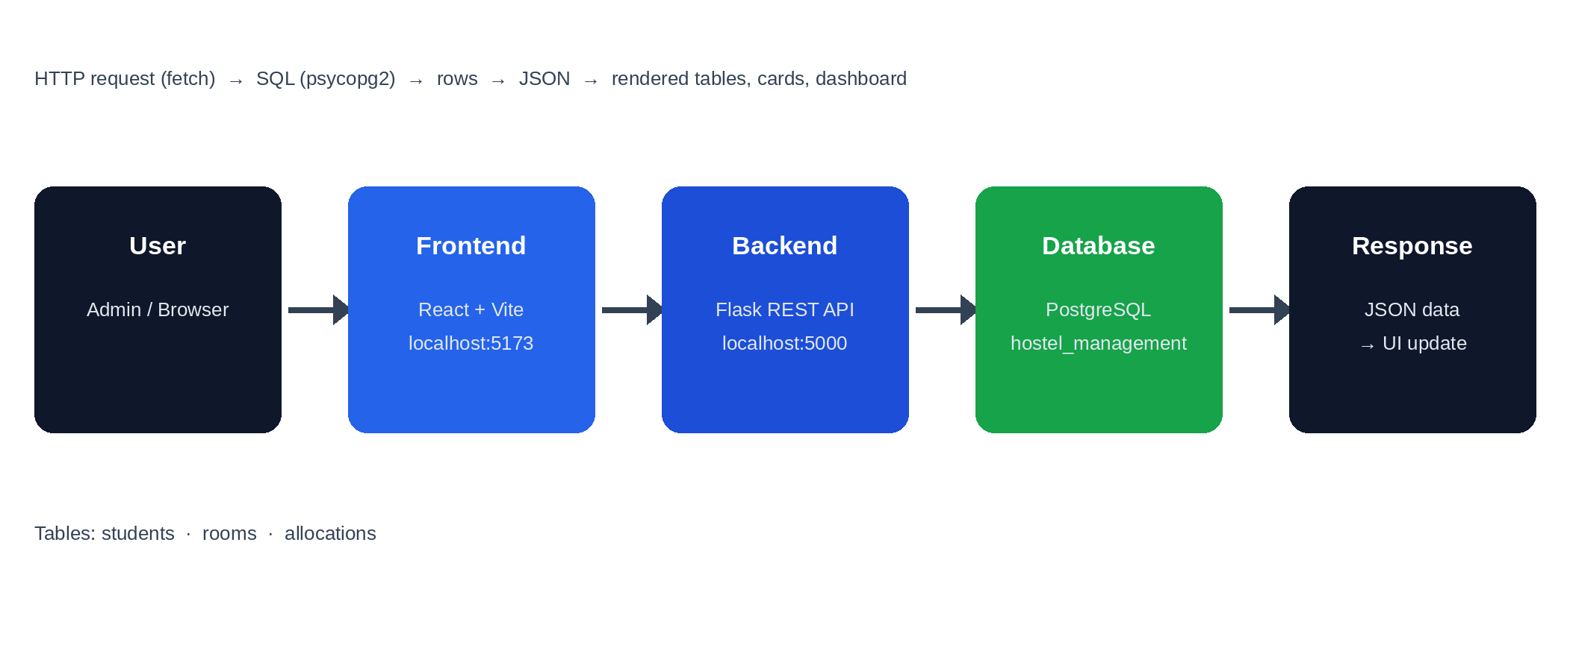
Figure 1: System architecture – User → React frontend → Flask API → PostgreSQL → JSON response

EXPERIMENTS
The system was run on a local development machine. The React frontend was started with npm run dev (Vite) and the Flask backend with python app.py, connected to a PostgreSQL database named hostel_management. Sample data of 5 students and 6 rooms (4 double rooms and 2 triple rooms, giving 14 beds in total) was loaded, and 5 bed allocations were created through the application.
The experiments verified every module through the user interface and the REST endpoints. Nine test cases were designed: a health check of the database connection; adding a valid student; adding a student with a duplicate roll number or email; allocating a free bed; allocating an already occupied bed; allocating a second bed to a student who already has one; giving an invalid bed number; cancelling an allocation; and checking the dashboard counts and the search filter. For each case the expected result was compared with the actual behaviour of the system, and the response time of the API and database was observed using the browser Network tab. Figure 2 shows the dashboard of the working application with live data from the database.
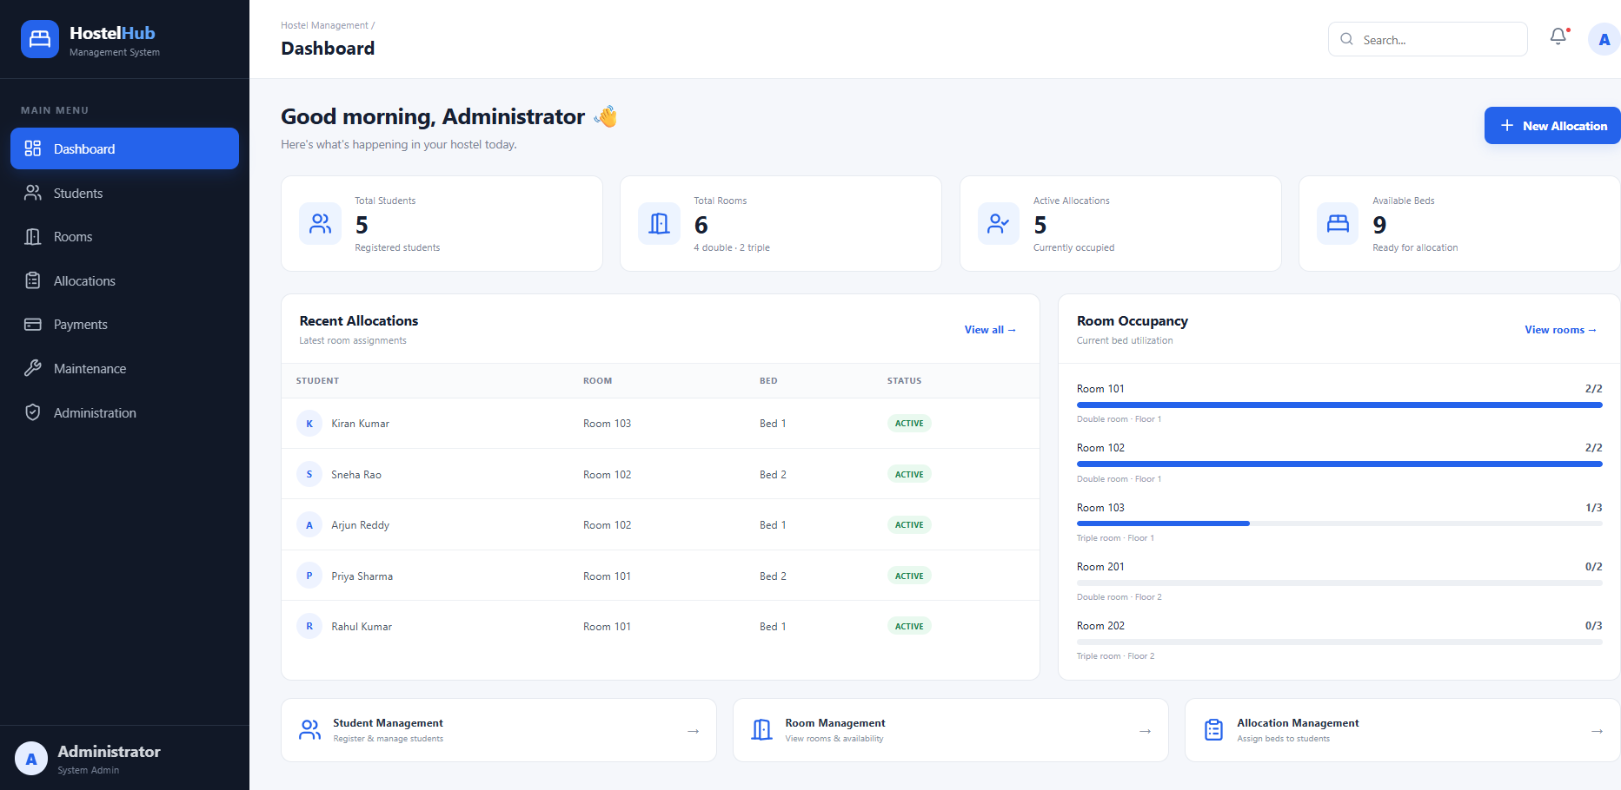
Figure 2: Dashboard showing students, rooms, active allocations, available beds, recent allocations and room occupancy
The Students page lists all registered students with search, the Rooms page shows each room as a card with its beds marked occupied or free, and the Allocations page lists every allocation with its status and a cancel button for active records.

RESULTS
Functional and Performance Results

The system behaved as expected in all nine test cases, as listed in Table 1. Valid operations succeeded, and every invalid operation was rejected with a clear message (HTTP 400, 404 or 409) without changing the database. Table 2 summarises the measurable results: all 9 test cases passed, giving a 0% error rate and a 100% pass rate, local API responses were below 100 ms and database queries below 50 ms. With 5 of 14 beds allocated the occupancy was about 36%, leaving 9 beds available.
Table 1: Functional test cases and results
Test Case | Expected Result | Actual Result | Status
Health check | Backend and DB connected | Connected | Pass
Add student | Record saved and listed | Added | Pass
Duplicate roll no./email | Rejected (409) | Rejected | Pass
Allocate free bed | Allocation created (ACTIVE) | Created | Pass
Allocate occupied bed | Blocked (409) | Blocked | Pass
Second bed for same student | Blocked (409) | Blocked | Pass
Invalid bed number | Rejected (400) | Rejected | Pass
Cancel allocation | Status CANCELLED, bed freed | Freed | Pass
Dashboard and search | Correct counts, filter works | Correct | Pass

Table 2: Performance and result summary
Metric | Result
Test cases executed | 9
Successful test cases | 9 (100%)
Error rate | 0%
API response time (local) | < 100 ms
Database response time (local) | < 50 ms
REST endpoints | 8
Students / Rooms | 5 / 6
Total beds / Allocated / Available | 14 / 5 / 9

CONCLUSION and FUTURE WORK
Conclusion
In this project we designed and implemented a Hostel Management System using React, Flask and PostgreSQL. The application registers students, shows room and bed availability, allocates and cancels beds, and summarises the hostel on a dashboard. Server-side validation, unique constraints and row locking ensure that no student holds two active beds and no bed is allocated twice. All nine test cases passed with a 0% error rate, so the project objectives were achieved.
Future work includes adding login and role-based access for administrators and wardens, completing the Payments module for fee collection and receipts, adding a Maintenance module for complaint tracking, and providing edit and delete options for students. Report generation and export, automatic notifications, search by department and year, and deployment on a cloud server with a production WSGI server and HTTPS are also planned.

References
- Miguel Grinberg, Flask Web Development, 2nd ed., O'Reilly Media (2018).
- Flask Documentation, Pallets Projects. https://flask.palletsprojects.com
- PostgreSQL Global Development Group, PostgreSQL Documentation. https://www.postgresql.org/docs
Psycopg2 Documentation, "psycopg – PostgreSQL database adapter for Python". https://www.psycopg.org
React Documentation, Meta Open Source. https://react.dev
Vite Documentation, "Next Generation Frontend Tooling". https://vitejs.dev
R. Elmasri and S. Navathe, Fundamentals of Database Systems, 7th ed., Pearson (2016).

