Hostel Management System
A Project Based Learning Report Submitted in partial fulfilment of the requirements for the award of the degree

of

Bachelor of Technology
in The Department of AI & DS
Project Based Learning (PBL) – Group 6

Submitted by
2510080055: AKSHAY CHANDRA
2510080052: MANOJ
2510080053: SAI CHARAN
2510080051: PRANITH REDDY

Under the guidance of
Laiphangbam Melinda



Department of AI & DS
Koneru Lakshmaiah Education Foundation, Aziz Nagar
Aziz Nagar – 500075
OCT - 2026.
Abstract
Managing hostel accommodation manually through paper registers is slow, error-prone and makes it difficult to know which beds are free. This project presents the Hostel Management System, a full-stack web application that digitises student registration, room management and bed allocation. The frontend is built with React and Vite, the backend is a Flask REST API written in Python, and all data is stored in a PostgreSQL relational database.
The system lets an administrator register students, view every room with its occupied and available beds, allocate a specific bed to a student, and cancel an allocation to release the bed. Business rules are enforced on the server using validated inputs, unique constraints and row-level locking, so a student cannot hold two active beds and a bed cannot be assigned twice. A live dashboard summarises total students, rooms, active allocations and available beds.
The report describes the problem, the design of the architecture and database, the backend and frontend implementation, the experiments and the results, and suggests future enhancements such as authentication, payments and maintenance modules.
Functional testing of nine scenarios, covering valid operations as well as duplicate, occupied-bed and invalid-input cases, produced the expected result in every case, and local API responses were fast. The modules for payments, maintenance and administration are planned as future work.
List of Figures
Figure 1: Development workflow of the project
Figure 2: System architecture – User → React frontend → Flask API → PostgreSQL → JSON response
Figure 3: Development environment on localhost
Figure 4: Use-case diagram
Figure 5: Entity-relationship diagram of the database
Figure 6: Level 0 data flow diagram (context diagram)
Figure 7: Level 1 data flow diagram
Figure 8: Flowchart of the bed allocation process
Figure 9: Sequence diagram of a bed allocation request
Figure 10: Life cycle (states) of an allocation record
Figure 11: Component hierarchy of the React frontend
Figure 12: Data flow inside the frontend
Figure 13: Dashboard showing students, rooms, active allocations, available beds, recent allocations and room occupancy
Figure 14: Share of occupied and available beds in the sample data
Figure 15: Capacity and occupied beds by room
List of Tables
Table 1: Comparison of hostel management approaches
Table 2: Functional requirements
Table 3: Non-functional requirements
Table 4: Hardware and software requirements
Table 5: Technologies and tools used
Table 6: Structure of the students table
Table 7: Structure of the rooms table
Table 8: Structure of the allocations table
Table 9: REST API endpoints
Table 10: Request and response details of the main endpoints
Table 11: Error messages of the allocation endpoint
Table 12: HTTP status codes used by the API
Table 13: React components
Table 14: State variables in the App component
Table 15: Experimental environment
Table 16: Sample data used in the experiments
Table 17: Allocations in the sample data
Table 18: Test procedures
Table 19: Functional test cases and results
Table 20: Performance and result summary
Table 21: Manual process versus the developed system
Table 22: Challenges and solutions
Table 23: Glossary of terms and abbreviations
Table of Contents
1. Introduction
a. Background
b. Problem Statement
c. Need and Motivation
d. Objectives
e. Scope and Limitations
f. Comparison with Existing Approaches
g. Feasibility Study
h. Organisation of the Report
2. Methodology
a. Development Approach
b. Requirement Analysis
c. Hardware and Software Requirements
d. Technology Stack
e. System Architecture
f. Use Cases
g. Database Design
h. Normalisation and Integrity Constraints
i. Indexes and Query Design
j. Data Flow
k. Module Description
l. Backend Design
m. API Specification
n. Allocation Logic and Concurrency Control
o. Transactions and ACID Properties
p. Frontend Design
q. Frontend Components and State
r. User Interface Design Decisions
s. Implementation of Key Parts
t. Security and Configuration
3. Experiments
a. Experimental Setup
b. Test Data
c. Test Plan
d. Detailed Test Procedures
e. API Request and Response Examples
f. Performance Measurement
g. Frontend Verification
4. Results
a. Functional Results
b. Performance Results
c. Description of the Screens
d. Occupancy Analysis
e. Comparison with the Manual Process
f. Discussion
g. Working Procedure (User Guide)
h. Challenges Faced and Solutions
i. Lessons Learned
5. Conclusion and Future Work
a. Conclusion
b. Future Work
References
Appendix A – Backend Source Code
Appendix B – Frontend Source Code
Appendix C – Installation and Execution Guide
Appendix D – API Test Commands
Appendix E – Glossary
Hostel Management System
Akshay Chandra, Manoj, Sai Charan, Pranith Reddy – Group 6, Department of AI & DS

Introduction

Background
Hostels accommodate hundreds of students, and every student needs a registered room and a specific bed. In many institutions this information is still kept in paper registers or scattered spreadsheets. Such methods make it hard to know which beds are free, allow the same bed to be given to two students by mistake, and take a lot of time whenever a record must be searched or corrected.
A database-driven information system solves these problems by keeping one reliable copy of the data and applying the same rules every time. A relational database is well suited to hostel data because students, rooms and allocations are naturally linked: a student is assigned to one bed in one room, and every room has a fixed capacity. Constraints and transactions in the database can guarantee that these relationships stay consistent even when several administrators work at the same time.
This project, the Hostel Management System, is a three-tier web application. The presentation tier is a single-page React interface built with Vite. The application tier is a Flask REST API that validates every request and talks to the database using parameterised SQL queries. The data tier is PostgreSQL, which stores the students, rooms and allocations tables. The administrator can register students, monitor room occupancy bed by bed, allocate or cancel a bed, search records, and view summary statistics on a dashboard.

Problem Statement
Hostel administration depends on three kinds of information: who the students are, what rooms and beds exist, and which student occupies which bed. When this information lives in registers or separate files, the same fact is written in several places and quickly becomes inconsistent. A warden who wants to know whether Bed 2 of Room 103 is free must search through pages of entries, and two wardens can accidentally allocate the same bed because neither can see the other's work.
The problem addressed in this project is therefore to build a centralised, validated and easy-to-use system that stores hostel data in a relational database, prevents conflicting allocations automatically, and shows the current occupancy of every room and bed in real time.

Need and Motivation
Institutional hostels serve a large and changing population. Every semester students join, leave or change rooms, and the administration must respond quickly and accurately. Manual handling consumes staff time, creates disputes when records disagree, and offers no summary view for planning. A small, low-cost software system that enforces the allocation rules and presents the data clearly can remove most of this effort.
The project also serves an academic purpose. It brings together the main topics of a database course (relational design, SQL, keys and constraints, transactions and locking) with a modern web stack, and demonstrates how they cooperate in a complete working application rather than as isolated exercises.

Objectives
• To digitise student, room and bed-allocation records in a PostgreSQL database.
• To allocate beds to students without conflicts, using server-side validation and row locking.
• To show real-time room occupancy and the number of available beds.
• To provide a simple dashboard and search facility for administrators.
• To integrate a React frontend, a Flask REST backend and a relational database into one working system.
• To keep the design modular so that payments, maintenance and administration modules can be added later.

Scope and Limitations
The implemented scope covers four modules: Dashboard, Student Management, Room Management and Bed Allocation. The administrator can register a student, list and search students, see every room with its bed-level status, create an allocation and cancel an active allocation. The Payments, Maintenance and Administration menu items are present in the interface as placeholders for the next implementation phase.
The current version has some limitations. It has no login or role-based access, so it is meant to be used by a single trusted administrator on a local network. Student records can be added and viewed but not yet edited or deleted from the interface. Rooms are created directly in the database rather than through the interface. These points are listed as future work in Section 5.

Comparison with Existing Approaches
Table 1 compares the proposed system with the methods most commonly used for hostel administration. The comparison is qualitative and based on the features each approach can realistically offer.
Table 1: Comparison of hostel management approaches
Feature | Paper register | Spreadsheet | Proposed system
Single shared copy of data | No | Partly | Yes
Prevents double allocation | No | No | Yes (validation + locking)
Bed-level availability | Manual search | Manual filter | Instant, visual
Search and filter | Manual | Basic | Live search
Summary dashboard | No | Manual formulas | Automatic
Multi-user safety | No | Low | Transaction-based
Cost and effort to set up | Low | Low | Moderate (one time)

Feasibility Study
Technical feasibility: every component of the system is available as mature open-source software (Python, Flask, React, Vite and PostgreSQL), runs on an ordinary laptop and has extensive documentation. The team already knew Python and JavaScript, so no new infrastructure or specialised hardware was needed.
Economic feasibility: there is no licence cost for any tool, and development and testing use only the team's own computers. A hostel could host the finished system on a single low-cost server or on a spare office computer, which is far cheaper than a commercial hostel ERP.
Operational feasibility: the interface uses plain language, icons and forms familiar to anyone who has used a web application, so a warden can learn it in a few minutes. The system replaces existing manual steps rather than adding new ones.
Schedule feasibility: because the work was divided into independent stages (database, API, frontend, integration and testing) and reviewed at fixed review points, the working system was completed within the semester.

Organisation of the Report
Section 1 introduces the problem, objectives and scope. Section 2 describes the methodology: development approach, requirements, technology stack, architecture, database design, backend and frontend design, and selected source code. Section 3 explains the experimental setup and the test cases. Section 4 presents and discusses the results. Section 5 gives the conclusion and future work, followed by the references.

METHODOLOGY

Development Approach
The project followed an iterative approach with six stages: requirement analysis, database design, REST API development, frontend development, integration and testing, as shown in Figure 1. In the requirement stage we identified the entities to be managed (students, rooms and bed allocations) and the rules that must hold, such as one active bed per student and no double booking of a bed. In the design stage these were converted into three related PostgreSQL tables. In the development stages the Flask API and the React interface were built and connected over HTTP using JSON, and each module was tested through the browser before the next one was added.
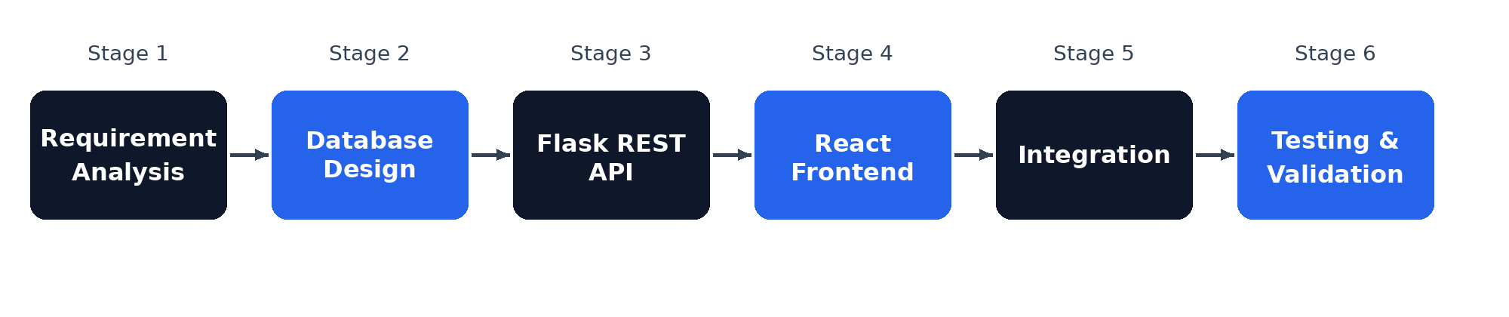
Figure 1: Development workflow of the project
Working iteratively allowed the team to demonstrate a working slice at every review: the database and API first, then the frontend screens, and finally the integrated and tested system. Version control with Git and GitHub was used throughout so that the four team members could work on the backend and frontend in parallel.

Requirement Analysis
The functional requirements describe what the system must do. They were derived from the day-to-day tasks of a hostel warden and are listed in Table 2. Each requirement is covered by at least one API endpoint and one screen of the frontend.
Table 2: Functional requirements
ID | Requirement | Module
FR1 | Register a student with roll number, name, gender, phone, email, department and year | Students
FR2 | List all students and search them by any field | Students
FR3 | Display every room with floor, type, capacity and bed-wise status | Rooms
FR4 | Allocate a specific bed of a room to a student | Allocations
FR5 | Reject an allocation if the bed is occupied or the student already has one | Allocations
FR6 | Cancel an active allocation and free the bed | Allocations
FR7 | Show totals, recent allocations and occupancy on a dashboard | Dashboard
FR8 | Report clear success and error messages to the user | All

The non-functional requirements, listed in Table 3, describe the quality expected from the system: correctness of data, responsiveness, usability on different screen sizes, and ease of maintenance.
Table 3: Non-functional requirements
Attribute | Requirement
Data integrity | No bed may be allocated twice; no student may hold two active beds
Performance | Pages and API calls respond within a fraction of a second on a local machine
Usability | Simple navigation, forms with required fields, immediate feedback
Responsiveness | Layout adapts to desktop and mobile widths with a collapsible sidebar
Maintainability | Separate frontend and backend; one route per operation; commented code
Portability | Runs on any system with Python, Node.js and PostgreSQL

Hardware and Software Requirements
Table 4 lists the recommended hardware and software for running the system. The requirements are modest because the data volume of a hostel is small.
Table 4: Hardware and software requirements
Item | Requirement
Processor and memory | Dual-core processor, 4 GB RAM or more
Storage | About 1 GB free (project, node_modules, database)
Operating system | Windows, Linux or macOS
Python | Python 3 with Flask, Flask-CORS, psycopg2 and python-dotenv
Node.js | Node.js and npm with React, React-DOM, Vite, @vitejs/plugin-react and lucide-react
Database | PostgreSQL server (default port 5432)
Browser | Any modern browser such as Chrome, Edge or Firefox

Technology Stack
The technologies, summarised in Table 5, were chosen because they are widely used, well documented and free. Python and Flask give a short path from SQL query to JSON response. React makes it easy to build interactive screens from reusable components, and Vite provides a very fast development server. PostgreSQL offers strong support for constraints, transactions and row-level locking, which are central to the allocation logic.
Table 5: Technologies and tools used
Layer | Technology | Purpose
Frontend | React, Vite | Single-page user interface and development server
Icons and styling | lucide-react, custom CSS | Icons, layout, cards, tables and responsive design
Backend | Python, Flask, Flask-CORS | REST API and cross-origin access for the frontend
Configuration | python-dotenv | Database settings read from environment variables
Database | PostgreSQL, psycopg2 | Relational storage and Python database driver
Tools | VS Code, Git, GitHub | Editing, version control and collaboration

System Architecture
Figure 2 shows the architecture. The administrator interacts with the React frontend, which sends fetch requests to the Flask API. Flask runs SQL queries on PostgreSQL through psycopg2 and returns the result as JSON, which React converts into tables, room cards and dashboard statistics. The three tiers are independent: the frontend knows only the API address and the JSON format, and the database is accessed only by the backend.
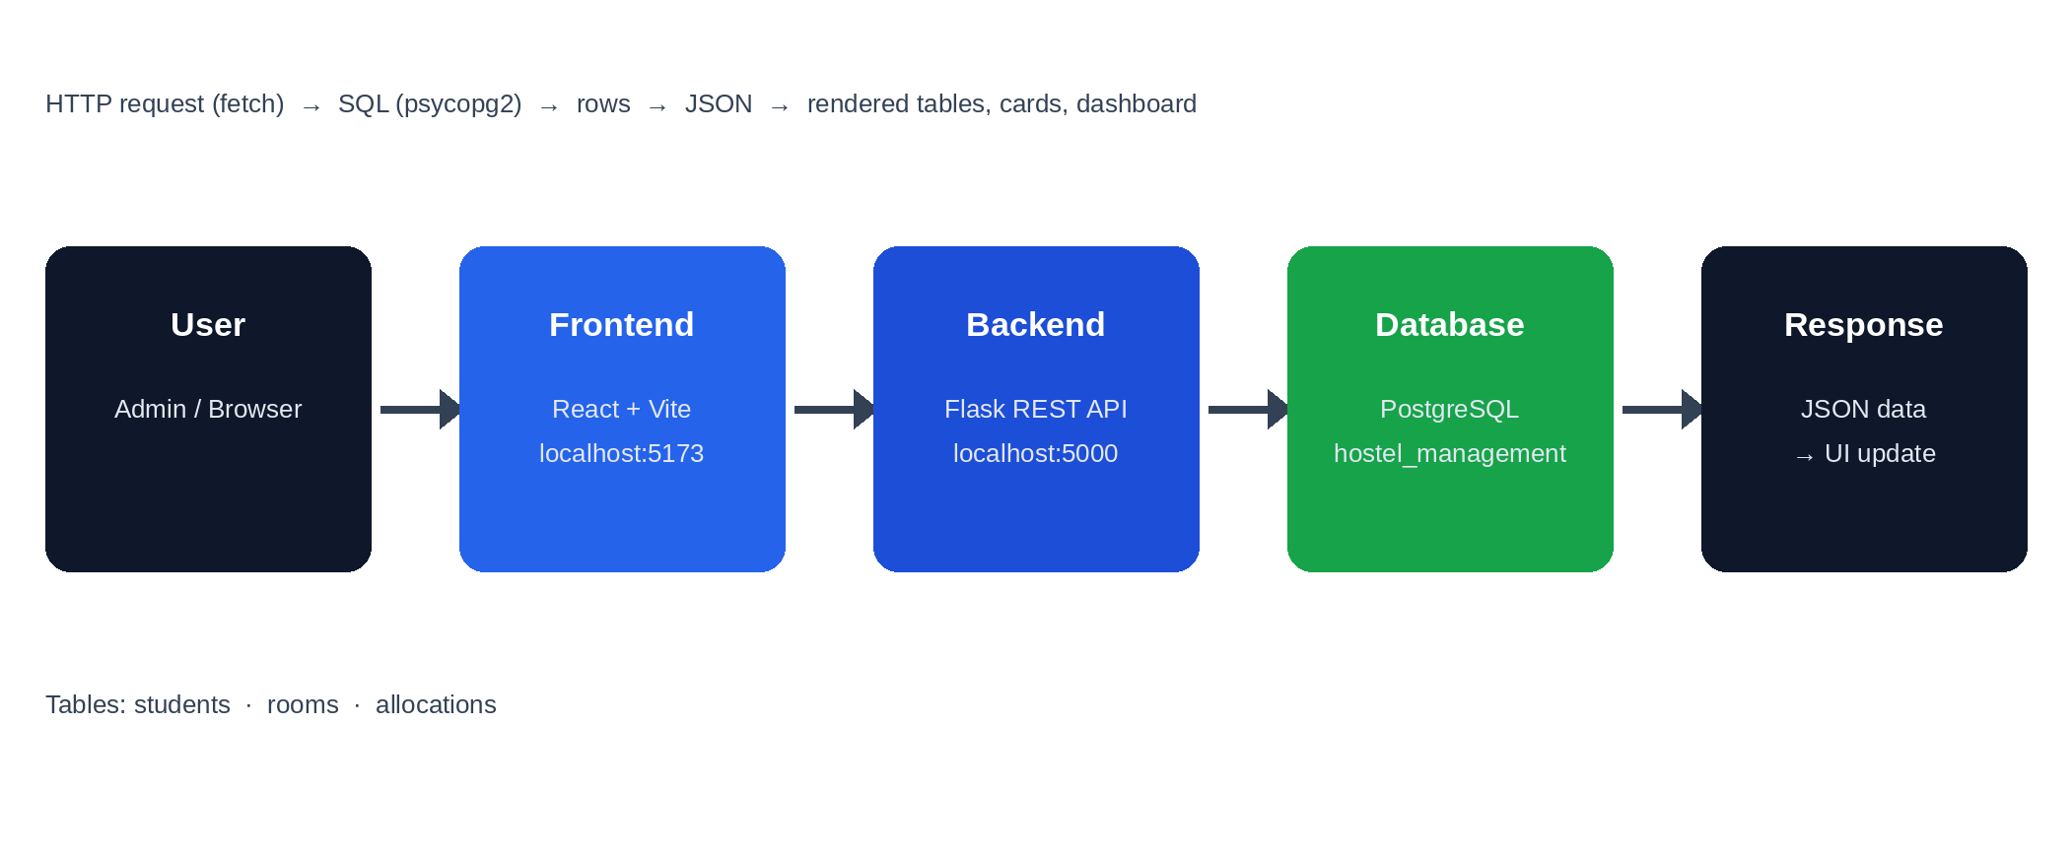
Figure 2: System architecture – User → React frontend → Flask API → PostgreSQL → JSON response
During development all components run on one machine, as shown in Figure 3. The browser loads the React application from the Vite server on port 5173, and the application calls the Flask server on port 5000, which in turn connects to PostgreSQL on port 5432. CORS is enabled for the /api routes so that the browser allows the frontend on one port to call the backend on another.
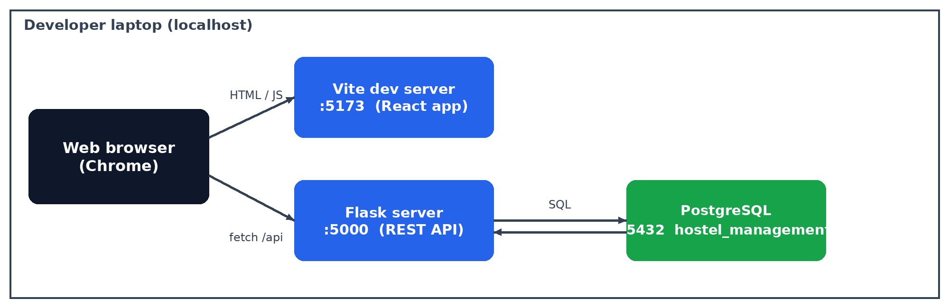
Figure 3: Development environment on localhost

Use Cases
The only actor in the current version is the Administrator (hostel warden). Figure 4 shows the use cases offered to the administrator: registering a student, searching and viewing students, viewing rooms and availability, allocating a bed, cancelling an allocation and viewing the dashboard.
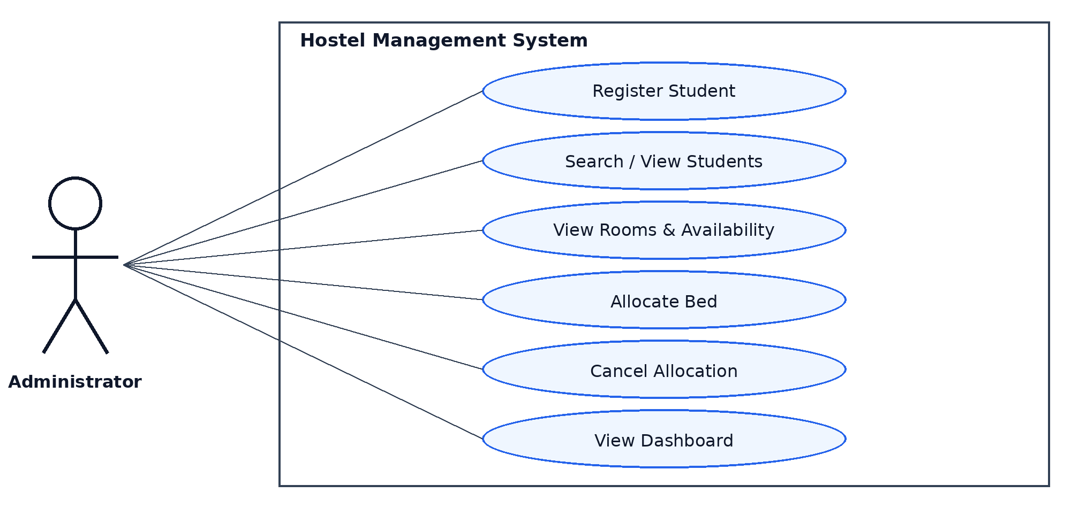
Figure 4: Use-case diagram

Database Design
The database has three tables, shown in the entity-relationship diagram in Figure 5. A student can appear in many allocation records over time (for example, after a cancellation and a new allocation), but only one of them may be ACTIVE. A room is also referenced by many allocation records, one active record for each occupied bed. The allocations table is therefore the link between students and rooms, and it stores the bed number, date and status of every assignment.
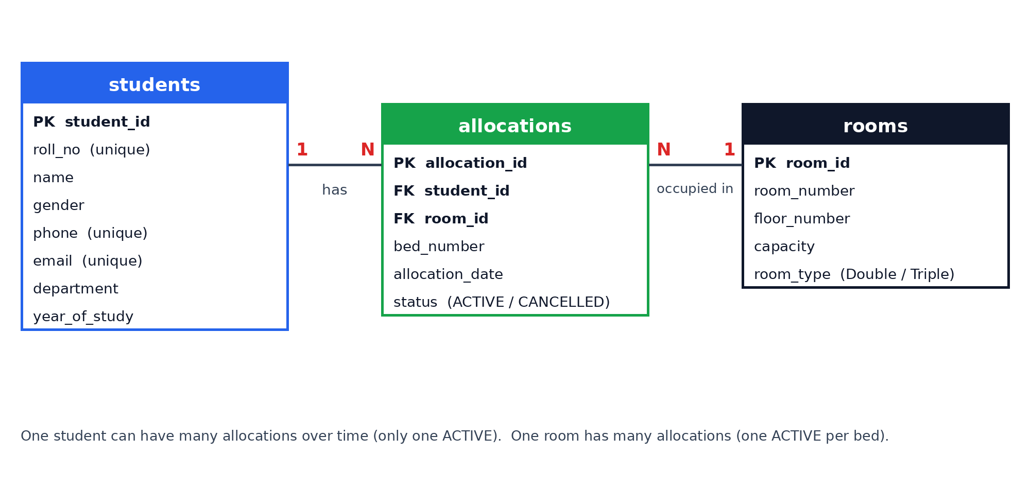
Figure 5: Entity-relationship diagram of the database
The students table, described in Table 6, stores the personal and academic details of each student. Roll number, phone number and email address are unique, so the same student cannot be registered twice. The API reports a violation of these constraints as a conflict (HTTP 409) with a readable message.
Table 6: Structure of the students table
Column | Description | Constraint
student_id | Auto-generated identifier | Primary key
roll_no | University roll number | Unique, not null
name | Full name | Not null
gender | Male / Female | Not null
phone | Contact number | Unique, not null
email | Email address | Unique, not null
department | AI & DS, CSE, ECE, EEE, Mechanical | Not null
year_of_study | Year 1 to 4 | Not null

The rooms table, described in Table 7, stores the physical rooms. The capacity column (2 for double rooms and 3 for triple rooms) defines how many beds the room has, and the valid bed numbers of a room are 1 to capacity. In the sample data there are four double rooms and two triple rooms, giving 14 beds.
Table 7: Structure of the rooms table
Column | Description | Constraint
room_id | Auto-generated identifier | Primary key
room_number | Room number such as 101 | Unique, not null
floor_number | Floor of the room | Not null
capacity | Number of beds (2 or 3) | Not null
room_type | Double or Triple | Not null

The allocations table, described in Table 8, records which student holds which bed. Instead of deleting a record when a student leaves, the status is changed from ACTIVE to CANCELLED. This keeps the full allocation history and still lets the same bed be given to someone else, because only ACTIVE rows are considered when checking availability.
Table 8: Structure of the allocations table
Column | Description | Constraint
allocation_id | Auto-generated identifier | Primary key
student_id | Student who holds the bed | Foreign key → students
room_id | Room of the bed | Foreign key → rooms
bed_number | Bed within the room (1 to capacity) | Not null
allocation_date | Date of allocation (current date) | Not null
status | ACTIVE or CANCELLED | Not null

Normalisation and Integrity Constraints
The tables were checked against the normal forms. All columns hold single, atomic values, so the tables are in first normal form. In every table the primary key is a single column, so no non-key attribute can depend on only a part of a key, which gives second normal form. In the students table every attribute depends only on student_id (and on the candidate keys roll_no, phone and email), and in the allocations table every attribute depends only on allocation_id, so both tables are also in third normal form.
The name of a student and the number of a room are stored only once, in their own tables, and are brought into the allocation list by a join. This removes update anomalies: correcting a student's name needs one change and every screen shows it. In the rooms table, room_type (Double or Triple) is determined by capacity, which is a small transitive dependency. It was kept on purpose because it makes the interface readable and does not risk inconsistency in a table that administrators rarely change.
Integrity is protected at four levels: primary keys identify rows, foreign keys ensure that an allocation can refer only to an existing student and room, unique constraints stop duplicate students and rooms, and CHECK constraints keep values such as status and year of study in their valid range. The partial unique indexes in Listing 1 add a final guarantee that at most one ACTIVE allocation exists per student and per bed, even if application code were bypassed.

Indexes and Query Design
Primary keys and unique constraints automatically create indexes, so lookups by student_id, room_id, roll_no and room_number are fast. The partial unique indexes on the allocations table also speed up the two most frequent checks, namely whether a student has an ACTIVE allocation and whether a bed is occupied, because both checks have exactly the same condition as the index. The queries use explicit column lists and parameter placeholders, avoid SELECT *, and use joins and COUNT with FILTER so that the database, not the application, does the aggregation.

Data Flow
Figure 6 is the level 0 data flow diagram. The administrator sends requests and form data to the system and receives tables, statuses and messages. The system exchanges SQL queries and result rows with the PostgreSQL database.
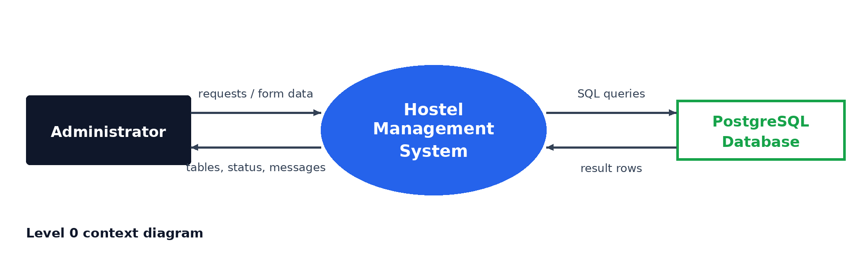
Figure 6: Level 0 data flow diagram (context diagram)
Figure 7 expands the system into four processes: managing students, viewing rooms, allocating and cancelling beds, and producing the dashboard. Each process reads from or writes to the students (D1), rooms (D2) and allocations (D3) data stores.
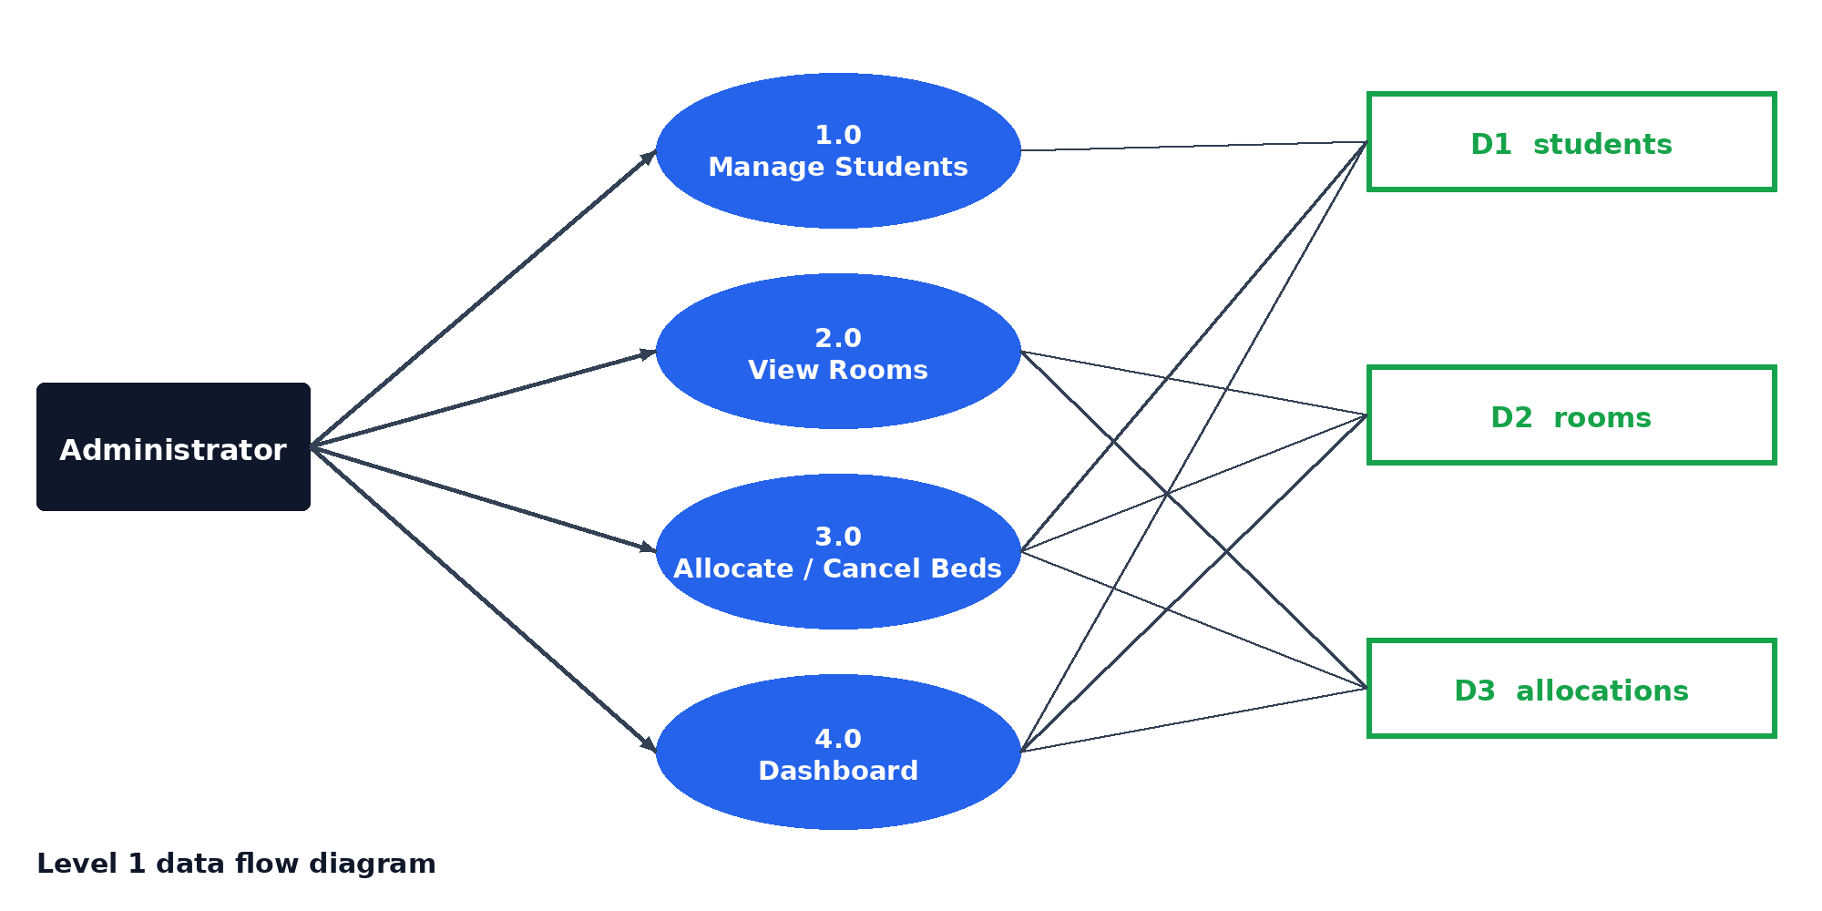
Figure 7: Level 1 data flow diagram

Module Description
The application is organised into four implemented modules and three planned ones. Each implemented module has a matching backend route group and a matching frontend page, which keeps the code easy to follow.
Student Management. This module stores the master data of the hostel. The administrator opens the Add Student form, which contains the fields roll number, full name, gender, phone, email, department and year of study. On saving, the frontend sends the values to POST /api/students. The backend checks that none of the fields is empty, inserts the row and returns it. The students table of the frontend then reloads and shows the new student. The search box above the table filters the list by joining all the values of a student into one lower-case string and testing whether it contains the typed text, so the administrator can search by name, roll number, department, phone or email with the same box.
Room Management. This module presents the physical capacity of the hostel. For every room the backend calculates the occupied and available beds with a single grouped query. The Rooms page shows three summary tiles (occupied beds, available beds and total rooms) and one card per room. Each card draws as many bed icons as the room capacity, colours the occupied beds, and displays a Full or Available label. The occupied beds are found by checking, for every bed index, whether an ACTIVE allocation with the same room and bed number exists.
Bed Allocation. This is the core module. The New Allocation form asks for a student, a room and a bed. When the room changes, the bed list is regenerated from the capacity of the new room and the bed number is reset to 1. Beds that already have an active allocation are shown as occupied and cannot be selected. On saving, the frontend calls POST /api/allocations and the backend runs the transactional checks described earlier. The Allocations page lists every record, including cancelled ones, with a coloured status label, and offers a cancel button only for ACTIVE records.
Dashboard. The dashboard gives the administrator an overview as soon as the application opens. The four statistic cards are filled from the dashboard endpoint and from the loaded lists. The Recent Allocations table shows the last five active allocations in reverse order, and the Room Occupancy panel shows progress bars for the first five rooms, where the width of each bar is the number of active allocations divided by the room capacity.
Payments, Maintenance and Administration. These three menu items open a Coming Soon page that explains that the module is planned for the next implementation phase. They are included now so that the navigation structure of the final product is already visible and so that new modules can be added without changing the layout.

Backend Design
The backend is a single Flask application that exposes eight endpoints, listed in Table 9. Every endpoint opens a database connection, runs parameterised SQL through a RealDictCursor so that rows are returned as dictionaries, and always closes the cursor and connection in a finally block. All responses use a common JSON format with a success flag, a message or data field, and an HTTP status code that reflects the outcome.
Table 9: REST API endpoints
Method | Endpoint | Purpose
GET | /api/health | Check that Flask and PostgreSQL are connected
GET | /api/dashboard | Totals of students, rooms, active allocations and available beds
GET | /api/students | List all students
POST | /api/students | Register a new student
GET | /api/rooms | List rooms with occupied and available beds
GET | /api/allocations | List allocations joined with student and room details
POST | /api/allocations | Allocate a bed to a student
PATCH | /api/allocations/<id>/cancel | Cancel an active allocation

The dashboard endpoint computes four values in one SQL statement: the number of students, the number of rooms, the number of active allocations, and the number of available beds, which is the sum of room capacities minus the active allocations. The rooms endpoint joins rooms with allocations and uses COUNT with a FILTER clause on status = 'ACTIVE' to calculate occupied and available beds for each room in a single query.
The student registration endpoint first checks that all seven required fields are present and not empty, and returns HTTP 400 otherwise. It then inserts the record and returns the saved row with HTTP 201. If the database rejects the insert because of a unique constraint, the endpoint rolls back the transaction and returns HTTP 409 with the message that the roll number, phone or email may already exist.

API Specification
Table 10 gives the request and response details of the endpoints that change or return data. All responses are JSON objects with a success field. Error responses also contain a message field.
Table 10: Request and response details of the main endpoints
Endpoint | Request data | Successful response | Error responses
GET /api/dashboard | None | data: total_students, total_rooms, active_allocations, available_beds | 500
GET /api/students | None | data: list of students | 500
POST /api/students | roll_no, name, gender, phone, email, department, year_of_study | 201 and the saved student | 400 missing field; 409 duplicate
GET /api/rooms | None | data: rooms with occupied_beds and available_beds | 500
GET /api/allocations | None | data: allocations with student name, roll number, room number and type | 500
POST /api/allocations | student_id, room_id, bed_number | 201 and the allocation | 400 invalid bed; 404 room or student; 409 conflict
PATCH /api/allocations/<id>/cancel | Allocation id in the URL | 200 and the cancelled allocation | 404 no active allocation

The messages returned by the allocation endpoint are written for the administrator and are shown directly in the toast notification of the frontend. Table 11 lists them together with the condition that produces each message.
Table 11: Error messages of the allocation endpoint
Condition | HTTP code | Message
Required field missing | 400 | <field> is required
Room id not found | 404 | Room not found
Bed number below 1 or above capacity | 400 | Invalid bed number. Room <n> has <c> beds.
Student id not found | 404 | Student not found
Student already has an ACTIVE allocation | 409 | Student already has an active allocation
Requested bed already ACTIVE | 409 | Bed <b> in Room <n> is already occupied
Database constraint violated | 409 | Allocation conflict. The student or bed may already be allocated.

Allocation Logic and Concurrency Control
Allocation is the most important operation because it must never produce a conflict, even if two administrators submit requests at the same moment. The endpoint therefore runs all its checks and the insert inside one database transaction, following the flow in Figure 8.
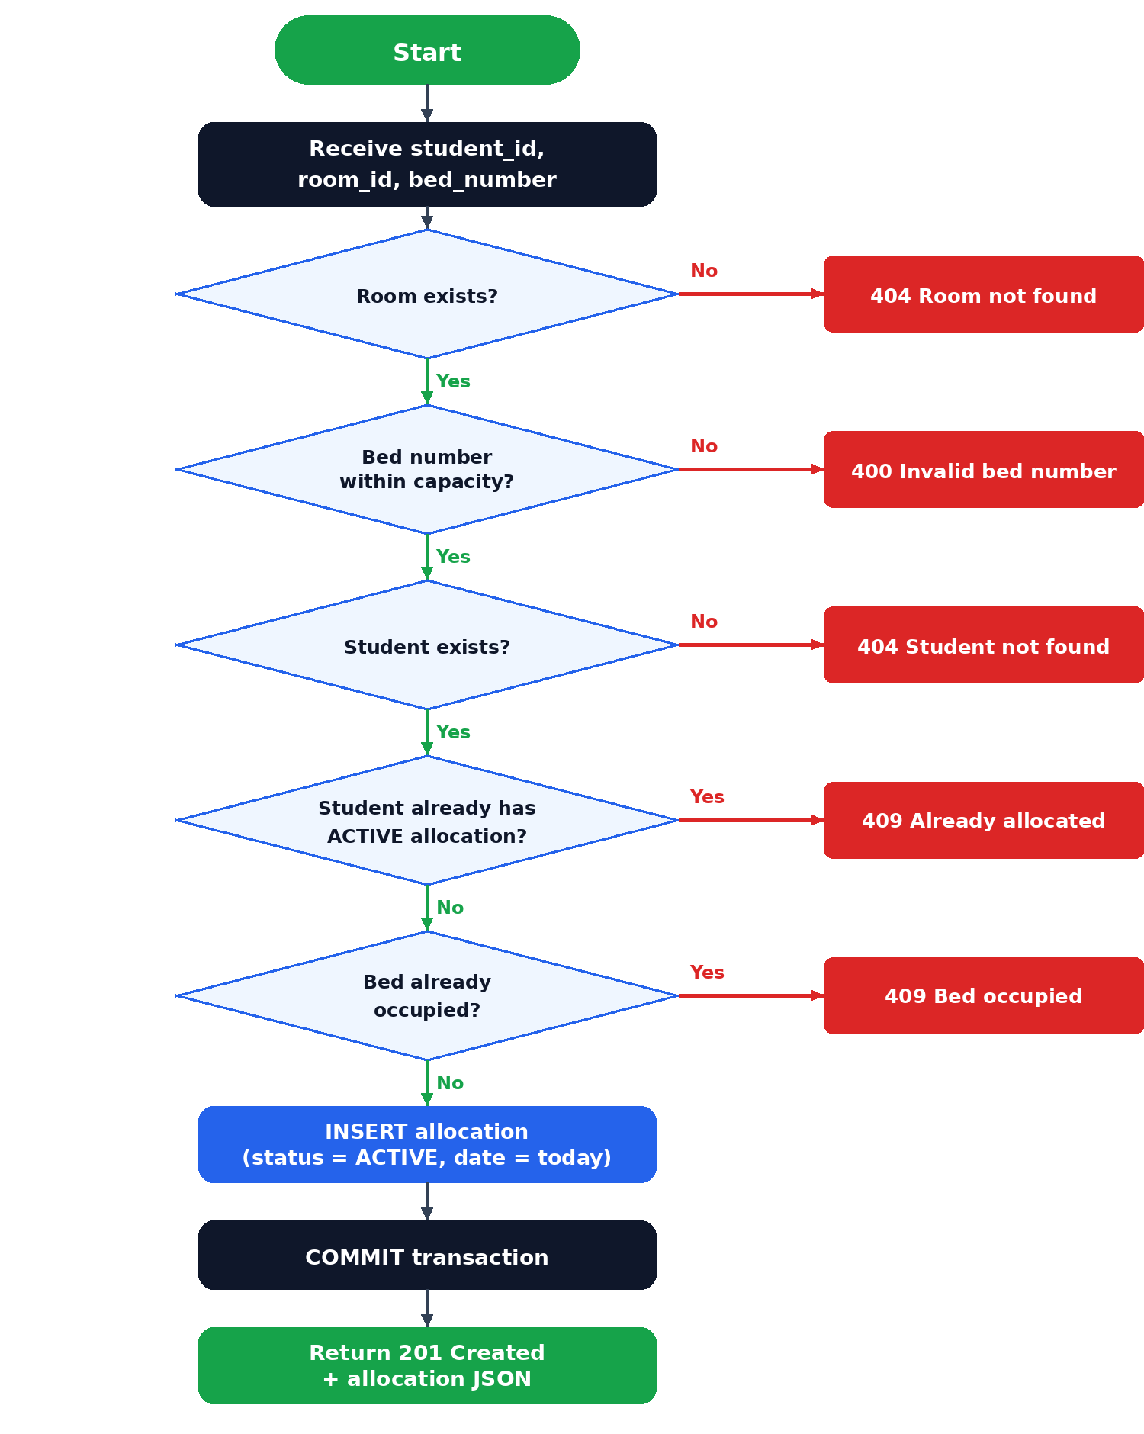
Figure 8: Flowchart of the bed allocation process
The transaction first locks the selected room row with SELECT ... FOR UPDATE. This makes concurrent requests for the same room wait for each other. It then validates the bed number against the room capacity, confirms that the student exists, checks that the student has no ACTIVE allocation, and checks that the requested bed has no ACTIVE allocation. Only if all checks succeed is the new row inserted with the current date and the status ACTIVE, followed by a commit. Every failed check rolls the transaction back and returns a specific message with HTTP 404, 400 or 409. As a last line of defence, an IntegrityError raised by the database is also caught and reported as a conflict.
The sequence of messages for one allocation request, from the click on the form to the refreshed screen, is shown in Figure 9.
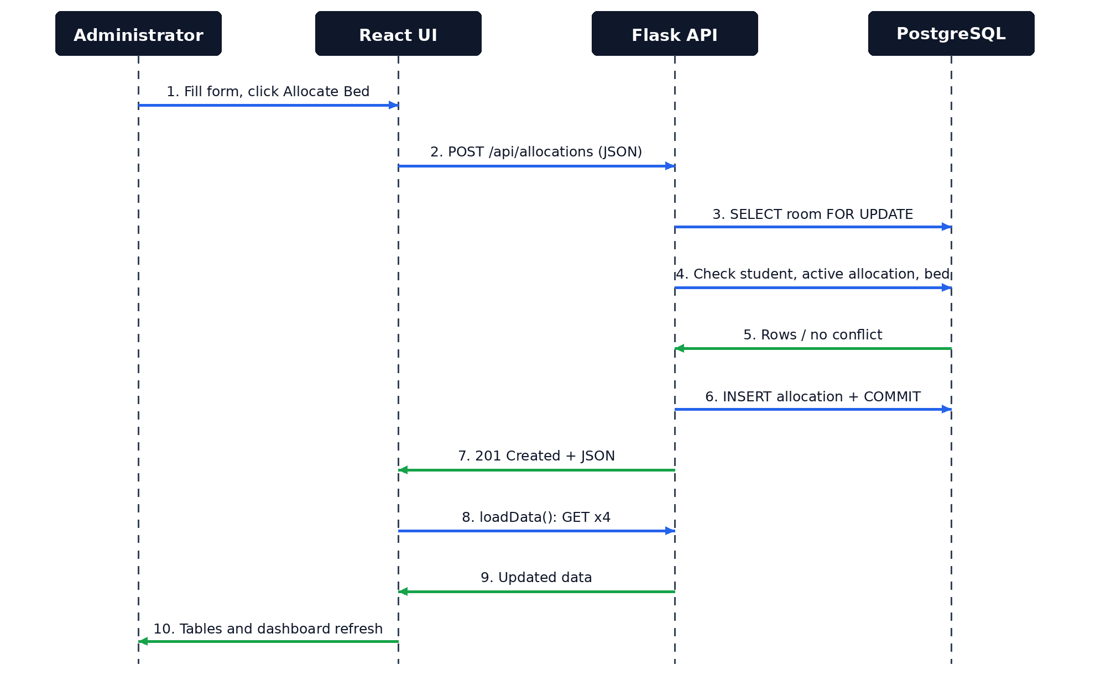
Figure 9: Sequence diagram of a bed allocation request
Cancelling an allocation is a single UPDATE statement that sets the status to CANCELLED where the allocation_id matches and the status is still ACTIVE. If no row is updated, the endpoint returns HTTP 404 with the message that no active allocation was found, so cancelling the same record twice is harmless. The HTTP status codes used by the API are summarised in Table 12.
Table 12: HTTP status codes used by the API
Code | Meaning | Used when
200 | OK | Data returned or allocation cancelled
201 | Created | Student or allocation created
400 | Bad request | Missing field or invalid bed number
404 | Not found | Room, student or active allocation not found; unknown endpoint
409 | Conflict | Duplicate student, student already allocated, bed occupied
500 | Server error | Unexpected database or server error

Transactions and ACID Properties
The allocation operation shows all four ACID properties. Atomicity: the checks and the insert belong to one transaction, which is rolled back if any check fails, so a half-completed allocation can never be stored. Consistency: the transaction moves the database from one valid state to another, because the rules on capacity, student and bed are verified before the row is inserted and the constraints verify them again. Isolation: the FOR UPDATE lock on the room row serialises concurrent allocations in the same room, so two requests cannot both see the same bed as free. Durability: after commit, PostgreSQL has written the change to its transaction log, so the allocation survives a restart.
psycopg2 starts a transaction automatically at the first statement and keeps it open until commit() or rollback() is called. The code therefore calls rollback() on every rejection path and commit() only after the insert has succeeded, and the connection is always closed in the finally block so that locks are released.
The life cycle of an allocation is simple and is shown in Figure 10. A new allocation is created in the ACTIVE state. The only allowed change is the cancellation, which moves it to CANCELLED. A cancelled record is never reactivated; a new allocation is created instead, which keeps the history complete.
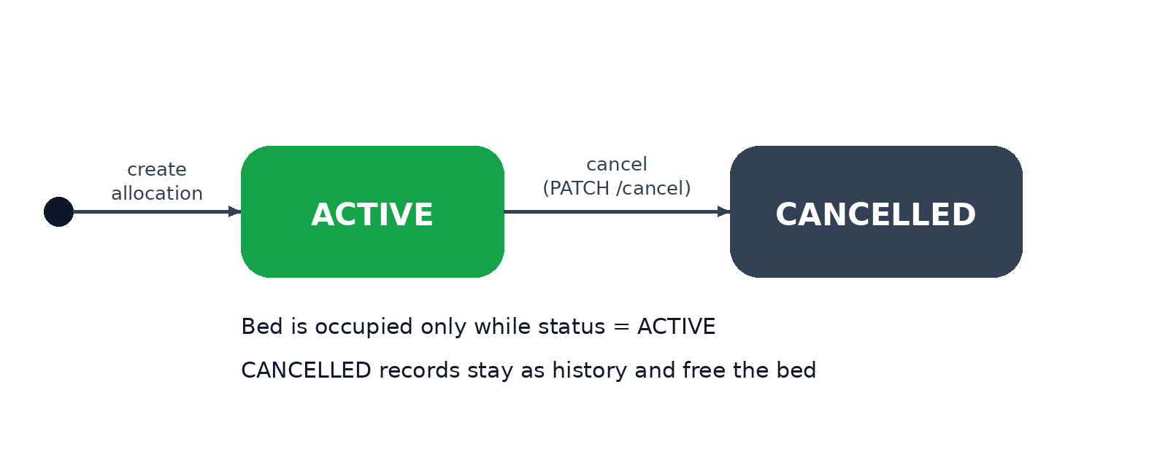
Figure 10: Life cycle (states) of an allocation record

Frontend Design
The frontend is a single-page application written with React function components and hooks. All screens are components rendered inside one layout that consists of a sidebar for navigation, a top bar with the page title, search box and avatar, and a content area. The selected page is stored in a state variable, so changing screens does not reload the browser.
The component hierarchy is shown in Figure 11. The App component owns the shared state (students, rooms, allocations, dashboard figures, search text, open modals, toast message and loading flag) and passes the data to the page components as props. Small reusable components such as Stat, PageHead, Field and Modal keep the code short and the appearance consistent.
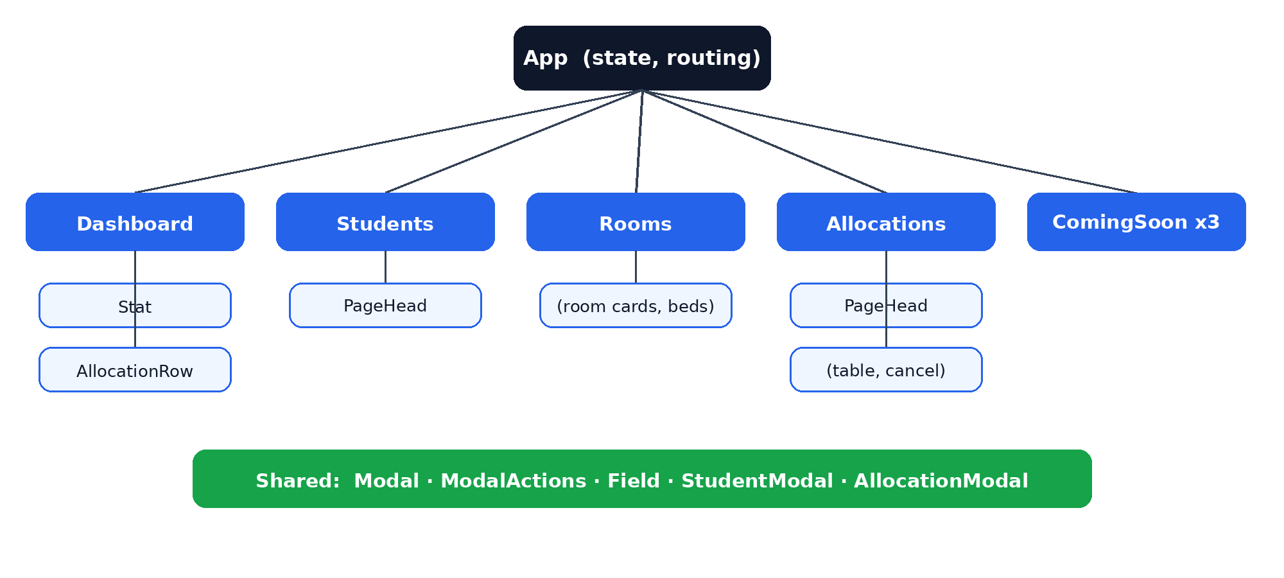
Figure 11: Component hierarchy of the React frontend
Data handling follows the pattern in Figure 12. When the application starts, a useEffect hook calls loadData(), which requests students, rooms, allocations and dashboard figures together using Promise.all. The database field names (for example student_id and room_number) are mapped to shorter frontend names (id and number) and stored with useState setters. User actions such as registering a student, allocating a bed or cancelling an allocation call a handler that sends a POST or PATCH request, shows a toast message and then calls loadData() again so that every screen shows the latest data.
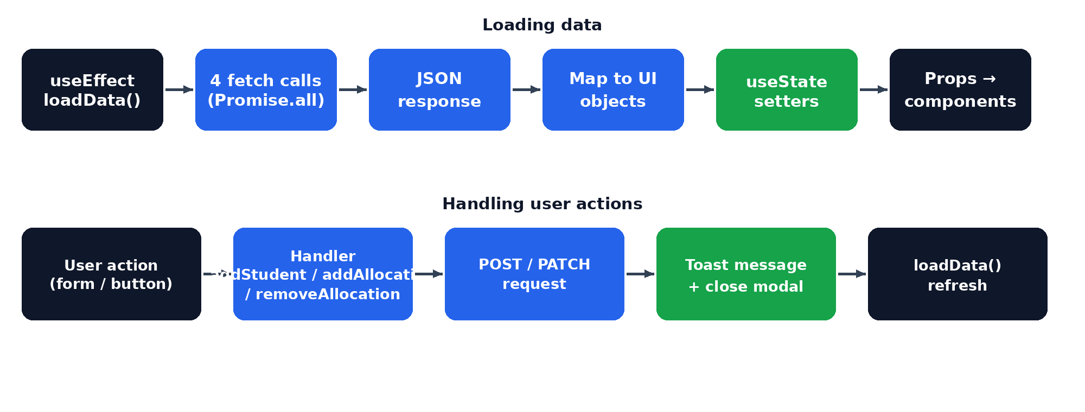
Figure 12: Data flow inside the frontend
The four implemented screens are described below.
• Dashboard: four statistic cards (total students, total rooms, active allocations, available beds), a table of recent allocations, occupancy progress bars for the first five rooms and quick-link buttons to the other modules.
• Students: a searchable table with roll number, name, gender, phone, email, department and year, and an Add Student button that opens a registration form.
• Rooms: summary tiles for occupied beds, available beds and total rooms, and a card for every room that draws each bed as occupied or free and labels the room Full or Available.
• Allocations: a searchable table of all allocation records with their status, a New Allocation form and a cancel button for active records.

The allocation form helps the user avoid mistakes. When a room is selected, the bed list is rebuilt from the room capacity, and beds that are already occupied are marked as occupied and disabled. A note under the form shows how many beds are free in the chosen room. The layout is responsive: on narrow screens the sidebar is hidden behind a menu button and opens as an overlay.

Frontend Components and State
Table 13 lists the React components of the application and their responsibilities, and Table 14 lists the state variables held by the App component. Keeping the shared state in one parent component makes the data flow predictable: data goes down as props and events go up as callback functions.
Table 13: React components
Component | Responsibility
App | Owns state, loads data, handles add / cancel actions, renders layout
Dashboard | Welcome banner, statistic cards, recent allocations, occupancy bars, quick links
Stat | One statistic card with icon, label, value and note
Students | Search bar and table of students
Rooms | Summary tiles and room cards with bed-level status
Allocations | Search bar, allocation table and cancel buttons
AllocationRow | One row of the recent allocations table
PageHead | Page title, subtitle and optional add button
ComingSoon | Placeholder page for planned modules
StudentModal | Registration form for a new student
AllocationModal | Form for student, room and bed selection
Field | Reusable input or select with label
Modal / ModalActions | Pop-up container and Cancel / Save buttons

Table 14: State variables in the App component
State variable | Type | Purpose
page | string | Name of the page currently displayed
students | array | Students loaded from the API
rooms | array | Rooms with occupied and available beds
allocations | array | All allocation records
dashboard | object | Totals from the dashboard endpoint
query | string | Text typed in the search boxes
sidebarOpen | boolean | Whether the mobile sidebar is open
studentModal, allocationModal | boolean | Whether each pop-up form is open
toast | string | Message shown for three seconds
loading | boolean | Shows the loading panel while data is fetched

User Interface Design Decisions
The interface was designed to be familiar to a hostel warden who is not a software specialist. The left sidebar uses clear words and icons for each module, the active page is highlighted in blue, and the page title and breadcrumb are always visible in the top bar. A consistent set of cards, tables, tags and buttons is used on all pages so that the user learns the interface once and can apply it everywhere.
Colour is used to carry meaning: green status labels for ACTIVE allocations and available rooms, red for full rooms and for the cancel action, and grey for cancelled records. Information that matters most for allocation, namely which beds are free, is presented visually in the room cards so that the administrator does not need to read a table. Immediate feedback is given by a toast message after every action, and a loading panel is displayed while data is being fetched, so that the user always knows what the system is doing.

Implementation of Key Parts
The following listings show the most important parts of the implementation in a shortened form. Listing 1 is the SQL schema that the application expects; Listing 2 is the core of the allocation endpoint; Listing 3 is the data-loading function of the frontend; Listing 4 is the room occupancy query.
Listing 1: PostgreSQL schema used by the application (representative DDL)
CREATE TABLE students (
student_id SERIAL PRIMARY KEY,
roll_no VARCHAR(20) UNIQUE NOT NULL,
name VARCHAR(100) NOT NULL,
gender VARCHAR(10) NOT NULL,
phone VARCHAR(15) UNIQUE NOT NULL,
email VARCHAR(100) UNIQUE NOT NULL,
department VARCHAR(50) NOT NULL,
year_of_study INT NOT NULL CHECK (year_of_study BETWEEN 1 AND 4)
);
CREATE TABLE rooms (
room_id SERIAL PRIMARY KEY,
room_number VARCHAR(10) UNIQUE NOT NULL,
floor_number INT NOT NULL,
capacity INT NOT NULL CHECK (capacity > 0),
room_type VARCHAR(20) NOT NULL
);
CREATE TABLE allocations (
allocation_id SERIAL PRIMARY KEY,
student_id INT NOT NULL REFERENCES students(student_id),
room_id INT NOT NULL REFERENCES rooms(room_id),
bed_number INT NOT NULL,
allocation_date DATE NOT NULL DEFAULT CURRENT_DATE,
status VARCHAR(10) NOT NULL DEFAULT 'ACTIVE'
CHECK (status IN ('ACTIVE','CANCELLED'))
);
-- one ACTIVE allocation per student and per bed
CREATE UNIQUE INDEX one_active_per_student
ON allocations(student_id) WHERE status = 'ACTIVE';
CREATE UNIQUE INDEX one_active_per_bed
ON allocations(room_id, bed_number) WHERE status = 'ACTIVE';
Listing 2: Core of the allocation endpoint (Flask, shortened)
@app.route("/api/allocations", methods=["POST"])
def create_allocation():
try:
data = request.get_json()
student_id = int(data["student_id"])
room_id = int(data["room_id"])
bed_number = int(data["bed_number"])
connection = get_connection()
cursor = connection.cursor(cursor_factory=RealDictCursor)
# lock the room so concurrent requests wait
cursor.execute("SELECT room_id, room_number, capacity FROM rooms "
"WHERE room_id = %s FOR UPDATE;", (room_id,))
room = cursor.fetchone()
if not room:
connection.rollback()
return jsonify({"success": False, "message": "Room not found"}), 404
if bed_number < 1 or bed_number > room["capacity"]:
connection.rollback()
return jsonify({"success": False,
"message": "Invalid bed number."}), 400
cursor.execute("SELECT student_id, name FROM students "
"WHERE student_id = %s;", (student_id,))
if not cursor.fetchone():
connection.rollback()
return jsonify({"success": False,
"message": "Student not found"}), 404
cursor.execute("SELECT allocation_id FROM allocations "
"WHERE student_id = %s AND status = 'ACTIVE' "
"FOR UPDATE;", (student_id,))
if cursor.fetchone():
connection.rollback()
return jsonify({"success": False, "message":
"Student already has an active allocation"}), 409
cursor.execute("SELECT allocation_id FROM allocations "
"WHERE room_id = %s AND bed_number = %s "
"AND status = 'ACTIVE' FOR UPDATE;",
(room_id, bed_number))
if cursor.fetchone():
connection.rollback()
return jsonify({"success": False,
"message": "Bed is already occupied"}), 409
cursor.execute("INSERT INTO allocations (student_id, room_id, "
"bed_number, allocation_date, status) "
"VALUES (%s, %s, %s, CURRENT_DATE, 'ACTIVE') "
"RETURNING *;", (student_id, room_id, bed_number))
allocation = cursor.fetchone()
connection.commit()
return jsonify({"success": True,
"message": "Bed allocated successfully",
"data": allocation}), 201
except IntegrityError as error:
connection.rollback()
return jsonify({"success": False,
"message": "Allocation conflict."}), 409
Listing 3: Data loading in the React frontend (shortened)
const loadData = async () => {
try {
setLoading(true);
const [s, r, a, d] = await Promise.all([
fetch(`${API_URL}/students`),
fetch(`${API_URL}/rooms`),
fetch(`${API_URL}/allocations`),
fetch(`${API_URL}/dashboard`)
]);
const students = await s.json();
const rooms = await r.json();
const allocations = await a.json();
const dashboard = await d.json();
setStudents(students.data.map(x => ({
id: x.student_id, roll: x.roll_no, name: x.name,
gender: x.gender, phone: x.phone, email: x.email,
dept: x.department, year: x.year_of_study })));
setRooms(rooms.data.map(x => ({
id: x.room_id, number: x.room_number, floor: x.floor_number,
capacity: x.capacity, type: x.room_type,
occupiedBeds: Number(x.occupied_beds || 0),
availableBeds: Number(x.available_beds || 0) })));
setAllocations(allocations.data.map(x => ({
id: x.allocation_id, studentId: x.student_id, roomId: x.room_id,
bed: x.bed_number, date: x.allocation_date, status: x.status })));
setDashboard(dashboard.data);
} catch (error) {
notify(`Backend connection error: ${error.message}`);
} finally {
setLoading(false);
}
};
useEffect(() => { loadData(); }, []);
Listing 4: Room occupancy query used by GET /api/rooms
SELECT r.room_id, r.room_number, r.floor_number,
r.capacity, r.room_type,
COUNT(a.allocation_id) FILTER (WHERE a.status = 'ACTIVE')
AS occupied_beds,
r.capacity - COUNT(a.allocation_id)
FILTER (WHERE a.status = 'ACTIVE') AS available_beds
FROM rooms r
LEFT JOIN allocations a ON r.room_id = a.room_id
GROUP BY r.room_id, r.room_number, r.floor_number,
r.capacity, r.room_type
ORDER BY r.room_id;

Security and Configuration
Database settings (host, port, name, user and password) are read from environment variables loaded with python-dotenv from a .env file, so that credentials are not written into the program logic. All SQL statements use placeholders instead of string concatenation, which protects against SQL injection. The .env file is excluded from version control through .gitignore. For a production deployment, authentication, restricted CORS origins and a production WSGI server would also be required, as listed in the future work.

EXPERIMENTS

Experimental Setup
The system was run and tested on a local development machine. The React frontend was started with npm run dev (Vite) and the Flask backend with python app.py, connected to a PostgreSQL database named hostel_management. Table 15 lists the environment.
Table 15: Experimental environment
Item | Details
Hardware | Laptop / desktop, 12 logical processors, 64-bit Windows
Operating system | Windows 11
Browser | Google Chrome (developer tools used for timing)
Frontend | React and Vite development server on port 5173
Backend | Python with Flask development server on port 5000
Database | PostgreSQL, database hostel_management
Tools | VS Code, Git and GitHub, browser Network tab

Test Data
Sample data was loaded to test every module realistically. It consists of five students, six rooms (four double rooms and two triple rooms, giving 14 beds) and five active allocations created through the application. Table 16 summarises the data.
Table 16: Sample data used in the experiments
Item | Count | Remarks
Students | 5 | Different names, departments and years
Rooms | 6 | 4 double rooms (2 beds) and 2 triple rooms (3 beds)
Total beds | 14 | Sum of room capacities
Active allocations | 5 | Rooms 101, 102 full; Room 103 has 1 of 3 beds used
Available beds | 9 | 14 beds minus 5 allocated

Table 17 lists the five allocations that exist in the sample data, as they appear in the Allocations page and in the Recent Allocations panel of the dashboard.
Table 17: Allocations in the sample data
Student | Room | Bed | Status
Rahul Kumar | 101 | Bed 1 | ACTIVE
Priya Sharma | 101 | Bed 2 | ACTIVE
Arjun Reddy | 102 | Bed 1 | ACTIVE
Sneha Rao | 102 | Bed 2 | ACTIVE
Kiran Kumar | 103 | Bed 1 | ACTIVE

Test Plan
Testing was functional (black-box). Each feature was exercised through the user interface, and the behaviour of the API was observed in the browser Network tab. Both valid inputs and invalid or conflicting inputs were used, because the correctness of an allocation system depends mainly on how it handles the invalid cases. Nine test cases were designed. For each one, the steps were performed, the expected result was written down in advance and the actual result was compared with it.
The test cases are described below.
• Test 1 – Health check: open /api/health. Expected: a success message showing that Flask and PostgreSQL are connected.
• Test 2 – Add student: fill the registration form with valid data and save. Expected: the student appears in the table and the total on the dashboard increases.
• Test 3 – Duplicate student: register a student with an existing roll number or email. Expected: the request is rejected with a conflict message (HTTP 409) and nothing is added.
• Test 4 – Allocate a free bed: choose a student without a bed, a room and a free bed. Expected: an ACTIVE allocation is created and the bed turns occupied in the Rooms page.
• Test 5 – Allocate an occupied bed: try to give an already occupied bed to another student. Expected: the request is blocked (HTTP 409); the form also shows the bed as disabled.
• Test 6 – Second bed for the same student: allocate a student who already has an active allocation. Expected: the request is blocked (HTTP 409).
• Test 7 – Invalid bed number: send a bed number larger than the room capacity directly to the API. Expected: rejection with HTTP 400 and a message stating the number of beds in the room.
• Test 8 – Cancel allocation: press the cancel button on an active allocation. Expected: the status changes to CANCELLED and the bed becomes available again.
• Test 9 – Dashboard and search: compare the dashboard figures with the tables and type text in the search boxes. Expected: counts are consistent and the lists are filtered as the user types.

Detailed Test Procedures
Table 18 gives the input and the steps used for each test case, so that the experiments can be repeated by anyone who has the sample data.
Table 18: Test procedures
No. | Steps and input | Expected outcome
1 | Open /api/health in the browser | success = true, database connected
2 | Students → Add Student; enter a new roll number, name, phone and email; Save | Student listed; dashboard total increases by 1
3 | Add Student with a roll number or email that already exists | 409 conflict message; table unchanged
4 | Allocations → New Allocation; select an unallocated student, Room 201, Bed 1; Allocate | 201 created; Room 201 shows 1 occupied bed
5 | Allocate another student to an occupied bed (request sent directly to the API) | 409; message that the bed is occupied
6 | Allocate a student who already has an ACTIVE allocation | 409; message that the student already has an allocation
7 | POST bed_number = 5 for a double room | 400; message that the room has 2 beds
8 | Allocations → cancel button on an ACTIVE record | Status CANCELLED; bed free; dashboard available beds + 1
9 | Compare dashboard counts with the lists; type a name in the search box | Counts consistent; list filtered while typing

API Request and Response Examples
The following examples show typical API exchanges observed during testing. The first is a successful allocation; the second is a rejected allocation of an occupied bed.
Listing 5: Successful allocation (POST /api/allocations)
Request body:
{ "student_id": 2, "room_id": 3, "bed_number": 2 }
Response (HTTP 201 Created):
{
"success": true,
"message": "Bed allocated successfully",
"data": {
"allocation_id": 6, "student_id": 2, "room_id": 3,
"bed_number": 2, "allocation_date": "2026-10-06",
"status": "ACTIVE"
}
}
Listing 6: Rejected allocation of an occupied bed
Request body:
{ "student_id": 4, "room_id": 1, "bed_number": 1 }
Response (HTTP 409 Conflict):
{
"success": false,
"message": "Bed 1 in Room 101 is already occupied"
}

Performance Measurement
Response times were observed in the Network tab of the browser for the main requests (loading the four data endpoints, registering a student, allocating a bed and cancelling an allocation). Because the system runs on the same machine as the database and the data set is small, the times are short, and they should be read as indicative values for a local environment rather than as a benchmark of a production deployment. The error rate was calculated as the number of test cases with an unexpected result divided by the number of test cases executed.

Frontend Verification
In addition to the functional tests, the frontend was checked visually. The Dashboard, Students, Rooms and Allocations pages were opened in turn, the sidebar navigation and the page titles were checked, the search boxes were used on the Students and Allocations pages, and the window was narrowed to confirm that the sidebar collapses behind the menu button. The loading panel, the toast messages for success and error, and the disabling of occupied beds in the allocation form were also confirmed. Figure 13 shows the dashboard of the working application with live data from the database.
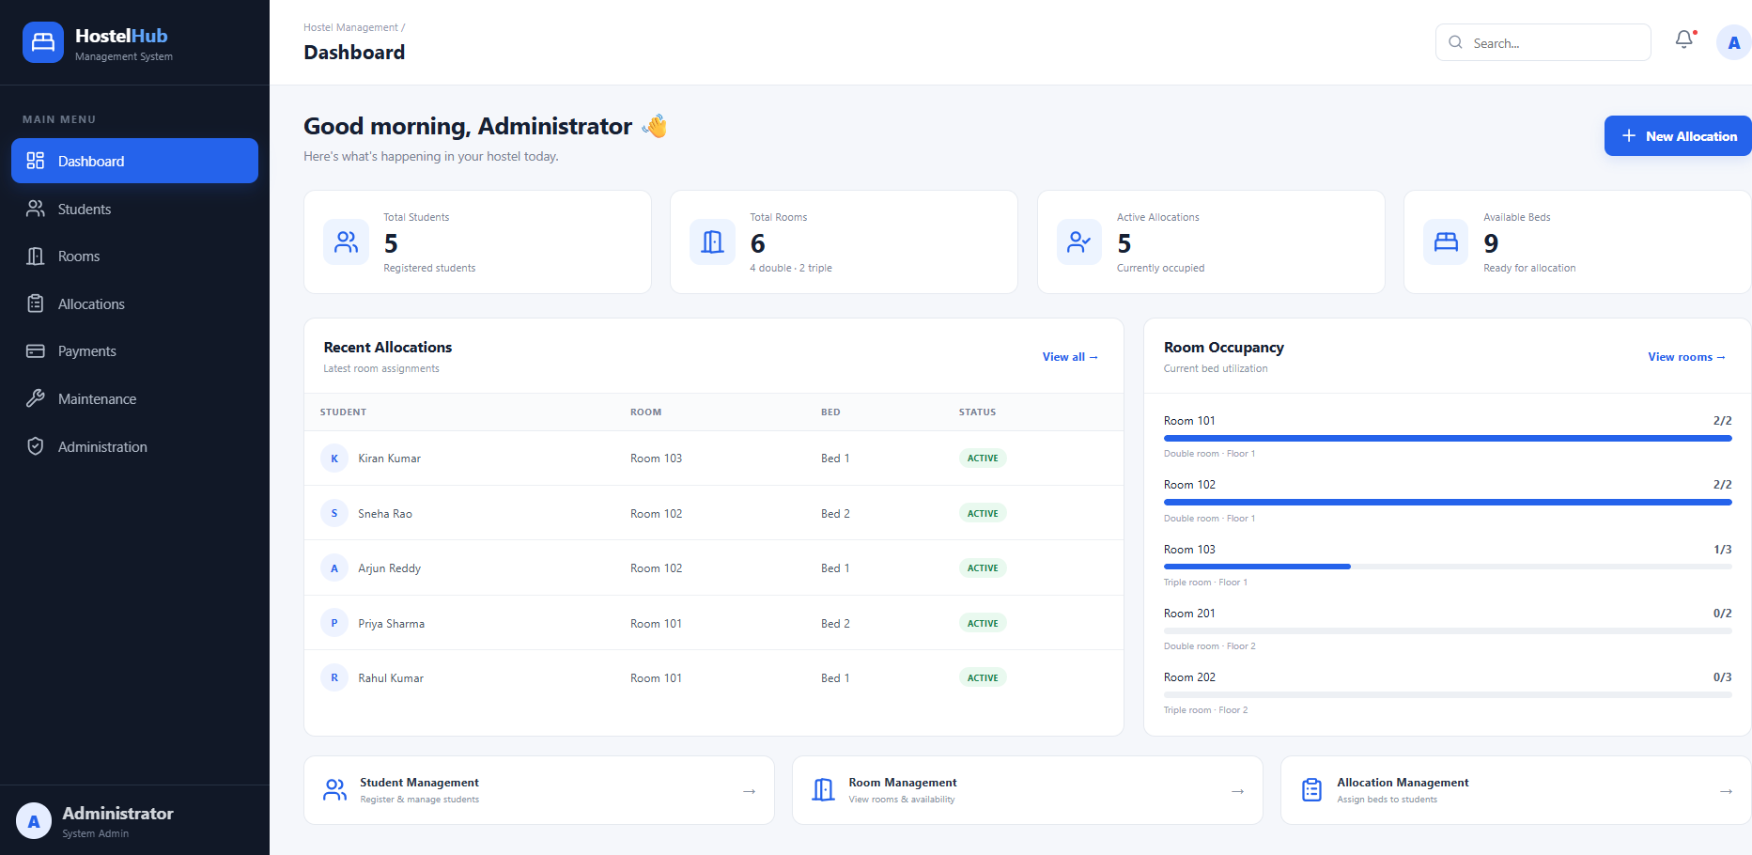
Figure 13: Dashboard showing students, rooms, active allocations, available beds, recent allocations and room occupancy
The Students page lists all registered students with search, the Rooms page shows each room as a card with its beds marked occupied or free, and the Allocations page lists every allocation with its status and a cancel button for active records.

RESULTS

Functional Results
The system behaved as expected in all nine test cases, as listed in Table 19. Valid operations succeeded, and every invalid operation was rejected with a clear message (HTTP 400, 404 or 409) without changing the database. In particular, the three conflict situations (duplicate student, second bed for one student and occupied bed) were stopped by the server even though the interface already discourages them, which confirms that the validation does not depend on the frontend alone.
Table 19: Functional test cases and results
Test Case | Expected Result | Actual Result | Status
Health check | Backend and DB connected | Connected | Pass
Add student | Record saved and listed | Added | Pass
Duplicate roll no./email | Rejected (409) | Rejected | Pass
Allocate free bed | Allocation created (ACTIVE) | Created | Pass
Allocate occupied bed | Blocked (409) | Blocked | Pass
Second bed for same student | Blocked (409) | Blocked | Pass
Invalid bed number | Rejected (400) | Rejected | Pass
Cancel allocation | Status CANCELLED, bed freed | Freed | Pass
Dashboard and search | Correct counts, filter works | Correct | Pass

Performance Results
Table 20 summarises the measurable results. All nine test cases passed, giving a 0% error rate and a 100% pass rate. The API responses were below 100 ms and the database queries below 50 ms in the local environment. The dashboard figures obtained from the database were consistent with the values shown in the tables.
Table 20: Performance and result summary
Metric | Result
Test cases executed | 9
Successful test cases | 9 (100%)
Error rate | 0%
API response time (local) | < 100 ms
Database response time (local) | < 50 ms
REST endpoints | 8
Students / Rooms | 5 / 6
Total beds / Allocated / Available | 14 / 5 / 9

Description of the Screens
Dashboard. The first screen after start-up shows a welcome banner with a New Allocation button, four statistic cards, the Recent Allocations table and the Room Occupancy panel (Figure 13). While the data is being fetched, a loading panel is shown instead of the cards. In the sample data the cards display 5 students, 6 rooms (4 double and 2 triple), 5 active allocations and 9 available beds.
Students page. A search box and a counter show how many students match the typed text. The table lists the roll number, the name with an initial avatar, gender, phone, email, department as a tag and the year of study. The Add Student button opens a pop-up form with seven fields; the required fields are validated by the browser and again by the server.
Rooms page. Three tiles at the top give the number of occupied beds, available beds and total rooms. Below them every room is a card with the room number, the floor and type, a Full or Available label, one icon for each bed (occupied beds are highlighted) and a footer with the counts of occupied and available beds.
Allocations page. All allocations are listed with a three-digit identifier, student, room, bed, allocation date and status. ACTIVE records are shown in green and have a cancel button; CANCELLED records are shown in grey without a button. The New Allocation form lists the students and rooms from the database and shows how many beds are still free in the selected room.
Placeholder pages. Payments, Maintenance and Administration display a Coming Soon page with a large icon and the note that the module is planned for the next implementation phase.

Occupancy Analysis
With 5 of the 14 beds allocated, the hostel occupancy in the sample data is about 36%, and 9 beds remain available (Figure 14). The dashboard presents the same information bed by bed, which a paper register cannot do without manual counting.
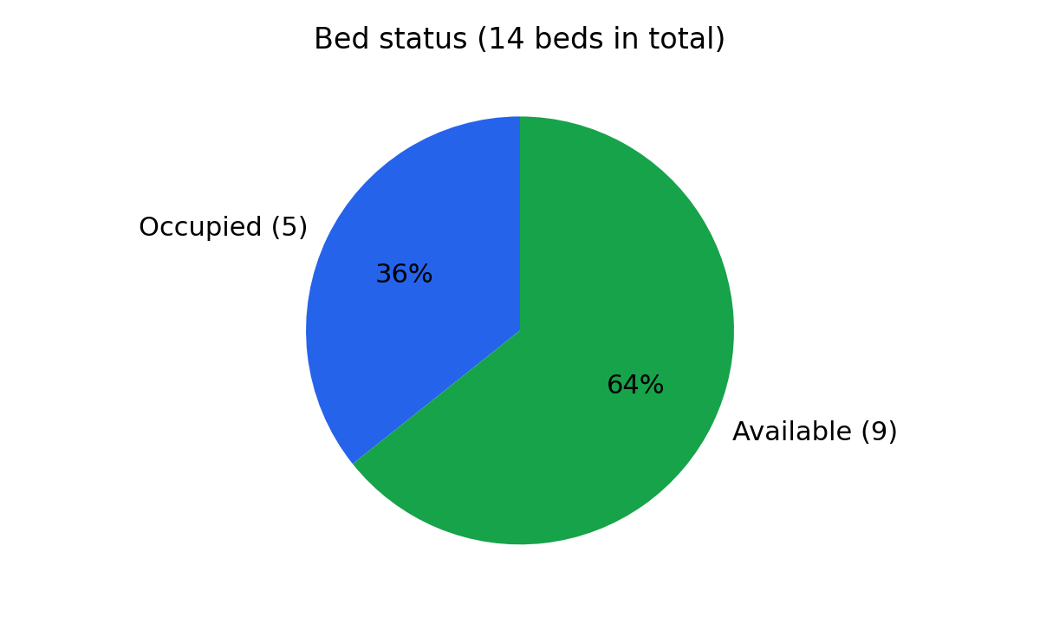
Figure 14: Share of occupied and available beds in the sample data
Figure 15 compares the capacity and the occupied beds of the first five rooms. Rooms 101 and 102 are full, Room 103 has one of its three beds in use, and Rooms 201 and 202 are empty. This view helps the warden to decide where the next students should be placed.
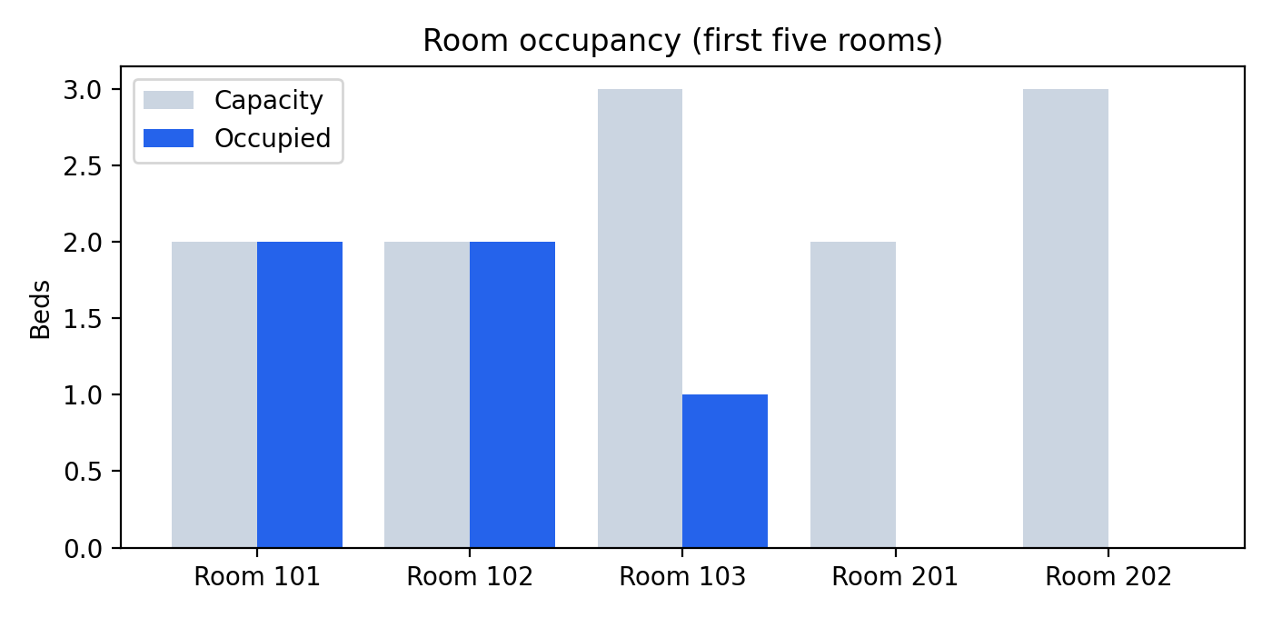
Figure 15: Capacity and occupied beds by room

Comparison with the Manual Process
Table 21 compares the common warden tasks in the manual process and in the developed system. The time and effort figures are qualitative: the manual process needs searching and cross-checking of records, while the system answers each question with one click or one search.
Table 21: Manual process versus the developed system
Task | Manual process | Hostel Management System
Find a free bed | Search pages or sheets | Open the Rooms page; free beds are shown
Allocate a bed | Write entry, check by hand | Select student, room and bed; checked automatically
Avoid double allocation | Depends on the warden | Enforced by the server
Find a student | Scan the register | Type in the search box
Free a bed | Edit or cross out entry | One click on cancel
Know total occupancy | Count manually | Dashboard shows it instantly

Discussion
The results show that moving the allocation rules from the person to the server is the most valuable part of the system. The row lock on the room, the checks on the student and on the bed, and the single transaction together guarantee that the data stays consistent. Keeping cancelled allocations in the table as history, instead of deleting them, preserves a record of past assignments and also simplified the availability queries, because only ACTIVE rows matter.
The separation between the React frontend and the Flask API also proved useful. The same API can be tested without the interface, and the interface can be changed without touching the database logic. The main limitations observed are the lack of authentication, the absence of edit and delete options for students and the use of the development servers, all of which are addressed in the future work.

Working Procedure (User Guide)
This section explains how an administrator uses the system once the backend and frontend are running.
• Start the system: run the Flask backend (python app.py) and the frontend (npm run dev), then open http://localhost:5173 in a browser. The dashboard loads automatically.
• Register a student: open Students, press Add Student, fill in the form and press Save Student. A confirmation message appears and the student is added to the table.
• Check room availability: open Rooms. Green Available labels mean that at least one bed is free; occupied beds are highlighted inside each room card.
• Allocate a bed: open Allocations, press New Allocation, choose the student, the room and a free bed, and press Allocate Bed. If the choice is not valid, the message from the server is shown and nothing is saved.
• Cancel an allocation: in the Allocations table press the cancel icon of an ACTIVE record. The record is marked CANCELLED and the bed is immediately available for another student.
• Search: type in the search box of the Students or Allocations page to filter the list instantly.

Challenges Faced and Solutions
Table 22 lists the main technical problems met during development and the way they were solved.
Table 22: Challenges and solutions
Challenge | Solution
Preventing two requests from taking the same bed | Lock the room row with FOR UPDATE and do all checks in one transaction
Browser blocking calls from port 5173 to port 5000 | Enable Flask-CORS for the /api routes
Different field names in database and frontend | Map every API row to a frontend object in loadData()
Showing occupied and available beds per room efficiently | One LEFT JOIN query with COUNT ... FILTER and GROUP BY
Keeping every screen up to date after a change | Call loadData() again after each add or cancel action
Keeping history without blocking reuse of a bed | Change status to CANCELLED instead of deleting, and test only ACTIVE rows

Lessons Learned
The team learned that correctness rules belong in the database and the backend, where every client is subject to them, and that the interface should only make the correct choice easy. We also learned the value of designing the tables and constraints first, because every later decision, from the API routes to the screens, followed from the structure of the three tables. Working with Git and GitHub taught the team to divide work between frontend and backend and to merge changes regularly.

CONCLUSION and FUTURE WORK

Conclusion
In this project we designed and implemented a Hostel Management System using React, Flask and PostgreSQL. The application registers students, shows room and bed availability, allocates and cancels beds, and summarises the hostel on a dashboard. Server-side validation, unique constraints and row locking ensure that no student holds two active beds and no bed is allocated twice. All nine test cases passed with a 0% error rate, so the project objectives were achieved.
The project gave the team practical experience in relational database design, SQL queries with joins and aggregation, transactions and locking, REST API design, component-based frontend development and the integration of the three tiers. It also showed the value of validating data on the server instead of trusting the interface.

Future Work
The following enhancements are planned for the next implementation phase.
• Authentication and roles: login for administrators and wardens with role-based access, password hashing and session or token handling.
• Payments module: hostel fee records, payment status, receipts and pending-fee reports linked to each student.
• Maintenance module: complaint registration and tracking for each room, with status updates and assignment to staff.
• Student management: edit and delete options, bulk upload from a spreadsheet and student profile pages.
• Room management: adding and editing rooms from the interface, and room transfer of a student in one step.
• Reports and export: occupancy and allocation reports exported as PDF or Excel.
• Notifications: email or SMS messages on allocation, cancellation and fee reminders.
• Deployment: hosting on a cloud server with a production WSGI server, HTTPS, restricted CORS origins and automated backups.

References
- Miguel Grinberg, Flask Web Development, 2nd ed., O'Reilly Media (2018).
- Flask Documentation, Pallets Projects. https://flask.palletsprojects.com
- PostgreSQL Global Development Group, PostgreSQL Documentation, including Explicit Locking. https://www.postgresql.org/docs
- Psycopg2 Documentation, "psycopg – PostgreSQL database adapter for Python". https://www.psycopg.org
- React Documentation, Meta Open Source. https://react.dev
- Vite Documentation, "Next Generation Frontend Tooling". https://vitejs.dev
- Lucide Icons Documentation, lucide-react package. https://lucide.dev
- MDN Web Docs, Fetch API and Cross-Origin Resource Sharing (CORS). https://developer.mozilla.org
- R. Fielding, Architectural Styles and the Design of Network-based Software Architectures, PhD dissertation, University of California, Irvine (2000).
- R. Fielding and J. Reschke, Hypertext Transfer Protocol (HTTP/1.1): Semantics and Content, RFC 7231, IETF (2014).
- R. Elmasri and S. Navathe, Fundamentals of Database Systems, 7th ed., Pearson (2016).
- A. Silberschatz, H. Korth and S. Sudarshan, Database System Concepts, 7th ed., McGraw-Hill (2019).
- R. Ramakrishnan and J. Gehrke, Database Management Systems, 3rd ed., McGraw-Hill (2003).
- I. Sommerville, Software Engineering, 10th ed., Pearson (2016).
- OWASP Foundation, SQL Injection Prevention Cheat Sheet. https://cheatsheetseries.owasp.org

Appendix A – Backend Source Code (app.py)
The complete Flask backend is listed below. Blank lines and decorative comments were removed to save space; the database password is read from the .env file and is not part of the source.
import os
import psycopg2
from psycopg2.extras import RealDictCursor
from psycopg2 import IntegrityError
from flask import Flask, jsonify, request
from flask_cors import CORS
from dotenv import load_dotenv
load_dotenv()
app = Flask(__name__)
CORS(app, resources={r"/api/*": {"origins": "*"}})
DB_CONFIG = {
"host": os.getenv("DB_HOST", "localhost"),
"port": os.getenv("DB_PORT", "5432"),
"database": os.getenv("DB_NAME", "hostel_management"),
"user": os.getenv("DB_USER", "postgres"),
"password": os.getenv("DB_PASSWORD") # set in the .env file
}
def get_connection():
return psycopg2.connect(**DB_CONFIG)
# ---------------- HEALTH CHECK ----------------
@app.route("/api/health", methods=["GET"])
def health_check():
try:
connection = get_connection()
cursor = connection.cursor()
cursor.execute("SELECT 1;")
cursor.fetchone()
cursor.close()
connection.close()
return jsonify({"success": True,
"message": "Flask backend and PostgreSQL are connected"})
except Exception as error:
return jsonify({"success": False,
"message": "Database connection failed",
"error": str(error)}), 500
# ---------------- DASHBOARD ----------------
@app.route("/api/dashboard", methods=["GET"])
def dashboard():
connection = None
cursor = None
try:
connection = get_connection()
cursor = connection.cursor(cursor_factory=RealDictCursor)
cursor.execute("""
SELECT
(SELECT COUNT(*) FROM students) AS total_students,
(SELECT COUNT(*) FROM rooms) AS total_rooms,
(SELECT COUNT(*) FROM allocations
WHERE status = 'ACTIVE') AS active_allocations,
(SELECT COALESCE(SUM(capacity), 0) FROM rooms)
- (SELECT COUNT(*) FROM allocations
WHERE status = 'ACTIVE') AS available_beds;
""")
result = cursor.fetchone()
return jsonify({"success": True, "data": result})
except Exception as error:
return jsonify({"success": False, "message": str(error)}), 500
finally:
if cursor:
cursor.close()
if connection:
connection.close()
# ---------------- GET ALL STUDENTS ----------------
@app.route("/api/students", methods=["GET"])
def get_students():
connection = None
cursor = None
try:
connection = get_connection()
cursor = connection.cursor(cursor_factory=RealDictCursor)
cursor.execute("""
SELECT student_id, roll_no, name, gender, phone,
email, department, year_of_study
FROM students
ORDER BY student_id;
""")
students = cursor.fetchall()
return jsonify({"success": True, "data": students})
except Exception as error:
return jsonify({"success": False, "message": str(error)}), 500
finally:
if cursor:
cursor.close()
if connection:
connection.close()
# ---------------- ADD STUDENT ----------------
@app.route("/api/students", methods=["POST"])
def add_student():
connection = None
cursor = None
try:
data = request.get_json()
required_fields = ["roll_no", "name", "gender", "phone",
"email", "department", "year_of_study"]
for field in required_fields:
if field not in data or str(data[field]).strip() == "":
return jsonify({"success": False,
"message": f"{field} is required"}), 400
connection = get_connection()
cursor = connection.cursor(cursor_factory=RealDictCursor)
cursor.execute("""
INSERT INTO students (roll_no, name, gender, phone,
email, department, year_of_study)
VALUES (%s, %s, %s, %s, %s, %s, %s)
RETURNING student_id, roll_no, name, gender, phone,
email, department, year_of_study;
""", (data["roll_no"], data["name"], data["gender"],
data["phone"], data["email"], data["department"],
int(data["year_of_study"])))
student = cursor.fetchone()
connection.commit()
return jsonify({"success": True,
"message": "Student added successfully",
"data": student}), 201
except IntegrityError as error:
if connection:
connection.rollback()
return jsonify({"success": False,
"message": "Student could not be added. Roll number, "
"phone or email may already exist.",
"error": str(error)}), 409
except Exception as error:
if connection:
connection.rollback()
return jsonify({"success": False, "message": str(error)}), 500
finally:
if cursor:
cursor.close()
if connection:
connection.close()
# ---------------- GET ALL ROOMS ----------------
@app.route("/api/rooms", methods=["GET"])
def get_rooms():
connection = None
cursor = None
try:
connection = get_connection()
cursor = connection.cursor(cursor_factory=RealDictCursor)
cursor.execute("""
SELECT r.room_id, r.room_number, r.floor_number,
r.capacity, r.room_type,
COUNT(a.allocation_id)
FILTER (WHERE a.status = 'ACTIVE') AS occupied_beds,
r.capacity - COUNT(a.allocation_id)
FILTER (WHERE a.status = 'ACTIVE') AS available_beds
FROM rooms r
LEFT JOIN allocations a ON r.room_id = a.room_id
GROUP BY r.room_id, r.room_number, r.floor_number,
r.capacity, r.room_type
ORDER BY r.room_id;
""")
rooms = cursor.fetchall()
return jsonify({"success": True, "data": rooms})
except Exception as error:
return jsonify({"success": False, "message": str(error)}), 500
finally:
if cursor:
cursor.close()
if connection:
connection.close()
# ---------------- GET ALL ALLOCATIONS ----------------
@app.route("/api/allocations", methods=["GET"])
def get_allocations():
connection = None
cursor = None
try:
connection = get_connection()
cursor = connection.cursor(cursor_factory=RealDictCursor)
cursor.execute("""
SELECT a.allocation_id, a.student_id, a.room_id,
a.bed_number, a.allocation_date, a.status,
s.roll_no, s.name AS student_name,
r.room_number, r.room_type
FROM allocations a
JOIN students s ON a.student_id = s.student_id
JOIN rooms r ON a.room_id = r.room_id
ORDER BY a.allocation_id;
""")
allocations = cursor.fetchall()
return jsonify({"success": True, "data": allocations})
except Exception as error:
return jsonify({"success": False, "message": str(error)}), 500
finally:
if cursor:
cursor.close()
if connection:
connection.close()
# ---------------- CREATE ROOM ALLOCATION ----------------
@app.route("/api/allocations", methods=["POST"])
def create_allocation():
connection = None
cursor = None
try:
data = request.get_json()
for field in ["student_id", "room_id", "bed_number"]:
if field not in data:
return jsonify({"success": False,
"message": f"{field} is required"}), 400
student_id = int(data["student_id"])
room_id = int(data["room_id"])
bed_number = int(data["bed_number"])
connection = get_connection()
cursor = connection.cursor(cursor_factory=RealDictCursor)
# lock the room
cursor.execute("""SELECT room_id, room_number, capacity
FROM rooms WHERE room_id = %s FOR UPDATE;""",
(room_id,))
room = cursor.fetchone()
if not room:
connection.rollback()
return jsonify({"success": False,
"message": "Room not found"}), 404
# validate bed number
if bed_number < 1 or bed_number > room["capacity"]:
connection.rollback()
return jsonify({"success": False, "message":
f"Invalid bed number. Room {room['room_number']} "
f"has {room['capacity']} beds."}), 400
# student exists?
cursor.execute("SELECT student_id, name FROM students "
"WHERE student_id = %s;", (student_id,))
if not cursor.fetchone():
connection.rollback()
return jsonify({"success": False,
"message": "Student not found"}), 404
# student already allocated?
cursor.execute("""SELECT allocation_id FROM allocations
WHERE student_id = %s AND status = 'ACTIVE'
FOR UPDATE;""", (student_id,))
if cursor.fetchone():
connection.rollback()
return jsonify({"success": False, "message":
"Student already has an active allocation"}), 409
# bed already occupied?
cursor.execute("""SELECT allocation_id FROM allocations
WHERE room_id = %s AND bed_number = %s
AND status = 'ACTIVE' FOR UPDATE;""",
(room_id, bed_number))
if cursor.fetchone():
connection.rollback()
return jsonify({"success": False, "message":
f"Bed {bed_number} in Room {room['room_number']} "
f"is already occupied"}), 409
# create allocation
cursor.execute("""
INSERT INTO allocations (student_id, room_id, bed_number,
allocation_date, status)
VALUES (%s, %s, %s, CURRENT_DATE, 'ACTIVE')
RETURNING allocation_id, student_id, room_id, bed_number,
allocation_date, status;
""", (student_id, room_id, bed_number))
allocation = cursor.fetchone()
connection.commit()
return jsonify({"success": True,
"message": "Bed allocated successfully",
"data": allocation}), 201
except IntegrityError as error:
if connection:
connection.rollback()
return jsonify({"success": False, "message":
"Allocation conflict. The student or bed may already "
"be allocated.", "error": str(error)}), 409
except Exception as error:
if connection:
connection.rollback()
return jsonify({"success": False, "message": str(error)}), 500
finally:
if cursor:
cursor.close()
if connection:
connection.close()
# ---------------- CANCEL ALLOCATION ----------------
@app.route("/api/allocations/<int:allocation_id>/cancel",
methods=["PATCH"])
def cancel_allocation(allocation_id):
connection = None
cursor = None
try:
connection = get_connection()
cursor = connection.cursor(cursor_factory=RealDictCursor)
cursor.execute("""
UPDATE allocations SET status = 'CANCELLED'
WHERE allocation_id = %s AND status = 'ACTIVE'
RETURNING allocation_id, student_id, room_id, bed_number,
allocation_date, status;
""", (allocation_id,))
allocation = cursor.fetchone()
if not allocation:
connection.rollback()
return jsonify({"success": False,
"message": "Active allocation not found"}), 404
connection.commit()
return jsonify({"success": True,
"message": "Allocation cancelled successfully",
"data": allocation})
except Exception as error:
if connection:
connection.rollback()
return jsonify({"success": False, "message": str(error)}), 500
finally:
if cursor:
cursor.close()
if connection:
connection.close()
# ---------------- ROOT, ERROR HANDLER, SERVER ----------------
@app.route("/", methods=["GET"])
def home():
return jsonify({"application": "Hostel Management System",
"backend": "Flask REST API", "database": "PostgreSQL",
"status": "running"})
@app.errorhandler(404)
def not_found(error):
return jsonify({"success": False,
"message": "API endpoint not found"}), 404
if __name__ == "__main__":
host = os.getenv("FLASK_HOST", "127.0.0.1")
port = int(os.getenv("FLASK_PORT", "5000"))
app.run(host=host, port=port, debug=True)

Appendix B – Frontend Source Code (React, shortened)
The frontend consists of one main file, App.jsx, with the components described in Table 17. The most important parts are listed below: the action handlers of the App component, the allocation form, the room cards, the dashboard, the student and allocation pages and the reusable form components.
Listing B1: Action handlers in App.jsx
// ---- action handlers in App ----
const addStudent = async (student) => {
try {
const response = await fetch(`${API_URL}/students`, {
method: "POST",
headers: { "Content-Type": "application/json" },
body: JSON.stringify({
roll_no: student.roll, name: student.name,
gender: student.gender, phone: student.phone,
email: student.email, department: student.dept,
year_of_study: Number(student.year) })
});
const result = await response.json();
if (!response.ok || !result.success)
throw new Error(result.message || "Unable to add student");
setStudentModal(false);
notify("Student added successfully");
await loadData();
} catch (error) { notify(error.message); }
};
const addAllocation = async (data) => {
try {
const response = await fetch(`${API_URL}/allocations`, {
method: "POST",
headers: { "Content-Type": "application/json" },
body: JSON.stringify({ student_id: Number(data.studentId),
room_id: Number(data.roomId), bed_number: Number(data.bed) })
});
const result = await response.json();
if (!response.ok || !result.success)
throw new Error(result.message || "Unable to allocate bed");
setAllocationModal(false);
notify("Bed allocated successfully");
await loadData();
} catch (error) { notify(error.message); }
};
const removeAllocation = async (id) => {
try {
const response = await fetch(`${API_URL}/allocations/${id}/cancel`,
{ method: "PATCH" });
const result = await response.json();
if (!response.ok || !result.success)
throw new Error(result.message || "Unable to cancel allocation");
notify("Allocation cancelled");
await loadData();
} catch (error) { notify(error.message); }
};
const notify = (message) => {
setToast(message);
setTimeout(() => setToast(""), 3000);
};
const nav = (name) => {
setPage(name); setQuery(""); setSidebarOpen(false);
};
const activeAllocations =
allocations.filter(a => a.status === "ACTIVE");
Listing B2: AllocationModal component
function AllocationModal({ students, rooms, allocations,
onClose, onSave }) {
const [form, setForm] = useState({
studentId: students[0]?.id || "",
roomId: rooms[0]?.id || "",
bed: 1 });
const room = rooms.find(r => r.id === Number(form.roomId));
const occupied = allocations
.filter(a => a.roomId === Number(form.roomId))
.map(a => a.bed);
return (
<Modal title="New Room Allocation" onClose={onClose}>
<form onSubmit={e => { e.preventDefault(); onSave(form); }}>
<div className="form-grid">
<Field label="Student" name="studentId" select
value={form.studentId}
onChange={e => setForm({...form, studentId: e.target.value})}
options={students.map(s => ({ value: s.id,
label: `${s.roll} — ${s.name}` }))} />
<Field label="Room" name="roomId" select
value={form.roomId}
onChange={e => setForm({...form,
roomId: e.target.value, bed: 1})}
options={rooms.map(r => ({ value: r.id,
label: `Room ${r.number} — ${r.type}` }))} />
<Field label="Bed Number" name="bed" select
value={form.bed}
onChange={e => setForm({...form, bed: e.target.value})}
options={Array.from({ length: room?.capacity || 1 },
(_, i) => ({ value: i + 1,
label: `Bed ${i + 1}` +
(occupied.includes(i + 1) ? " — Occupied" : ""),
disabled: occupied.includes(i + 1) }))} />
</div>
<div className="availability-note">
{room ? `${room.capacity - occupied.length} bed(s) available`
+ ` in Room ${room.number}` : ""}
</div>
<ModalActions onClose={onClose} save="Allocate Bed" />
</form>
</Modal>
);
}
Listing B3: Rooms component
function Rooms({ rooms, allocations }) {
const active = allocations.filter(a => a.status === "ACTIVE");
const totalBeds = rooms.reduce((sum, r) => sum + r.capacity, 0);
const availableBeds = totalBeds - active.length;
return (
<div>
<PageHead title="Room Management"
subtitle="Monitor room capacity and bed availability." />
<div className="room-summary"> ... occupied / available / total ... </div>
<div className="rooms-grid">
{rooms.map(room => {
const used = active.filter(a => a.roomId === room.id).length;
const free = room.capacity - used;
return (
<div className="room-card" key={room.id}>
<div className="room-top">
<div className="room-number">Room {room.number}</div>
<span className={`status ${free === 0 ? "danger" : "success"}`}>
{free === 0 ? "Full" : "Available"}
</span>
</div>
<p>Floor {room.floor} · {room.type} room</p>
<div className="beds">
{Array.from({ length: room.capacity }).map((_, i) => {
const occupied = active.some(a =>
a.roomId === room.id && a.bed === i + 1);
return (
<div key={i} className={`bed ${occupied ? "occupied" : ""}`}>
<BedDouble size={17} /><small>Bed {i + 1}</small>
</div>);
})}
</div>
<div className="room-bottom">
<span>{used} occupied</span><b>{free} available</b>
</div>
</div>);
})}
</div>
</div>
);
}
Listing B4: Dashboard and Stat components
function Dashboard({ students, rooms, allocations,
availableBeds, nav, loading }) {
const recent = allocations.slice(-5).reverse();
return (
<div>
<div className="welcome">
<div><h2>Good morning, Administrator</h2>
<p>Here's what's happening in your hostel today.</p></div>
<button className="primary" onClick={() => nav("Allocations")}>
<Plus size={18} /> New Allocation</button>
</div>
{loading ? <div className="panel loading-panel">
Loading hostel data...</div> : (<>
<div className="stats">
<Stat icon={<Users />} label="Total Students"
value={students.length} note="Registered students" />
<Stat icon={<DoorOpen />} label="Total Rooms"
value={rooms.length}
note={`${rooms.filter(r => r.type === "Double").length} double`
+ ` · ${rooms.filter(r => r.type === "Triple").length} triple`} />
<Stat icon={<UserCheck />} label="Active Allocations"
value={allocations.length} note="Currently occupied" />
<Stat icon={<BedDouble />} label="Available Beds"
value={availableBeds} note="Ready for allocation" />
</div>
<div className="grid-2">
<div className="panel"> ... Recent Allocations table:
{recent.map(a => <AllocationRow key={a.id} a={a}
students={students} rooms={rooms} />)} </div>
<div className="panel"> ... Room Occupancy:
{rooms.slice(0, 5).map(room => {
const used = allocations.filter(a => a.roomId === room.id).length;
const pct = room.capacity > 0
? Math.round(used / room.capacity * 100) : 0;
return (<div className="occ" key={room.id}>
<div className="occ-top"><span>Room {room.number}</span>
<b>{used}/{room.capacity}</b></div>
<div className="progress">
<span style={{ width: `${pct}%` }} /></div>
<small>{room.type} room · Floor {room.floor}</small>
</div>);
})} </div>
</div>
</>)}
</div>
);
}
function Stat({ icon, label, value, note }) {
return (<div className="stat">
<div className="stat-icon">{icon}</div>
<div><small>{label}</small><strong>{value}</strong>
<span>{note}</span></div>
</div>);
}
Listing B5: Students and Allocations pages
function Students({ students, query, setQuery, onAdd }) {
const filtered = students.filter(s =>
Object.values(s).join(" ").toLowerCase()
.includes(query.toLowerCase()));
return (
<div>
<PageHead title="Student Management"
subtitle="Register, view and manage hostel students."
button="Add Student" onClick={onAdd} />
<div className="filterbar">
<div className="table-search"><Search size={17} />
<input placeholder="Search by name, roll number, department..."
value={query} onChange={e => setQuery(e.target.value)} />
</div>
<span>{filtered.length} students</span>
</div>
<div className="panel"><div className="table-wrap"><table>
<thead><tr><th>Roll No.</th><th>Student</th><th>Gender</th>
<th>Phone</th><th>Email</th><th>Department</th>
<th>Year</th><th>Action</th></tr></thead>
<tbody>{filtered.map(s => (
<tr key={s.id}>
<td><b>{s.roll}</b></td>
<td><div className="person">
<div className="person-avatar">{s.name[0]}</div>
<span>{s.name}</span></div></td>
<td>{s.gender}</td><td>{s.phone}</td><td>{s.email}</td>
<td><span className="tag">{s.dept}</span></td>
<td>Year {s.year}</td>
<td><button className="row-btn"><Pencil size={15} /></button></td>
</tr>))}</tbody>
</table></div></div>
</div>
);
}
function Allocations({ students, rooms, allocations, query,
setQuery, onAdd, onCancel }) {
const filtered = allocations.filter(a => {
const s = students.find(x => x.id === a.studentId);
const r = rooms.find(x => x.id === a.roomId);
return `${a.id} ${s?.name || ""} ${r?.number || ""} ${a.status}`
.toLowerCase().includes(query.toLowerCase());
});
return (
<div>
<PageHead title="Room & Bed Allocation"
subtitle="Assign and track hostel beds for students."
button="New Allocation" onClick={onAdd} />
... search bar ...
<table> ... {filtered.map(a => {
const s = students.find(x => x.id === a.studentId);
const r = rooms.find(x => x.id === a.roomId);
return (<tr key={a.id}>
<td>#{String(a.id).padStart(3, "0")}</td>
<td>{s?.name}</td><td><b>Room {r?.number}</b></td>
<td><span className="bed-pill">Bed {a.bed}</span></td>
<td>{a.date}</td>
<td><span className={`status ${a.status === "ACTIVE"
? "success" : "muted"}`}>{a.status}</span></td>
<td>{a.status === "ACTIVE" &&
<button className="row-btn danger-btn" title="Cancel"
onClick={() => onCancel(a.id)}>
<LogOut size={15} /></button>}</td>
</tr>);
})} </table>
</div>
);
}
Listing B6: StudentModal, Field, Modal and ModalActions
function StudentModal({ onClose, onSave }) {
const [form, setForm] = useState({ roll: "", name: "",
gender: "Male", phone: "", email: "", dept: "AI & DS", year: 2 });
const change = e =>
setForm({ ...form, [e.target.name]: e.target.value });
return (
<Modal title="Register Student" onClose={onClose}>
<form onSubmit={e => { e.preventDefault(); onSave(form); }}>
<div className="form-grid">
<Field label="Roll Number" name="roll" value={form.roll}
onChange={change} required />
<Field label="Full Name" name="name" value={form.name}
onChange={change} required />
<Field label="Gender" name="gender" value={form.gender}
onChange={change} select options={["Male", "Female"]} />
<Field label="Phone" name="phone" value={form.phone}
onChange={change} required />
<Field label="Email" name="email" value={form.email}
onChange={change} type="email" required />
<Field label="Department" name="dept" value={form.dept}
onChange={change} select
options={["AI & DS", "CSE", "ECE", "EEE", "Mechanical"]} />
<Field label="Year of Study" name="year" value={form.year}
onChange={change} select options={[1, 2, 3, 4]} />
</div>
<ModalActions onClose={onClose} save="Save Student" />
</form>
</Modal>
);
}
function Field({ label, name, value, onChange, type = "text",
select, options = [], required }) {
return (
<label className="field">
<span>{label}</span>
{select ? (
<select name={name} value={value} onChange={onChange}>
{options.map(o => typeof o === "object"
? <option key={o.value} value={o.value}
disabled={o.disabled}>{o.label}</option>
: <option key={o} value={o}>{o}</option>)}
</select>
) : (
<input type={type} name={name} value={value}
onChange={onChange} required={required} />
)}
</label>
);
}
function Modal({ title, onClose, children }) {
return (
<div className="modal-backdrop"><div className="modal">
<div className="modal-head"><h3>{title}</h3>
<button onClick={onClose}><X /></button></div>
{children}
</div></div>
);
}
function ModalActions({ onClose, save = "Save Student" }) {
return (
<div className="modal-actions">
<button type="button" className="secondary"
onClick={onClose}>Cancel</button>
<button type="submit" className="primary">{save}</button>
</div>
);
}

Appendix C – Installation and Execution Guide
The following steps start the complete system on a new computer.
• Install Python 3, Node.js and PostgreSQL.
• Create a database named hostel_management and run the schema of Listing 1; insert the rooms (and, if desired, sample students).
• Create a .env file in the backend folder with the entries shown in Listing C1.
• In the backend folder install the packages (Flask, Flask-CORS, psycopg2 and python-dotenv) with pip and start the server with python app.py. The API is then available at http://127.0.0.1:5000.
• In the frontend folder run npm install and then npm run dev. Open http://localhost:5173 in the browser.
• Open http://127.0.0.1:5000/api/health to confirm that Flask and PostgreSQL are connected.

Listing C1: Example .env file (use your own values)
DB_HOST=localhost
DB_PORT=5432
DB_NAME=hostel_management
DB_USER=postgres
DB_PASSWORD=<your database password>
FLASK_HOST=127.0.0.1
FLASK_PORT=5000
Listing C2: Dependencies in package.json (frontend)
{
"name": "hostel-management-frontend",
"private": true,
"version": "1.0.0",
"type": "module",
"scripts": { "dev": "vite", "build": "vite build", "preview": "vite preview" },
"dependencies": {
"@vitejs/plugin-react": "latest",
"vite": "latest",
"react": "latest",
"react-dom": "latest",
"lucide-react": "latest"
}
}

Appendix D – API Test Commands
The API can be tested without the frontend, for example with curl. The commands below correspond to the test cases of Section 3.
Listing D1: curl commands for API testing
# Test 1 - health check
curl http://127.0.0.1:5000/api/health
# Dashboard figures
curl http://127.0.0.1:5000/api/dashboard
# Lists
curl http://127.0.0.1:5000/api/students
curl http://127.0.0.1:5000/api/rooms
curl http://127.0.0.1:5000/api/allocations
# Test 2 - add a student
curl -X POST http://127.0.0.1:5000/api/students \
-H "Content-Type: application/json" \
-d '{"roll_no":"2510080099","name":"Test Student","gender":"Male",
"phone":"9000000000","email":"test@example.com",
"department":"AI & DS","year_of_study":2}'
# Test 4 - allocate a bed
curl -X POST http://127.0.0.1:5000/api/allocations \
-H "Content-Type: application/json" \
-d '{"student_id":2,"room_id":4,"bed_number":1}'
# Test 7 - invalid bed number (expect HTTP 400)
curl -X POST http://127.0.0.1:5000/api/allocations \
-H "Content-Type: application/json" \
-d '{"student_id":2,"room_id":4,"bed_number":5}'
# Test 8 - cancel an allocation
curl -X PATCH http://127.0.0.1:5000/api/allocations/1/cancel

Appendix E – Glossary
Table 23: Glossary of terms and abbreviations
Term | Meaning
API | Application Programming Interface: the set of routes through which the frontend talks to the backend
REST | Representational State Transfer: an API style that uses HTTP methods on resource URLs
JSON | JavaScript Object Notation: the text format of API requests and responses
SPA | Single-page application: a web app that changes screens without reloading the page
CORS | Cross-Origin Resource Sharing: browser rule that must allow calls between different ports or sites
CRUD | Create, read, update and delete operations on data
DDL | Data definition language: SQL that creates tables and constraints
ACID | Atomicity, consistency, isolation, durability: properties of reliable transactions
ER diagram | Entity-relationship diagram showing tables and their relationships
DFD | Data flow diagram showing how data moves between processes and stores
Hook | A React function such as useState or useEffect that adds state or effects to a component
Toast | A short message that appears on screen and disappears after a few seconds

