Chat Message Search System
A Project Based Learning Report Submitted in partial fulfilment of the requirements for the award of the degree

of

Bachelor of Technology
in The Department of Artificial Intelligence and Data Science (AI&DS)
25CS2103E – DATA STRUCTURES AND ALGORITHMS - 3

Submitted by
2510080055 : Akshay Chandra
2510080052 : Manoj
2510080051 : Pranith Reddy
2510080046 : Balaji
2510080053 : Sai Charan

Under the guidance of
Anitha P



Department of Artificial Intelligence and Data Science
Koneru Lakshmaiah Education Foundation, Aziz Nagar
Aziz Nagar – 500075
OCT - 2026.
Abstract
Messaging applications accumulate thousands of messages, and locating a particular word or phrase in a long conversation history depends directly on the efficiency of the string-matching algorithm that is used. A naive linear scan is expensive and does not scale as the history grows. This project, the Chat Message Search System, implements five classical string-matching algorithms (Naive, Knuth–Morris–Pratt, Rabin–Karp, Z Algorithm and Aho–Corasick) from scratch in Java and benchmarks them on the same chat message dataset. Every message is stored as an object holding a unique ID, sender, timestamp and content. The user enters a keyword or phrase and either selects one algorithm or chooses "Compare All"; the system scans the messages, returns each matching message with its sender, timestamp and match position, and reports the number of character comparisons and the execution time in milliseconds for every algorithm. The results of the five algorithms are cross-validated, and metrics are reported only when all of them return identical match sets. For the pattern "machine", all five algorithms found the same two matching messages. Rabin–Karp needed the fewest comparisons (17) and KMP was the fastest (0.1278 ms), whereas the Z Algorithm (24.1979 ms) and Aho–Corasick (4.5574 ms) showed visible overhead. The study shows that fewer comparisons do not always mean less time, and it connects theoretical data structures and algorithms concepts with a practical text-search application.
Keywords: String matching, Chat message search, Naive, KMP, Rabin–Karp, Z Algorithm, Aho–Corasick, Java, Performance comparison

List of Figures
Fig. 1. Architecture of the Chat Message Search System. 8
Fig. 2. Workflow of the search and comparison process. 8
Fig. 3. Aho–Corasick trie with failure links for the example patterns {he, she, his, hers}. 9
Fig. 4. Output screen of the "Compare All Algorithms" option for the pattern "machine". 12
Fig. 5. Comparisons (a) and execution time (b) of the five algorithms for the pattern "machine". 12

List of Tables
TABLE I. Summary of Related Work 7
TABLE II. LPS Array for the Example Pattern "abcabd" 9
TABLE III. Comparison of the Five Algorithms 10
TABLE IV. Tools, Technologies and Requirements 10
TABLE V. Modules of the System 10
TABLE VI. Performance of the Algorithms for the Pattern "machine" 12
TABLE VII. Guidance on Choosing an Algorithm 13
TABLE VIII. Test Cases 13
TABLE IX. Challenges and Solutions 14

Table of Contents
I. Introduction 6
A. Need for the Project 6
B. Problem Statement 6
C. Objectives 6
D. Scope and Organisation of the Report 6
II. Literature Review 7
III. Proposed System 7
A. Overview and Features 7
B. System Architecture 7
IV. Methodology 8
A. Workflow 8
B. Preprocessing 8
C. String-Matching Algorithms 9
D. Complexity Comparison 9
E. Choice of Evaluation Metrics 10
V. Tools and Technologies 10
VI. Implementation 10
A. Modules 10
B. Working Process 10
C. User Interface 10
D. Measurement of Metrics 11
E. Validation and Output 11
VII. Experiments 11
A. Experimental Setup 11
B. Procedure 11
VIII. Results 12
A. Observations 12
B. Discussion 13
C. Choosing an Algorithm 13
IX. Testing 13
A. Edge Cases Considered 14
X. Advantages and Applications 14
A. Advantages 14
B. Applications 14
XI. Challenges Faced 14
XII. Conclusion and Future Work 14
References 15

Chat Message Search System
Efficient String Pattern Matching in Chat Messages

Introduction
Instant messaging has become the main channel through which students, professional teams and customers communicate. Applications such as WhatsApp, Slack and Microsoft Teams store every message that is exchanged, so a single active group can produce hundreds of messages in one day and tens of thousands over a few months. Users rely on the search feature of these applications to recover a decision, a link, a deadline or a piece of code that was mentioned long ago. At its core, this operation is a string-matching problem: given a pattern P of length m and a text T of length n, find every position at which P occurs in T. For a chat archive, the "text" is the collection of all stored messages, and the speed with which the pattern is located decides whether the search feels instantaneous or sluggish.
The simplest approach is a naive linear scan that tries to align the pattern at every character position of every message. It is easy to write, but its worst-case cost of O(nm) grows quickly with the size of the archive, and it repeats work that earlier comparisons have already made available. Classical computer science has produced several algorithms that avoid this waste. The Knuth–Morris–Pratt (KMP) algorithm remembers how much of the pattern has already matched and never moves backwards in the text. Rabin–Karp compares a numeric hash of the pattern with rolling hashes of the text windows and checks characters only when the hashes agree. The Z Algorithm builds an array of prefix-match lengths, and Aho–Corasick builds a trie with failure links so that many patterns can be searched in a single pass. Each idea is elegant in theory, yet the textbook analysis describes worst-case behaviour; actual performance also depends on the data, the length of the pattern and the overhead of preprocessing and memory allocation.
This project, the Chat Message Search System, connects that theory with practice. It is a Java console application that implements the five algorithms named above from scratch and runs them on the same collection of chat messages. Every message is stored as an object containing a unique message ID, the sender, a timestamp and the message content. The user enters a keyword or a multi-word phrase and either selects one algorithm or chooses the "Compare All" option. The system then scans the messages, lists every matching message together with its sender, timestamp and match position, and reports the number of character comparisons and the execution time in milliseconds for each algorithm. Because all algorithms work on identical data and identical queries, the comparison is fair and reproducible.

Need for the Project
A naive linear scan over thousands of messages is expensive and does not scale, while a search tool that is slow discourages people from using the history that has been stored. Developers also need evidence, not only theory, to decide which algorithm suits a particular workload. There is therefore a need to compare the classical algorithms on realistic chat data and to express the result in measurable quantities, namely the number of comparisons, the execution time and the correctness of the matches. The project fills this need and, in the process, gives students a concrete application of the string-processing topics studied in the course Data Structures and Algorithms – 3.

Problem Statement
As the number of chat messages grows, finding a specific word or phrase in a large conversation history becomes difficult and time-consuming. A naive linear scan over thousands of messages is computationally expensive and does not scale. The problem is to design and implement a system that searches and retrieves relevant chat messages quickly using string-processing algorithms, and that provides fast and measurable pattern matching across the whole message collection.

Objectives
- To search for words or phrases within chat messages.
- To implement multiple string-matching algorithms (Naive, KMP, Rabin–Karp, Z Algorithm and Aho–Corasick).
- To compare the algorithms by execution time and by the number of character comparisons.
- To retrieve and display the messages that contain the searched pattern, with sender, timestamp and position.
- To demonstrate the practical application of data structures and algorithms to text search.

Scope and Organisation of the Report
The scope of the work is the implementation and benchmarking of five classical string-matching algorithms on a chat message dataset; graphical interfaces, fuzzy matching and indexing structures are outside the present scope and are listed as future enhancements. The expected outcome is an insight into how each algorithm behaves under different search conditions, with a clear comparison by time, comparisons and accuracy. The remainder of this report is organised as follows: Section II reviews related work; Section III presents the proposed system and its architecture; Section IV explains the methodology and the five algorithms; Section V lists the tools and technologies; Section VI describes the implementation; Sections VII and VIII report the experiments and the results; Section IX describes the testing; Sections X and XI discuss the advantages, applications and challenges; and Section XII concludes the report with the future work.

Literature Review
Research on searching in conversational data has largely concentrated on how people search, how messages can be mined or classified, and how search should be embedded in conversational platforms. Table I summarises the works that were studied for this project and the focus of each.
- Summary of Related Work
Work | Focus
Galal, Koopman and Zuccon (2024) | Search behaviour, intent and pain-points of users in professional instant messaging applications such as Slack and Microsoft Teams.
Zhang, Simoff and Debenham (2006) | Text mining techniques applied to the analysis of chat messages.
Hui, He and Dong (2008) | Retrieval and classification of messages from chat-room servers using Bayesian networks.
Avula et al. (2019) | Embedding a search function into a conversational platform to support collaborative search.
Schneider et al. (2024) | Review of the applications, architectures and functional components of conversational search systems.

Galal et al. [1] studied the behaviour and pain-points of users who search inside professional messaging tools, which confirms that finding past messages is a frequent and sometimes frustrating activity. Zhang et al. [2] and Hui et al. [3] treat chat logs as a source of information to be mined, classified and retrieved by statistical or machine-learning methods. Avula et al. [4] show how search can be placed inside a conversation so that a group can search together, and Schneider et al. [5] give a broad review of how conversational search systems are designed. Underneath all of these systems is an exact string-matching step, the theory of which is covered in standard algorithm texts [6] and in the original papers on KMP [7], Rabin–Karp [8] and Aho–Corasick [9].
Research gap. The existing work targets user behaviour, natural language processing and system design. Few studies compare the classical string-matching algorithms directly on chat data with empirical benchmarks that report both comparison counts and running time. The present project addresses this gap by placing five algorithms on one dataset, measuring them with the same instrumentation, and validating their outputs against each other.

Proposed System

Overview and Features
The proposed system is a DSA-focused chat search application that implements five classical string-matching algorithms on the same dataset and benchmarks them: five algorithms, one dataset, and measurable, reproducible results. The principal features are listed below.
- Keyword or phrase search: any single word or multi-word phrase can be searched.
- Algorithm selection: the user chooses one of the five algorithms or selects the "Compare All" option.
- Rich results: each result shows the message text, the sender, the timestamp and the position of the match.
- Built-in benchmarking: the number of comparisons and the execution time are reported for every run.

System Architecture
The architecture is a linear pipeline of six stages, shown in Fig. 1. Chat messages are held in a dataset as objects. The preprocessing stage normalises the message text and the search pattern so that every algorithm receives input in the same form. The user query supplies the keyword or phrase and the algorithm choice. The pattern-matching stage runs the selected algorithm (or all five), the match-detection stage records which messages match and at which positions, and the final stage presents the results together with the performance metrics.
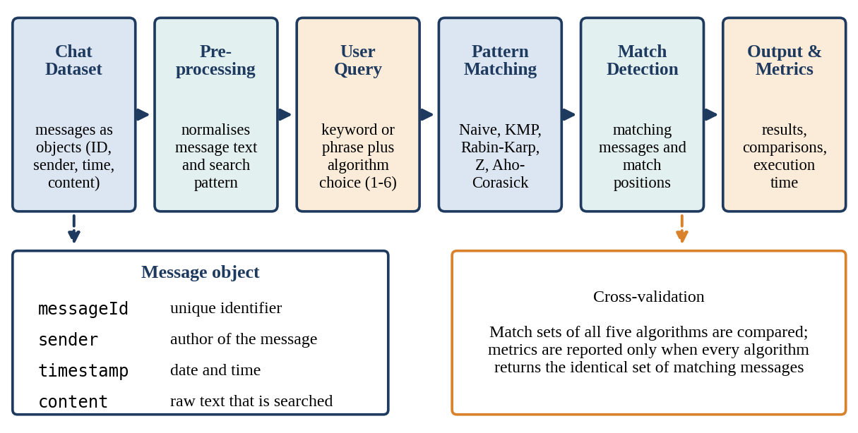
- Architecture of the Chat Message Search System.
Message structure. Each message is an object with four fields: a unique Message ID, the Sender (author), a Timestamp (date and time) and the Message Content, which is the raw text that is searched. Storing messages as objects in an ArrayList keeps the metadata attached to the text, so that a match can be reported with its context and not only as an index. Validation. As indicated in Fig. 1, the match sets of all five algorithms are cross-checked, and the metrics are reported only when every algorithm returns an identical set of matching messages. This step turns the comparison into a correctness test as well as a speed test.

Methodology

Workflow
The methodology follows the six steps shown in Fig. 2: (1) collect the chat dataset, (2) preprocess the text, (3) accept the query, (4) run the algorithm, (5) detect the matches and (6) measure and compare. When the user selects the "Compare All" option, steps 4 to 6 are executed for each of the five algorithms on the same pattern and the same messages, and the results are cross-validated before they are displayed.
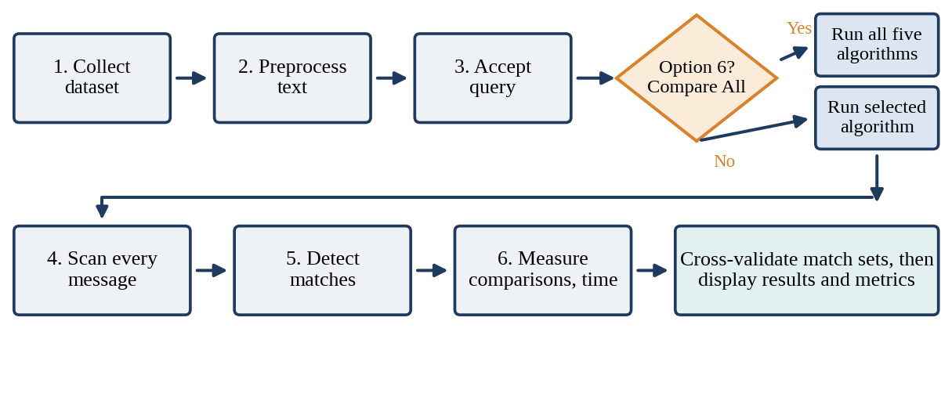
- Workflow of the search and comparison process.

Preprocessing
Before matching, the search pattern and the message text are normalised so that both are represented consistently. This guarantees that the five algorithms operate on exactly the same input and that any difference in their output can be attributed to the algorithm and not to the data. Preprocessing in the sense of the algorithms themselves (building the LPS array, the hash of the pattern, the Z-array or the trie) is described below, since it is the main source of the differences in cost.

String-Matching Algorithms
1) Naive algorithm. The pattern is aligned with every position of the text, and the characters are compared one by one until a mismatch is found or the whole pattern has matched. No preprocessing is needed and no extra memory is used, but after a mismatch the algorithm discards all information gained and restarts from the next position. Its worst-case time is O(nm). On ordinary text, where mismatches usually occur at the first or second character, the observed cost is close to n comparisons.
2) Knuth–Morris–Pratt (KMP). KMP precomputes the longest-proper-prefix-which-is-also-suffix (LPS) array of the pattern in O(m) time. When a mismatch occurs after j characters have matched, the LPS value of the previous position tells the algorithm how many characters of the pattern are still known to match, so the pattern is shifted without re-examining text characters. The text pointer never moves backwards, and the search takes O(n) time. Table II shows the LPS array of an example pattern.
- LPS Array for the Example Pattern "abcabd"
Index | 0 | 1 | 2 | 3 | 4 | 5
Pattern character | a | b | c | a | b | d
LPS value | 0 | 0 | 0 | 1 | 2 | 0

3) Rabin–Karp. The algorithm computes a hash of the pattern and a rolling hash of each window of m characters in the text. The hash of the next window is obtained from the previous one in constant time by removing the leading character and adding the trailing one: if h(i) is the hash of the window starting at position i, then h(i+1) = (d × (h(i) − T[i] × d^(m−1)) + T[i+m]) mod q, where d is the base (alphabet size) and q is a prime modulus. Only when the hash of a window equals the hash of the pattern are the characters compared to rule out a collision. The average time is O(n + m); the worst case, with many collisions, is O(nm). Because most windows are rejected by the hash alone, the number of character comparisons is usually very small.
4) Z Algorithm. The pattern, a separator character that does not occur in the text, and the text are concatenated, and the Z-array is computed. Z[i] is the length of the longest substring starting at position i that is also a prefix of the concatenated string. A position where Z[i] equals the pattern length m marks an occurrence of the pattern. Construction and search both take O(n + m) time [10], but the concatenated string and the Z-array require additional memory proportional to n + m.
5) Aho–Corasick. The algorithm builds a trie of the patterns and adds failure links that connect every state to the state representing the longest proper suffix that is also a prefix of some pattern. Fig. 3 shows the trie for the classic pattern set {he, she, his, hers}. The text is then scanned once, following trie edges and failure links, and every output state that is reached reports the patterns that end at that position. The search takes O(n + z), where z is the number of matches, after a preprocessing cost proportional to the total length of the patterns. The algorithm is designed for multi-pattern search, so for a single keyword the cost of building the trie is pure overhead.
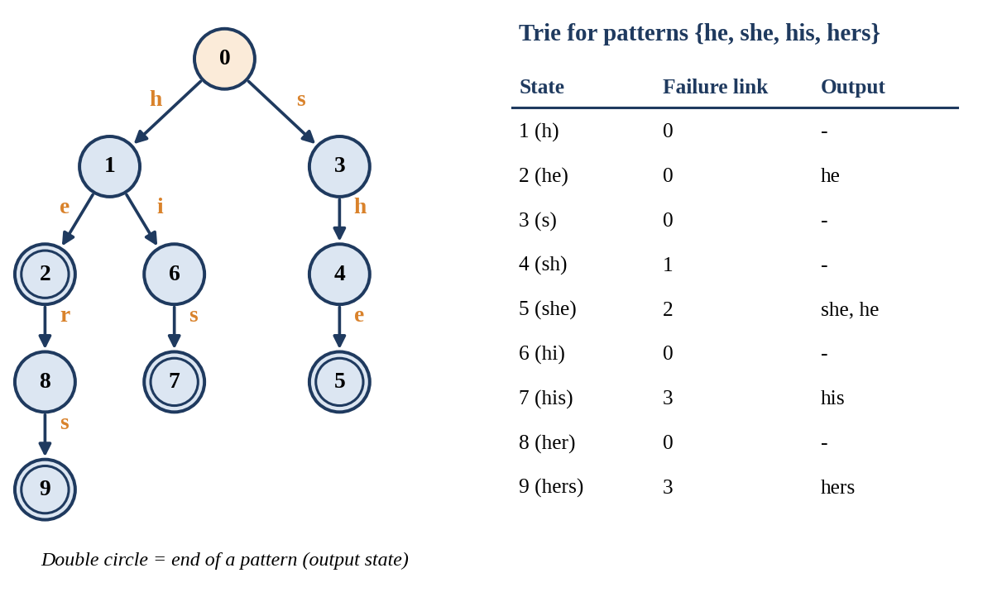
- Aho–Corasick trie with failure links for the example patterns {he, she, his, hers}.

Complexity Comparison
Table III compares the five techniques. The preprocessing and search-time columns are those used in this project; the worst-case and space columns are the standard textbook values, with n the total length of the text, m the length of the pattern and z the number of matches.
- Comparison of the Five Algorithms
Algorithm | Technique | Preprocessing | Search time | Worst case | Extra space
Naive | Check the pattern at every position | O(1) | O(nm) | O(nm) | O(1)
KMP | LPS array avoids re-comparisons | O(m) | O(n) | O(n + m) | O(m)
Rabin–Karp | Rolling hash, verify on hash match | O(m) | O(n) average | O(nm) | O(1)
Z Algorithm | Z-array on pattern + text | O(m) | O(n) | O(n + m) | O(n + m)
Aho–Corasick | Trie with failure links | O(total pattern length) | O(n + matches) | O(n + m + z) | O(total pattern length)

Choice of Evaluation Metrics
Two complementary measures are used because each hides something that the other shows. The number of character comparisons is independent of the machine and of the programming language, so it reflects the logic of the algorithm: it is the quantity that the textbook analysis predicts. The execution time is what a user actually experiences, and it includes every cost that the comparison count ignores, such as computing hashes, allocating and filling arrays, and building the trie. Reporting both makes it possible to see when an algorithm that looks efficient on paper pays for it elsewhere, and the correctness check on the match sets ensures that no algorithm has become faster by missing some matches. The accuracy of an algorithm is therefore expressed as agreement with the other four on the set of matching messages.

Tools and Technologies
The whole system, including the algorithms, the data structures and the console interface, is implemented from scratch in Java, so that the comparison counts and timings reflect the algorithms themselves and not a library. The choices are summarised in Table IV.
- Tools, Technologies and Requirements
Item | Details
Programming language | Java; all algorithms, data structures and the console interface are implemented from scratch.
Data structures | ArrayList for message storage; trie with failure links for Aho–Corasick; LPS array for KMP; Z-array for the Z Algorithm.
Software requirements | JDK 8 or higher; a Java IDE or a terminal (for example IntelliJ, Eclipse or VS Code); Windows, Linux or macOS.
Hardware requirements | Standard PC or laptop; 4 GB RAM or more; dual-core processor or better.

Implementation

Modules
The program is divided into modules, each with a single responsibility, as listed in Table V. This separation made it possible to develop and test every algorithm independently on small examples before it was connected to the common interface.
- Modules of the System
Module | Role
Message module | Stores the message ID, sender, timestamp and content in an ArrayList.
Preprocessing module | Normalises the pattern and the message text for consistent matching.
Algorithm modules (five) | Naive, KMP, Rabin–Karp, Z Algorithm and Aho–Corasick.
Metrics module | Counts character comparisons and times each search loop in milliseconds.
Validation and output | Cross-checks the match sets and shows message, sender, timestamp and position.

Working Process
The user enters a pattern and selects one algorithm, or the "Compare All" option. The system scans every message with the chosen algorithm, collects the matches and displays them with the performance metrics. For the comparison option the same procedure is repeated for all five algorithms, and the match sets are compared before the table of metrics is printed.

User Interface
The interface is a console menu. The program prints the list of available algorithms, asks for the search pattern and then for the option to run, as shown below. Choosing an option from 1 to 5 runs the corresponding algorithm alone, while option 6 runs all five and prints the performance table that is used in Section VII.
Console menu of the program
Available Algorithms:
1. Naive String Matching
2. Knuth-Morris-Pratt (KMP)
3. Rabin-Karp
4. Z Algorithm
5. Aho-Corasick
6. Compare All Algorithms

Enter search pattern:
Select option (1-6):

Measurement of Metrics
Two measures are recorded for every run. The number of comparisons is obtained by a counter that is incremented at every character-level comparison inside the algorithm, so that all five algorithms are counted in the same way. The execution time is the wall-clock time, in milliseconds, captured around the search loop of each algorithm. The pseudocode in Algorithm 1 and Algorithm 2 shows where the counter is placed in two of the algorithms.
Algorithm 1: KMP search with comparison counter (pseudocode)
build lps[0..m-1] for the pattern
i = 0; j = 0
while i < n:
comparisons = comparisons + 1
if text[i] == pattern[j]: i++; j++
if j == m: report match at i - j; j = lps[j - 1]
else if i < n and text[i] != pattern[j]:
if j != 0: j = lps[j - 1] else: i++

Algorithm 2: Rabin–Karp search with comparison counter (pseudocode)
hp = hash(pattern); ht = hash(text[0..m-1])
for i = 0 to n - m:
if hp == ht: // possible match, verify
for k = 0 to m - 1:
comparisons = comparisons + 1
if text[i + k] != pattern[k]: break
if all m characters matched: report match at i
ht = rolling_hash(ht, text[i], text[i + m])

Validation and Output
After the search, the system compares the lists of matching positions returned by the five algorithms. Only if all of them are identical are the results accepted and displayed. For each matching message the output shows the message text, the sender, the timestamp and the position of the match, followed by the number of matches, the comparisons and the time of every algorithm that was run.

Experiments
The experiment evaluates all five algorithms on the same chat dataset with the same query. The search pattern was the word "machine", and the "Compare All Algorithms" option (option 6) was chosen, so that the five algorithms ran one after another under identical conditions. The measures reported are the number of matches, the number of character comparisons and the execution time in milliseconds, as defined in Section VI. Fig. 4 shows the output screen of the program for this run.

Experimental Setup
The dataset is a collection of chat messages held in an ArrayList, each message being an object with a message ID, a sender, a timestamp and the message content. The same dataset, the same preprocessing and the same query are supplied to all five algorithms, so that any difference in the results is caused by the algorithms alone. The program was run from the console with JDK 8 or higher, and the figures were read directly from the output of the program.

Procedure
- Step 1: start the program, which prints the list of algorithms and the menu of options.
- Step 2: enter the search pattern "machine".
- Step 3: select option 6 (Compare All Algorithms).
- Step 4: the program runs the five algorithms in turn over every message, cross-checks the match sets and counts comparisons and time.
- Step 5: record the number of matches, the comparisons and the time of each algorithm from the performance table.
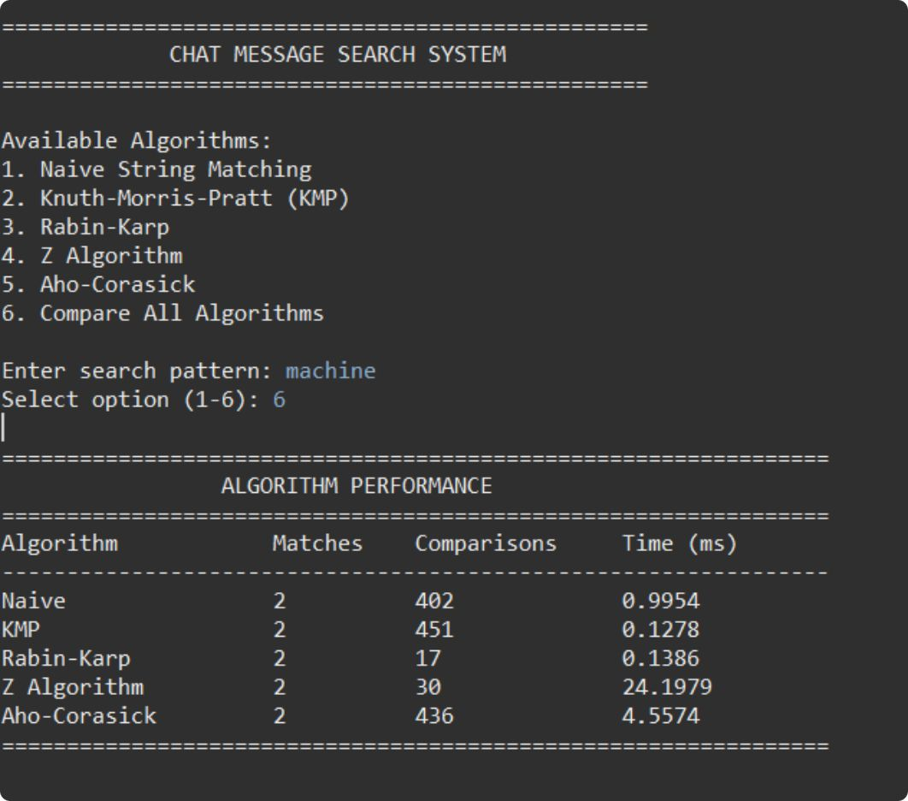
- Output screen of the "Compare All Algorithms" option for the pattern "machine".

Results
The values read from the output screen are collected in Table VI and plotted in Fig. 5. All five algorithms found the same two matching messages, so the match sets are identical and the comparison of the metrics is valid.
- Performance of the Algorithms for the Pattern "machine"
Algorithm | Matches | Comparisons | Time (ms)
Naive | 2 | 402 | 0.9954
KMP | 2 | 451 | 0.1278
Rabin–Karp | 2 | 17 | 0.1386
Z Algorithm | 2 | 30 | 24.1979
Aho–Corasick | 2 | 436 | 4.5574

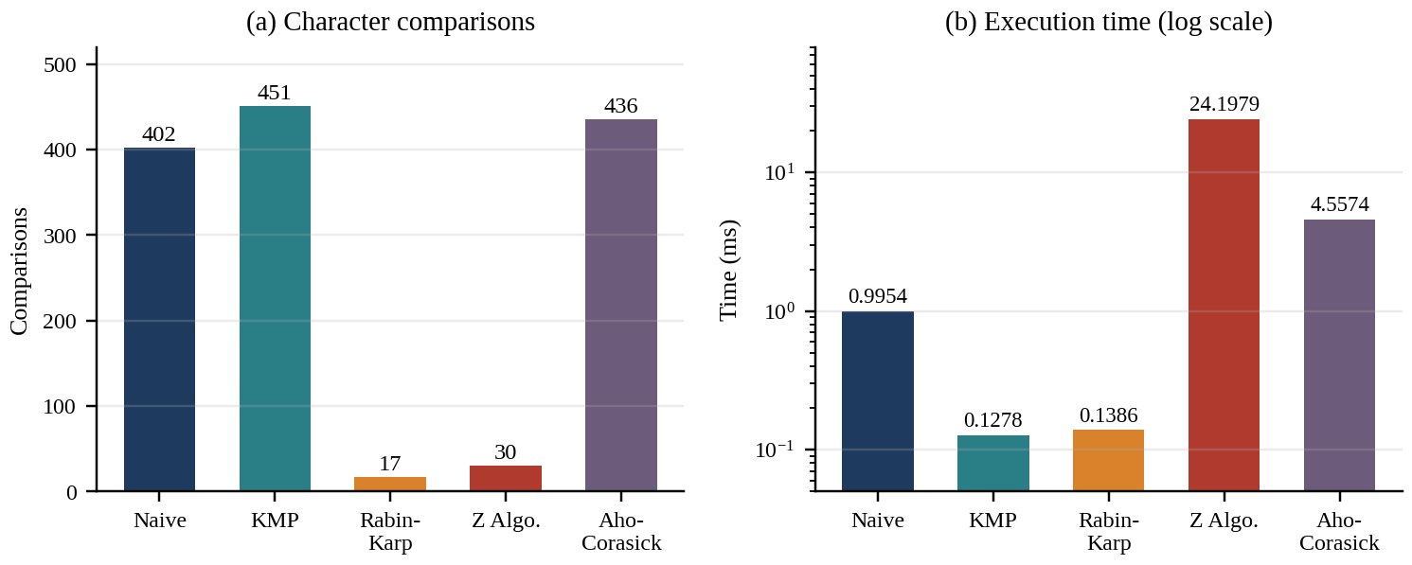
- Comparisons (a) and execution time (b) of the five algorithms for the pattern "machine".

Observations
- All five agree. Every algorithm found the same two matching messages for "machine".
- KMP was the fastest. It took 0.1278 ms, about 7.8 times faster than the Naive algorithm (0.9954 ms), even though it made 451 comparisons.
- Rabin–Karp was the most efficient in comparisons. It made only 17 comparisons, about 4% of the 402 made by the Naive algorithm, because hash filtering rejects almost every window; its time of 0.1386 ms is close to that of KMP.
- The Z Algorithm was the slowest. It made only 30 comparisons but needed 24.1979 ms, the highest wall-clock time.
- Aho–Corasick showed overhead. It took 4.5574 ms; the cost of building the trie appears in the time, because the algorithm is designed for multi-pattern search.

Discussion
The most important finding is that the number of comparisons and the running time do not rank the algorithms in the same order. Rabin–Karp and the Z Algorithm have the two lowest comparison counts, yet only Rabin–Karp is also among the fastest. The counts measure only the character-level comparisons inside the matching logic; the time also includes work that is not counted, such as hash computation, building and filling the Z-array on the concatenated string, and constructing the trie. The large time of the Z Algorithm is therefore most likely the cost of that auxiliary work together with run-time effects of the Java Virtual Machine, and not of the comparisons themselves. That KMP made more comparisons than the Naive algorithm (451 against 402) is consistent with natural-language text, in which the Naive algorithm usually fails at the first character of a window, so that its count stays close to the text length, while KMP's count also reflects its fallbacks on the LPS array; the exact figure depends on where the counter is placed in the code.
Agreement with theory. The measurements agree with the theoretical picture in Table III in several respects. The Naive algorithm, whose worst case is O(nm), made a number of comparisons of the same order as the text length, as expected for ordinary words. Rabin–Karp behaved according to its average-case analysis: the hash test discarded nearly all windows, so character comparisons were needed only to confirm the true matches and a few other windows. KMP and the Z Algorithm are both linear in theory, and the large gap between them in time shows that two algorithms of the same asymptotic order can differ greatly in constant factors and memory behaviour. Aho–Corasick, which pays a preprocessing cost proportional to the pattern set, is the right tool when many keywords are searched together, such as in moderation filters, and is not expected to win for one short keyword.
Limitations. The figures come from a single run on a small dataset. At the scale of fractions of a millisecond, timings are sensitive to JVM warm-up, just-in-time compilation and garbage collection, so the differences between Naive, KMP and Rabin–Karp should be treated as indicative and not as final. Repeating each query many times and averaging, and testing on larger datasets, are included in the future work.

Choosing an Algorithm
Taking the measurements together with the theory, Table VII offers guidance on which algorithm suits which situation. The recommendations are drawn from a single benchmark and from the standard analysis, and they should be confirmed on larger datasets.
- Guidance on Choosing an Algorithm
Situation | Suitable algorithm | Reason
Very small archive, one-off search | Naive | No preprocessing and no extra memory; the cost is small when the text is short.
Single keyword, general use | KMP or Rabin–Karp | Both ran in about 0.13 ms; KMP never moves back in the text, Rabin–Karp needs very few comparisons.
Many keywords at once | Aho–Corasick | One pass over the text finds all patterns; the trie cost is shared among them.
Memory is limited | Naive, KMP or Rabin–Karp | The Z Algorithm needs space proportional to the pattern plus the text.

Testing
Six test cases were designed to cover the existence of the pattern, its length and the size of the dataset (Table VIII). The cross-algorithm validation is applied in every case: all five algorithms must return identical match sets before the metrics are reported. The first test case has been executed and passed. The remaining cases are planned, and their expected results are stated; the observed values are to be entered when those runs are completed.
- Test Cases
# | Test case | Condition | Result | Status
1 | Pattern "machine" | Existing word, small dataset | All five algorithms return 2 matches | Passed
2 | Non-existing pattern | Pattern not present in any message | Expected: 0 matches from all algorithms | Planned
3 | Short pattern | Few characters | Expected: identical match sets | Planned
4 | Long pattern / phrase | Multi-word phrase | Expected: identical match sets | Planned
5 | Varying dataset size | Different numbers of messages | Time and comparisons recorded for each size | Planned
6 | Varying message length | Short versus long messages | Time and comparisons recorded for each length | Planned

Edge Cases Considered
Besides the six test cases, the validation step is intended to catch errors in boundary situations that string-matching code commonly gets wrong: an empty pattern; a pattern longer than the message; a pattern at the very beginning or the very end of a message; overlapping occurrences, such as "aa" in "aaaa", which contains three matches; and phrases that contain spaces or punctuation. Each message is scanned as a separate text, so a match never spans two messages. An algorithm that mishandles any of these cases would disagree with the other four, and the disagreement would be detected before any metrics are reported.

Advantages and Applications

Advantages
- Fast and accurate retrieval of the messages that contain a word or a phrase.
- Five algorithms on one dataset give a fair and reproducible comparison.
- Both the number of comparisons and the execution time are tracked, not just one measure.
- Results show the sender, the timestamp and the match position, which gives context.
- Cross-validation of all the algorithms confirms the correctness of the output.
- The project links theoretical DSA concepts to a practical application.

Applications
- Messaging applications: in-app search over the chat history.
- Collaboration tools: Slack- and Teams-style workspace search.
- Customer support logs: locating past issues and keywords.
- Text mining: keyword detection in conversation logs.
- Education: teaching and benchmarking string algorithms.
- Multi-keyword filtering: Aho–Corasick for moderation or alerts.

Challenges Faced
Several difficulties had to be solved while building a fair benchmark. They and their solutions are summarised in Table IX.
- Challenges and Solutions
Challenge | Solution
Fair comparison across algorithms | The same dataset and the same queries are used for all five algorithms.
Counting comparisons consistently | A counter is incremented at each character-level comparison.
Accurate timing | Wall-clock time is captured around each algorithm's search loop.
Verifying correctness | Cross-algorithm validation of the match sets.
Complexity of the trie and the Z-array | Both were implemented from scratch and tested on small examples first.

Conclusion and Future Work
A Java chat message search system was built with five classical string-matching algorithms: Naive, KMP, Rabin–Karp, Z Algorithm and Aho–Corasick. For the pattern "machine", all algorithms returned identical and correct matches. Rabin–Karp used the fewest comparisons (17), while KMP was the fastest (0.1278 ms). The results show that fewer comparisons do not always mean less time: the Z Algorithm and Aho–Corasick carry an overhead that appears in the running time. The project connects DSA theory to practical text search. In short: five algorithms, one dataset, and measurable, reproducible results.
Future work. The system can be extended in the following directions:
- Test on larger, real-world chat datasets with many more messages, and repeat each measurement to average out timing noise.
- Add Boyer–Moore and other algorithms to the comparison.
- Support case-insensitive, fuzzy and regular-expression search.
- Build a graphical or web interface.
- Index the messages (inverted index, suffix tree) for faster repeated searches.
- Add multi-keyword search and ranking of the results.
References
- Galal, Koopman and Zuccon, "Searching in Professional Instant Messaging Applications: User Behaviour, Intent, and Pain-points," 2024.
- Zhang, Simoff and Debenham, "Text Mining for Chat Message Analysis," 2006.
- Hui, He and Dong, "Message Retrieval and Classification from Chat Room Servers Using Bayesian Networks," 2008.
- Avula et al., "Embedding Search into a Conversational Platform to Support Collaborative Search," 2019.
- Schneider et al., "Engineering Conversational Search Systems: A Review of Applications, Architectures, and Functional Components," 2024.
- T. H. Cormen, C. E. Leiserson, R. L. Rivest and C. Stein, Introduction to Algorithms (chapter on string matching), MIT Press.
- D. E. Knuth, J. H. Morris and V. R. Pratt, "Fast pattern matching in strings," SIAM Journal on Computing, vol. 6, no. 2, pp. 323–350, 1977.
- R. M. Karp and M. O. Rabin, "Efficient randomized pattern-matching algorithms," IBM Journal of Research and Development, vol. 31, no. 2, pp. 249–260, 1987.
- A. V. Aho and M. J. Corasick, "Efficient string matching: an aid to bibliographic search," Communications of the ACM, vol. 18, no. 6, pp. 333–340, 1975.
- D. Gusfield, Algorithms on Strings, Trees and Sequences, Cambridge University Press, 1997.

