House Price Prediction using Machine Learning
A Project Based Learning Report Submitted in partial fulfilment of the requirements for the award of the degree

of

Bachelor of Technology
in The Department of Artificial Intelligence and Data Science
Machine Learning

Submitted by
2510080055 : Akshay Chandra
2510080052 : Manoj
2510080051 : Pranith Reddy
2510080053 : Sai Charan

Under the guidance of
Gangamohan Paidi



Department of Artificial Intelligence and Data Science
Koneru Lakshmaiah Education Foundation, Aziz Nagar
Aziz Nagar – 500075
OCT - 2026.
Abstract
House prices in Hyderabad depend on factors such as location, built-up area and the number of bedrooms, which makes manual estimation unreliable. This project builds a machine learning model that predicts house prices from these three inputs. The dataset (price.json) is cleaned, bedroom counts are extracted from text such as "3 BHK", the location is one-hot encoded and the data is split 80:20 into training and test sets. A Random Forest Regressor with 200 trees is trained and evaluated using MAE, MSE, RMSE and R². The trained model is saved with pickle and used by a Streamlit web application, where the user selects a location, area and number of bedrooms and receives the estimated price and the price per square foot. For example, the application estimated ₹1.32 Crores for a 1500 sq. ft., 3-bedroom property in Kokapet.
Keywords: Machine Learning, Random Forest, Regression, House Price Prediction, Streamlit.
List of Figures
Fig. 1. Machine learning pipeline of the house price prediction system. 3
Fig. 2. Working of the Random Forest regression model. 4
Fig. 3. Project files and the app launched in Visual Studio Code. 5
Fig. 4. Streamlit web application: property input form (left) and estimated price output (right). 6
List of Tables
TABLE I. Dataset features and target variable. 4
TABLE II. Evaluation metrics used for the model. 5
TABLE III. Sample prediction produced by the web application. 6
Table of Contents
1. Introduction 3
2. Methodology 3
a. Dataset and Preprocessing 3
b. Feature Engineering 4
c. Random Forest Algorithm 4
d. Evaluation Metrics 4
e. Web Application 5
3. Experiments 5
a. Experimental Setup 5
b. Training and Testing 5
4. Results 6
a. Web Application Output 6
b. Expected Outcome 6
5. Conclusion and Future Work 6
References 6

Hyderabad House Price Prediction using Machine Learning

Introduction
Real estate is one of the largest and most active markets in India, and Hyderabad is among its fastest-growing cities. The price of a house depends on many factors at the same time, such as the locality, the built-up area and the number of bedrooms. Because these factors interact in complex ways, a simple rule of thumb rarely gives a reliable price [1].
Buyers, sellers and agents usually depend on rough estimates or on comparing a few listings, and such estimates differ from person to person and take time to collect. A data-driven approach learns the relationship between property details and price from past listings and can then give a consistent estimate within seconds. This is a supervised regression problem: the inputs are known property details and the output is a continuous value, the price.
In this project, a house price prediction system for Hyderabad is developed using the Random Forest algorithm [2] implemented in scikit-learn [3]. The trained model is deployed through a Streamlit web application [4] so that any user can obtain an estimate without writing code. The main objectives are:
- Load, clean and prepare the house price dataset (area, location, bedrooms and price).
- Convert text and categorical data into numeric features that the model can use.
- Train a Random Forest Regressor and evaluate it with MAE, MSE, RMSE and R².
- Build a web application that returns the estimated price and the price per square foot.
The report is organized as follows. Section 2 describes the dataset, preprocessing, algorithm, metrics and application. Section 3 explains the experimental setup, Section 4 presents the results and expected outcome, and Section 5 concludes with future work.

METHODOLOGY
The overall workflow is shown in Fig. 1. The raw dataset is cleaned, converted into features, split into training and test sets, used to train the Random Forest model, evaluated, saved and finally used by the web application.
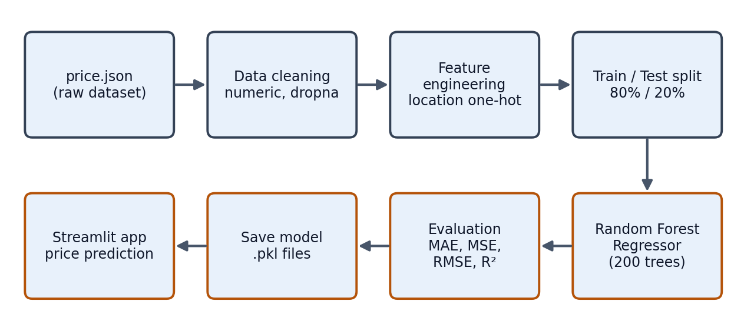
- Machine learning pipeline of the house price prediction system.

Dataset and Preprocessing
The dataset is stored in price.json and is loaded with pandas [5]. Column names are stripped and converted to lower case, and the presence of the four required columns is checked. The area and price columns are converted to numbers, and the number of bedrooms is extracted from text such as "3 BHK Apartment" using a regular expression that picks the digits. The location text is trimmed. Rows with missing values are removed, and rows in which the area, bedrooms or price is zero or negative are also removed. TABLE I lists the columns that are used.
- Dataset features and target variable.
Feature | Description | Type
area | Total area in square feet | Numeric input
bedrooms | Number of bedrooms, extracted from text such as "3 BHK" | Numeric input
location | Locality in Hyderabad | Categorical input (one-hot encoded)
price | Property price (read in lakhs by the application) | Numeric target

Feature Engineering
The location is a categorical variable, so it is one-hot encoded with pd.get_dummies using the prefix Location_, which creates one binary column for every locality. The feature matrix X combines area, bedrooms and these location columns, and the target y is the price. The data is divided into 80% training data and 20% test data with train_test_split and random_state = 42, so that the model is tested on houses it has not seen during training.

Random Forest Algorithm
A decision tree predicts a price by asking a series of questions about the input, for example whether the area is above a value or whether the location is a particular locality, until it reaches a leaf that holds a price. A single deep tree fits the training data very closely but can overfit and give unstable results on new data.
A Random Forest [2] is an ensemble of many such trees. Each tree is trained on a different random sample of the training rows (bootstrap sampling, called bagging), so the trees make different errors. For regression, the final prediction is the average of the predictions of all trees, as shown in Fig. 2. Averaging reduces variance and overfitting, handles non-linear relationships between area, bedrooms and location, and does not need feature scaling. The model in this project uses n_estimators = 200 trees, random_state = 42 for repeatable results and n_jobs = -1 to train on all CPU cores.
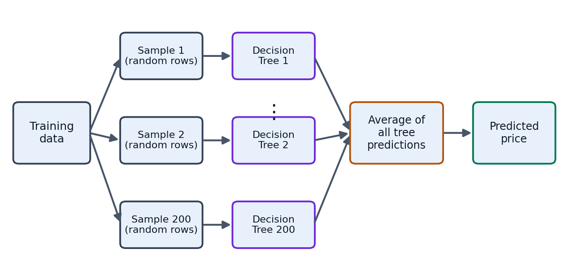
- Working of the Random Forest regression model.

Evaluation Metrics
The predictions on the test set are compared with the actual prices using four standard regression metrics from scikit-learn, summarized in TABLE II. Lower MAE, MSE and RMSE and an R² close to 1 indicate a better model.
- Evaluation metrics used for the model.
Metric | Formula | Meaning
MAE | (1/n) Σ |y - ŷ| | Average absolute error in price
MSE | (1/n) Σ (y - ŷ)² | Average squared error; large errors count more
RMSE | √MSE | Error in the same unit as the price
R² | 1 - Σ(y - ŷ)² / Σ(y - ȳ)² | Share of price variation explained by the model

Web Application
The trained model and the list of feature columns are saved with pickle as house_price_model.pkl and model_columns.pkl. The Streamlit application app.py loads both files once and builds the list of localities from the columns that start with Location_. The user selects a location, enters the area (300 to 20000 sq. ft.) and chooses the number of bedrooms (1 to 10). When the button is pressed, the application creates a one-row table of zeros with the same columns as the training data, sets the area, the bedrooms and the selected location column to the entered values, and calls model.predict. The price is shown in crores when it is 100 lakhs or more, otherwise in lakhs, together with the price per square foot, which is the predicted price multiplied by 100000 and divided by the area.

EXPERIMENTS

Experimental Setup
The project was implemented in Python using Visual Studio Code on Windows. The libraries used are pandas and NumPy for data handling, scikit-learn for the model and the metrics, pickle for saving the model and Streamlit for the interface. The project folder contains price.json, train_model.py, app.py and the two saved files, as seen in Fig. 3. Running train_model.py trains the model and creates house_price_model.pkl and model_columns.pkl, and the application is started with the command streamlit run app.py, which serves it at http://localhost:8501.
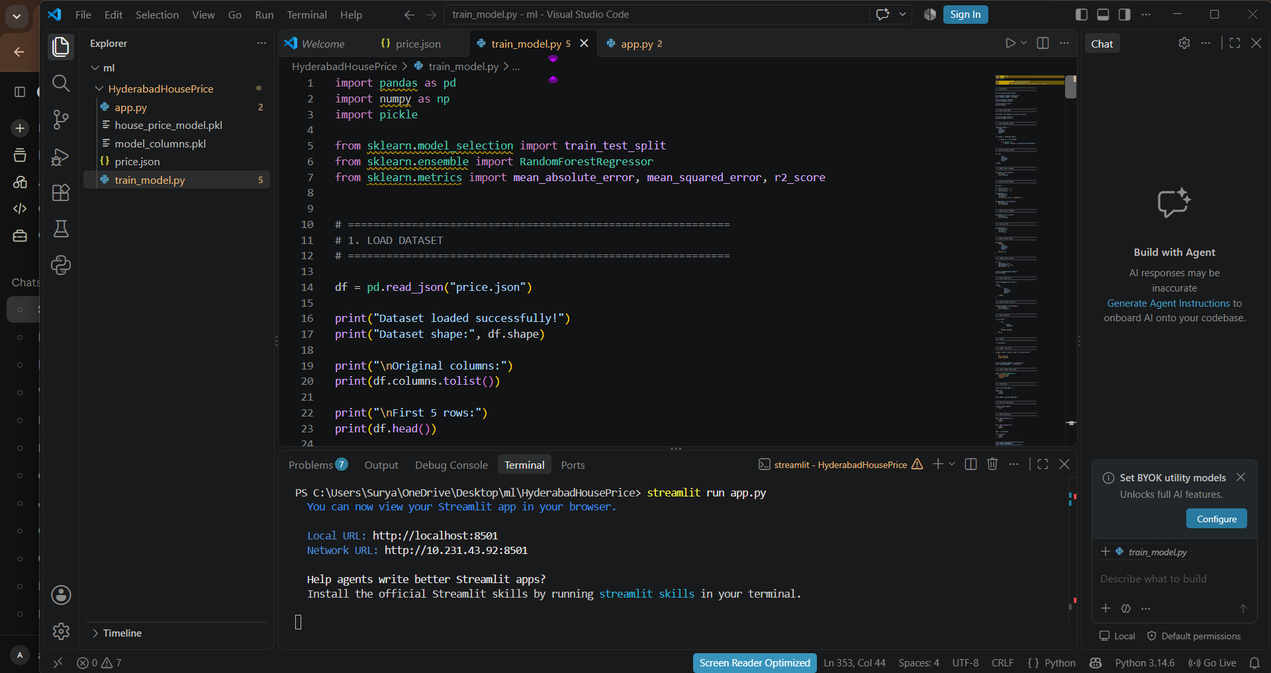
- Project files and the app launched in Visual Studio Code.

Training and Testing
After cleaning, the script prints the shape of the dataset and the numbers of training and testing samples. The Random Forest is trained on the training set, predictions are made on the test set, and MAE, MSE, RMSE and R² are calculated and printed. The script also reports how many locations the model knows and lists sample locations.

RESULTS

Web Application Output
Fig. 4 shows the working application. For a property in Kokapet with an area of 1500 sq. ft. and 3 bedrooms, the model gives the estimate listed in TABLE III. The values are consistent with each other: 132.09 lakhs equals 1.32 crores, and 132.09 lakhs divided by 1500 sq. ft. gives about 8,806 rupees per square foot.
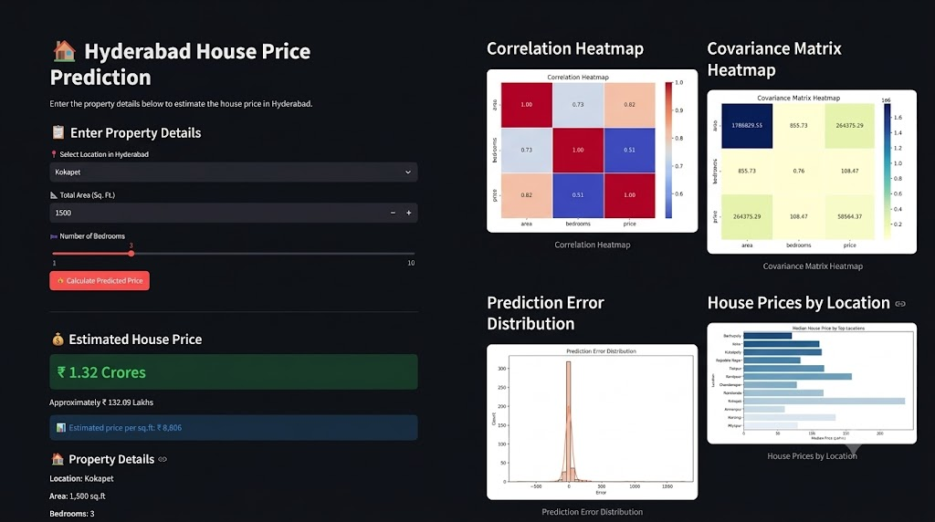
- Streamlit web application: property input form (left) and estimated price output (right).
- Sample prediction produced by the web application.
Location | Area (sq. ft.) | Bedrooms | Estimated price | In lakhs | Price per sq. ft.
Kokapet | 1500 | 3 | ₹ 1.32 Crores | ₹ 132.09 | ₹ 8,806

The model quality on the test set is reported by train_model.py through MAE, MSE, RMSE and R², as described in Section 2.d.

Expected Outcome
- A cleaned dataset with numeric area, bedrooms and one-hot encoded locations.
- A trained Random Forest model saved as reusable pickle files.
- Measured performance using MAE, MSE, RMSE and R².
- An easy-to-use web application that gives an instant price estimate for any available location.

CONCLUSION and FUTURE WORK
In this project, a Random Forest regression model was trained on area, bedrooms and location to predict house prices in Hyderabad, and it was deployed as a Streamlit web application that shows the estimated price and the price per square foot. The project shows how raw property data can be cleaned, converted into features, modelled with an ensemble algorithm, evaluated and delivered as a practical tool. Future work can include:
- Adding more features such as property age, floor, amenities and distance to the city centre.
- Comparing Random Forest with other algorithms such as linear regression and gradient boosting.
- Tuning the hyperparameters and using more recent data.
- Deploying the application online for public use.

References
- A. Géron, Hands-On Machine Learning with Scikit-Learn, Keras and TensorFlow, 3rd ed., O’Reilly Media, 2022.
- L. Breiman, "Random forests," Machine Learning, vol. 45, no. 1, pp. 5-32, 2001.
- F. Pedregosa et al., "Scikit-learn: Machine learning in Python," Journal of Machine Learning Research, vol. 12, pp. 2825-2830, 2011.
- Streamlit Documentation. [Online]. Available: https://docs.streamlit.io
- W. McKinney, "Data structures for statistical computing in Python," Proc. 9th Python in Science Conference, pp. 56-61, 2010.

