Shell-Based Build Automation Tool
A Project Based Learning Report Submitted in partial fulfilment of the requirements for the award of the degree

of

Bachelor of Technology
in The Department of Artificial Intelligence and Data Science
Operating Systems and Systems Programming

Submitted by
2510080055 : Akshay Chandra
2510080052 : Manoj
2510080046 : Balaji
2510080053 : Sai Charan

Under the guidance of
Dr. P. Kalpana



Department of Artificial Intelligence and Data Science
Koneru Lakshmaiah Education Foundation, Aziz Nagar
Aziz Nagar – 500075
OCT - 2026.
Abstract
Software projects involve many source files, compilation commands, processes and input/output operations, and managing them by hand is repetitive and error-prone. This project presents a Shell-Based Build Automation Tool, a lightweight Linux shell written in C that integrates core Operating Systems concepts into a single modular system. The tool provides an interactive prompt, command parsing and tokenization, process creation with fork(), execvp() and waitpid(), built-in commands, signal handling, pipes and input/output redirection. In its final stage it adds POSIX multithreading: the build command starts a build thread and a monitor thread whose shared status is protected by a mutex to prevent race conditions. The project was developed incrementally over ten weeks, and each concept was integrated into the existing code base instead of being implemented as an isolated program. The tool is compiled with the provided Makefile using the -pthread option and runs on Linux and WSL. The test output shows the build task starting, being monitored and completing successfully. The modular design provides a foundation for a make-like system with dependency checking and automatic rebuilding.
Keywords: Shell, Process Management, Pipes, Signals, POSIX Threads, Mutex, Build Automation.

List of Figures
Fig. 1. Architecture of the Shell-Based Build Automation Tool. 7
Fig. 2. Build workflow with the build thread, monitor thread and mutex-protected shared status. 8
Fig. 3. GitHub repository of the project showing the include and src directories, Makefile and README. 8
Fig. 4. Terminal output of make, make run and the build command. 9

List of Tables
TABLE I. Week-wise development of the project. 6
TABLE II. Test categories and behaviour verified. 9
TABLE III. Summary of implemented features and the OS concepts demonstrated. 10

Table of Contents
1. Introduction 6
2. Methodology 6
a. Development Approach 6
b. System Architecture 7
c. Core Shell Features 7
d. Advanced Operating Systems Features 7
e. Multithreading and Synchronization 7
3. Experiments 8
a. Experimental Setup 8
b. Test Cases 8
4. Results 9
a. Build Command Output 9
b. Summary of Implemented Features 9
5. Conclusion and Future Work 10
References 10

Shell-Based Build Automation Tool

Introduction
Software development projects rarely consist of a single file. A typical project contains several source files, compilation commands, running processes, input and output operations and execution dependencies that must all be coordinated correctly. The command-line shell is the natural place to coordinate this work, because it sits between the user and the operating system and exposes the services of the kernel through system calls. Building a shell is therefore one of the most effective ways to understand how an operating system creates processes, connects them, delivers signals to them and shares resources between concurrent activities [1], [2].
When these tasks are carried out manually, several problems appear. Compilation requires the same commands to be typed again and again, processes must be started and monitored by the user, and input and output redirection is cumbersome without dedicated support. Combining commands needs additional shell functionality such as pipes, signals must be handled correctly, and build-related tasks consume a great deal of time. In addition, when several activities run concurrently and update shared data without synchronization, race conditions can corrupt that data [3].
To address these problems, this project develops a Shell-Based Build Automation Tool for Linux and the Windows Subsystem for Linux (WSL), using POSIX system calls [4] and written in C [5]. The tool combines the functionality of a Unix shell with Operating Systems and Systems Programming concepts in one modular system. Instead of implementing process creation, signals, pipes, redirection and threads as separate programs, each concept is integrated step by step into the same code base, so that the final tool shows how these mechanisms work together in a practical application. The main objectives of the project are:
- Develop an interactive command-line shell with continuous command processing and implement command parsing and tokenization.
- Create and manage processes using Linux system calls and execute external Linux commands.
- Implement built-in shell commands and support environment variables.
- Implement signal handling, pipes between commands and input/output redirection.
- Introduce POSIX multithreading and synchronize shared resources using mutexes.
- Provide a foundation for build automation through a build command.
The remainder of this report is organized as follows. Section 2 describes the methodology, architecture and implementation of the tool. Section 3 explains the experimental setup and the test cases. Section 4 presents the results, including the output of the build command, and Section 5 concludes the report and outlines future work.

METHODOLOGY

Development Approach
The tool was developed over ten weeks following the cycle of concept, implementation, testing and integration. Each week introduced one Operating Systems concept, which was added to the existing project instead of replacing it with a separate implementation. TABLE I summarizes the weekly progression.
- Week-wise development of the project.
Week | Major concept | Week | Major concept
1 | Project setup and REPL | 6 | Signal handling
2 | Input handling | 7 | Pipes
3 | Command parsing | 8 | I/O redirection
4 | Process management | 9 | Shell integration and advanced command handling
5 | Built-in commands and environment | 10 | POSIX threads and synchronization

System Architecture
Fig. 1 shows the architecture of the tool. User input is read by the interactive shell and passed through the input-handling and parser modules. The parsed command is dispatched to the built-in command module, the pipe module or the redirection module. External programs are executed by the process-management module using fork(), execvp() and waitpid(), while the signal-handling module controls how signals are treated. The build command finally starts the POSIX thread management module, which runs the build thread and the monitor thread.
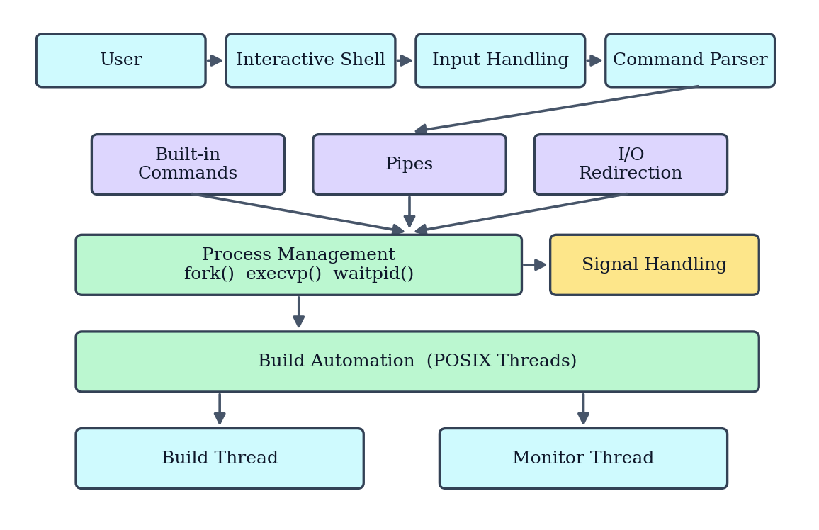
- Architecture of the Shell-Based Build Automation Tool.
The source code is organized as separate modules with separate header files, which makes incremental integration and future extension easier. As seen in the repository (Fig. 3) and in the compile command (Fig. 4), the modules are main.c, input.c, parser.c, process.c, builtin.c, signals.c, pipes.c, redirect.c and thread.c, compiled together from the src directory with the headers kept in the include directory.

Core Shell Features
The shell displays a prompt (myshell>) and continuously accepts commands from the user. The input is tokenized with strtok() and converted into a NULL-terminated argument list. For an external command, fork() creates a child process, execvp() replaces the child with the requested program and waitpid() makes the parent wait until the child has finished. Built-in commands are executed inside the shell itself: cd changes the working directory, pwd prints it, help lists the available commands, clear clears the screen, env displays the environment variables, exit terminates the shell and build starts the build workflow.

Advanced Operating Systems Features
Signal handling provides controlled behaviour for signals generated during command execution, and child processes can restore the default signal handling before they run a new program. Pipes enable inter-process communication: in a command such as ls | grep .c, the output of the first process is connected through a pipe() to the input of the second process. Input and output redirection works on file descriptors, so that commands such as ls > output.txt, cat < input.txt and ls >> output.txt read from or write to files instead of the terminal. Together these features demonstrate inter-process communication, file descriptors, process synchronization and signal management.

Multithreading and Synchronization
The final version introduces concurrent execution using POSIX threads. When the user enters build, the parser identifies the command and the shell creates a build thread with pthread_create(). A monitor thread runs alongside it and reports the status of the build, as shown in Fig. 2. Both threads access a shared build-status variable, which forms a critical section. The variable is therefore protected with pthread_mutex_lock() and pthread_mutex_unlock(), so that only one thread uses it at a time and race conditions are prevented. When the work is finished, pthread_join() waits for the threads to complete.
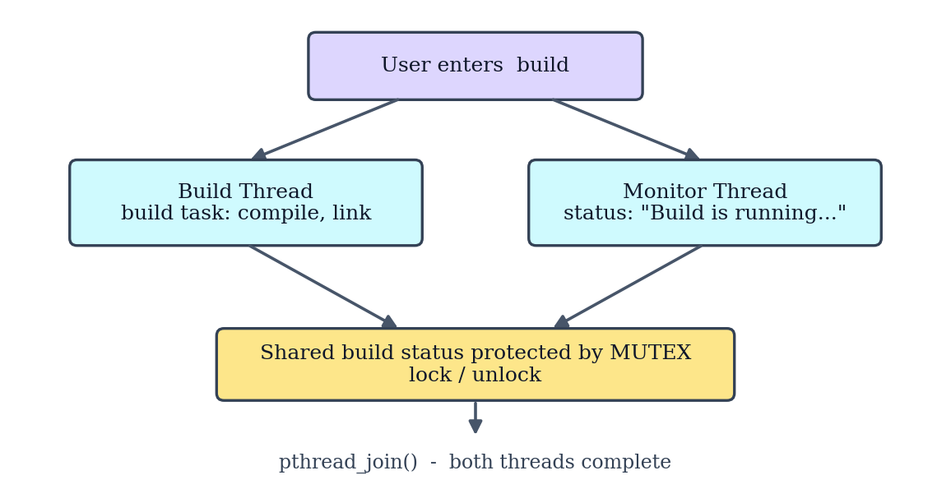
- Build workflow with the build thread, monitor thread and mutex-protected shared status.

EXPERIMENTS

Experimental Setup
The tool was developed and tested on Linux using WSL. It is compiled with the provided Makefile [6]: the default target creates the bin directory and runs cc with the options -Wall -Wextra -g -Iinclude over all the source files together with -pthread, producing the executable bin/shellbasedautomationtool. The clean target removes the generated files with rm -rf bin/*, and the run target starts the shell. The source code, Makefile and README are maintained in a public GitHub repository [7], shown in Fig. 3, whose commit history follows the weekly development, for example "Week 10: Added POSIX thread support".
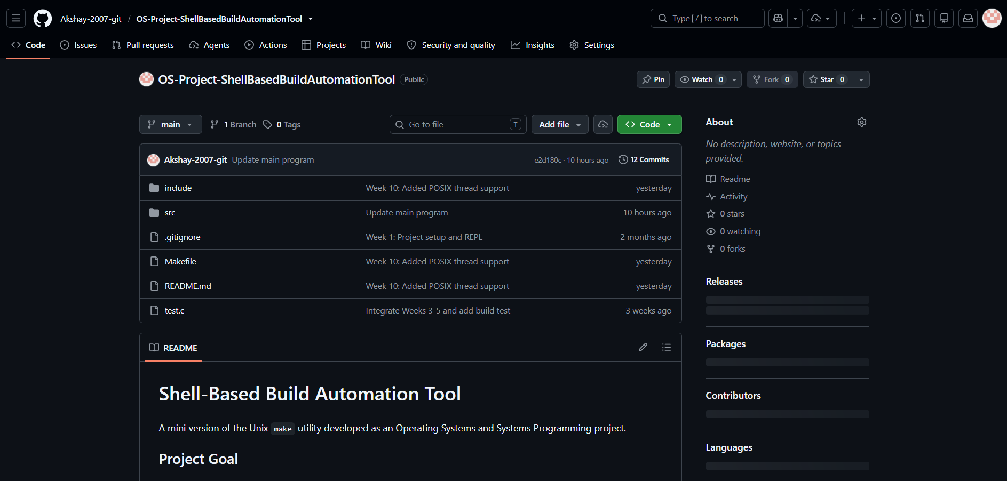
- GitHub repository of the project showing the include and src directories, Makefile and README.

Test Cases
The system was tested in several categories: basic commands, process execution, advanced features, the build feature and multithreading. TABLE II lists the test cases and the behaviour that each one verifies.
- Test categories and behaviour verified.
Category | Test command | Behaviour verified
Basic commands | pwd, ls, ls -l, cd, env, help, clear, exit | Built-in and external commands run correctly
Process execution | Any external command | fork(), execvp() and waitpid() create, run and wait for the child
Pipes | ls | grep .c | Output of the first command feeds the second command
Redirection | ls > output.txt, cat < input.txt, ls >> output.txt | Input and output are redirected to and from files; append works
Build feature | build | Build thread and monitor thread start, run and complete
Multithreading | build | Thread creation, monitor execution, shared-state synchronization, successful completion and no race condition in protected status variables

RESULTS

Build Command Output
Fig. 4 shows the actual output of the tool. After make clean and make, the shell was started with make run and the build command was entered. The build thread reported that the build task started, then the compiling and linking stages, and finally that the build task completed successfully. In parallel, the monitor thread repeatedly reported that the build was running. The interleaving of [Build] and [Monitor] lines shows that the two threads executed concurrently, and the correct final message shows that the shared status was handled consistently. The shell then exited normally with the exit command.
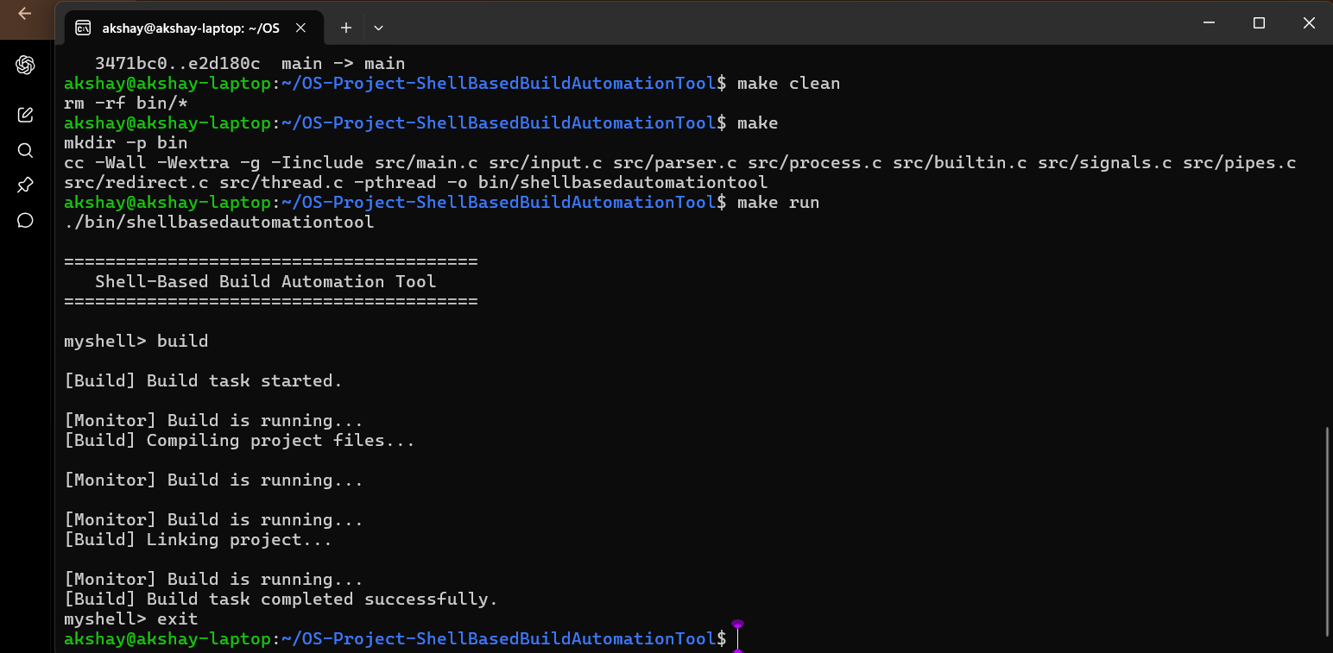
- Terminal output of make, make run and the build command.

Summary of Implemented Features
TABLE III maps each feature of the final system to its purpose and to the main Operating Systems concept or system call that it demonstrates.
- Summary of implemented features and the OS concepts demonstrated.
Feature | Purpose | OS concept / API
Interactive shell and parsing | Reads and tokenizes user commands | strtok(), argument lists
Process creation | Runs external Linux commands | fork(), execvp(), waitpid()
Built-in commands | Provides internal shell functionality | cd, pwd, help, clear, env, exit, build
Signal handling | Controls signal behaviour | Signals
Pipes | Process-to-process communication | pipe()
I/O redirection | Redirects command input and output | File descriptors
POSIX threads | Concurrent build and monitoring | pthread_create(), pthread_join()
Mutex synchronization | Protects shared build state | pthread_mutex_lock(), pthread_mutex_unlock()
Modular architecture | Makes future extension easier | Separate source and header files

The results show that all major features were integrated into a single working tool and that the build workflow executes correctly with concurrent build and monitor threads.

CONCLUSION and FUTURE WORK
In this project, a basic command-line shell was developed step by step into an integrated Shell-Based Build Automation Tool. Input handling, command parsing, process management, built-in commands, signals, pipes, I/O redirection, multithreading and synchronization were combined in one modular Linux-based system, and the build command demonstrated concurrent building and monitoring with mutex-protected shared state. The project shows how Operating Systems concepts can be combined to create a practical, modular and extensible tool.
The current modular architecture provides a foundation for further build automation. Possible extensions are:
- Dependency-aware builds with file timestamp checking and automatic recompilation.
- Build configuration files and parallel compilation of independent files.
- Build logs and error reporting, and improved command syntax.
- Job and background process management.
- Automated dependency resolution.
The long-term vision is to evolve the project into a lightweight Unix make-like build automation system.

References
- A. Silberschatz, P. B. Galvin and G. Gagne, Operating System Concepts, 10th ed., Wiley, 2018.
- W. R. Stevens and S. A. Rago, Advanced Programming in the UNIX Environment, 3rd ed., Addison-Wesley, 2013.
- D. R. Butenhof, Programming with POSIX Threads, Addison-Wesley, 1997.
- M. Kerrisk, The Linux Programming Interface, No Starch Press, 2010.
- B. W. Kernighan and D. M. Ritchie, The C Programming Language, 2nd ed., Prentice Hall, 1988.
- Free Software Foundation, GNU Make Manual. [Online]. Available: https://www.gnu.org/software/make/manual/
- Akshay-2007-git, OS-Project-ShellBasedBuildAutomationTool, GitHub repository. [Online]. Available: https://github.com/Akshay-2007-git/OS-Project-ShellBasedBuildAutomationTool

