QUESTIGO - A GAME-BASED INTERACTIVE LEARNING PLATFORM WITH AI-ASSISTED CONTENT GENERATION
Submitted in partial fulfilment of the requirement for the
Award of the Degree of
MASTER OF COMPUTER APPLICATIONS
DEPARTMENT OF COMPUTER SCIENCE AND ENGINEERING,
UCE(A) OSMANIA UNIVERSITY
Submitted by
MADARAVENA AKSHAY YADAV
Hall Ticket No.: 100524862041
Under the esteemed Guidance of
Project Supervisor
DR. V. SUKANYA
Assistant Professor
Department of Computer Science, UCE(A), OU

DEPARTMENT OF COMPUTER SCIENCE & ENGINEERING
UNIVERSITY COLLEGE OF ENGINEERING (A) OSMANIA UNIVERSITY
2024 - 2026

UNIVERSITY COLLEGE OF ENGINEERING (A)
OSMANIA UNIVERSITY, HYDERABAD - 500007
DEPARTMENT OF COMPUTER SCIENCE AND ENGINEERING

CERTIFICATE
This is to certify that the project report entitled “QUESTIGO — A GAME-BASED INTERACTIVE LEARNING PLATFORM WITH AI-ASSISTED CONTENT GENERATION” is a bonafide work carried out by MADARAVENA AKSHAY YADAV, Hall Ticket No. 100524862041, in partial fulfilment of the requirements for the award of the Degree of Master of Computer Applications (MCA), submitted to Osmania University, Hyderabad.
The work embodied in this project has been carried out by the student under my supervision during the academic year 2024-2026. This project report has not been submitted earlier, either in part or in full, to any other university or institution for the award of any degree or diploma.

Project Supervisor Head of the Department
DR. V. SUKANYA DR. K. SHYAMALA
Assistant Professor, Senior Professor, Dept of CSE, UCE (A), OU Dept of CSE, UCE (A), OU

Signature of Internal Examiner Signature of External Examiner
DECLARATION
I hereby declare that the project entitled “QUESTIGO — A GAME-BASED INTERACTIVE LEARNING PLATFORM WITH AI-ASSISTED CONTENT GENERATION ”, submitted in partial fulfilment of the requirements for the award of the Degree of Master of Computer Applications (MCA) to Osmania University, is a record of original work carried out by me under the guidance of Dr. V. Sukanya, Assistant Professor, Department of Computer Science, University College of Engineering (A), Osmania University.
I further declare that this project report has not been submitted, either in part or in full, to any other university or institution for the award of any degree, diploma, or certificate. The work presented in this report is genuine, and all sources of information used have been duly acknowledged through proper references.

M. AKSHAY YADAV Signature of the Candidate
Hall Ticket No.: 100524862041

ACKNOWLEDGEMENT
The successful completion of this project would not have been possible without the encouragement, support, and guidance of several individuals. I take this opportunity to express my sincere gratitude to everyone who contributed, directly or indirectly, towards the completion of this work.
First and foremost, I express my heartfelt gratitude to Dr. V. Sukanya, Assistant Professor, Department of Computer Science, University College of Engineering (A), Osmania University, for her valuable guidance, constant encouragement, insightful suggestions, and continuous support throughout the development of this project. Her technical expertise and constructive feedback played a vital role in shaping this project into its present form.
I sincerely thank Dr. K. Shyamala, Senior Professor and Head of the Department, Department of Computer Science and Engineering, University College of Engineering (A), Osmania University, for providing an excellent academic environment, infrastructure, and resources necessary for carrying out this project successfully.
I would like to express my sincere thanks to Prof. P. Chandra Sekhar, Principal, University College of Engineering (A), Osmania University, for his encouragement and leadership.
I extend my gratitude to all the faculty members of the Department of Computer Science and Engineering for sharing their valuable knowledge and providing continuous motivation throughout my postgraduate studies. I would also like to thank my classmates and friends for their suggestions, discussions, and encouragement during various stages of the project; their cooperation and moral support helped me overcome several challenges encountered during development.
I am thankful to the developers and maintainers of the open-source technologies used in this project, including React, TypeScript, FastAPI, SQLAlchemy, PostgreSQL, Tailwind CSS, and the Monaco Editor, whose tools and libraries significantly simplified the implementation of this platform. I also acknowledge Groq for providing free access to large language model inference used in the AI-assisted content generation module.
Finally, I express my deepest gratitude to my parents and family members for their unconditional love, continuous encouragement, patience, and unwavering support throughout my academic journey. Their belief in me has been the greatest source of motivation in accomplishing this project successfully.
ABSTRACT
Learning to program remains one of the most difficult transitions in computer science education. Conventional e-learning platforms rely heavily on passive video lectures and multiple-choice assessment, which test recognition of a fact rather than genuine understanding of how the parts of a system relate to one another. This gap in engagement and depth of assessment is the motivation for Questigo, a game-based interactive learning platform designed to teach programming and computer-science fundamentals through active construction rather than passive consumption.
Questigo reframes assessment around three distinct, complementary game mechanics that share a single progression engine. The Sequence Builder mechanic asks a student to reconstruct a real process — such as the SQL query-execution pipeline or the OSI network layers — by arranging shuffled concept tiles into the correct order, with every adjacent connection validated individually and incorrect links surfaced as targeted teaching explanations. The Code Forge mechanic embeds a Monaco-based code editor in which the student implements a real Python function that is executed and graded against hidden server-side test cases. The Rapid Arena mechanic presents timed multiple-choice questions under a countdown with a three-heart and streak system, testing recall speed and confidence under pressure. All three mechanics plug into one Skill-Tree progression engine, awarding experience points (XP), deriving a level from a fixed threshold table, unlocking achievements, and ranking students on a leaderboard.
A defining feature of the platform is its AI-assisted content pipeline. A teacher uploads a PDF or pastes study material, and a Large Language Model, accessed through the Groq API using an OpenAI-compatible client, converts the material into structured, playable quest drafts. Generated drafts are never shown to students directly — a mandatory teacher review-and-approval workflow gates every AI-authored quest before publication, and for coding challenges the platform additionally derives each expected test output by executing the model's own reference solution through the same sandboxed runner used for student submissions, guaranteeing that generated test cases are solvable by construction rather than merely plausible.
The system is implemented as a modern, layered full-stack web application: a React 19 and TypeScript single-page frontend built with Vite and Tailwind CSS, communicating over a versioned JSON REST API with a Python FastAPI backend organised into routes, services, and CRUD layers, backed by a normalised PostgreSQL schema. Authentication uses JSON Web Tokens with bcrypt-hashed passwords and role-gated routes for the Student and Teacher roles. All reward-affecting outcomes — quest completion, XP awards, and code-test results — are re-verified on the server, so no client can spoof progress.
The complete MVP — authentication, all three game mechanics, XP and level persistence, achievements, leaderboard, student profile, teacher authoring, and the full AI generation-and-approval workflow — was implemented, deployed as a three-container Docker stack, and verified end-to-end in the browser with zero console errors. During development, a fourth mechanic, Data Detective (a SQL-sandbox investigation game), was built and then deliberately retired after evaluation showed it demanded a disproportionately heavy authoring burden from teachers compared to the other mechanics — a documented design decision rather than an abandoned feature. The resulting platform demonstrates that a genuinely different mode of assessment — construction instead of recognition — can be delivered as a complete, extensible, production-shaped system within the scope of an MCA major project.

LIST OF ABBREVIATIONS
Abbreviation | Description
AI | Artificial Intelligence
API | Application Programming Interface
CRUD | Create, Read, Update, Delete
CSS | Cascading Style Sheets
DB | Database
DFD | Data Flow Diagram
EdTech | Educational Technology
ER | Entity–Relationship
HTML | HyperText Markup Language
HTTP | HyperText Transfer Protocol
IDE | Integrated Development Environment
JS | JavaScript
JSON | JavaScript Object Notation
JWT | JSON Web Token
LLM | Large Language Model
MCA | Master of Computer Applications
MCQ | Multiple Choice Question
MVP | Minimum Viable Product
ORM | Object-Relational Mapping
OS | Operating System
OSI | Open Systems Interconnection
REST | Representational State Transfer
SDLC | Software Development Life Cycle
SPA | Single Page Application
SQL | Structured Query Language
UI | User Interface
UML | Unified Modelling Language
UX | User Experience
XP | Experience Points

TABLE OF CONTENTS
Contents | Page No.
ACKNOWLEDGEMENT | iv
ABSTRACT | v
LIST OF ABBREVIATIONS | vii
TABLE OF CONTENTS | viii
CHAPTER 1: INTRODUCTION | 2
1.1 Introduction | 2
1.2 Background of the Study | 2
1.3 Programming Education and the Engagement Problem | 3
1.4 Need for a Construction-Based Assessment Model | 3
1.5 Gamification and Game-Based Learning | 3
1.6 Artificial Intelligence in Educational Content Generation | 3
1.7 Problem Statement | 4
1.8 Objectives of the Project | 4
1.9 Scope of the Project | 5
1.10 Existing System | 5
1.11 Proposed System | 6
1.12 Advantages of the Proposed System | 6
1.13 Applications | 7
1.14 Chapter Summary | 7
CHAPTER 2: LITERATURE SURVEY | 8
2.1 Introduction | 8
2.2 Review of Literature (20 Papers) | 8
2.3 Comparative Analysis of Existing Research | 9
2.4 Research Gap | 10
2.5 Motivation for the Proposed Work | 10
2.6 Comparison between Existing System and Proposed System | 11
2.7 Chapter Summary | 11
CHAPTER 3: REQUIREMENT ANALYSIS | 12
3.1 Introduction | 12
3.2 Software Development Methodology | 12
3.3 Functional Requirements | 12
3.4 Non-Functional Requirements | 14
3.5 Hardware Requirements | 14
 | 14
3.6 Software Requirements | 15
3.7 Description of Software Tools | 15
3.8 Feasibility Study | 16
3.9 Chapter Summary | 16
CHAPTER 4: SYSTEM DESIGN | 17
4.1 Introduction | 17
4.2 Overall System Architecture | 17
4.3 System Workflow | 18
4.4 Data Flow Diagrams (Level 0 & Level 1) | 18
4.5 Use Case Diagram | 19
4.6 Activity Diagram | 19
4.7 Sequence Diagram | 20
4.8 Component Diagram | 21
4.9 Deployment Diagram | 21
4.10 Folder Structure | 22
4.11 Module Description | 22
4.12 Chapter Summary | 23
CHAPTER 5: SYSTEM DEVELOPMENT METHODOLOGY | 24
5.1 Introduction | 24
5.2 Overall Methodology | 24
5.3 Database Schema Design (Entity–Relationship Model) | 24
5.4 The Quest-Kind Extensibility Pattern | 25
5.5 The Gamification Engine — XP, Levels, and Achievements | 26
5.6 The Sequence Builder Mechanic — Design and Validation Logic | 26
5.7 The Code Forge Mechanic — Sandbox Design | 26
5.8 The Rapid Arena Mechanic — Design | 27
5.9 The AI Content Generation Pipeline | 27
5.10 Self-Consistent Test-Case Derivation | 27
5.11 Evaluation Approach — Correctness and Integrity Checks | 28
5.12 Design Decision Log | 28
 | 28
5.13 Chapter Summary | 29
CHAPTER 6: PROJECT IMPLEMENTATION | 30
6.1 Introduction | 30
6.2 Development Environment | 30
6.3 Project Directory Structure | 30
6.4 Backend Core Implementation (Code) | 30
6.5 AI Generation and Code Runner Implementation (Code) | 31
6.6 FastAPI Application Development (Code) | 31
6.7 Frontend Development | 32
6.8 Gameplay Workflow and XP Award | 32
6.9 Testing | 33
6.10 Challenges Faced During Development | 33
6.11 Chapter Summary | 34
CHAPTER 7: RESULTS AND DISCUSSION | 35
7.1 Introduction | 35
7.2 Experimental Setup | 35
7.3 Feature Completion and Verified Behaviour | 35
7.4 Screenshot-wise Discussion | 36
7.5 Sample Test Cases | 39
7.6 Discussion of Results | 40
7.7 Advantages and Limitations | 41
7.8 Chapter Summary | 41
CHAPTER 8: CONCLUSION AND FUTURE SCOPE | 42
8.1 Conclusion | 42
8.2 Project Achievements | 42
8.3 Future Scope | 43
REFERENCES | 44
ANNEXURE A: SOURCE CODE | 46
ANNEXURE B: DATABASE SCHEMA / SAMPLE SEED DATA | 47
USER MANUAL | 48
For Students | 48
For Teachers | 48
INSTALLATION GUIDE | 49
Option A — Local Development (no Docker) | 49
Option B — Docker Compose (recommended for a clean, reproducible demo) | 49
GLOSSARY | 50

CHAPTER 1: INTRODUCTION

1.1 Introduction
Computer science and programming are, by their nature, procedural and structural disciplines. A student does not truly understand a sorting algorithm, a database normalisation process, or a network protocol stack by reading a definition — understanding is demonstrated by being able to reconstruct the process, predict what happens when a step is skipped or reordered, and apply the same reasoning to a new example. Yet the dominant format for digital learning content today is the multiple-choice quiz, a format optimised for automated grading rather than for testing this kind of structural understanding.
Questigo is a full-stack, game-based interactive learning platform built to close this gap. Instead of asking a student to recognise a correct statement among four options, Questigo asks the student to build the correct process from its parts, write and run real code against hidden tests, or answer rapid-fire questions under time pressure — three different but complementary modes of active engagement, unified by a single RPG-inspired progression system of experience points, levels, achievements, and leaderboards. A parallel and equally important goal of the project is to reduce the manual burden on teachers who must author this content, which the platform addresses through an AI-assisted generation pipeline that always keeps a human teacher in the approval loop.

1.2 Background of the Study
Online and blended learning has grown rapidly, but most platforms converge on the same shallow interaction model: watch a video, read a slide, answer a quiz. Platforms that depart from this specialise narrowly — LeetCode/HackerRank test code correctness but not conceptual sequencing; Duolingo applies strong RPG mechanics to vocabulary drills, not structural systems knowledge; Kahoot gamifies recall but never verifies reasoning. No mainstream platform combines construction-based assessment, real code execution, and RPG progression under one roof — the gap this project targets.
At the same time, generative AI has matured to the point where it is realistic to use it in a production educational tool, provided the output is verified rather than trusted blindly. This project treats that verification step, not the generation step, as the harder engineering problem, and designs the platform's AI pipeline around it.

1.3 Programming Education and the Engagement Problem
Introductory programming courses report high early attrition, commonly attributed to abstract subject matter and low moment-to-moment feedback. An MCQ gives a binary right/wrong signal; a student who mis-orders a pipeline step instead receives a localised explanation of why that connection is wrong — a richer signal closer to human tutoring. Reward structures borrowed from games — progress bars, level-ups, achievements, rankings — measurably improve sustained engagement (surveyed in Chapter 2) when applied to genuinely meaningful actions, not layered on an unchanged quiz.

1.4 Need for a Construction-Based Assessment Model
Many CS topics are naturally ordered processes: SQL execution order, table normalisation, the OSI/TCP-IP layers, the SDLC, and the OS process lifecycle are all sequences with dependencies between steps. A quiz can ask "which is step 3?" but not whether a student understands the dependency between steps 3 and 4. A construction exercise that validates every adjacent pair tests exactly that dependency — the deeper, more transferable form of understanding.

1.5 Gamification and Game-Based Learning
Gamification applies game-design elements — points, levels, badges, leaderboards — to a non-game context to increase engagement. Game-based learning goes further, embedding the activity itself inside game-like mechanics rather than decorating an unchanged activity with points. Questigo pursues the deeper form: Sequence Builder, Code Forge, and Rapid Arena are not quizzes with an RPG coat of paint — each tests a different kind of thinking (procedural, practical, recall), unified by one shared XP/level/achievement/leaderboard layer.

1.6 Artificial Intelligence in Educational Content Generation
A major barrier to non-MCQ content is authoring cost: hand-authoring a validated process sequence with distractors and explanations, or a coding challenge with a reference solution and edge-case tests, takes considerably longer. Questigo lets a teacher supply raw material — a PDF or pasted text — and uses an LLM to draft structured content automatically. Critically, the model's output is treated as a draft, not a fact: every AI-generated quest stays invisible to students until a teacher reviews and approves it, and for coding challenges the expected outputs are independently re-derived by executing the model's own proposed solution rather than trusted from its report. This human-in-the-loop design is a necessary condition for using generative AI responsibly in an educational product, not an optional safeguard.

1.7 Problem Statement
Students struggle to learn programming and computer-science fundamentals effectively because current tools share a common set of weaknesses:
- Learning is passive and theory-heavy — watch, read, memorise.
- MCQ-based assessment tests recall rather than reasoning, and does not develop logical or structural thinking.
- Abstract processes (query execution, normalisation, protocol stacks, process lifecycles) are hard to visualise from text alone.
- Existing platforms provide limited engagement and weak feedback loops, so learners disengage before mastery.
- Teachers spend significant manual effort authoring exercises, distractors, and answer keys for anything beyond a plain quiz.

1.8 Objectives of the Project
The primary objective is to develop a gamified learning platform that enables students to learn programming and computer-science concepts through interactive, construction-based challenges and a structured progression system, while giving teachers AI-assisted tools to author and verify content quickly. This primary objective is decomposed into the following specific objectives:
Table 1.1: Specific Objectives of the Project
# | Specific Objective
1 | Implement secure authentication with two roles (Student, Teacher) using JSON Web Tokens.
2 | Build a construction-based game mechanic (Sequence Builder) with per-link validation and teaching feedback.
3 | Build a real coding-challenge mechanic (Code Forge) that executes and grades student-submitted code server-side.
4 | Build a timed recall mechanic (Rapid Arena) with hearts, streak scoring, and server-side re-grading.
5 | Design and implement a gamification engine — XP, a ten-tier level ladder, achievements, and a leaderboard — shared by all game mechanics.
6 | Design a Skill-Tree progression model in which content unlocks only after its prerequisite is completed.
7 | Implement AI-assisted generation of quests from teacher-supplied PDFs or pasted text.
8 | Enforce a mandatory teacher review-and-approval workflow for all AI-generated content.
9 | Provide student progress tracking, a profile view, and completion history.
10 | Deliver a responsive, professional, game-inspired user interface usable down to 375px width.
11 | Build a maintainable, layered, and extensible architecture that adds new mechanics without redesigning the progression engine.

1.9 Scope of the Project
The scope of this project is the design, implementation, and verification of a complete, working MVP (Minimum Viable Product) of the Questigo platform, covering the full student and teacher journeys described in Chapter 3, deployed both as a local development stack and as a containerised three-service Docker deployment. The project intentionally proves the full architecture end-to-end on one seeded subject track rather than building an exhaustive content library — content breadth is deferred to future work (Section 8.3), while the platform's structural completeness — authentication, all three game mechanics, the gamification engine, the AI pipeline, and the teacher tooling — is the primary deliverable.

1.10 Existing System
Three broad categories of existing platforms were studied as points of comparison, each of which addresses part of the problem but not the whole of it:
- Quiz-based platforms (e.g. Kahoot, Google Forms Quizzes) — fast to author and highly gamified in presentation, but structurally limited to single-answer recognition; they cannot test whether a student understands how several concepts relate to each other in sequence.
- Competitive coding judges (e.g. LeetCode, HackerRank) — excellent at verifying that submitted code is correct, but offer no progression narrative, no construction-based conceptual assessment, and generally assume the learner already has baseline programming literacy.
- Gamified consumer learning apps (e.g. Duolingo) — apply strong RPG progression mechanics (streaks, levels, hearts) very effectively, but to short, low-stakes recall drills; none of the mainstream gamified apps execute real, arbitrary student code or validate a multi-step structural answer.
None of these categories, individually or combined, offers construction-based sequence assessment, real code execution, and RPG progression under a single extensible engine, nor do any of them offer a teacher-facing AI content pipeline with a mandatory human approval gate. This gap is the specific opening Questigo is designed to fill.

1.11 Proposed System
The proposed system, Questigo, is a full-stack web application comprising a React and TypeScript single-page frontend and a Python FastAPI backend over a PostgreSQL database. It delivers three distinct game mechanics — Sequence Builder, Code Forge, and Rapid Arena — sharing one Skill-Tree progression engine, one XP-and-level system, one achievement catalogue, and one leaderboard. Content can be authored by hand by a teacher or generated by a Large Language Model from uploaded material, with every AI draft passing through a mandatory teacher approval step before it is visible to any student. All reward-affecting actions — quest completion, XP award, and code-test results — are verified again on the server before being persisted, so a student cannot spoof progress by manipulating the client.

1.12 Advantages of the Proposed System
- Tests structural, procedural understanding rather than recognition — a deeper and more transferable form of assessment.
- Combines three complementary interaction modes under one progression engine instead of three disconnected tools.
- Reduces teacher authoring effort through AI-assisted generation while preserving trust through mandatory human approval.
- Generated coding challenges are self-consistent by construction — expected outputs are derived by executing the model's own reference solution, not merely reported by it.
- Server-side re-verification of every reward-affecting action removes the possibility of client-side score manipulation.
- A generic, extensible node-type architecture — adding a new mechanic requires one quest kind, one table, one component, and one validator, not a redesign of the engine.
- Fully database-driven with no mock data, so a live demonstration shows the actual product rather than a scripted facade.

1.13 Applications
- Supplementary practice platform for undergraduate and postgraduate computer-science courses (DBMS, Operating Systems, Networks, Software Engineering).
- A teacher-authoring tool that turns existing lecture material (PDFs, slide notes) into interactive practice content with minimal manual effort.
- A self-paced revision tool for students preparing for examinations, using the Skill-Tree structure to enforce prerequisite-ordered review.
- A template architecture for building similarly structured game-based learning tools in other technical domains where processes and pipelines are common (e.g. compiler phases, cryptographic protocols, algorithm design paradigms).

1.14 Chapter Summary
This chapter introduced the motivation for Questigo — the observation that structural, procedural understanding in computer science is poorly served by multiple-choice assessment — and set out the problem statement, objectives, scope, and a comparison with existing systems that together justify the proposed system. The next chapter surveys the academic literature on gamification, game-based learning, and AI-assisted educational content generation that informed the platform's design.

CHAPTER 2: LITERATURE SURVEY

2.1 Introduction
This chapter surveys prior work in three areas that together justify Questigo's design: the foundations of gamification and intrinsic motivation, the application of gamification and game-based learning to programming education, and the use of Large Language Models to generate educational content. Twenty publications spanning foundational theory (1980s) to 2025 were reviewed, summarised below by contribution and the gap each leaves — a gap this project's design directly addresses.

2.2 Review of Literature (20 Papers)
Foundational motivation, flow, and gamification theory:
Table 2.1: Foundational Motivation, Flow, and Gamification Theory
# | Author(s) & Year | Contribution | Gap
1 | Malone (1981) | Challenge, curiosity, fantasy drive intrinsic motivation. | Predates digital gamification; not CS-specific.
2 | Papert (1980) | Constructionism — understanding via building artefacts. | Theory only; not operationalised for online CS ed.
3 | Csikszentmihalyi (1990) | Flow — challenge matched to skill with clear feedback. | General psychology, not programming pedagogy.
4 | Deci & Ryan (2000) | Self-Determination Theory — autonomy/competence/relatedness. | No mapping to concrete game mechanics.
5 | Prensky (2001) | Coined Digital Game-Based Learning as a category. | Conceptual; little implementation guidance.
6 | Deterding et al. (2011) | Formal definition of gamification. | Framework-level; no CS-education implementation.
7 | Hamari et al. (2014) | Meta-review of 24 gamification studies — mostly positive. | Most studied systems use simple points/badges only.
8 | Kapp (2012) | Structural vs. content gamification distinction. | No worked implementation for CS topics.

Gamification and games in programming / CS education:
Table 2.2: Gamification and Game-Based Learning in Programming / CS Education
# | Author(s) & Year | Contribution | Gap
9 | Papastergiou (2009) | DGBL improved CS learning and motivation vs. non-game equivalent. | One custom game, one topic; not a general platform.
10 | Barata et al. (2013) | Gamified engineering course raised participation. | Structural gamification, not a new assessment type.
11 | Sailer et al. (2017) | Isolated which game elements satisfy which psychological needs. | Element-level study; no construction-based mechanic.
12 | Zeybek & Saygı (2024) | Systematic review of gamification-in-education patterns. | MCQ-style gamified quizzes remain the norm.
13 | Mellado et al. (2024) | Measurable gains from a gamified programming activity. | Wraps existing exercises; no new mechanic.
14 | Zeng et al. (2024) | Meta-analysis (2008–2023): positive effect, varies by game type. | Doesn't isolate sequence/code-execution mechanics.

AI-assisted content generation and reliability:
Table 2.3: AI-Assisted Educational Content Generation and Reliability
# | Author(s) & Year | Contribution | Gap
15 | Gligorea et al. (2023) | Review of 63 papers on AI-driven adaptive learning. | No teacher-verification of AI-authored answer keys.
16 | arXiv:2401.05914 (2024) | Teachers use LLMs + Bloom's Taxonomy to draft quizzes. | MCQ generation only; no code or construction content.
17 | arXiv:2408.04394 (2024) | Strategies for LLM question generation across Bloom levels. | No re-verification of generated-answer correctness.
18 | Ji et al. (2023) | Survey: LLMs can be fluent yet factually wrong. | General NLG survey; no domain-specific fix proposed.

Programming-specific serious games:
Table 2.4: Programming-Specific Serious Games
# | Author(s) & Year | Contribution | Gap
19 | Vahldick et al. (2014) | Reviews serious games for introductory programming skill. | Targets code-writing only, not process sequencing.
20 | Kazimoglu et al. (2012) | Serious game teaching computational thinking pre-syntax. | Single fixed game; not an extensible engine.

2.3 Comparative Analysis of Existing Research
Together, the twenty works establish three claims: (a) gamification measurably improves motivation and, under the right conditions, learning outcomes (#1, #4, #6, #7, #12, #14); (b) game-based approaches in programming/CS show positive effects but are almost always simple structural gamification or a single bespoke game for one narrow skill (#9, #10, #11, #13, #19, #20); and (c) LLMs increasingly generate usable educational content, but can be fluent and wrong at once (#15–#18). No reviewed work combines construction-based, per-step-validated assessment, real code execution, and a teacher-verification-gated AI pipeline in one extensible platform — the combination Questigo implements.

2.4 Research Gap
- Gamified tools overwhelmingly gamify recognition-based assessment (MCQs) rather than replacing it with construction-based assessment.
- Programming serious games are typically single-purpose and non-extensible, without a shared progression engine across assessment types.
- AI-generation research rarely couples generation with an independent, executable re-verification step — the hallucination risk (#18) is acknowledged but not engineered around.
- No reviewed system combines an RPG-style shared progression engine across three structurally different mechanics (sequence, code, timed recall).

2.5 Motivation for the Proposed Work
The literature justifies each major design decision. Malone's intrinsic-motivation framework and Csikszentmihalyi's flow theory motivate the immediate per-link and per-test feedback in the Sequence Builder and Code Forge mechanics. Deci and Ryan's Self-Determination Theory motivates the achievement and leaderboard systems (competence and relatedness). Papert's constructionism directly motivates reconstructing a process rather than recognising a fact — the basis for the Sequence Builder. Ji et al.'s hallucination survey (#18) motivates the platform's most distinctive engineering decision: an AI-generated coding challenge's expected outputs are computed by executing the model's own reference solution, not trusted from its report — turning a known LLM risk into an engineered guarantee.

2.6 Comparison between Existing System and Proposed System
Table 2.5: Existing Systems vs. the Proposed Questigo System
Capability | Kahoot | LeetCode/HackerRank | Duolingo | Questigo
Tests construction, not recall | No | Partial | No | Yes
Structural / sequence reasoning | No | No | No | Yes
RPG progression (XP/levels/tree) | Partial | Partial | Yes | Yes
Real code execution & grading | No | Yes | No | Yes
Timed recall with streaks | Yes | No | Yes | Yes
Per-step teaching feedback | No | Partial | Partial | Yes
AI generates from teacher material | No | No | No | Yes
Teacher-verified AI answer keys | N/A | N/A | No | Yes
Self-consistent AI test cases | N/A | N/A | N/A | Yes

2.7 Chapter Summary
The literature supports gamification and construction-based learning as effective, and confirms LLM generation is capable but unreliable without safeguards. No existing system combines construction-based multi-mechanic assessment, a shared RPG engine, and a verification-gated AI pipeline — the gap Questigo fills, detailed in the remaining chapters.

CHAPTER 3: REQUIREMENT ANALYSIS

3.1 Introduction
This chapter documents the requirements that shaped Questigo's design, derived from the problem statement and objectives set out in Chapter 1. Requirements are grouped into functional (what the system must do), non-functional (the qualities the system must have), and the hardware/software environment needed to build, run, and demonstrate it. The chapter closes with a feasibility assessment covering technical, operational, and economic dimensions.

3.2 Software Development Methodology
The project followed an iterative, phase-based development methodology closer to Agile practice than a strict Waterfall model, which suited a single-developer academic project with an evolving understanding of the gamification design space. Development was organised into six phases — (1) project setup and authentication, (2) dashboards, (3) subjects/topics/quests, (4) the coding challenge module, (5) progression and leaderboards, and (6) demo polish — each delivering a vertically complete, demonstrable slice of the product rather than a horizontal layer (e.g. "all of the database" or "all of the UI"). Within each phase, features were built, manually verified end-to-end against a live database, and documented in a running development log before the next phase began, allowing scope and design (such as the later addition of the Rapid Arena mechanic, and the retirement of the Data Detective mechanic) to adapt based on what was learned while building the previous phase.

3.3 Functional Requirements

3.3.1 Student-Facing Requirements
- Register and log in with an email and password; receive a signed JWT identifying the user's role.
- View a personalised dashboard showing XP, level, level progress, and recent activity.
- Browse subjects and view each subject's Skill Tree of quests, with locked/available/completed states.
- Play a Sequence Builder quest: place shuffled tiles into the correct order and receive per-link validation.
- Play a Code Forge quest: write Python code in an embedded editor and run it against test cases.
- Play a Rapid Arena quest: answer timed multiple-choice questions with hearts and a streak multiplier.
- Receive XP and, where applicable, a bonus for a flawless ("clean") completion; see the level recalculated automatically.
- Receive achievement-unlock notifications at the moment an achievement's condition is met.
- View a leaderboard of all students ranked by XP, with their own row highlighted.
- View a personal profile showing level, XP, completed-quest history, and an achievements grid.

3.3.2 Teacher-Facing Requirements
- Log in with a seeded teacher account (teacher self-registration is out of scope for the MVP).
- View a dashboard with real subject, quest, and student counts.
- Hand-author a Sequence or Coding quest from scratch, including tiles, distractors, and link explanations, or a coding prompt, starter code, and test cases.
- Structurally edit an existing Sequence quest (add, remove, or reorder tiles; edit distractors and explanations).
- Upload a PDF or paste text and request AI-generated quest drafts of a chosen kind and count.
- Review each AI-generated draft and either approve it (publishing it to students) or reject it.
- View a roster of students with their completion and achievement counts.

3.3.3 Platform / System Requirements
- Enforce role-based access control on every protected route, both in the UI and at the API layer.
- Persist all state (users, content, progress, achievements) in a relational database — no client-only or mock data.
- Re-verify every reward-affecting action (quest completion, code test results, arena answers) on the server before persisting it.
- Never expose coding-challenge test inputs or expected outputs to the student-facing API.
- Fail safely: if the AI provider is unreachable or a key is not configured, fall back to a deterministic offline content generator rather than failing the request.

3.4 Non-Functional Requirements
Table 3.1: Non-Functional Requirements
Category | Requirement
Security | Passwords hashed with bcrypt; authentication via signed, expiring JWTs; role checks enforced server-side, not just hidden in the UI.
Integrity | All XP, level, and pass/fail outcomes are computed or re-computed on the server; the client is never trusted as the source of truth for a reward.
Usability | A responsive, mobile-first interface usable down to 375px width; every asynchronous action shows a loading state; errors surface as toasts, not blank screens.
Performance | The coding sandbox enforces a 5-second wall-clock timeout per submission so a runaway or infinite-looping submission cannot stall the server.
Maintainability | A strict layered backend (routes → services → CRUD → models) and a feature-sliced frontend, so each concern is isolated and independently testable.
Extensibility | Adding a new quest mechanic requires one new quest kind, one database table, one frontend component, and one server-side validator — not a redesign of the shared progression engine.
Portability | The full stack runs identically from local processes or as a three-container Docker Compose deployment, with no code changes between the two.
Availability of demo data | The system ships with zero hardcoded mock data in the frontend; every screen is driven by the live database, so a demo reflects the real product.

3.5 Hardware Requirements
Table 3.2: Hardware Requirements
Component | Minimum Specification (Development / Demo)
Processor | Dual-core 2.0 GHz or equivalent (Intel/AMD/Apple Silicon)
RAM | 8 GB (16 GB recommended when running the full Docker stack alongside an IDE)
Storage | 5 GB free disk space (source, dependencies, Docker images, and the PostgreSQL data volume)
Display | 1366×768 minimum; the UI is tested responsive down to 375px width for mobile review
Network | Internet connectivity required only for AI-assisted generation (Groq API); all other features work fully offline

3.6 Software Requirements
Table 3.3: Software Requirements
Component | Software / Version
Operating System | Windows 10/11, macOS, or Linux (developed and demonstrated on Windows 11)
Runtime — Frontend | Node.js 20+, npm
Runtime — Backend | Python 3.11+, isolated virtual environment (venv)
Database | PostgreSQL 17
Containerisation (optional) | Docker Desktop / Docker Engine + Docker Compose
Browser | Any modern evergreen browser (Chrome, Edge, Firefox) for the SPA client
IDE / Editor | Visual Studio Code (development environment used throughout the project)
Version Control | Git

3.7 Description of Software Tools
The key frameworks and libraries used, and the specific engineering reason each was chosen, are summarised below (see also Section 4.2 and Chapter 5 for how they fit together).
Table 3.4: Description of Software Tools
Tool | Role | Why It Was Chosen
React 19 + TypeScript | Frontend UI framework | Component-based UI with static typing that catches integration errors before runtime.
Vite | Frontend build tool / dev server | Near-instant hot-module-reload; substantially lighter than a Webpack/CRA setup.
Tailwind CSS v4 | Styling | Utility-first styling enabling a consistent dark, game-inspired theme via design tokens.
Zustand | Client state (auth) | Minimal global-state store with far less boilerplate than Redux for a single auth slice.
TanStack React Query | Server-state caching | Handles loading/error/cache-invalidation for all API-backed data uniformly.
Monaco Editor | Embedded code editor | The same editor engine as VS Code, giving students a familiar, capable coding surface.
FastAPI (Python) | Backend web framework | Asynchronous, high-performance, and auto-generates interactive OpenAPI documentation.
SQLAlchemy 2.0 | ORM | Mature, typed object-relational mapping over PostgreSQL.
PostgreSQL 17 | Relational database | Native enum types and JSONB support fit the quest-kind and test-case data models directly.
PyJWT + bcrypt | Authentication | Stateless, signed token authentication with salted password hashing.
OpenAI-compatible client → Groq | AI content generation | One client interface targets a free, fast LLM provider (Groq) while remaining provider-swappable.
pypdf | PDF text extraction | Extracts raw text from a teacher-uploaded PDF prior to sending it to the LLM.
Docker / Docker Compose | Deployment | Reproducible three-container deployment (database, backend, frontend) with one command.

3.8 Feasibility Study
Table 3.5: Feasibility Study
Dimension | Assessment
Technical | Mature, free/open-source stack (React, FastAPI, PostgreSQL) plus one external dependency (Groq) with a documented offline fallback. The two real risk areas — safe execution of untrusted code, and reliable conversion of teacher text to gradable content — are resolved by the safeguards in Chapter 5 (isolated runner with timeout; self-consistent AI test-case derivation).
Operational | Students use familiar game-UI patterns; teachers use a guided generate-review-approve workflow needing no AI/prompt-engineering knowledge. Docker Compose reduces setup to one command.
Economic | Built entirely on free/open-source software; Groq's free tier covers development and demo, and the system runs fully offline via a deterministic stub. No licensing cost at current scale.
Schedule | Delivered across six development phases within the MCA major-project timeline, MVP feature-complete ahead of the documentation/binding phase.

3.9 Chapter Summary
This chapter established the functional and non-functional requirements, the development methodology, the hardware/software environment, and a four-dimension feasibility assessment that together confirm the project was realistic in scope and correctly resourced. Chapter 4 translates these requirements into a concrete system design.

CHAPTER 4: SYSTEM DESIGN

4.1 Introduction
This chapter translates the requirements of Chapter 3 into a concrete system design: the overall architecture, the system workflow, data-flow and UML diagrams, the codebase's folder structure, and a description of each module. The design follows a classic decoupled client–server pattern, chosen for its clean separation between presentation, business logic, and persistence, and for how naturally it maps onto a small, single-developer team building against a fixed timeline.

4.2 Overall System Architecture
Questigo follows a three-tier architecture: a single-page React client, a stateless FastAPI application server, and a PostgreSQL persistence layer, with an external LLM provider (Groq) consulted only by the AI content-generation feature. Every request from the client to the server carries a JWT in its Authorization header and receives a response in a standard envelope, { "data": ..., "error": null }, so the frontend has one uniform way to handle both success and failure.
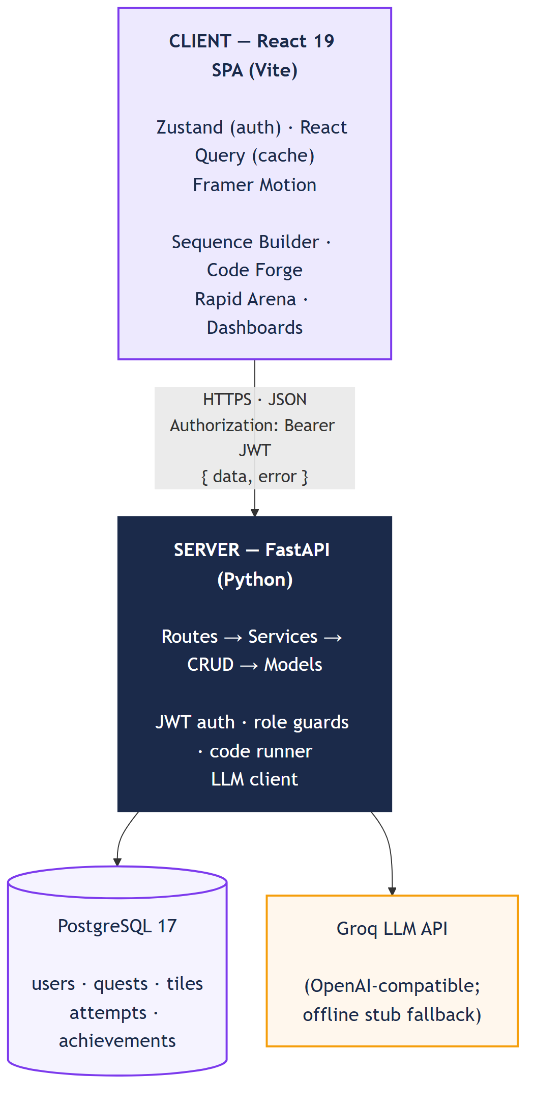
Figure 4.1: Overall System Architecture

4.3 System Workflow
At a high level, the system supports two parallel workflows that meet at the content layer:
- Teacher content workflow: the teacher authors a quest by hand, or uploads a PDF/text for AI generation → the server parses/generates draft content → the draft is stored with status PENDING_TEACHER_REVIEW → the teacher reviews and approves or rejects it → approved content becomes PUBLISHED and is now visible to students.
- Student learning workflow: the student registers/logs in → browses a subject's Skill Tree → opens an available (unlocked) quest → completes the quest's mechanic (Sequence Builder, Code Forge, or Rapid Arena) → the client submits the result to the server → the server re-verifies the result, awards XP, recomputes the level, checks achievement predicates, and marks the quest attempt COMPLETED → the next quest in the tree unlocks.

4.4 Data Flow Diagrams (Level 0 & Level 1)
Level 0 (context): Student and Teacher exchange requests/responses with the Questigo System process, which reads/writes PostgreSQL and calls the Groq LLM API only for generation.
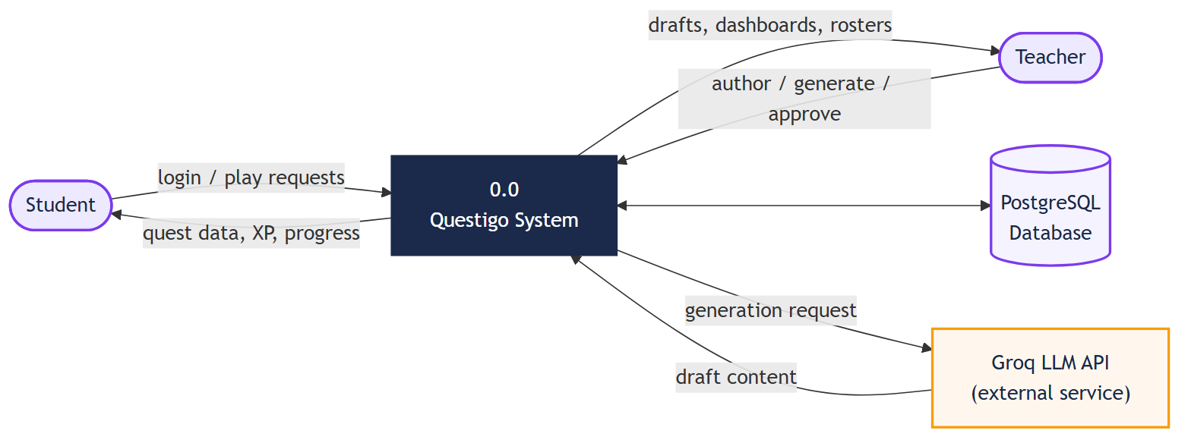
Figure 4.2: Data Flow Diagram — Level 0 (Context Diagram)
Level 1 decomposes the system into five processes — Authenticate User, Manage Content, Deliver Skill Tree & Quest, Evaluate Submission, Update Progression — against four data stores (Users, Content, Attempts, Achievements).
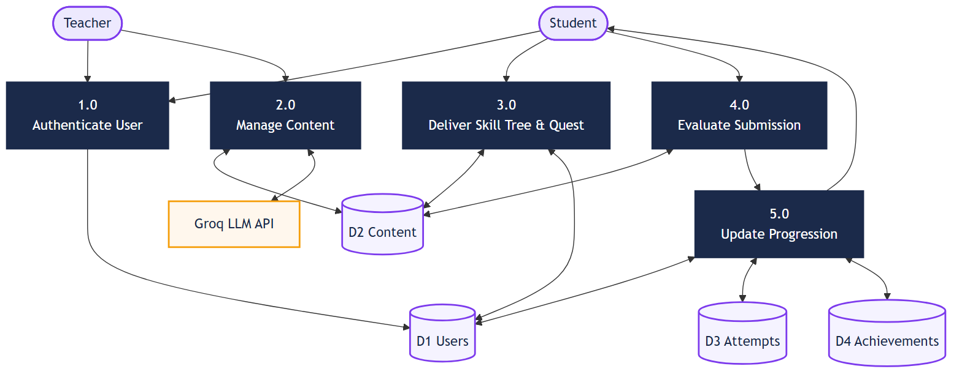
Figure 4.3: Data Flow Diagram — Level 1

4.5 Use Case Diagram
Student and Teacher actors; Play Sequence Builder / Code Forge / Rapid Arena all extend a shared Complete Quest use case, which includes Award XP & Update Progression — modelling the shared engine at the use-case level.
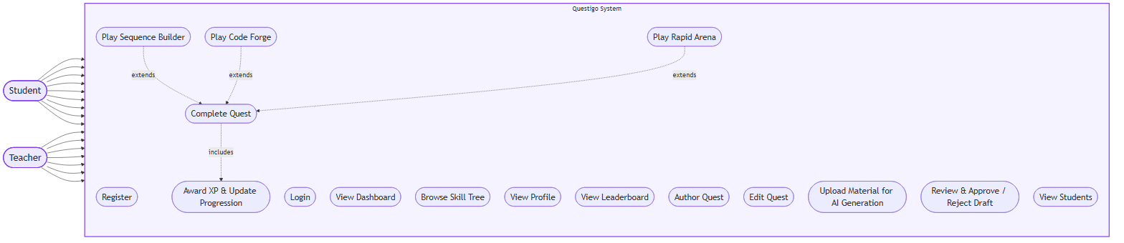
Figure 4.4: Use Case Diagram

4.6 Activity Diagram
The core student loop: Login → role branch → Select Subject/Node (locked ends; available continues) → Play Mechanic → Submit → Server Validates (fail returns to Play; pass continues) → Award XP & Recompute Level → Check Achievements → Unlock Next Node → End.
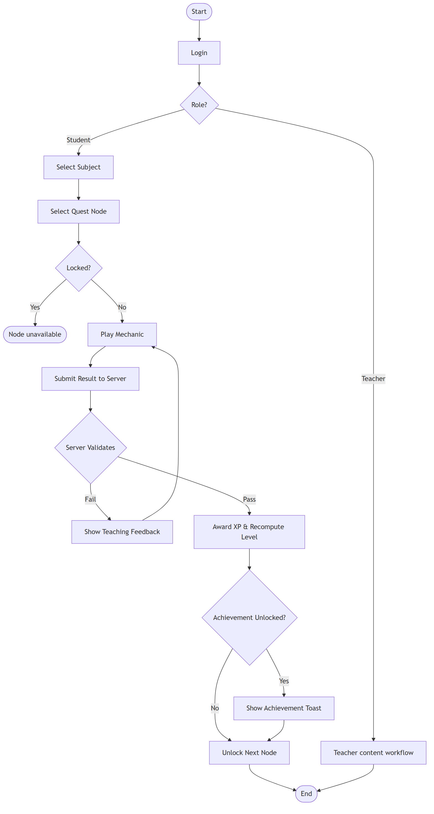
Figure 4.5: Activity Diagram — Student Gameplay Loop

4.7 Sequence Diagram
"Student completes a Sequence Builder quest": Student, React Client, FastAPI Server, Service Layer, and PostgreSQL lifelines, ending in the XP-award and achievement-check round trip re-verified server-side.
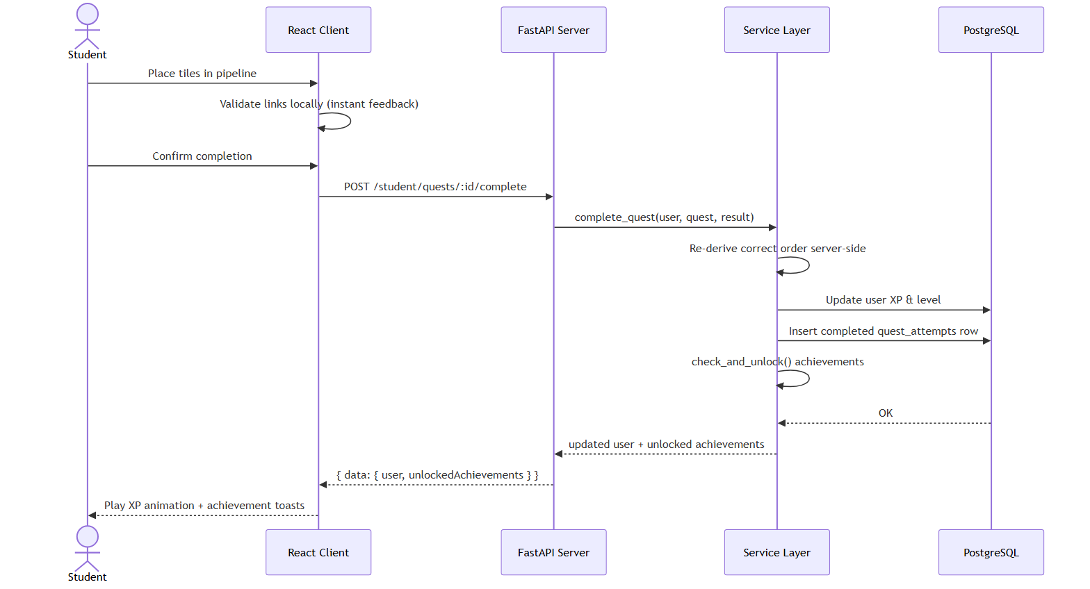
Figure 4.6: Sequence Diagram — Student Completes a Sequence Builder Quest

4.8 Component Diagram
Frontend: Auth, Dashboard, Play (Sequence/Coding/Arena), Teacher, Leaderboard, Profile — all via a shared API Client. Backend: Auth, Content, and Generation Services (the last calling an LLM Client), Code Runner, Achievement Service, and CRUD/Models — all via the Database.
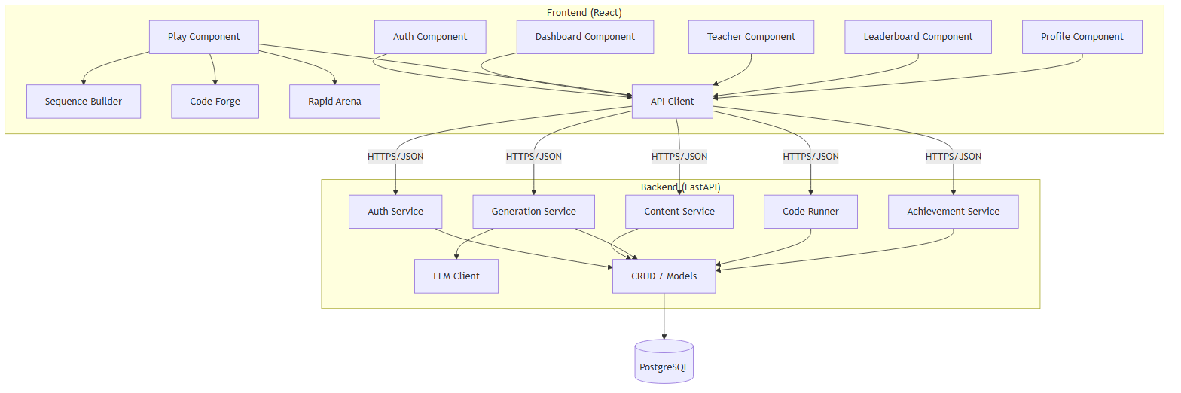
Figure 4.7: Component Diagram

4.9 Deployment Diagram
Three Docker containers — frontend/nginx (:5173, proxying /api), backend/uvicorn (:8000), db/PostgreSQL 17 (:5433, named volume) — plus the external Groq API reached only from the backend. Local development runs the same three nodes as host processes.
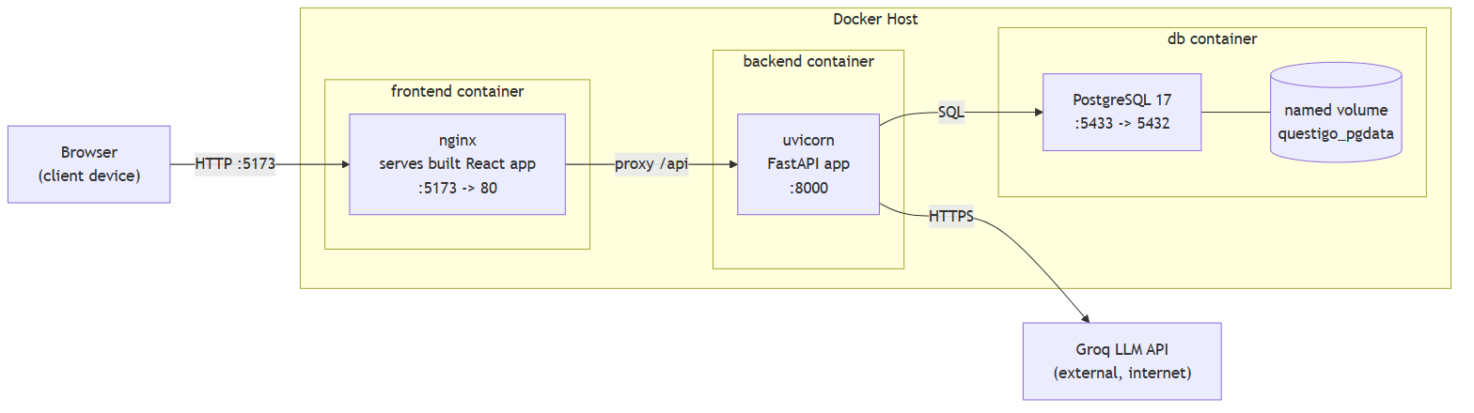
Figure 4.8: Deployment Diagram

4.10 Folder Structure
The codebase is organised as a monorepo with two top-level applications:
questigo/
|-- client/ # React 19 + TypeScript frontend (Vite)
| `-- src/
| |-- components/ui/ # Button, Card, Badge, Progress (Radix-based)
| |-- features/
| | |-- auth/ # Login . Register . Teacher login
| | |-- dashboard/ # Student & Teacher dashboards
| | |-- play/ # Skill Tree . Sequence Builder . Coding . Arena
| | |-- teacher/ # Upload . Generate . Approve . Students
| | |-- leaderboard/
| | `-- profile/ # XP, achievements, completion history
| |-- store/ # Zustand auth store (persisted)
| |-- lib/ # axios instance . levels . API modules
| `-- router/ # routes + ProtectedRoute (role guard)
|-- server/ # Python FastAPI backend
| `-- app/
| |-- api/v1/ # thin route handlers per domain
| |-- services/ # business logic (XP, generation, achievements)
| |-- crud/ # database read/write helpers
| |-- models/ # SQLAlchemy ORM classes
| `-- sql/ # canonical raw-SQL schema + seed scripts
|-- docker/ # postgres initdb snapshot, compose helpers
|-- docker-compose.yml # 3-service orchestration (db . backend . frontend)
`-- docs/ # engineering documentation (this report's sources)

4.11 Module Description
Table 4.1: Module Description
Module | Responsibility
Authentication & Authorisation | Registration, login, JWT issuance/verification, bcrypt password hashing, role guards on both client routes and server endpoints.
Student Experience | Dashboard, Skill Tree, the three gameplay mechanics, Profile, Leaderboard.
Teacher Experience | Dashboard, quest authoring & structural editing, AI generation request, draft review/approval, student roster.
Gamification Engine | XP accrual, level derivation from the fixed threshold table, achievement predicate evaluation, leaderboard ranking.
AI Content Pipeline | PDF/text ingestion, LLM prompting, draft normalisation into quest data, self-consistent test-case derivation for coding quests.
Code Execution Engine | Isolated subprocess execution of student (and reference) Python code against test cases, with a wall-clock timeout.
Data Persistence Layer | SQLAlchemy models and CRUD helpers over the canonical raw-SQL PostgreSQL schema.

4.12 Chapter Summary
This chapter presented Questigo's three-tier architecture, its two primary system workflows, the DFD/UML views modelling the system from context down to deployment, the monorepo folder structure, and a description of each functional module. Chapter 5 describes the development methodology used to build these modules, including the design of the AI content pipeline and the extensible quest-kind pattern that lets new mechanics be added without redesigning the engine.

CHAPTER 5: SYSTEM DEVELOPMENT METHODOLOGY

5.1 Introduction
Unlike a project centred on training a single predictive model, Questigo's core engineering problem is architectural: designing a data model and a set of services generic enough that three structurally different game mechanics can share one progression engine, and designing an AI content pipeline whose output can be trusted without trusting the model that produced it. This chapter documents the methodology behind both — the extensible data model, each mechanic's internal design, the AI generation-and-verification pipeline, and the key design decisions made and their rationale.

5.2 Overall Methodology
The guiding engineering principle, stated explicitly in the project's own engineering handbook, was "simplicity first": prefer the obvious implementation and add abstraction only once the simple version demonstrably fails. This principle directly shaped the decision to model all three quest mechanics as rows in one quests table distinguished by a kind enum, rather than three separate parallel systems — the simple, unified model turned out to be sufficient, so no more elaborate plugin architecture was introduced. The same principle shaped the decision to keep the progression engine (XP, levels, achievements) completely mechanic-agnostic: it reacts only to a "quest completed" event and a reward amount, with no knowledge of which mechanic produced them.

5.3 Database Schema Design (Entity–Relationship Model)
PostgreSQL is the single source of truth for the system; the schema is relational and normalised, defined by canonical raw-SQL scripts and mapped by SQLAlchemy models (the ORM never auto-creates tables, so the SQL schema remains authoritative).
users (id, name, email, password_hash, role, xp, level, created_at)
| role in { STUDENT, TEACHER }
|
+--< quest_attempts (user_id, quest_id, status, clean_build, completed_at)
| status in { IN_PROGRESS, COMPLETED }
+--< user_achievements (user_id, achievement_id, unlocked_at)
subjects (id, slug, title, description)
|
+--< quests (id, slug, title, subject_id, position, difficulty,
| xp_reward, kind, status, created_by, source_name)
| kind in { SEQUENCE, CODING, ARENA }
| status in { PENDING_TEACHER_REVIEW, PUBLISHED, REJECTED }
|
+--< quest_tiles (quest_id, tile_key, label, sub, is_distractor) -- SEQUENCE
+--< quest_links (quest_id, from_key, to_key, explanation) -- SEQUENCE
+--1 coding_challenges (quest_id, prompt, starter_code,
| language, test_cases JSONB) -- CODING
+--< arena_rounds (quest_id, prompt, options JSONB,
correct_index, position) -- ARENA
achievements (id, key, title, description, icon, position)
Key modelling decisions and their rationale:
Table 5.1: Key Database Modelling Decisions
Decision | Rationale
quests.kind enum (SEQUENCE / CODING / ARENA) | One quests table serves all three mechanics — the Skill-Tree engine stays uniform regardless of mechanic.
quests.status enum | Drives the AI approval workflow; students only ever see PUBLISHED rows, never PENDING_TEACHER_REVIEW ones.
Tiles + Links as separate tables (not one JSON blob) | A relational model lets the answer key be validated, edited, and re-keyed by position safely, and lets links be derived automatically from tile order.
arena_rounds as its own table | Keeps timed multiple-choice rounds independently orderable and re-gradable without touching the SEQUENCE tables.
test_cases as JSONB on coding_challenges | A flexible per-challenge shape; inputs and expected outputs never leave the server-side response.
users.level derived from users.xp | Level is recomputed from total XP after every award using a fixed threshold table, so it can never drift out of sync with XP.
One quest_attempts row per (user, quest) | Guarantees XP is awarded only on first completion; re-plays are idempotent by construction.

5.4 The Quest-Kind Extensibility Pattern
The platform's central architectural claim — that new game mechanics can be added without redesigning the engine — rests on a simple, deliberately repeated pattern: a new mechanic needs (1) a new value in the quests.kind enum, (2) one new table holding that mechanic's content (mirroring quest_tiles/quest_links, coding_challenges, or arena_rounds), (3) one new React component under features/play/, and (4) one new server-side validator function invoked from the shared "complete quest" service. Every other part of the system — authentication, the Skill Tree, XP/level math, achievements, and the leaderboard — is written once against the abstract notion of "a quest was completed" and needs no changes when a new mechanic is added. This pattern was exercised twice during development: once to add the Code Forge (coding) mechanic after Sequence Builder, and again to add Rapid Arena — in both cases, no code in the progression engine itself was modified.

5.5 The Gamification Engine — XP, Levels, and Achievements
Levels are derived from a fixed XP threshold table (0/100/300/600/1200/2100/3000/4200/5800/8000 for levels 1–10) rather than a dynamic formula — predictable, and impossible to desynchronise from XP since level is always recomputed, never stored independently. XP is strictly additive, and a clean completion earns a fixed +30 bonus, deterministic and mechanic-agnostic (in-mechanic score, e.g. Arena's streak, is presentation only and never feeds XP — keeping the leaderboard fair across mechanics of different difficulty). Achievements use server-side predicate functions evaluated after each completion/level-up, persisted per user and shown as stacked toasts.

5.6 The Sequence Builder Mechanic — Design and Validation Logic
The Sequence Builder does not grade an answer as a single right/wrong outcome — it validates each connection between adjacent tiles independently. A link between position i and i+1 is correct only when both endpoints hold the tile the canonical order (the quest author's intended sequence) expects at those positions; an incorrect link surfaces the pre-authored teaching explanation for the connection that should exist there, turning a wrong answer directly into a targeted learning moment rather than a bare "incorrect" marker. Distractor tiles — plausible but wrong steps mixed into the shuffled tile pool — are optional per quest and increase the mechanic's difficulty without changing its validation logic.

5.7 The Code Forge Mechanic — Sandbox Design
Coding submissions execute in an isolated Python subprocess (python -I, which disables the user site-packages and current-directory imports) with a five-second wall-clock timeout. Each test case calls the student's solution(...) function and compares its printed output against the expected string; compile errors, runtime exceptions, and timeouts are all captured and surfaced as failed tests rather than crashing the request. This is explicitly designed and documented as an MVP-grade isolation boundary suitable for a single-user local or classroom demo — it is not a hardened, resource- and syscall-isolated sandbox, and a production deployment would replace it with a container-based judge such as Judge0. This limitation is stated openly in this report (see also Section 8.3) rather than left implicit.

5.8 The Rapid Arena Mechanic — Design
Rapid Arena presents a sequence of timed multiple-choice rounds with three "hearts" (lives) and a streak multiplier that affects the in-game score display. A critical design constraint is that the answer key never reaches the browser ahead of time: each round ships to the client as a prompt and a set of options only, the student's chosen option index is sent to the server, and the server grades it against the stored correct_index one round at a time. On completion, the full run is re-graded server-side and the "clean" flag (no incorrect answers) is recomputed from the server's own record of the run rather than trusted from the client — the same anti-spoof posture applied to the Code Forge sandbox, applied here to a timed quiz format instead.

5.9 The AI Content Generation Pipeline
A teacher's PDF is parsed to raw text via pypdf (pasted text is used directly), then sent to the configured LLM (Groq by default, via an OpenAI-compatible client so the provider is swappable) with a strict JSON-mode prompt for the chosen kind — ordered tiles with distractors and per-link explanations for Sequence, or a prompt/starter code/reference solution for Coding. The response is normalised into the same shape a hand-authored quest uses and inserted as PENDING_TEACHER_REVIEW — invisible to students until approved. With no API key configured, the pipeline falls back to a deterministic extractive stub so the demo stays fully functional offline.

5.10 Self-Consistent Test-Case Derivation
For AI-generated coding quests, the model also produces a referenceSolution. Rather than trusting its reported expectedOutput values, the server executes that reference through the same sandboxed runner used to grade students and stores the actual output as ground truth; the reference is then discarded and never shown to anyone. This closes a documented LLM risk — fluent but factually wrong output (Section 2.2, #18) — by replacing trust in the model's claim with an executable, independently verifiable fact.

5.11 Evaluation Approach — Correctness and Integrity Checks
Because Questigo is a software system rather than a predictive model, its "evaluation metrics" are correctness and integrity properties verified through direct testing rather than statistical accuracy scores. The properties verified throughout development, detailed further in Chapter 7, include: idempotency of XP award on re-completion, correct level recomputation after every XP change, server-side rejection of incorrect code and incorrect arena answers with zero XP awarded, role-based endpoint isolation (403 for a wrong role, 404 for an unapproved draft), and the non-leakage of coding-challenge test data to the student-facing API.

5.12 Design Decision Log
Table 5.2: Key Design Decisions and Their Rationale
Decision | Alternative Considered | Rationale
Backend in Python + FastAPI | Node.js + Express + Prisma (originally planned) | Python's strength in AI/LLM integration and its native fit with the sandboxed Python code runner; FastAPI's auto-generated OpenAPI docs materially sped up manual testing.
One quests table with a kind enum | Separate tables/entities per mechanic | Keeps the Skill-Tree and progression engine mechanic-agnostic; validated by adding two further mechanics without touching that engine.
Retire the Data Detective (SQL-sandbox) mechanic | Keep all four mechanics | Authoring a single case required a teacher to hand-write a database schema, seed data, and expected queries — a far heavier authoring burden than any other mechanic, conflicting with the objective of reducing teacher effort. Rapid Arena replaced it because multiple-choice is a format teachers already author fluently.
Fixed XP threshold table for levels | A dynamic/continuous level formula | Predictable, tamper-resistant, and trivially kept identical between client display logic and server authority.
Deterministic offline generation stub | Hard-require a live API key | The AI generation and teacher-approval workflow remains fully demonstrable with no external dependency or cost.

5.13 Chapter Summary
This chapter described the methodology underpinning Questigo's extensibility — a single mechanic-agnostic progression engine driven by an extensible quest-kind pattern — the internal design of each of the three gameplay mechanics, the AI content pipeline and its self-consistent test-case safeguard, and the key design decisions made during development along with their rationale. Chapter 6 walks through the concrete implementation of these designs, including representative source code.

CHAPTER 6: PROJECT IMPLEMENTATION

6.1 Introduction
This chapter walks through the concrete implementation of the design described in Chapter 5, with representative source code for the pieces of logic that are the technical heart of the project: server-side XP/level derivation, the sandboxed code runner, self-consistent AI test-case generation, and the sequence-validation algorithm. Full source code excerpts are additionally provided in Annexure A.

6.2 Development Environment
- Editor: Visual Studio Code, with the Python and ESLint/Prettier extensions.
- Backend: Python 3.11+ in an isolated virtual environment (server/.venv) so dependencies never leak into the system Python.
- Frontend: Node.js 20+ with npm; Vite dev server with hot-module reload.
- Database: a local PostgreSQL 17 instance (questigo_dev) during development, and a containerised PostgreSQL 17 instance for the Docker deployment.
- Version control: Git, with the project documentation (docs/) tracking a running development log alongside the source.

6.3 Project Directory Structure
The monorepo layout is described in full in Section 4.10 (Figure/Listing 4.1). In summary, client/ holds the React/TypeScript frontend organised by feature, server/ holds the layered FastAPI backend (routes → services → CRUD → models), and docker/ plus docker-compose.yml at the repository root define the three-container deployment described in the Installation Guide.

6.4 Backend Core Implementation (Code)
The backend enforces a strict one-way dependency flow: route handlers are thin, parsing the request and delegating to a service; services hold all business logic; CRUD functions isolate SQLAlchemy queries; models map to the canonical raw-SQL schema. A representative role-guard dependency, used to protect every teacher-only endpoint, looks as follows:
def require_role(required_role: str):
def dependency(current_user: User = Depends(get_current_user)):
if current_user.role != required_role:
raise HTTPException(status_code=403, detail="Forbidden")
return current_user
return dependency

6.5 AI Generation and Code Runner Implementation (Code)
The sandboxed Python code runner executes student (and AI reference) submissions in an isolated interpreter with a wall-clock timeout:
def run_tests(source: str, test_cases: list) -> list:
results = []
for tc in test_cases:
harness = source + f"\nprint(solution({tc['input']}))"
proc = subprocess.run(
[sys.executable, "-I", "-c", harness], # isolated interpreter
capture_output=True, text=True, timeout=5, # wall-clock limit
)
got = proc.stdout.strip()
results.append({
"id": tc["id"],
"passed": got == str(tc["expectedOutput"]).strip(),
"description": tc["description"], # inputs/expected stay server-side
})
return results
For AI-generated coding quests, the same runner derives expected outputs from the model's own reference solution rather than trusting the model's report of them:
def expected_from_reference(reference: str, inputs: list) -> list:
# run the model's own reference solution to derive ground truth
computed = []
for inp in inputs:
out = run_single(reference, inp) # same sandbox as students
computed.append(out if out.ok else model_fallback(inp))
return computed # reference is never stored or shown to anyone

6.6 FastAPI Application Development (Code)
XP award and level derivation are re-verified entirely server-side, making the operation idempotent and impossible to spoof from the client:
def level_for_xp(xp: int) -> int:
# fixed threshold table -- Level 1 = 0 XP ... Level 10 = 8000 XP
level = 1
for lvl, threshold in LEVEL_THRESHOLDS:
if xp >= threshold:
level = lvl
return level
def complete_quest(db, user, quest, clean_build):
attempt = get_attempt(db, user.id, quest.id)
if attempt and attempt.status == "COMPLETED":
return {"xpAwarded": 0, "alreadyCompleted": True} # idempotent
reward = quest.xp_reward + (30 if clean_build else 0)
user.xp += reward # additive, never decreases
user.level = level_for_xp(user.xp) # recomputed, never drifts
mark_completed(db, user.id, quest.id, clean_build)
unlocked = check_and_unlock(db, user) # achievement predicates
db.commit()
return {"xpAwarded": reward, "unlockedAchievements": unlocked}

6.7 Frontend Development
The frontend is organised by feature rather than by file type: each folder under features/ owns its screens, components, and API calls, while shared UI primitives live in components/ui/ with no business logic. The Sequence Builder's validation logic runs client-side first, for instant visual feedback, and is re-verified server-side before any reward is granted:
// The canonical answer is simply the order of `tiles`.
function validatePipeline(placed, correctOrder, linkExplanations) {
const links = [];
for (let i = 0; i < placed.length - 1; i++) {
const fromOk = placed[i]?.id === correctOrder[i].id;
const toOk = placed[i + 1]?.id === correctOrder[i + 1].id;
const ok = fromOk && toOk;
links.push({
ok,
// turn a wrong link into a teaching moment
hint: ok ? null
: linkExplanations[`${correctOrder[i].id}->${correctOrder[i+1].id}`],
});
}
const solved = links.every(l => l.ok) && placed.length === correctOrder.length;
return { links, solved };
}

6.8 Gameplay Workflow and XP Award
Regardless of which of the three mechanics a student plays, the end-of-quest workflow converges on the same sequence: the client posts the raw result (placed tile order, submitted code, or selected answer indices) to a mechanic-specific completion endpoint; the corresponding service re-derives correctness independently of anything the client claims; on success, the shared complete_quest routine shown in Section 6.6 runs once, regardless of mechanic; the client then receives the updated user object and any unlocked achievements, and plays the XP-bar animation and achievement toasts. This convergence point is what makes the progression engine mechanic-agnostic in practice, not just in intent.

6.9 Testing
Verification emphasised end-to-end behavioural testing against the live database over exhaustive unit testing — the strategy judged to best de-risk a live viva demonstration. Testing activity is detailed fully in Chapter 7 (Results and Discussion) and Section 7.5 (Sample Test Cases); in summary it combined FastAPI TestClient integration tests, scripted round-trips against the real database, tsc -b static type-checking plus a full Vite production build on every phase, and manual browser click-through testing at both desktop and 375px mobile width.

6.10 Challenges Faced During Development
Table 6.1: Development Challenges and Resolutions
Challenge | Resolution
Trusting AI-generated coding test cases | Resolved by deriving expected outputs from executing the model's own reference solution (Section 5.10) instead of trusting its reported values.
Large AI-generated payloads (Arena rounds) truncating mid-JSON | The LLM client was not given an explicit max_tokens limit; larger structured outputs silently truncated and failed JSON-mode parsing. Fixed by setting an explicit, sufficiently large max_tokens value in the LLM client configuration.
Data Detective mechanic's authoring cost | Building a working prototype revealed that authoring a single case required a teacher to hand-write a schema, seed data, and expected queries — evaluated as disproportionately heavy, and the mechanic was deliberately retired in favour of Rapid Arena (Section 5.12).
PostgreSQL cannot drop a single enum value | The retired DETECTIVE value in the quest_kind enum, and its now-empty detective_cases table, cannot be cleanly removed without recreating the enum type. Documented explicitly as an intentional, understood retirement rather than accidental dead code (Section 7.7).
Misleading "clean" TypeScript check | tsc --noEmit against the repository's root tsconfig.json (a solution file with an empty files list) silently checks nothing and reports false success. The verified command is tsc -b, run from client/.
Keeping local and containerised environments equivalent | Local development and the Docker snapshot could drift in seed content; resolved by making the seed scripts tolerant of either naming scheme and documenting the reconciliation step when a new snapshot is taken.

6.11 Chapter Summary
This chapter presented the concrete implementation of Questigo's backend and frontend, with representative code for role-based access control, the sandboxed code runner, self-consistent AI test-case derivation, server-side XP/level integrity, and client-side sequence validation, alongside the genuine engineering challenges encountered and how each was resolved. Chapter 7 presents the results of testing this implementation and discusses them against the project's objectives.

CHAPTER 7: RESULTS AND DISCUSSION

7.1 Introduction
This chapter presents the results of verifying the implemented system against the objectives set out in Chapter 1, discusses representative screenshots and sample test cases, and closes with an honest assessment of the platform's advantages and current limitations.

7.2 Experimental Setup
Verification was carried out against a live PostgreSQL 17 database (questigo_dev) with the backend running under uvicorn on port 8000 and the frontend served by the Vite development server on port 5173, and was independently re-verified against the containerised three-service Docker Compose deployment to confirm the same behaviour holds in a from-scratch, production-shaped environment. Three seeded accounts were used throughout: two students and one teacher, exercising every role-gated code path.

7.3 Feature Completion and Verified Behaviour
Table 7.1: Feature Completion Against the MVP Scope
Module | Outcome
Authentication (JWT + bcrypt, 2 roles) | Complete
Sequence Builder (per-link validation, Clean Build bonus) | Complete
Code Forge (Monaco editor + sandboxed Python runner) | Complete
Rapid Arena (timed MCQ, hearts, streak, server-side re-grading) | Complete
XP, Levels, Achievements, Leaderboard | Complete
Skill-Tree progression (prerequisite gating) | Complete
AI generation (all three kinds) + mandatory teacher approval | Complete
Teacher authoring & structural editing | Complete
Student profile & completion history | Complete
Responsive UI (mobile-first to 375px) + error boundaries | Complete
Containerised (Docker Compose) deployment | Complete

Representative confirmed results from end-to-end verification against the live database:
- XP integrity — completing a quest awards the exact configured reward plus the +30 clean bonus where earned, recomputes the level, and re-orders the leaderboard; replaying an already-completed quest awards 0 XP (idempotent).
- Anti-spoof (coding) — submitting incorrect code returns HTTP 400 and awards nothing; the server re-runs the code before crediting any XP.
- Anti-spoof (arena) — the answer key is never sent to the browser ahead of time; each round is graded server-side one at a time and the full run is re-graded on completion.
- Content security — students receive coding-test descriptions only; inputs and expected outputs never leave the server.
- Role isolation — a student calling a teacher endpoint receives 403; an unapproved draft quest is invisible (404) to students.
- Live AI generation — a Groq run over uploaded lecture material produced correctly-ordered sequence steps, sensible distractors, meaningful per-link explanations, and (for coding quests) self-consistent, solvable test cases.

7.4 Screenshot-wise Discussion
The following screens were captured during end-to-end verification against the live database, demonstrating each mechanic and the AI content pipeline in the running application.
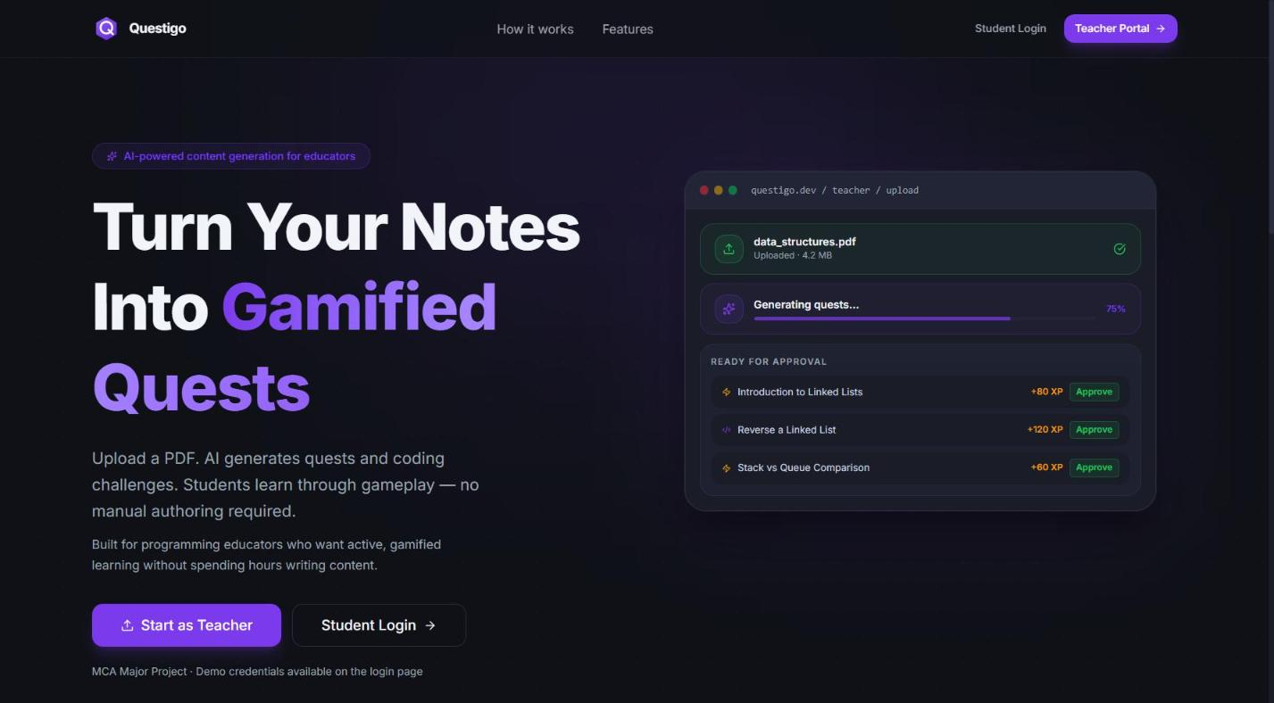
Figure 7.1: Landing Page
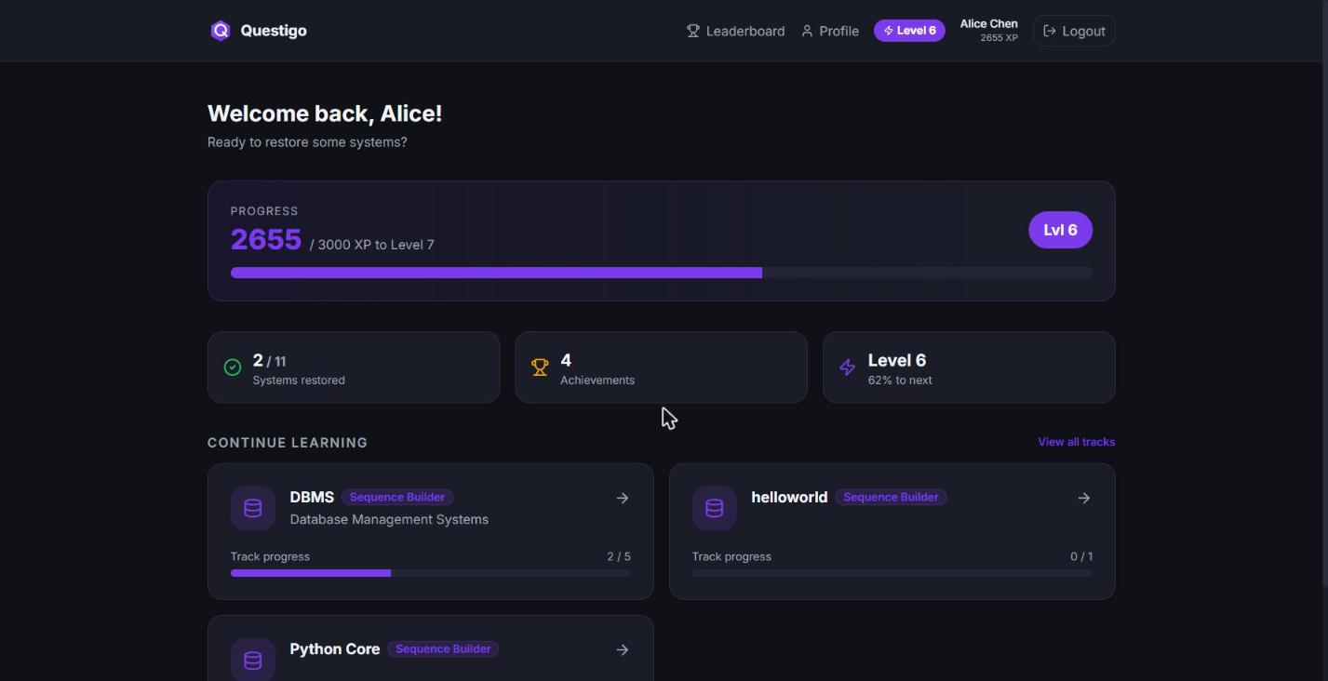
Figure 7.2: Student Dashboard (logged in as Alice)
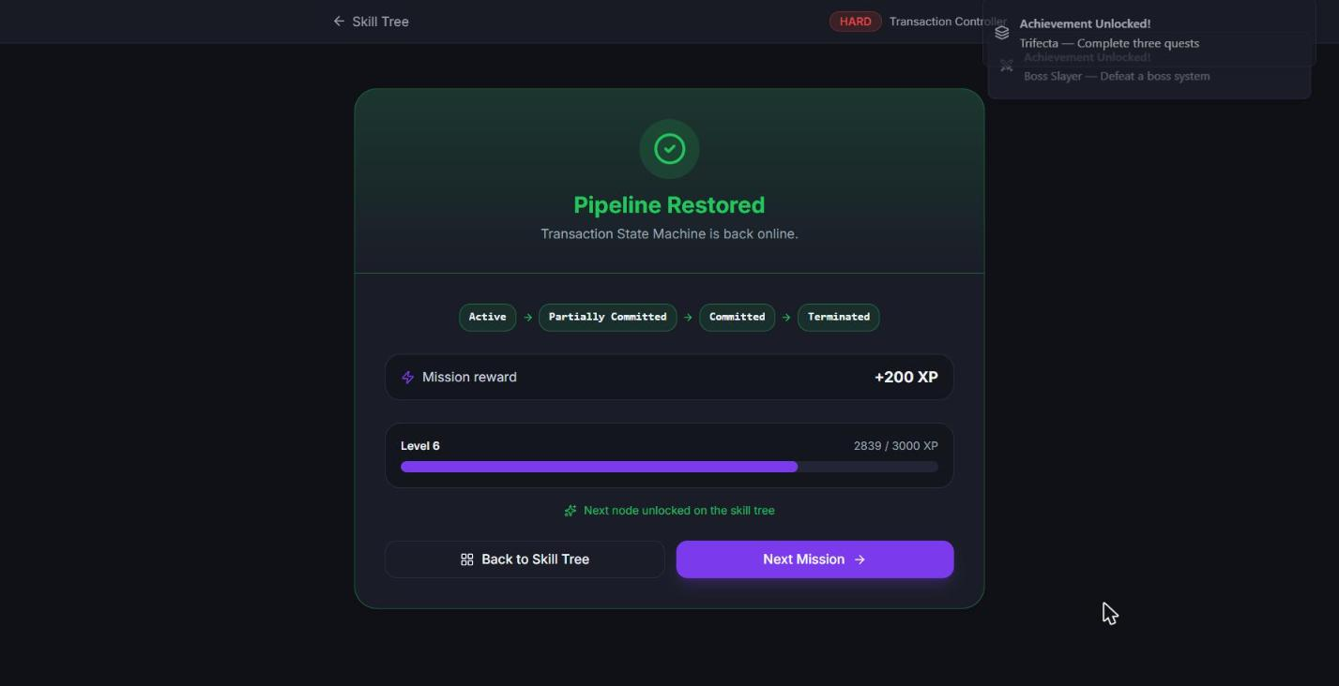
Figure 7.3: Sequence Builder — pipeline restored, XP awarded, achievements unlocked
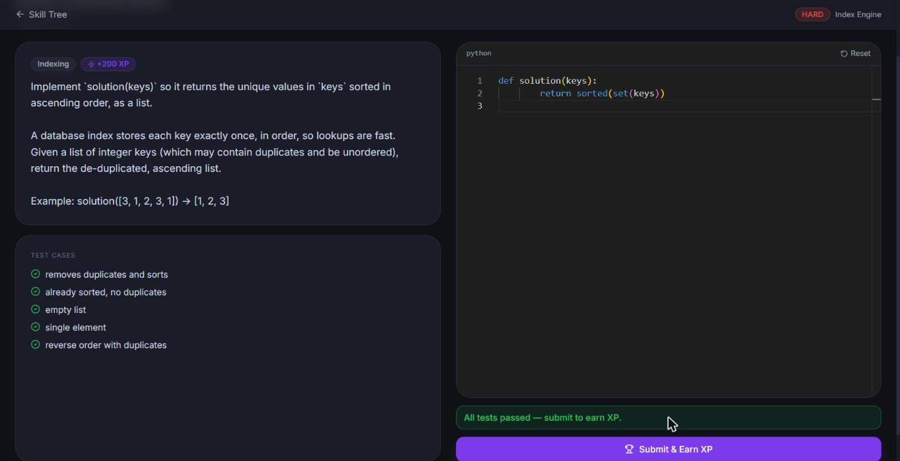
Figure 7.4: Code Forge — all tests passed, ready to submit for XP
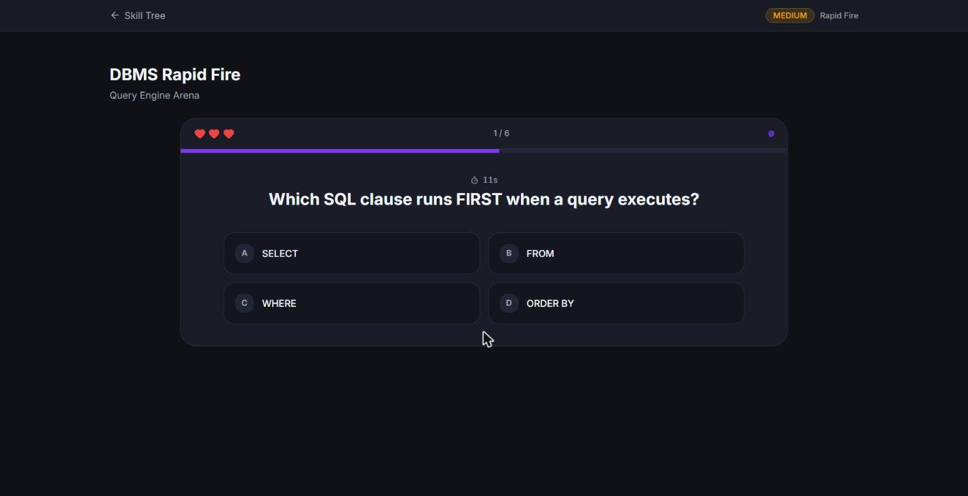
Figure 7.5: Rapid Arena — timed multiple-choice round with hearts and countdown
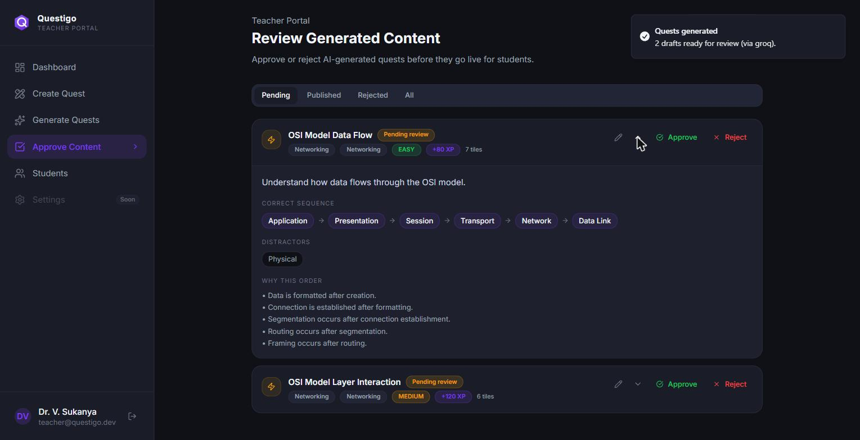
Figure 7.6: Teacher — Approve Content: live Groq-generated draft with sequence, distractor, and explanations
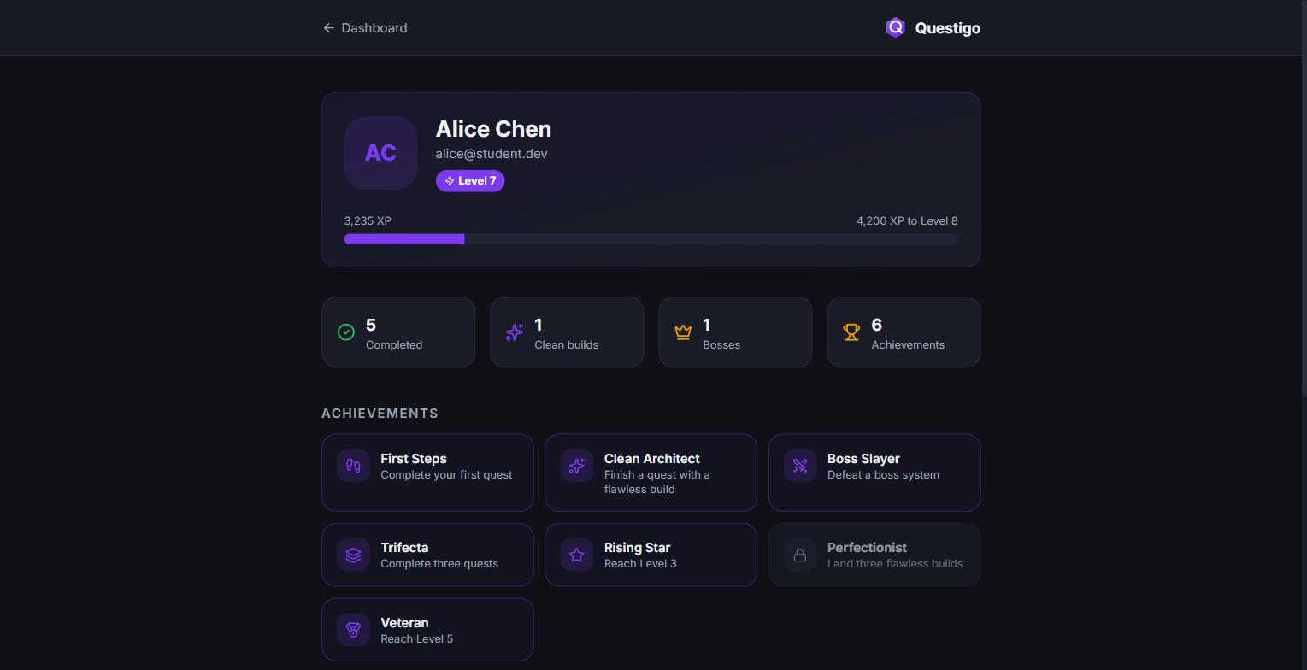
Figure 7.7: Student Profile — level, XP, stats, and achievements grid

7.5 Sample Test Cases
Table 7.2: Sample Test Cases and Verified Results
# | Scenario | Expected Result | Actual Result
1 | Student completes a quest cleanly (no wrong attempts) | Base XP + 30 clean bonus awarded; level recalculated; relevant achievements unlocked | Pass
2 | Student re-plays an already-completed quest | 0 XP awarded (idempotent) | Pass
3 | Student submits failing code, then a correct fix | First submission: HTTP 400, no XP. Second: XP awarded once tests pass | Pass
4 | Student calls a teacher-only endpoint | HTTP 403 Forbidden | Pass
5 | Student requests an unapproved (PENDING) draft quest | HTTP 404 (hidden, not merely restricted) | Pass
6 | Teacher generates quests from an uploaded PDF (Groq live) | Valid, correctly-ordered quest drafts created with status PENDING_TEACHER_REVIEW | Pass
7 | AI-generated coding challenge solved by a genuinely correct solution() | All tests pass (self-consistent by construction) | Pass
8 | Structural edit attempted on a CODING-kind quest | Rejected with HTTP 400 — structural editing is Sequence-only | Pass
9 | Rapid Arena run with one deliberately wrong answer | Run completes, XP awarded without the clean bonus, streak resets on the wrong answer | Pass
10 | Full application build (tsc -b + vite build) | Zero type errors; production bundle builds successfully | Pass

7.6 Discussion of Results
Every objective listed in Section 1.8 was delivered and independently verified. Beyond the original MVP boundary, the project additionally shipped a third game mechanic (Rapid Arena, added after the initial two-mechanic MVP), persisted achievements with predicate-based unlocking, structural quest authoring/editing in the teacher UI, and AI generation extended to all three quest kinds — features that were originally scoped as post-MVP future work. A fourth mechanic, Data Detective, was built, evaluated against the project's own teacher-effort objective, and deliberately retired — a result reported here as a considered design decision (Section 5.12) rather than an omission, since a feature built, measured, and consciously removed is stronger engineering evidence than a feature never attempted.
Engineering-quality indicators observed during development: zero hardcoded mock data anywhere in the shipped frontend (every screen is database-driven); a full TypeScript codebase passing tsc -b with zero errors; a four-layer backend separation (routes/services/CRUD/models) maintained throughout; and a minimum verified responsive width of 375px across every screen. The Monaco editor is loaded as its own lazy-loaded code-split chunk, so it is only downloaded when a Code Forge quest is actually opened, keeping the main application bundle lighter for all other screens.

7.7 Advantages and Limitations

7.7.1 Advantages
- Three structurally distinct, complementary assessment mechanics under one shared, mechanic-agnostic progression engine.
- Server-side re-verification of every reward-affecting outcome removes client-side spoofing as an attack surface.
- AI content generation is paired with a mandatory human-approval gate and, for coding quests, an executable self-consistency check on generated test data.
- Demonstrated extensibility: two new mechanics (Coding, then Arena) were added after the initial design without modifying the shared progression engine.
- Fully database-driven with no mock data, so a live demonstration reflects the actual, running product.

7.7.2 Limitations
- The code execution sandbox is an isolated subprocess with a wall-clock timeout, not a hardened, resource- and syscall-isolated judge — adequate for a supervised local demo, explicitly not production-safe at scale (a container-based judge such as Judge0 is the correct next step).
- The coding runner supports Python only.
- The retired DETECTIVE value remains in the quests.kind enum and its detective_cases table remains (now empty) in the schema, because PostgreSQL cannot drop a single enum value without recreating the type; this is a deliberate, documented retirement rather than an oversight.
- Content breadth is limited to the seeded demonstration subject track(s) — the project proves architectural completeness rather than shipping an exhaustive content library.
- No adaptive difficulty, multiplayer, or LMS integration in the current MVP (see Section 8.3, Future Scope).

7.8 Chapter Summary
This chapter demonstrated that every project objective was met and independently verified, presented representative screenshots and sample test cases, and gave an honest account of the platform's advantages alongside its current, explicitly documented limitations. Chapter 8 concludes the report and sets out the future scope of the project.

CHAPTER 8: CONCLUSION AND FUTURE SCOPE

8.1 Conclusion
Questigo set out to answer a simple question: what if learning a technical subject felt less like reading a textbook and more like playing through a well-designed game? The delivered platform answers it concretely. Students learn by reconstructing real systems — validated connection by connection — by writing and running real code, and by testing recall under time pressure, all inside one RPG-style progression of XP, levels, achievements, and leaderboards that keeps them coming back.
Technically, the project is a complete, modern, full-stack application: a typed React 19 single-page frontend over a layered FastAPI and PostgreSQL backend, secured with JWT authentication, and integrated with a live Large Language Model to turn a teacher's raw material into playable content — always behind a mandatory human-approval gate that keeps the AI trustworthy, and, for coding quests, behind an executable self-consistency check that keeps generated answer keys provably solvable. Every objective set out in Chapter 1 was met, and several features originally scoped as post-MVP were delivered within the project timeline. Crucially, the system is fully database-driven with no mock data, which means a live demonstration shows the real product, not a rehearsed facade.
As an MCA major project, Questigo demonstrates competence across the breadth of the discipline — web technologies, relational database design, layered software architecture, authentication and authorisation, and applied use of generative AI — while contributing a genuinely original idea: assessment by construction rather than by recognition. It is ambitious in concept, complete in execution, and honest about both its limits and its road ahead.

8.2 Project Achievements
- Designed and implemented three structurally distinct game mechanics — Sequence Builder, Code Forge, and Rapid Arena — unified under one extensible progression engine.
- Delivered a complete AI-assisted content pipeline from raw teacher material to a verified, self-consistent, publishable quest, gated by mandatory human approval.
- Built and shipped a layered, typed, full-stack architecture with zero mock data, verified end-to-end in the browser with zero console errors.
- Made and documented a considered engineering trade-off — building and then retiring the Data Detective mechanic — as evidence of evaluative, not just additive, engineering judgement.
- Deployed the complete system both as local development processes and as a reproducible, three-container Docker Compose stack.

8.3 Future Scope
The architecture was deliberately built to extend. Each item below is a natural next step, not a rewrite:
Table 8.1: Future Scope
Area | Planned Extension
Hardened code sandbox | Replace the subprocess runner with a container-isolated judge (e.g. Judge0 or gVisor) for safe, multi-language execution at scale.
Additional languages | Extend the coding runner beyond Python to Java, C++, and JavaScript.
Adaptive difficulty | Use a student's attempt history to tune quest difficulty and recommend the next node — a personalised learning path, informed by the AI-adaptive-learning literature reviewed in Chapter 2.
Multiplayer battles | Real-time head-to-head Sequence or Code Forge races over WebSockets, with a live spectator leaderboard.
Mixed-kind AI generation | Let the model decide, per topic, whether a concept is best taught as a sequence, a coding challenge, or a recall round.
Analytics and LMS integration | Teacher dashboards with cohort-level analytics, plus LTI or Google Classroom export of grades and progress.
Native mobile application | The tap-to-place mechanic and vertical layout are already mobile-first, easing a React Native port.
Production hardening | Rate-limiting and refresh-token rotation on authentication, managed PostgreSQL with schema migrations (Alembic), a reverse proxy and CDN-served static assets, and structured logging/error tracking.

In one line: Questigo turns passive, quiz-based learning into an active, game-based journey where students build their understanding — literally — one validated connection, one passing test, and one correct answer at a time.

REFERENCES
Academic literature:
- Malone, T. W. (1981). Toward a Theory of Intrinsically Motivating Instruction. Cognitive Science, 5(4), 333–369.
- Papert, S. (1980). Mindstorms: Children, Computers, and Powerful Ideas. Basic Books, New York.
- Csikszentmihalyi, M. (1990). Flow: The Psychology of Optimal Experience. Harper & Row, New York.
- Deci, E. L., & Ryan, R. M. (2000). Self-Determination Theory and the Facilitation of Intrinsic Motivation, Social Development, and Well-Being. American Psychologist, 55(1), 68–78.
- Prensky, M. (2001). Digital Game-Based Learning. McGraw-Hill, New York.
- Deterding, S., Dixon, D., Khaled, R., & Nacke, L. (2011). From Game Design Elements to Gamefulness: Defining Gamification. Proceedings of the 15th International Academic MindTrek Conference, 9–15.
- Hamari, J., Koivisto, J., & Sarsa, H. (2014). Does Gamification Work? A Literature Review of Empirical Studies on Gamification. Proceedings of the 47th Hawaii International Conference on System Sciences, 3025–3034.
- Kapp, K. M. (2012). The Gamification of Learning and Instruction: Game-Based Methods and Strategies for Training and Education. Pfeiffer, San Francisco.
- Papastergiou, M. (2009). Digital Game-Based Learning in High School Computer Science Education: Impact on Educational Effectiveness and Student Motivation. Computers & Education, 52(1), 1–12.
- Barata, G., Gama, S., Jorge, J., & Gonçalves, D. (2013). Engaging Engineering Students with Gamification. Proceedings of the 5th International Conference on Games and Virtual Worlds for Serious Applications (VS-GAMES), 24–31.
- Sailer, M., Hense, J. U., Mayr, S. K., & Mandl, H. (2017). How Gamification Motivates: An Experimental Study of the Effects of Specific Game Design Elements on Psychological Need Satisfaction. Computers in Human Behavior, 69, 371–380.
- Zeybek, N., & Saygı, E. (2024). Gamification in Education: Why, Where, When, and How? — A Systematic Review. Games and Culture / SAGE Open. DOI: 10.1177/15554120231158625.
- Mellado, F. et al. (2024). Gamification Improves Learning: Experience in a Training Activity of Computer Programming in Higher Education. Journal of Computer Assisted Learning. DOI: 10.1111/jcal.13000.
- Zeng, Z. et al. (2024). Exploring the Impact of Gamification on Students' Academic Performance: A Comprehensive Meta-Analysis of Studies from the Year 2008 to 2023. British Journal of Educational Technology. DOI: 10.1111/bjet.13471.
- Gligorea, I., Cioca, M., Oancea, R., Gorski, A.-T., Gorski, H., & Tudorache, P. (2023). Adaptive Learning Using Artificial Intelligence in e-Learning: A Literature Review. Education Sciences, 13(12), Article 1216. DOI: 10.3390/educsci13121216.
- How Teachers Can Use Large Language Models and Bloom's Taxonomy to Create Educational Quizzes (2024). arXiv:2401.05914.
- Automated Educational Question Generation at Different Bloom's Skill Levels Using Large Language Models: Strategies and Evaluation (2024). arXiv:2408.04394.
- Ji, Z., Lee, N., Frieske, R., Yu, T., Su, D., Xu, Y., et al. (2023). Survey of Hallucination in Natural Language Generation. ACM Computing Surveys, 55(12), Article 248. DOI: 10.1145/3571730.
- Vahldick, A., Mendes, A. J., & Marcelino, M. J. (2014). A Review of Games Designed to Improve Introductory Computer Programming Competencies. Proceedings of the IEEE Frontiers in Education Conference (FIE), 1–7.
- Kazimoglu, C., Kiernan, M., Bacon, L., & Mackinnon, L. (2012). A Serious Game for Developing Computational Thinking and Learning Introductory Computer Programming. Procedia – Social and Behavioral Sciences, 47, 1991–1999.
Technical documentation:
- React documentation — https://react.dev
- FastAPI documentation — https://fastapi.tiangolo.com
- PostgreSQL 17 documentation — https://www.postgresql.org/docs/17/
- SQLAlchemy 2.0 documentation — https://docs.sqlalchemy.org
- Docker Compose documentation — https://docs.docker.com/compose/
- Groq API documentation — https://console.groq.com/docs
- Monaco Editor documentation — https://microsoft.github.io/monaco-editor/

ANNEXURE A: SOURCE CODE
This annexure indexes the key source files referenced throughout this report; representative excerpts appear in Chapter 6 (Sections 6.4–6.7). Full source is contained in the project repository submitted alongside this report.
Table 10.1: Indexed Source Files
File | Purpose
server/app/main.py | FastAPI application entry point, CORS and exception-handler setup.
server/app/api/v1/auth.py | Registration, login, and /me endpoints.
server/app/api/v1/student.py | Quest completion, XP award, and profile endpoints.
server/app/api/v1/teacher.py | Authoring, structural editing, generation, and approval endpoints.
server/app/services/student_service.py | XP/level derivation and quest-completion business logic.
server/app/services/generation_service.py | AI content generation and self-consistent test-case derivation.
server/app/services/code_runner.py | Sandboxed subprocess execution of student/reference code.
server/app/services/achievement_service.py | Achievement predicate evaluation and unlocking.
server/sql/01_schema.sql | Canonical relational schema (DDL).
client/src/features/play/components/SequenceBuilder.tsx | Sequence Builder gameplay component and client-side validation.
client/src/features/play/components/CodeForge.tsx | Monaco-based coding challenge component.
client/src/features/play/components/ArenaGame.tsx | Rapid Arena timed multiple-choice component.
client/src/store/authStore.ts | Zustand authentication store (persisted JWT + user).
client/src/lib/api.ts | Axios instance, JWT interceptor, and API error extraction.

ANNEXURE B: DATABASE SCHEMA / SAMPLE SEED DATA
Representative seed rows illustrating the schema described in Section 5.3:
-- users
id | name | email | role | xp | level
---+---------------+------------------------+---------+------+------
1 | Teacher Demo | teacher@questigo.dev | TEACHER | 0 | 1
2 | Alice | alice@student.dev | STUDENT | 2655 | 6
3 | Bob | bob@student.dev | STUDENT | 850 | 3
-- quests (subject: DBMS)
id | slug | title | kind | status | xp_reward
---+---------------+---------------------------+----------+-----------+----------
1 | sql-execution | SQL Execution Order | SEQUENCE | PUBLISHED | 150
2 | normalization | Normalization Steps | SEQUENCE | PUBLISHED | 175
3 | index-builder | Index Builder Challenge | CODING | PUBLISHED | 200
-- achievements
key | title | description
---------------+------------------+---------------------------------------
first_quest | First Quest | Complete your first quest
clean_architect| Clean Architect | Complete a quest with zero wrong links
boss_slayer | Boss Slayer | Defeat a track's boss node
Full seed scripts are contained in server/sql/02_seed.sql and server/scripts/seed.py in the project repository.

USER MANUAL

For Students
- Open the application URL in a web browser and select Register to create an account, or Login with existing credentials.
- On the Dashboard, review your current XP, level, and recent activity.
- Select a subject to open its Skill Tree; nodes are shown as locked, available, or completed.
- Open an available node to start its quest and read the mission brief.
- Complete the quest's mechanic: arrange tiles into the correct order (Sequence Builder), write and run code (Code Forge), or answer timed questions (Rapid Arena).
- On success, XP is awarded automatically and any unlocked achievements appear as toast notifications; the next node in the tree unlocks.
- Visit Profile at any time to review your level, XP progress, completed quests, and achievements grid.
- Visit Leaderboard to see how your XP ranks against other students.

For Teachers
- Log in with a teacher account to reach the Teacher Dashboard, showing subject, quest, and student counts.
- To hand-author a quest, open the quest builder for the target subject, choose a quest kind, and fill in its content (tiles/links for Sequence, or prompt/starter code/tests for Coding).
- To generate content with AI, open Generate, upload a PDF or paste text, choose a quest kind and how many quests to produce, and submit.
- Open Approve to review each AI-generated draft in full — including its answer key — and either Approve (publishing it to students) or Reject it.
- Open Students to view a roster of all students with their completion and achievement counts.

INSTALLATION GUIDE

Option A — Local Development (no Docker)
Prerequisites: Node.js 20+, Python 3.11+, PostgreSQL 17, and (optionally) a Groq API key for live AI generation.
- Create a PostgreSQL database named questigo_dev and run the schema/seed scripts in server/sql/.
- In server/, create an isolated virtual environment, install dependencies from requirements.txt, and configure server/.env (DATABASE_URL, JWT secret, CORS origin, optional AI_API_KEY).
- Start the backend: ./.venv/Scripts/python.exe -m uvicorn app.main:app --reload --port 8000
- In client/, run npm install (first run only), configure client/.env (VITE_API_URL), and start the frontend: npm run dev
- Open http://localhost:5173 in a browser and log in with a seeded demo account (Section 10.4 / Chapter 6).

Option B — Docker Compose (recommended for a clean, reproducible demo)
Prerequisites: Docker Desktop or Docker Engine with Compose.
- From the repository root, run: docker compose up -d --build
- Open http://localhost:5173. The database is pre-loaded from a snapshot (docker/postgres/initdb/10_snapshot.sql), which Postgres loads automatically only when its data volume is empty (first boot, or after a down -v).
- Check backend health directly at http://localhost:8000/health.
- Day-to-day changes persist in the named volume across stop/start/up/down; to reset to the known-good snapshot, run docker compose down -v && docker compose up -d.
Note: the AI provider key and JWT secret are read from server/.env via env_file in both options. As stated in Section 7.7.2, any live third-party API key present in this file should be rotated or removed before the project repository or this report is submitted, printed, or shared publicly.

GLOSSARY
Table 15.1: Glossary of Terms
Term | Definition
Achievement | A named milestone (e.g. "First Quest") that unlocks for a student when its server-side predicate condition is met.
Clean Build | Completing a quest with zero incorrect attempts, earning a fixed +30 XP bonus.
Code Forge | The coding-challenge game mechanic: a Monaco editor in which a student implements and runs real Python code against hidden test cases.
Distractor | A plausible but incorrect tile mixed into a Sequence Builder quest's shuffled tile pool.
Gamification | The application of game-design elements (points, levels, badges, leaderboards) to a non-game context to increase engagement.
JWT (JSON Web Token) | A signed, stateless token used to authenticate a user and carry their role between requests.
Leaderboard | A ranking of all students by total XP, refreshed on load.
Quest | A single unit of learning content — one node in a subject's Skill Tree — of a specific kind (Sequence, Coding, or Arena).
Quest Kind | The enumerated type of a quest (SEQUENCE, CODING, or ARENA) that determines which mechanic and which content tables apply.
Rapid Arena | The timed multiple-choice game mechanic, with hearts and a streak multiplier.
Sequence Builder | The construction-based game mechanic in which a student reconstructs a process by ordering shuffled tiles, with per-link validation.
Skill Tree | The prerequisite-gated map of a subject's quests, in which a node unlocks only once its predecessor is completed.
Self-consistent test case | A coding-quest test case whose expected output was computed by executing the AI model's own reference solution, rather than trusted from the model's report.
XP (Experience Points) | The additive, never-decreasing score awarded on quest completion, from which a student's level is derived via a fixed threshold table.

