FIFA World Cup Performance Analysis using Power BI and Python
Submitted By:
Akshay
MCA – 2nd Year
Academic Year: 2024–2026

Abstract
This project analyzes FIFA World Cup match performance using Power BI and Python-based advanced analytics. The dashboard provides insights into total goals, win rate, possession trends, attendance patterns, goal distribution, team performance comparison, clustering behavior, correlation analysis, and multi-dimensional visualization.
Power BI is used for interactive business intelligence dashboards, while Python is integrated for advanced statistical and machine learning analysis including correlation heatmaps, PCA, clustering, violin plots, density analysis, radar charts, 3D visualization, and network analysis.

Introduction
Football performance analysis involves evaluating match statistics such as goals scored, possession percentage, shots on target, attendance, and win rate. Modern analytics integrates statistical modeling and interactive visualization tools.
Project Aims:
- Analyze World Cup team performance trends
- Identify goal-scoring and win-rate patterns
- Study attendance and possession impact
- Apply advanced analytical techniques using Python
- Create an interactive multi-page Power BI dashboard

Objectives of the Project
- Analyze FIFA World Cup performance metrics
- Visualize goal distribution by team and year
- Evaluate correlation between key match metrics
- Identify performance clusters using PCA and K-Means
- Create interactive dashboards using Power BI
- Integrate Python-based advanced analytics visuals

Tools & Technologies Used
- Power BI Desktop – Data visualization & dashboard
- Python – Advanced statistical analysis
- Pandas – Data preprocessing
- Matplotlib / Seaborn – Visualization
- Scikit-learn – PCA & Clustering
- NetworkX – Network graph analysis

Dataset Description
- worldcup_year
- home_team
- away_team
- home_score
- away_score
- possession_home
- shots_on_target_home
- shots_on_target_away
- attendance
- stadium
- host_country
- match_date
- match_id

Data Preprocessing
- Removed missing values
- Standardized team names
- Created calculated measures (Total Goals, Goal Difference, Win Rate, Average Possession, Total Matches)
- Aggregated goals by team and year
- Structured dataset for Power BI visualization

Dashboard Pages Explanation

Page 1 – Overview Dashboard
- Total Goals KPI
- Win Rate KPI
- Average Attendance KPI
- Average Possession KPI
- Total Goals by Home Team (Bar Chart)
- Home Team & Attendance Map

Page 2 – Goals & Trend Analysis
- Home Goals vs Away Goals by Year
- Total Goals by Year (Area Chart)
- Goal Difference Waterfall Chart
- Sum of Home Score by Year

Page 3 – Team Performance Comparison
- Donut Chart – Total Goals by Home Team
- Bubble Chart – Possession vs Total Goals
- Team Contribution Distribution

Page 4 – Correlation & Distribution Analysis
- Correlation Heatmap
- Violin Plot
- Density Distribution of Goals
- Pair Plot

Page 5 – Advanced Analytics (Python Visuals)
- PCA Projection Plot
- K-Means Clustering Visualization
- 3D Performance Scatter Plot
- Radar Chart

Page 6 – Network & Interaction Analysis
- Team Interaction Network Graph
- Bubble Matrix Analysis by Year
- Hexbin Density Plot

Conclusion
This project demonstrates how Power BI and Python can be integrated to perform comprehensive FIFA World Cup performance analysis. The dashboard provides descriptive and advanced statistical insights using clustering, PCA, correlation analysis, and network modeling.

References
- Microsoft Power BI Documentation
- Pandas Documentation
- Scikit-learn Documentation
- Matplotlib Documentation
- Seaborn Documentation

Dashboard Screenshots

Page 1: Overview Dashboard
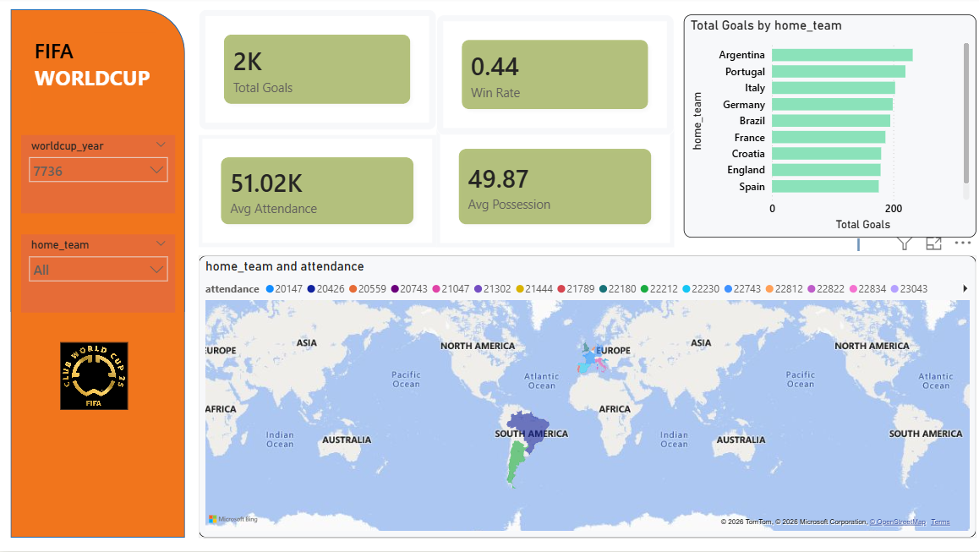
Description:
• Total Goals KPI
• Win Rate KPI
• Average Attendance KPI
• Average Possession KPI
• Total Goals by Home Team (Bar Chart)
• Home Team & Attendance Map
Purpose:
Provides high-level summary of World Cup performance indicators.

Page 2: Goals & Trend Analysis
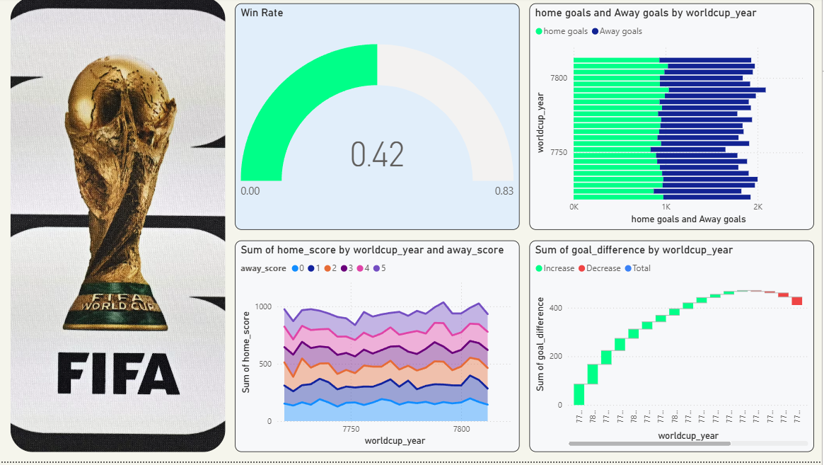
• Home Goals vs Away Goals by Year (Bar Chart)
• Total Goals by Year (Area Chart)
• Goal Difference Waterfall Chart
• Sum of Home Score by Year (Line Chart)
Purpose:
Analyzes scoring trends and goal variations across tournaments.

Page 3: Team Performance Comparison
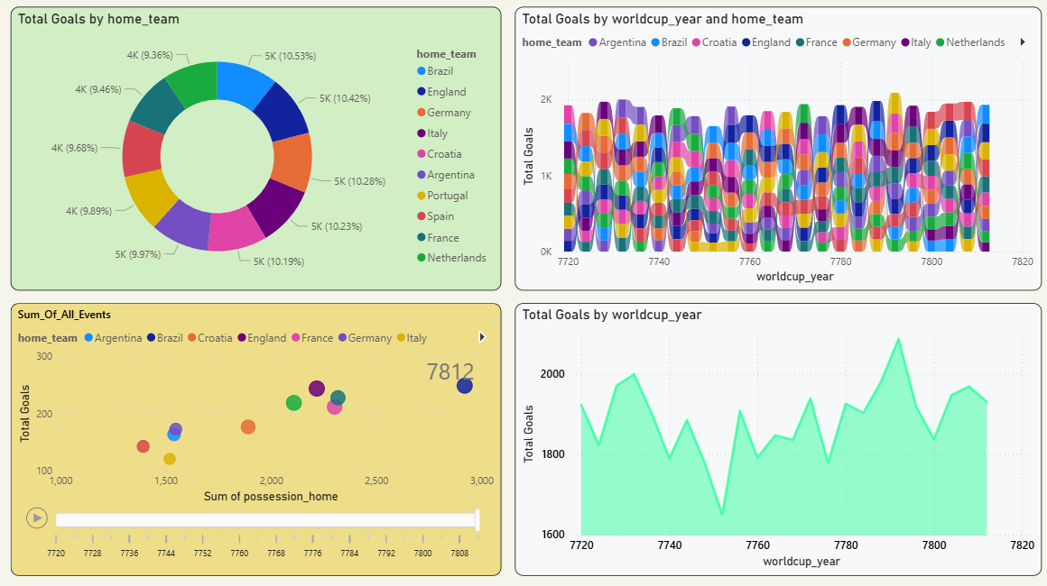
Description:
• Donut Chart – Total Goals by Home Team
• Bubble Chart – Possession vs Total Goals
• Multi-Team Comparison Chart
• Team Contribution Distribution
Purpose:
Compares team-level performance and contribution patterns.

Page 4: Correlation & Distribution Analysis
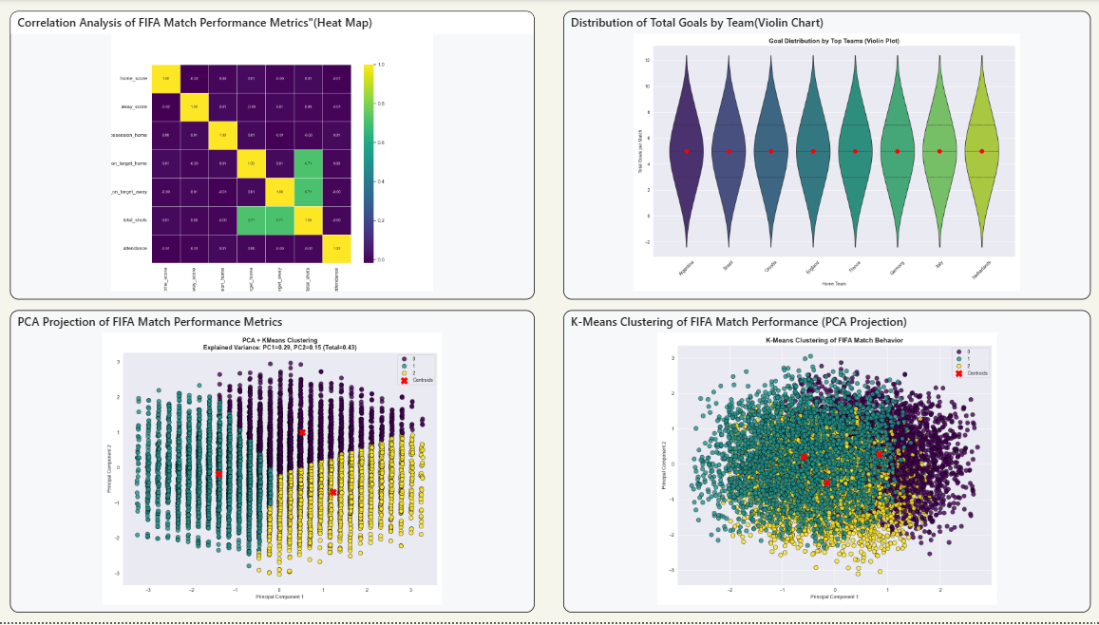
Description:
• Correlation Heatmap
• Violin Plot (Goal Distribution by Team)
• Density Distribution of Match Goals
• Pair Plot (Performance Variables Relationship)
Purpose:
Identifies statistical relationships between performance metrics.

Page 5: Advanced Analytics (Python Visuals)
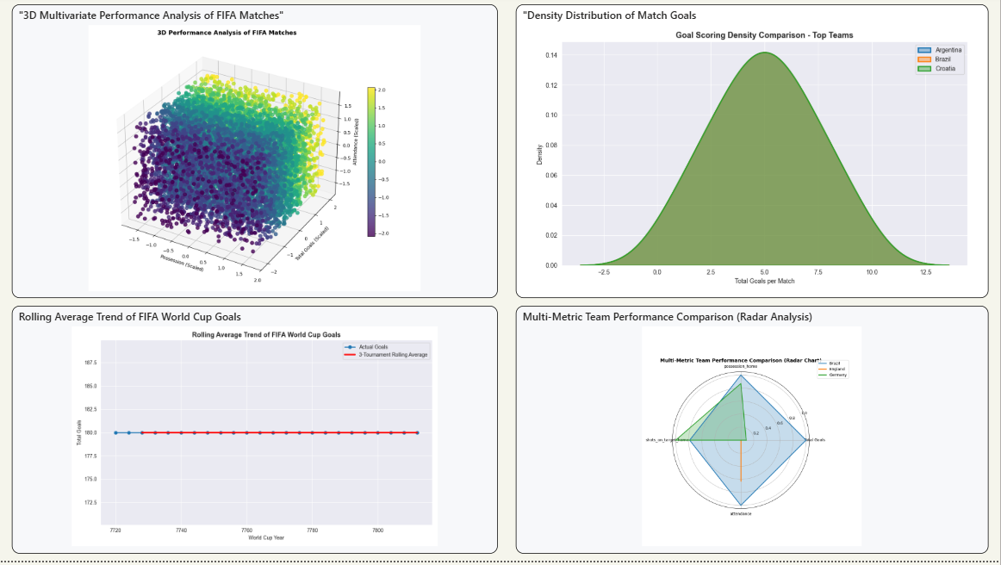
Description:
• PCA Projection Plot
• K-Means Clustering Visualization
• 3D Performance Analysis Scatter Plot
• Radar Chart (Multi-Metric Comparison)
Purpose:
Provides dimensionality reduction, clustering insights, and multi-variable comparison.

Screenshot – Page 6: Network & Interaction Analysis
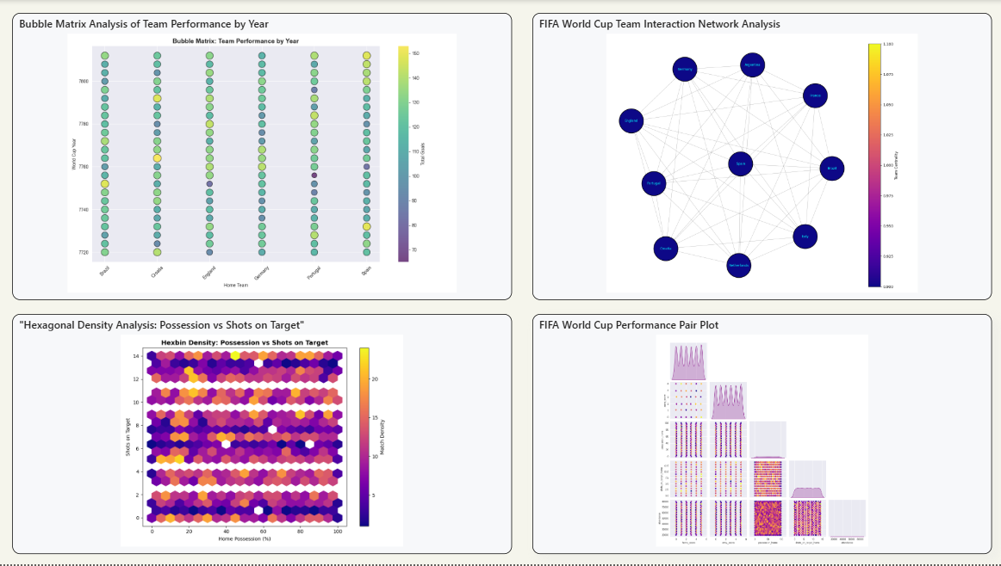
Description:
• PCA Projection Plot
• K-Means Clustering Visualization
• 3D Performance Analysis Scatter Plot
• Radar Chart (Multi-Metric Comparison)
Purpose:
Provides dimensionality reduction, clustering insights, and multi-variable comparison.

