AlgoTrader Platform
Technical Design Document (TDD)
Swing Level — Detection, Scanning & Breakout Trading
Written in plain language so that both technical and non-technical readers can follow it.
Field | Details
Document | Swing Level — Technical Design Document
Product | AlgoTrader (algorithmic trading platform)
Version | 1.0
Date | 12 June 2026
Status | Implemented (branch: swing-strategy)
Audience | Product owners, business stakeholders, QA, developers

1. Purpose of this Document
This document explains, in simple words, how the "Swing Level" feature of the AlgoTrader platform is designed and how it works from end to end. It covers what the feature does, the parts it is made of, the information it stores, and the step-by-step flow of each activity — with flow charts.
No trading or programming background is needed. Wherever a technical idea appears, it is explained with an everyday example.

2. What is the Swing Level Feature?
Imagine the price of a stock as a bouncing ball. Over time, the ball keeps bouncing off certain invisible floors (the price does not fall below them) and keeps hitting certain invisible ceilings (the price does not rise above them).
- A floor is called Support — a price where buyers usually step in and stop the fall.
- A ceiling is called Resistance — a price where sellers usually step in and stop the rise.
The Swing Level feature automatically finds these floors and ceilings on the price chart. It then looks for one special situation:
THE BIG IDEA — "Strong + Nearest": when the very next floor or ceiling near today’s price is also a STRONG one (a price the market has respected several times), that stock becomes interesting. If the price then punches through that strong wall, it often keeps moving in the same direction — and that is the moment the system trades.
The feature is used in four ways:
- See the levels drawn on a chart for one stock (for the admin to study).
- Scan the entire market and list all stocks that show the special situation.
- Test the idea on past data ("backtest") to see how it would have performed.
- Trade automatically — with practice money (paper) or real money (live).
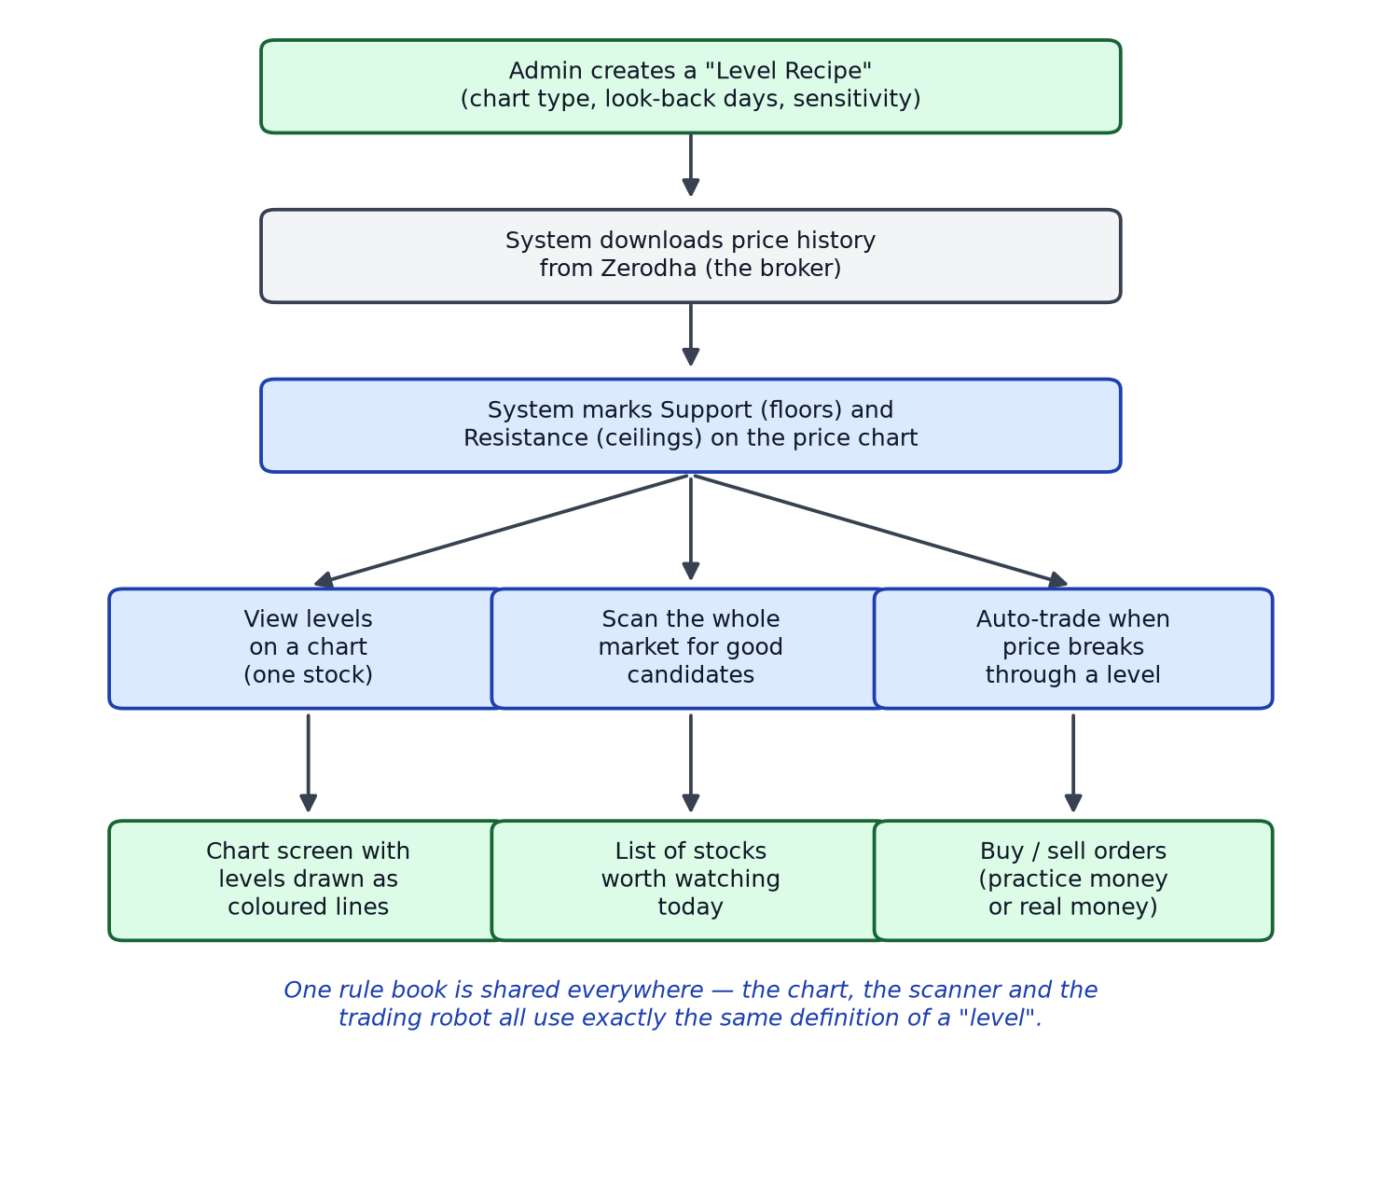
Flow chart 1 — The big picture: one rule book, four uses

3. Key Terms in Simple Words
Term | Plain-language meaning
Candle | A small bar on a price chart that shows how the price moved during a fixed time slot (for example, one 4-hour slot). Many candles together make the chart.
Swing level | A clear hilltop (ceiling) or valley (floor) on the chart. A hilltop must be higher than several candles on both sides of it to count.
Support | A floor — a price where the stock has stopped falling before.
Resistance | A ceiling — a price where the stock has stopped rising before.
Strong wall (strong level) | Two or more levels sitting almost at the same price (within a small %, e.g. 0.5%). Like a wall that has been tested many times — it matters more.
Nearest level | The first ceiling above today’s price, and the first floor below it. The next "obstacle" the price will meet.
Breakout | The moment the price punches through a wall instead of bouncing off it.
LTP | "Last Traded Price" — simply the current live price of the stock.
Level Recipe (config) | The admin’s saved settings: which chart size to use (e.g. 4-hour), how many days to look back, how picky to be when finding hilltops, and how close levels must be to form a strong wall.
Stop-loss | A safety net. If the trade goes the wrong way and falls to this price, the system sells immediately to limit the loss.
Target | A profit point. When the price reaches it, the system sells some or all of the position to lock in profit.
Paper trading | Practice mode — trades use pretend money, but everything else behaves like the real thing.
Backtest | A "time machine" test — replay old price data and see what trades the rules would have made and how much they would have earned or lost.
Zerodha Kite | The stock broker’s service the platform connects to for live prices, price history and placing real orders.

4. How the System is Built (Building Blocks)
The platform has three layers, like a restaurant: the dining area (what users see), the kitchen (where the work happens), and the store room (where things are kept).

4.1 The screens (dining area)
Screen | What the user does there
Level Recipe screens | Admin creates and edits the recipes (chart size, look-back period, sensitivity).
Single-Stock Scan screen | Admin checks one stock and sees its levels drawn on an interactive chart.
Saved Results screen | Admin re-opens any of the last 20 saved scans for a recipe.
Market Scanner screen | Admin scans a whole exchange; a progress bar fills up and matching stocks appear in a table.
Strategy & Backtest screens | Strategies are linked to a recipe; users run backtests and start paper/live sessions.

4.2 The brain (kitchen)
The server holds four cooperating pieces:
- Level Finder — turns raw price history into the list of floors and ceilings.
- Rule Book — the single shared definition of "nearest", "strong wall" and "breakout". Every other piece asks the Rule Book, so the chart, the scanner, the backtest and the trading robot can never disagree with each other.
- Market Scanner — a background worker that checks every stock on an exchange one by one against the Rule Book.
- Trading Robot (engine) — watches the live price for a started strategy, enters on a breakout, and then manages the stop-loss and profit targets automatically.

4.3 The store room (database)
What is stored | Plain description
Level Recipes | The admin’s saved detection settings. Reusable everywhere.
Scan results | The levels found for a stock, with date and period. Only the latest 20 per recipe are kept; older ones are removed automatically.
Strategy link | Each trading strategy points to exactly one Level Recipe. A strategy cannot trade or backtest without one.
Trade story | Every order, every log line and the live state of a running session — so nothing is lost if the browser is refreshed or the server restarts.
Market-scan runs | Deliberately NOT stored in the database. They live in the server’s short-term memory (last 5 runs) because they are quick look-ups, not records.

5. Step by Step — How Levels are Found
This is the heart of the feature. The same five steps run everywhere:
- Look at the chart. Download the price history (with some extra days before the start, so the first hilltops can be judged fairly).
- Mark hilltops and valleys. A candle is a hilltop only if it is higher than 5 candles to its left AND 5 to its right (the number is set in the recipe). Valleys are the mirror image.
- Tidy up. Ceilings and floors should take turns. If two ceilings come in a row, only the higher (stronger) one is kept.
- Find strong walls. Levels sitting within a small percentage of each other (e.g. 0.5%) are grouped into one strong wall.
- Check "Strong + Nearest". Is the level closest to today’s price part of a strong wall? If yes — this stock has the special setup.
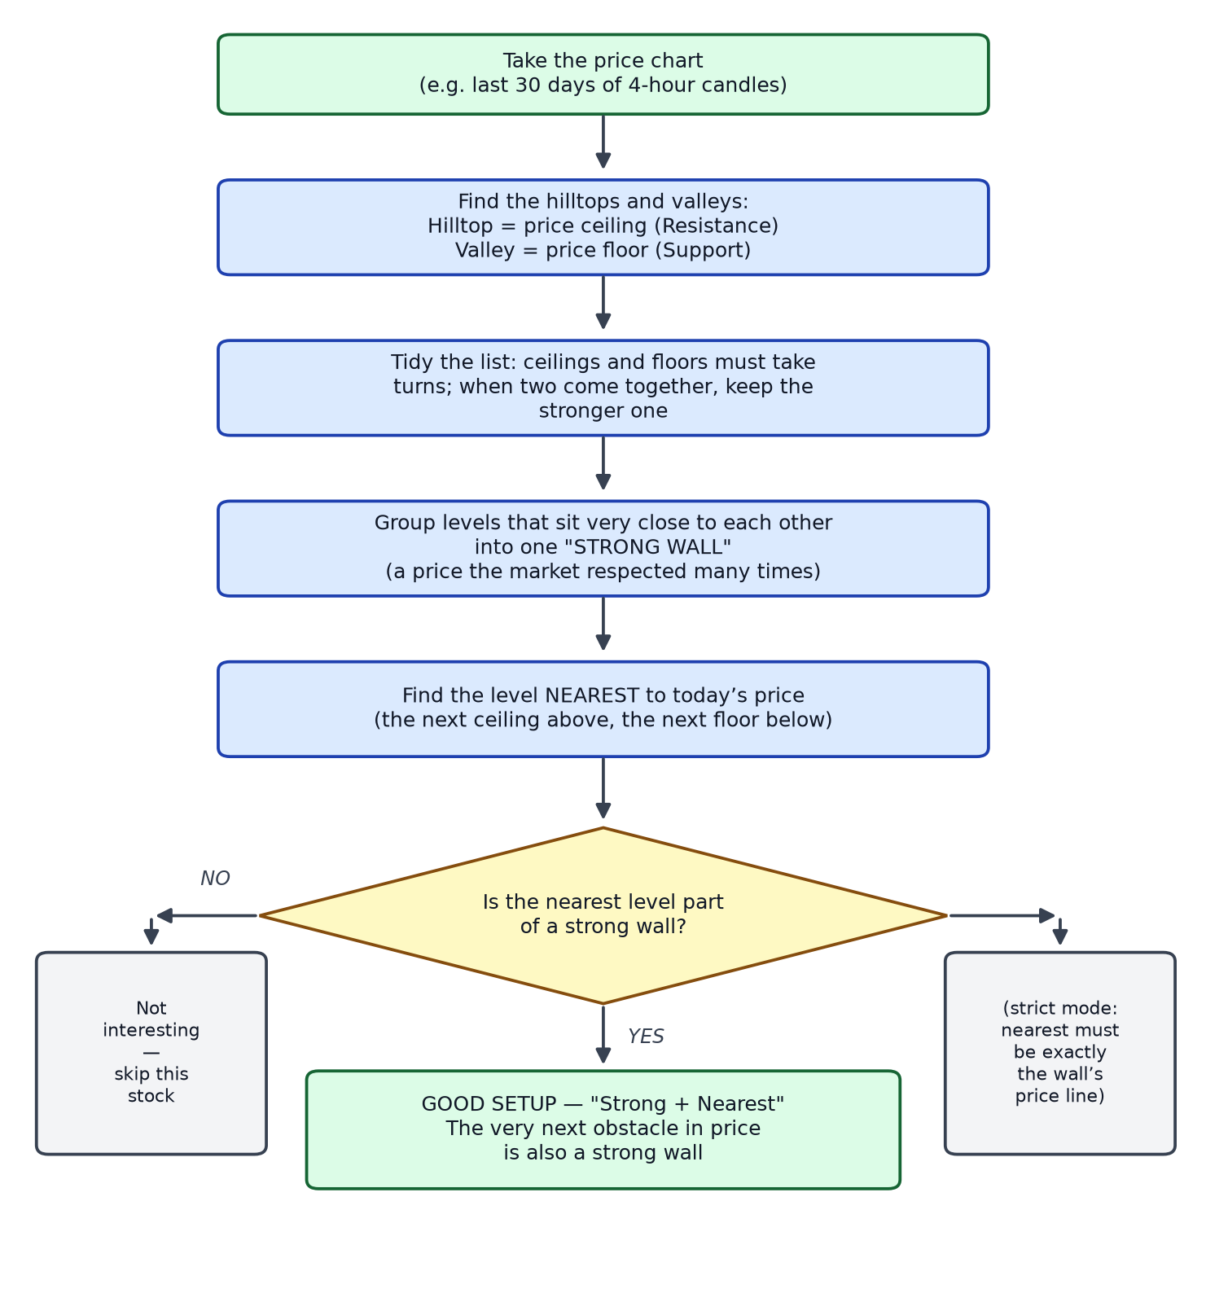
Flow chart 2 — How the system finds and grades the levels

6. Step by Step — Scanning the Whole Market
Checking one stock is useful; checking 1,500+ stocks by hand is impossible. The Market Scanner does it automatically:
- The admin picks a recipe and an exchange (NSE, BSE, futures, indices or commodities) and clicks "Run Scan".
- Only one scan may run at a time — a second request is politely refused.
- The scan runs in the background. The broker allows roughly 3 history downloads per second, so the scanner deliberately works slowly and steadily; a full exchange takes several minutes.
- The screen polls for progress every few seconds: a progress bar, an error count, and the growing list of matches.
- For every match the admin sees: the stock name, current price, the wall price, how far away it is (in %), and how many levels make up the wall.
- The admin can cancel a running scan at any moment.
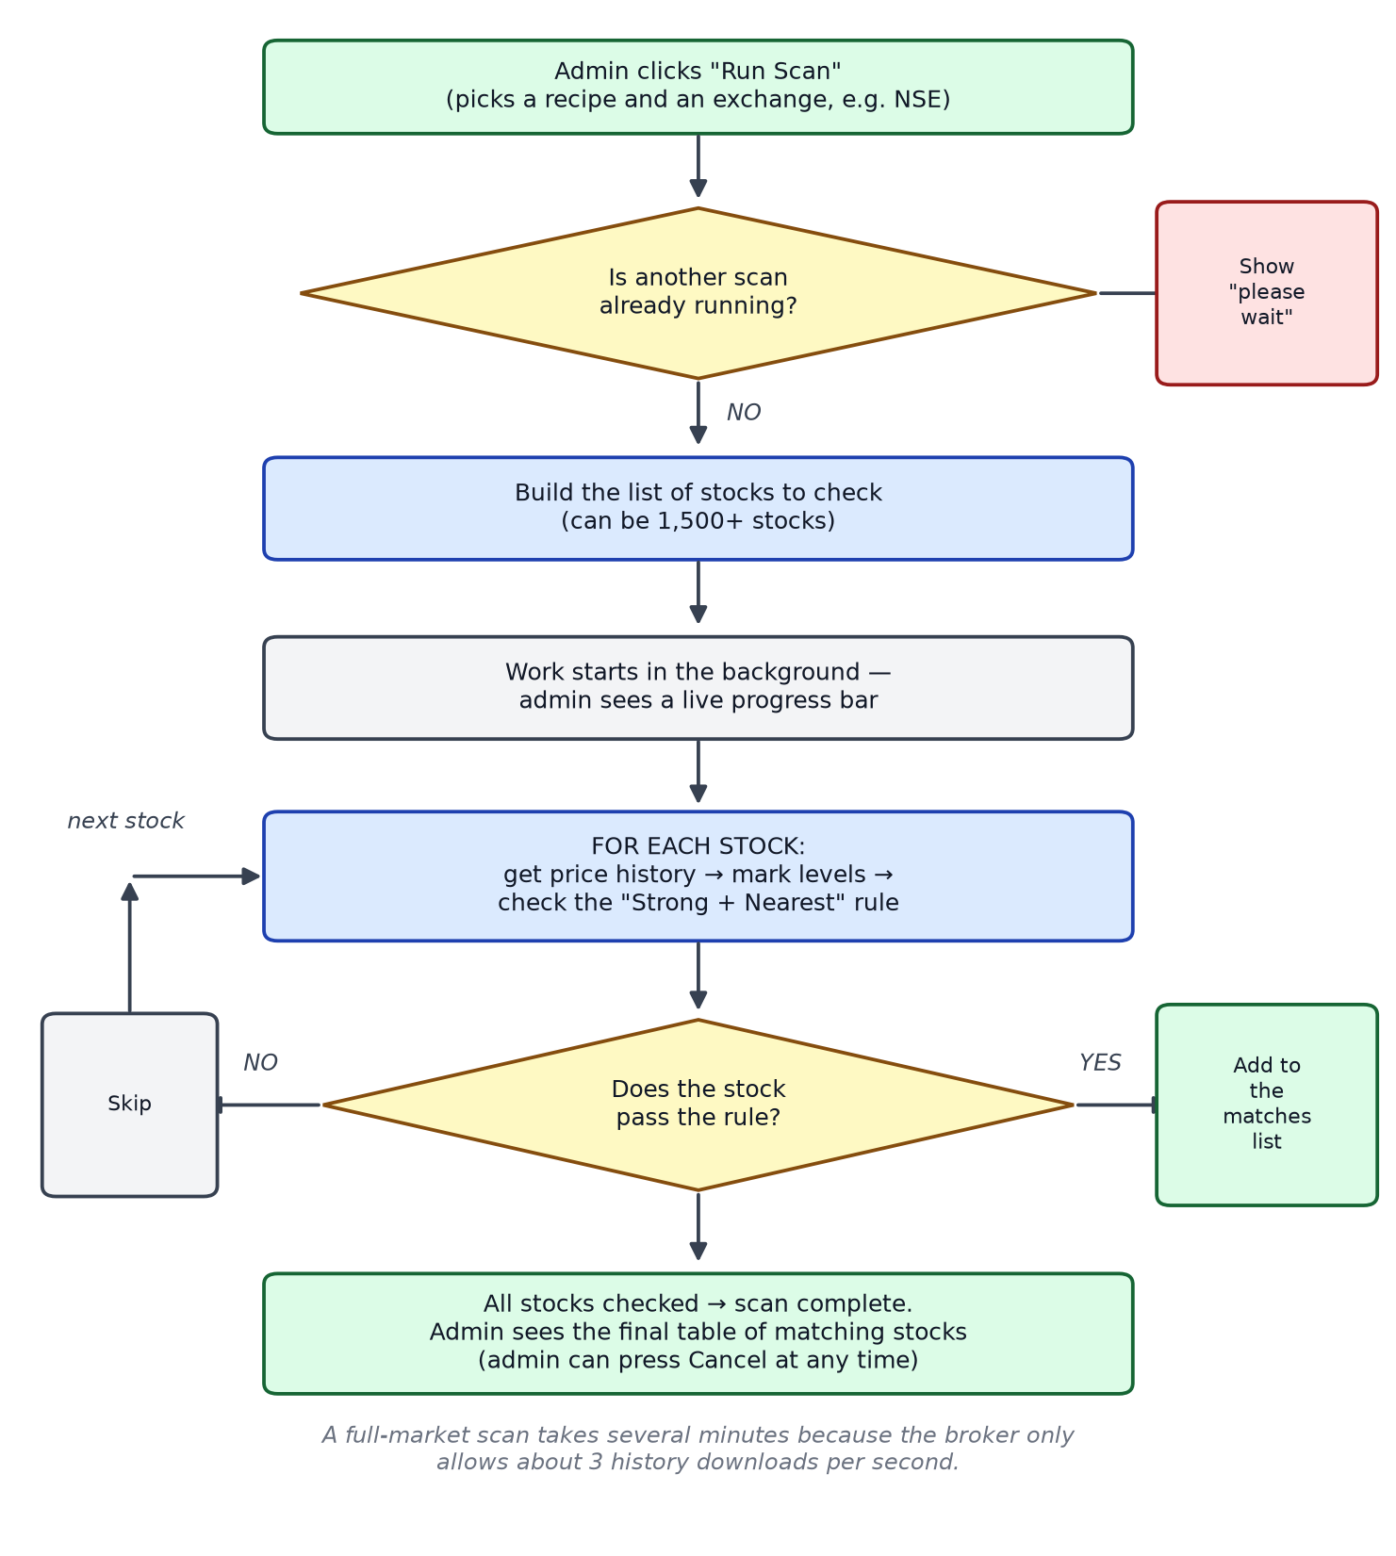
Flow chart 3 — The background market scanner

7. Step by Step — Automatic Trading
When a customer starts a strategy, a small "robot" is created on the server just for that session. It works in two phases:

7.1 Phase 1 — Watching
- Every 3 seconds the robot reads the live price.
- It keeps the level map fresh (price history is re-checked every 5 minutes) and only uses fully finished candles — never a half-formed one.
- The most recently formed level sets the expected direction: if the newest level is a ceiling, the robot looks for an upward breakout (buy); if it is a floor, a downward breakout (sell).
- The trade is taken only when the "Strong + Nearest" condition holds AND the price actually crosses the strong wall between one check and the next.

7.2 Phase 2 — In a trade
- Safety first: a stop-loss is always in place. If hit, everything is sold at once.
- Profit is booked in steps: at target 1 sell a part, at target 2 another part, and so on.
- Optional protections: the stop-loss can move up to the entry price once the trade is in profit ("break-even"), and a structural stop exits if price falls below the breakout candle.
- Every event is written to a readable log: "Breakout signal…", "T1 hit — exited…", "Stop Loss @ …", so the customer can replay the whole story afterwards.
Paper mode and live mode follow exactly the same logic — paper mode writes pretend orders against a virtual account, live mode places real orders with the broker.
Options mode: if the strategy is set to trade options, the breakout is still detected on the main index/stock, but the actual buy happens on the matching option contract. Option positions are always "buy first, sell later" — the system never short-sells options.
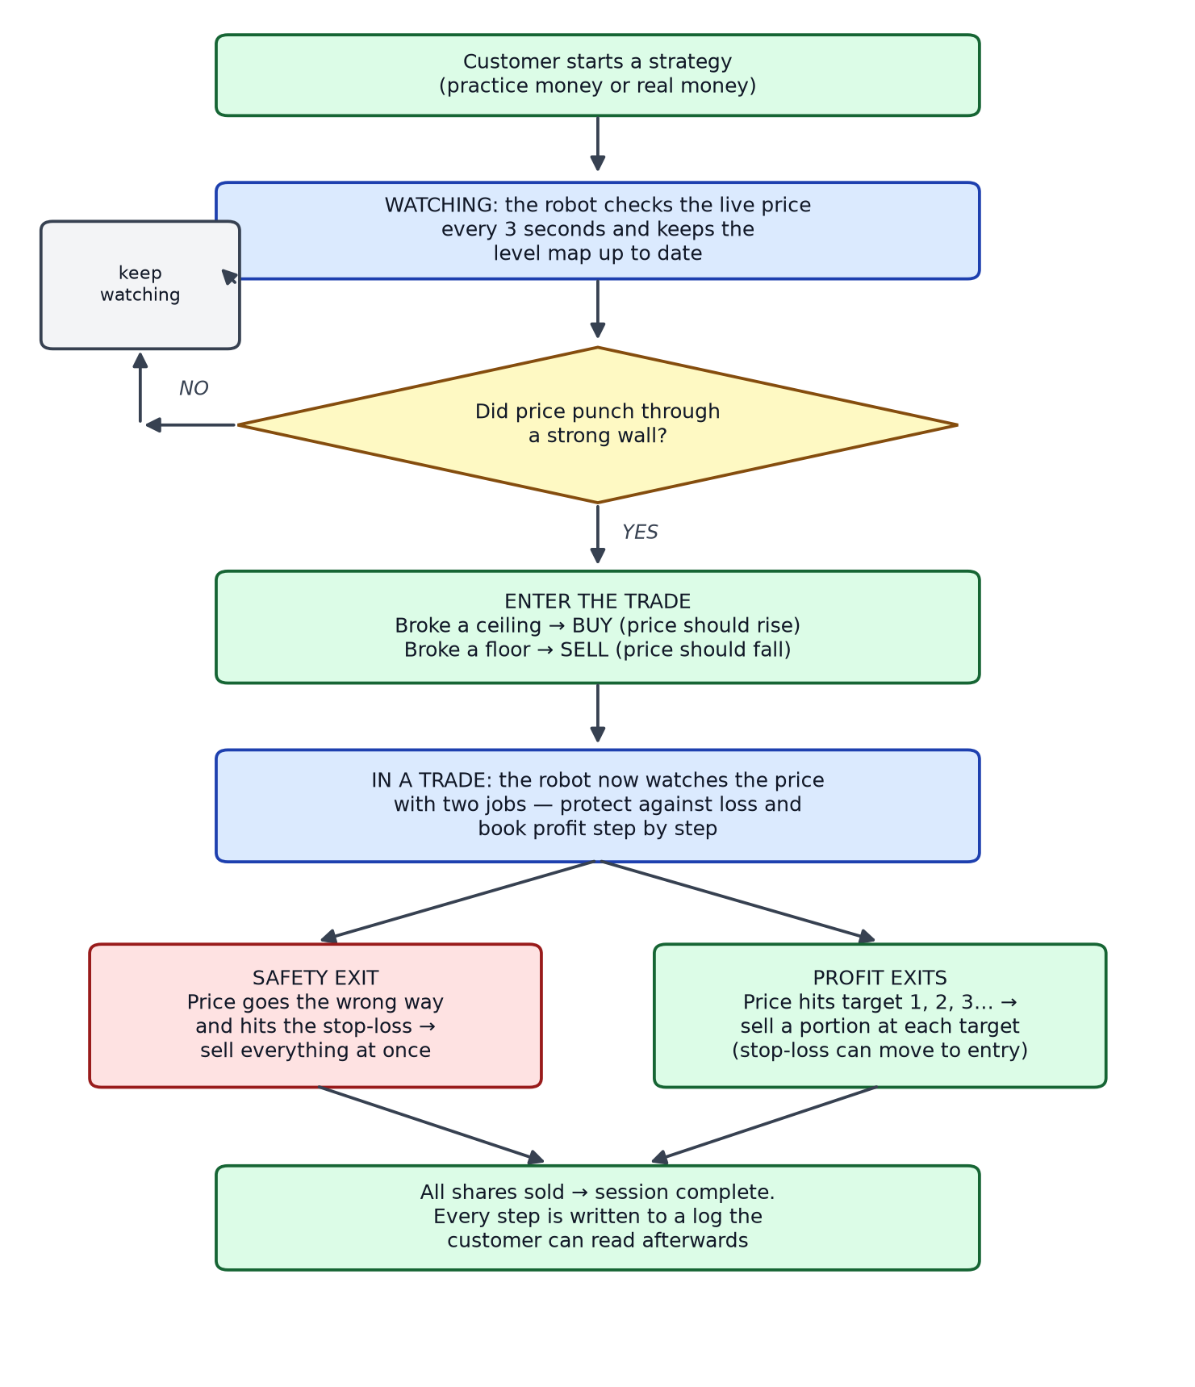
Flow chart 4 — The trading robot: watch, enter, protect, book profit

8. Step by Step — Backtesting (the Time Machine)
Before risking money, a user can replay the past:
- Pick a strategy and a past period (for example, the last 60 days).
- The system replays the old chart candle by candle, asking at each step: "Would the robot have entered here?" — using the very same Rule Book as live trading.
- Each pretend trade is followed through: entry price, stop-loss, targets, exit, and the profit or loss in rupees and percent.
- The report lists every trade with its full story, so results can be verified by hand.
- After one trade finishes, the replay jumps past it — the same move is never traded twice.
The only difference from live trading: the backtest sees one price per candle, while the live robot sees the price every 3 seconds. This is a known and accepted simplification.
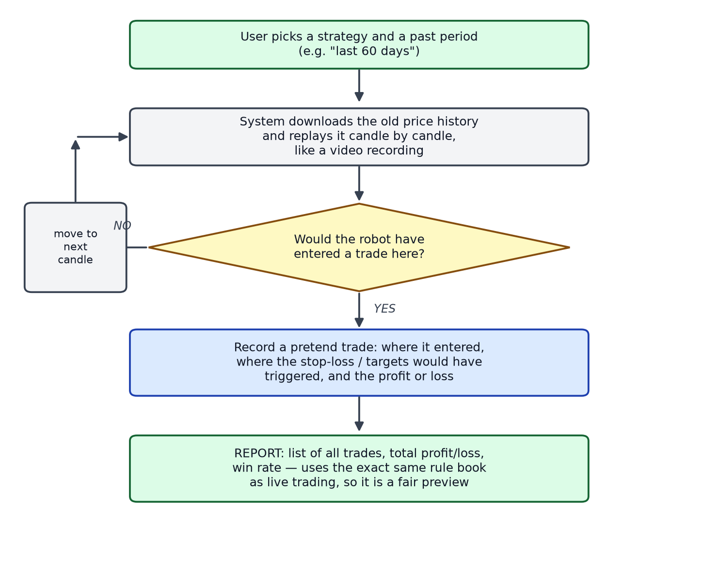
Flow chart 5 — Backtest: replaying the past with the same rules

9. Built-in Rules and Safety Limits
Rule | Why it exists
Sensitivity values are fixed choices (e.g. strong-wall closeness can only be 0.1 / 0.5 / 1.0 / 1.5 / 2.0 %). | Stops typing mistakes from silently changing trading behaviour.
Date ranges are capped per chart size (e.g. 1-minute charts: max ~60 days). | The broker refuses bigger downloads; the system blocks the request up front with a clear message.
Only one market scan at a time. | Protects the broker’s download limit and the server.
Minimum amount of history required before any level is declared. | A hilltop needs enough candles on both sides to be judged; too little data means no levels rather than wrong levels.
Trading state is saved on every meaningful change. | A browser refresh or a server restart never loses a running trade; sessions resume automatically.
Stop-loss is always part of the trade plan. | No position is ever left without a safety exit.

10. Known Limitations and Future Ideas
- Scanner results are short-lived. Market-scan runs are kept only in the server’s memory (last 5). Restarting the server clears them. Future: save runs to the database.
- The level mathematics exists twice — once for the chart in the browser and once on the server. Any change must be made in both places, or the chart could disagree with the robot. Future: generate one from the other, or add an automatic comparison test.
- Backtests use candle prices, not tick-by-tick prices, so live results can differ slightly.
- A full-exchange scan takes minutes by design (broker speed limit). Future: allow scanning a custom shortlist of stocks.

