1. Introduction and Project Overview:
#Research Question:
How do shipping costs (Ship Mode) and discount strategies impact profitability
across different product categories and fiscal periods?

Sub-Questions:
1. What is the relationship between discount levels and profit margins?
2. Which product categories generate the highest COGS-to-Sales ratio?
3. How does profitability vary across fiscal quarters and years?
4. What is the impact of shipping mode on profit margins?
5. Are there seasonal patterns in sales performance?

# Dataset Information:
- Source: Kaggle Superstore Dataset
- Time Period: 2014-2017
- Transactions: ~10,000 records
- Domain: Retail sales with comprehensive financial metrics
# Import Required Libraries :
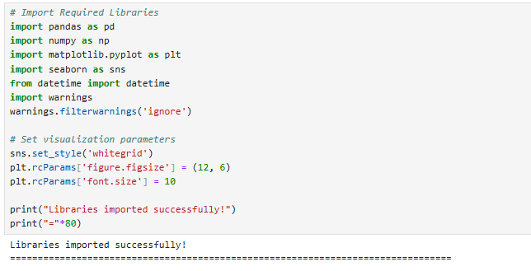
# 2. Data Loading and Initial Exploration :
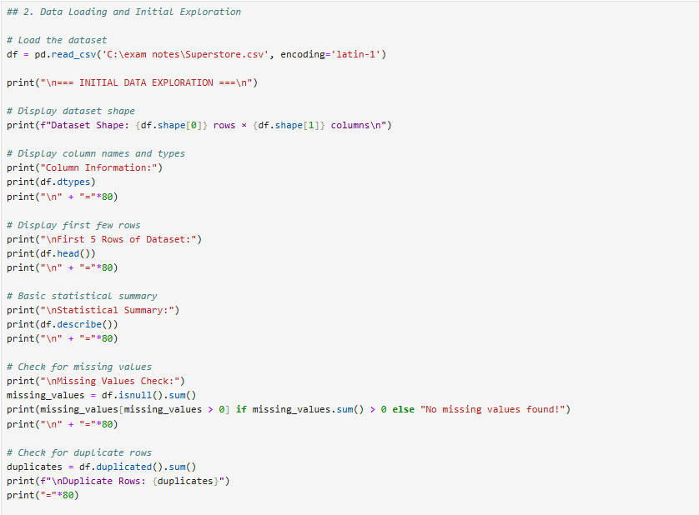

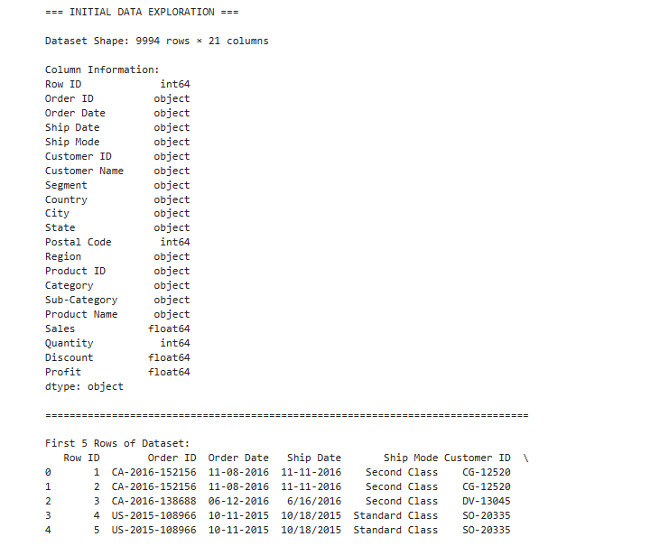
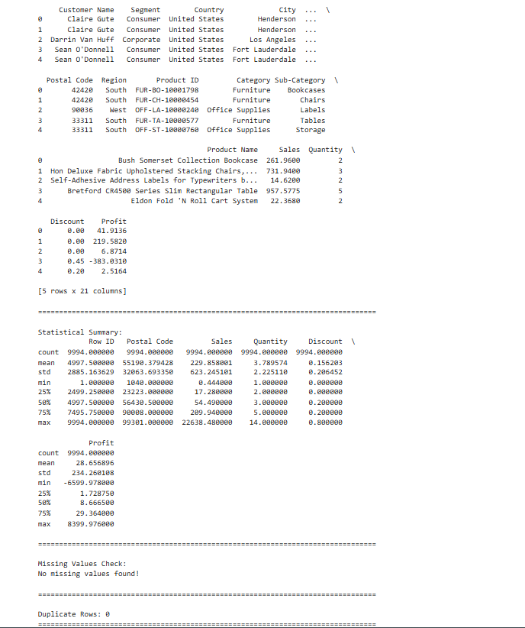
# 3. Data Cleaning and Preparation :
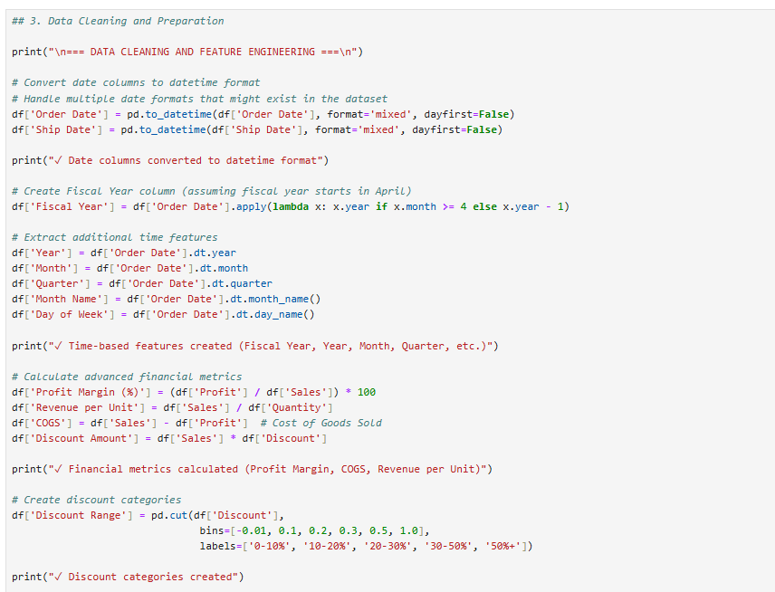
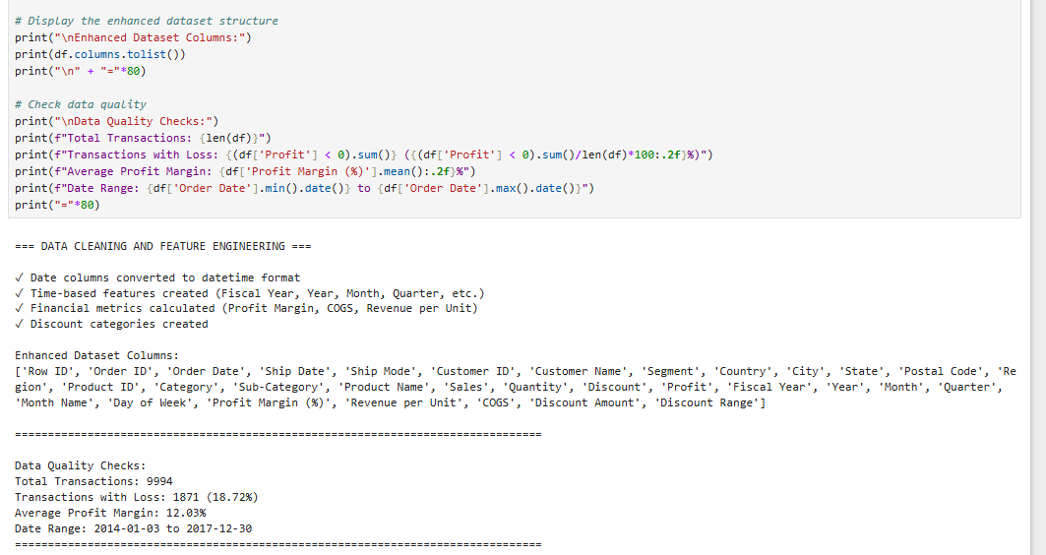

# 4. Exploratory Data Analysis (EDA) :
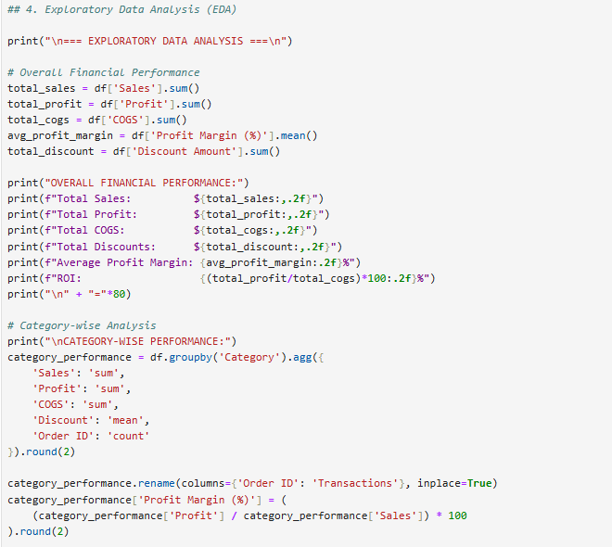
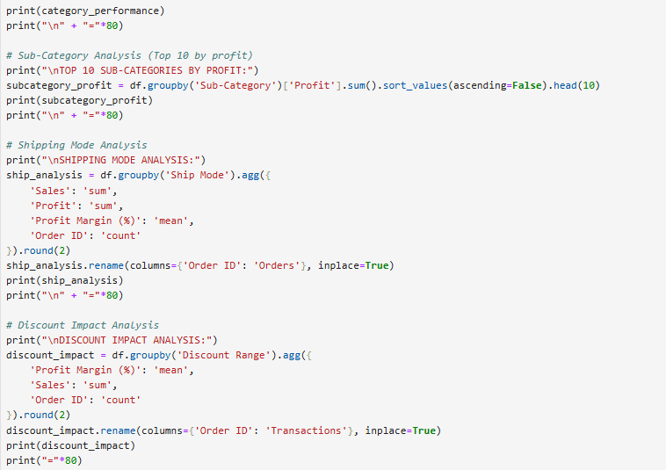
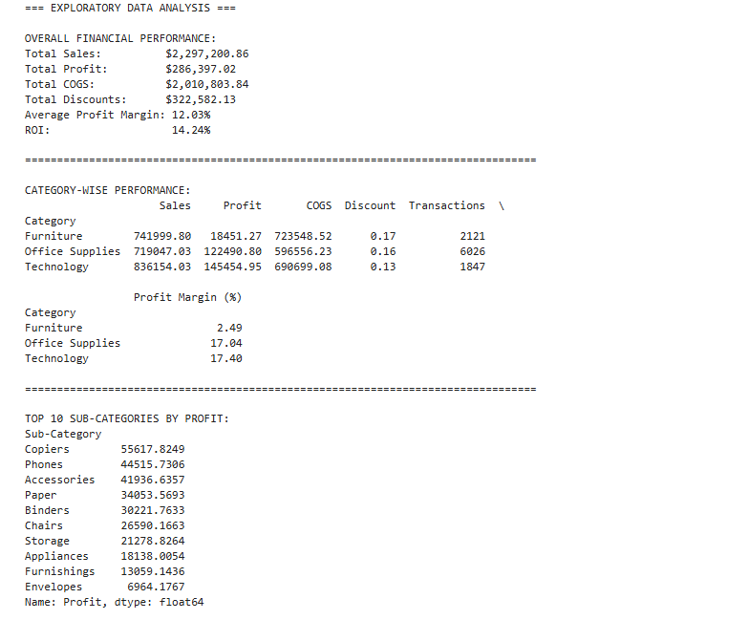
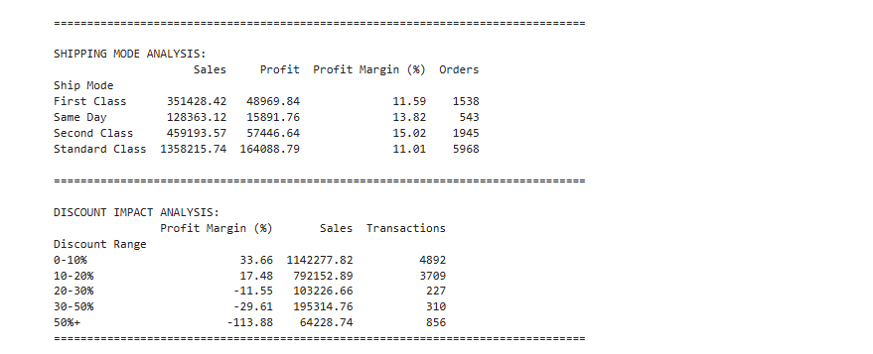

# 5. VISUALIZATION 1: Sales, COGS, and Profit Trends Across Fiscal Years

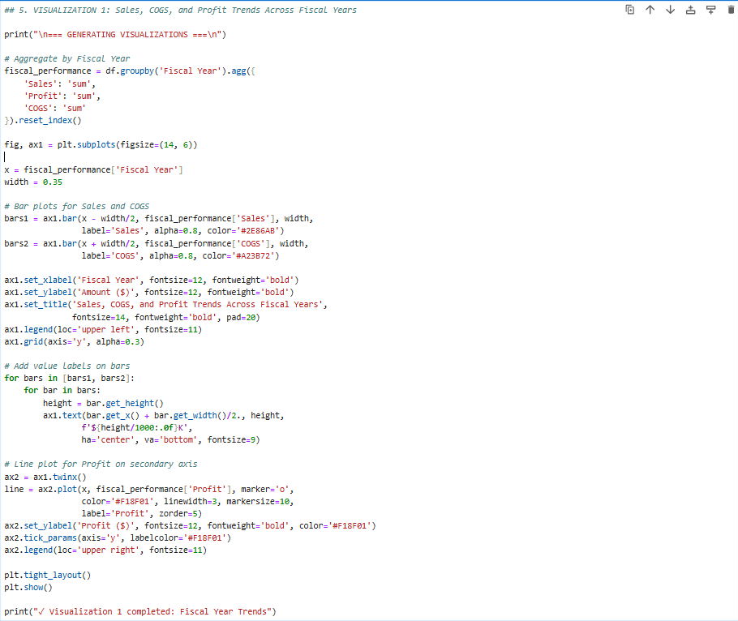

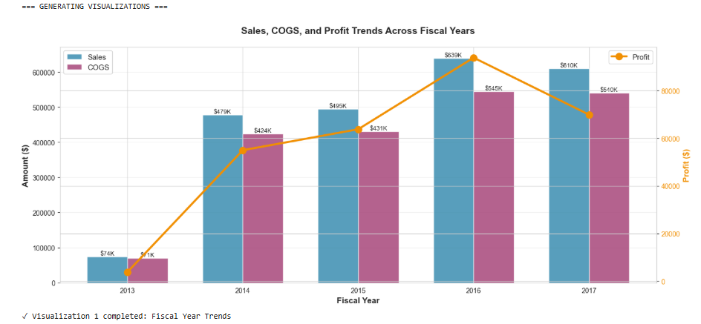

# 6. VISUALIZATION 2: Discount Impact on Profit Margin

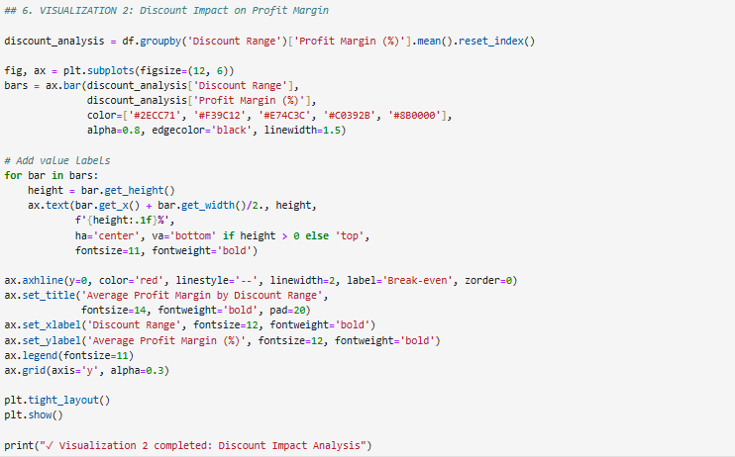

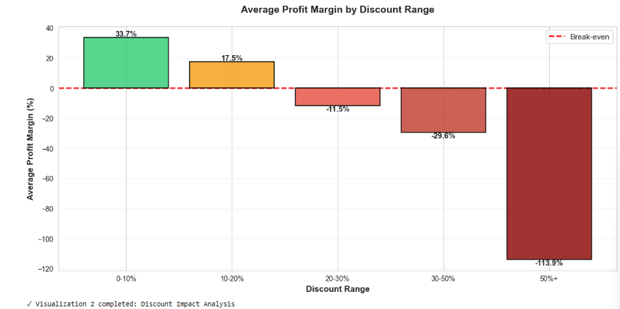

# 7. VISUALIZATION 3: Category and Sub-Category Profitability Heatmap

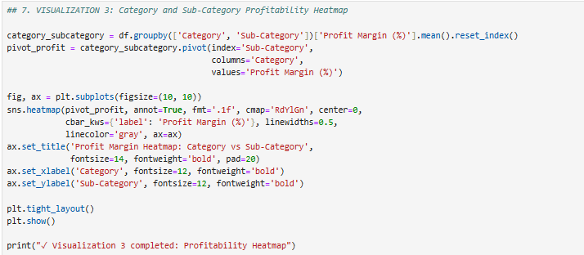

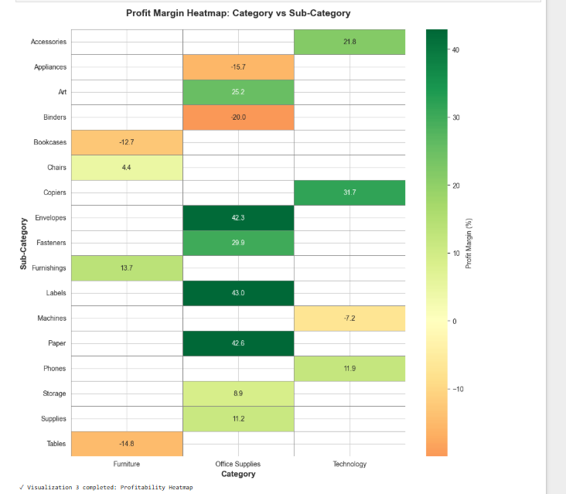

8. VISUALIZATION 4: Shipping Mode Impact on Profitability
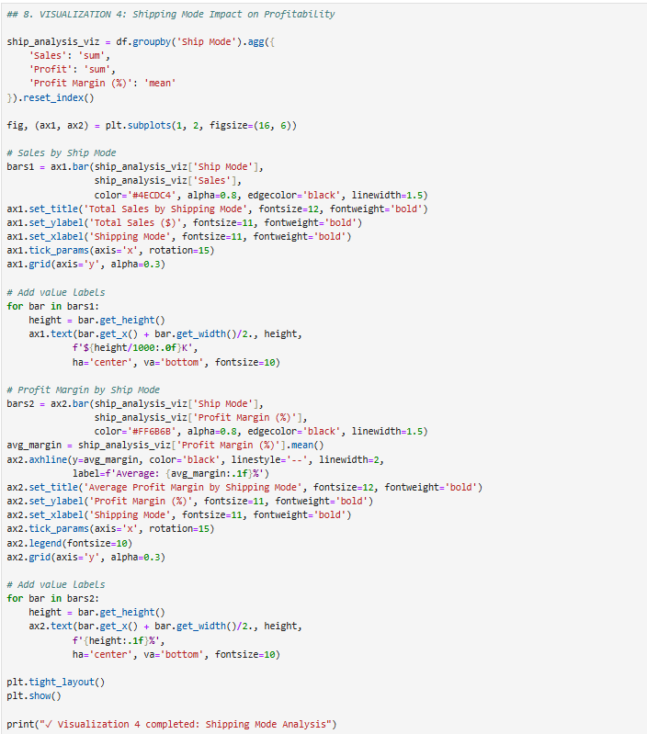
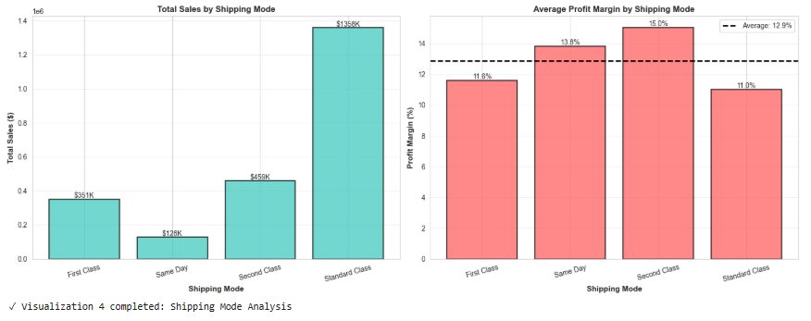

# 9. VISUALIZATION 5: Quarterly Seasonality Analysis

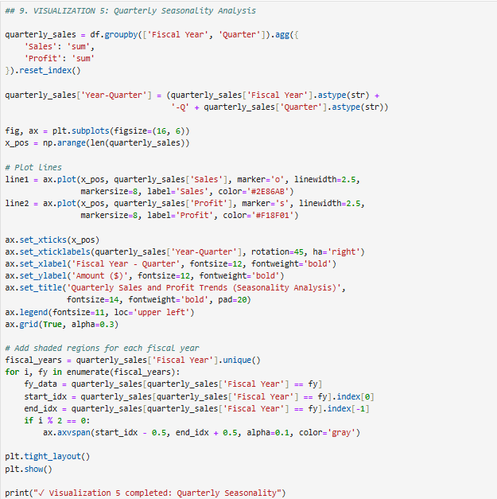

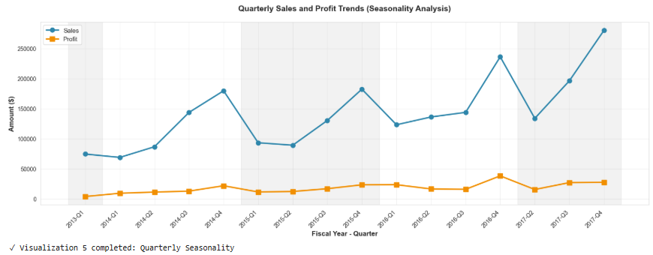

# 10. VISUALIZATION 6: COGS vs Sales Relationship by Category

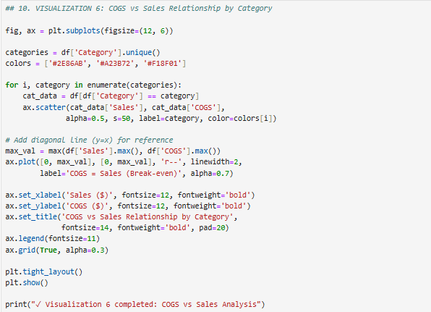

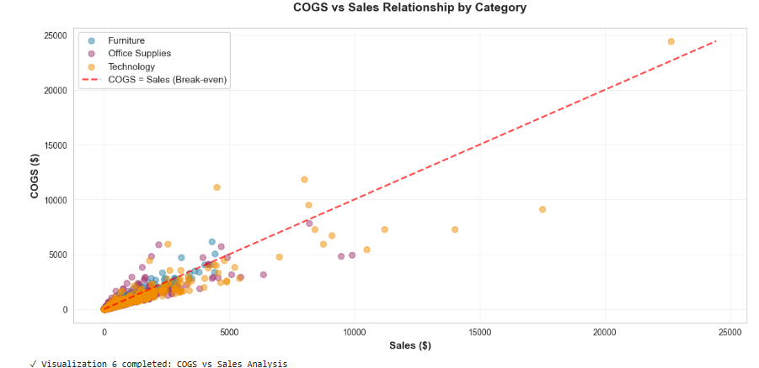

# 11. Advanced Statistical Analysis

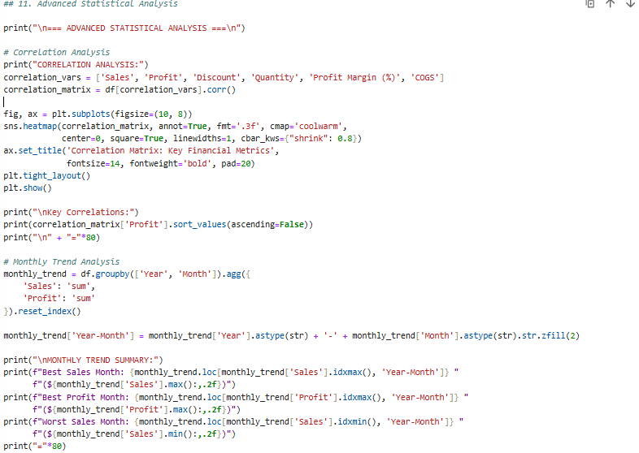
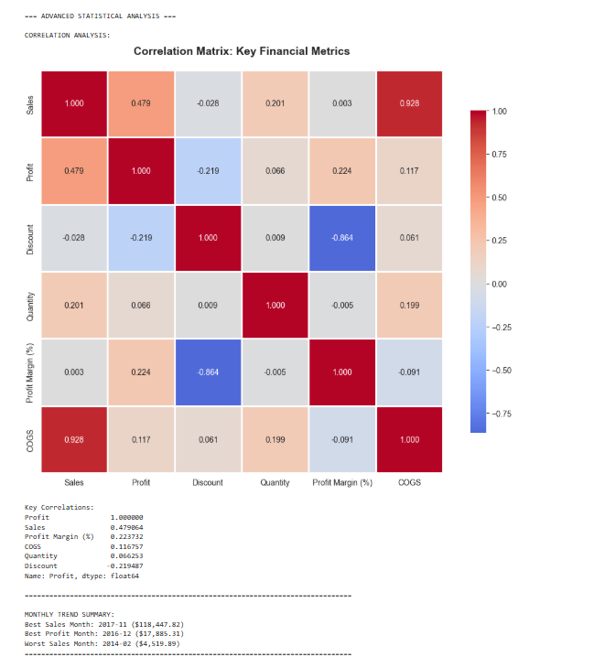
======================================================================
KEY FINDINGS AND INSIGHTS
======================================================================

1. DISCOUNT STRATEGY IMPACT:
• High Discount (>30%): Avg Profit Margin = -91.47%
• Low Discount (≤10%): Avg Profit Margin = 33.66%
• Insight: Heavy discounting significantly erodes profitability
• Transactions with discounts >30%: 1166 (11.7%)

2. CATEGORY PERFORMANCE:
• Most Profitable: Technology (17.40% margin)
• Least Profitable: Furniture (2.49% margin)
• Highest Sales: Technology ($836,154.03)

3. FISCAL YEAR PERFORMANCE:
• Sales Growth (FY2013 to FY2017): 719.46%
• Profit Growth: 1734.92%
• Best Fiscal Year (Sales): FY2016

4. SHIPPING MODE ANALYSIS:
• Highest Profit Margin: Second Class (15.02%)
• Highest Sales Volume: Standard Class ($1,358,215.74)
• Insight: Balance between fast shipping and profitability needed

5. LOSS ANALYSIS:
• Total Loss-Making Transactions: 1871 (18.72%)
• Total Loss Amount: $156,131.29
• Category with Most Losses: Office Supplies (886 transactions)

6. SEASONALITY INSIGHTS:
• Best Quarter: FY2017-Q4 ($280,054.07)
• Average Quarterly Sales: $143,575.05
• Sales Volatility (Std Dev): $59,229.73

======================================================================
STRATEGIC RECOMMENDATIONS
======================================================================

1. Optimize discount strategy - limit discounts above 30% to clearance items only
2. Focus marketing efforts on Technology category for highest margins
3. Investigate Furniture category for margin improvement opportunities
4. Consider shipping cost optimization for Standard Class (highest volume)
5. Prepare inventory for Q4 peak season based on historical patterns
6. Review and minimize loss-making transactions through better pricing
7. Analyze customer segments for targeted discount strategies

======================================================================
ANALYSIS COMPLETE
======================================================================

This comprehensive analysis demonstrates:
✓ Advanced data cleaning and feature engineering
✓ Fiscal year and temporal analysis
✓ Financial metrics calculation (COGS, profit margins, ROI)
✓ Multiple sophisticated visualizations
✓ Statistical correlation analysis
✓ Business insights and strategic recommendations

Dataset: Superstore Sales (Kaggle)
Analysis Period: 2014-2017
Total Transactions Analyzed: 9,994
=====================================================================

