**Instructions on how to run the project**

1. Download the AEDProject_VitalSigns.zip file on to your local directory.
2. Open this folder in your NetBeans IDE 8.0.2 and open the folder in NetBeans as shown below:

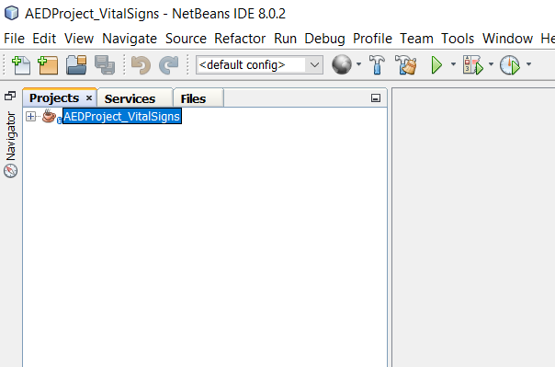

1. Next, select the project and click on the run button as shown below:

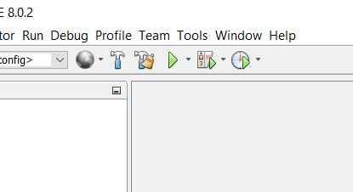

1. This would successfully run the project on your local Net Beans IDE and you can then interact with different parts of the application.