**Homework 5**

Fin 6204 (8204) - 001

Fall 2019

Name: **Akshay Patil (#801034919)**

**Purpose**: Experiment on Monte Carlo Integration.

The aim is to compute prices of European call and put options using Monte Carlo simulation using Regression II method.

**Output:**

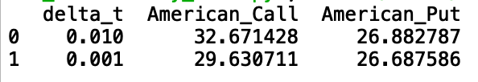

**Analysis**:

Compared to Regression I, Regression II approach provides better valuation for American call and put option. As Regression II method only considers in the money values to converge to the true value, the values are efficient and computation is faster.

When dt = 0.01, that value of call option is greater than put option which is consistent with the theory.

When dt = 0.001

The number of time steps will be 1000

I find that increase in time steps from 100 to 1,000 leads in decreasing in value of call to 29.630711 but still which is greater than put value, which is consistent with the theory. The reason could be when we have more number of time steps, the probability of getting noisy payoffs is increasing. The smaller the time-step, the better for accuracy and stability. Hence, I think 100 number of simulations are optimal for running Regression II method.