**Homework 6**

Fin 6204 – Numerical Methods for Financial Derivatives

Fall 2019

Name: **Akshay Patil (#801034919)**

**Purpose:**

The objective of this Python program is to compute the prices of European calls and puts using Fourier transform techniques. Geometric Brownian Motion as the underlying diffusion process for the Stock price. Under risk neutral evaluation, the Brownian Motion is transformed in such a way that we can make use of Fourier transform provided the characteristic function is known. The pricing integrals using the Fourier transform and inverse Fourier transform are derived and then the summation is approximated using the Trapezoidal rule. Half frequency domain and Full frequency domain are used to compute the option prices. The algorithm gives us the European call or put option prices based on the dampening factor(alpha) give. For a positive alpha, it gives us the European call option price where for negative alpha, we will get the European put option price. The input parameters required are provided by the user.

**Output:**

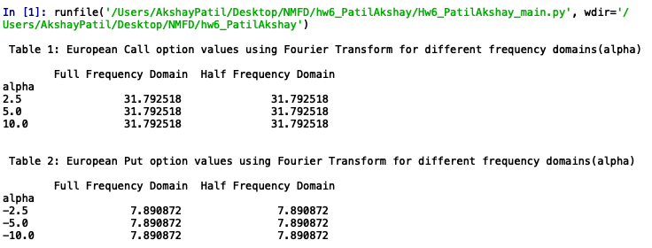

**Analysis:**

The Fourier transform techniques are used to calculate the prices of European call and put options.

The main observation here is that the option prices for both European call and put are not changing

with respect to the dampening factor (alpha). Also, the price remains same for both the domain.