**Math 6205 - Numerical Methods for Financial Derivatives**

**Fall 2019**

**HW 9**

**Output:**

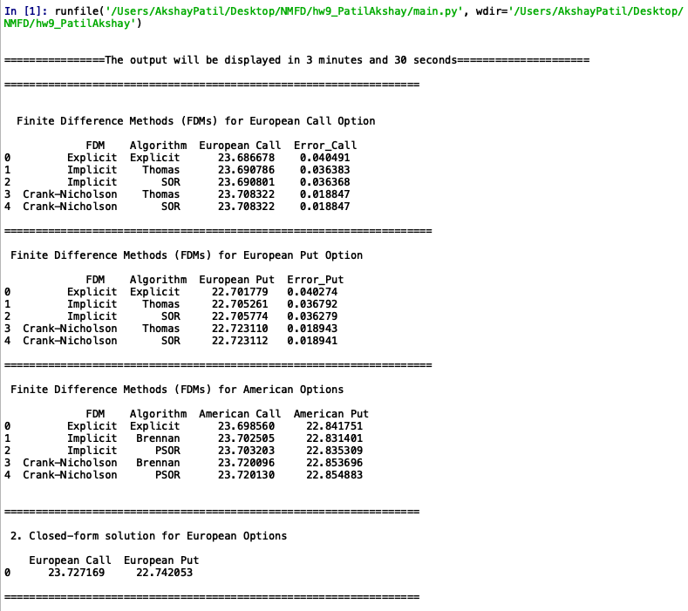

**Analysis:**

The objective of this Python program is to compute the prices of European and American calls and puts using Finite Difference Methods (FDMs) and the closed form solutions. Every method has its pros and cons. We have used Explicit, Implicit and Crank-Nicholson discretization methods to solve using differing algorithms such as Thomas, Brennan-Schwartz, SOR and PSOR. We know that American options are costlier than European counterparts and we validated using different methods. Also, we have calculated the absolute difference compared to the closed form, Black Scholes solution.

In explicit method, we discretize the heat equation. Once we discretize the heat equation, we create the mesh for space and time and then use the mesh as a tridiagonal system. The tridiagonal system can be solved by using algorithms such as Thomas and SOR for European options and Brennan-Schwartz and PSOR for American options

Thomas and Brennan-Schwartz algorithm is a simplified version of the Gaussian elimination. This algorithm involves two core substitutions, a forward loop and a backward loop in which we calculate a multiplier and use it as required. This algorithm can be used to solve any generate tridiagonal matrix.

SOR and PSOR algorithms are an extension of Gauss-Seidel algorithm which is an extension of Jacobi algorithm. They are iterative method for solving linear system of equations. SOR algorithm is very useful is pricing European style options, while PSOR algorithm is very useful in pricing American Style options. We use a relaxation parameter and a convergence condition so that the iterative solution converges. This algorithm can be used to solve any general tridiagonal matrix.