Assignment-5

Create a Jenkins master, clone git repo with the help of maven compile and build the project. Take the war file and push it to the s3 bucket(create bucket with the help of script only).
Download the WAR on slave1 machine, deploy it on tomcat and check on browser. Delete the s3 bucket later on do all the steps with script only

- Create Jenkins master and slave
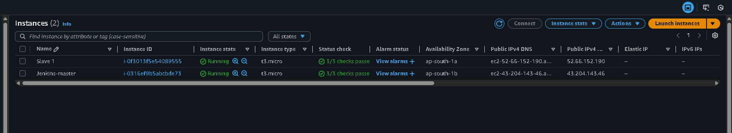

- Configure the slave with master
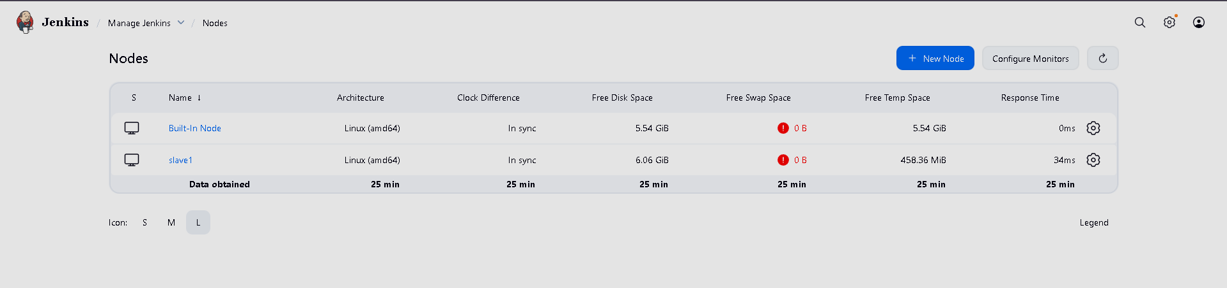
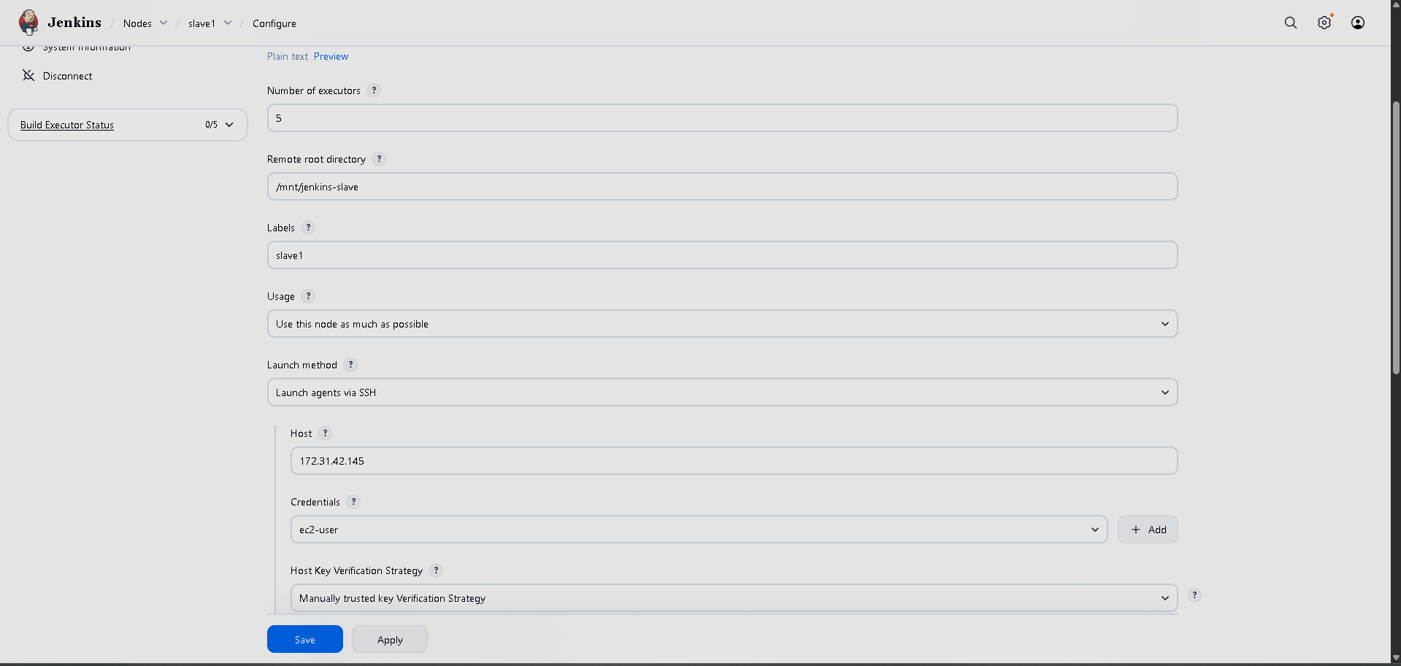
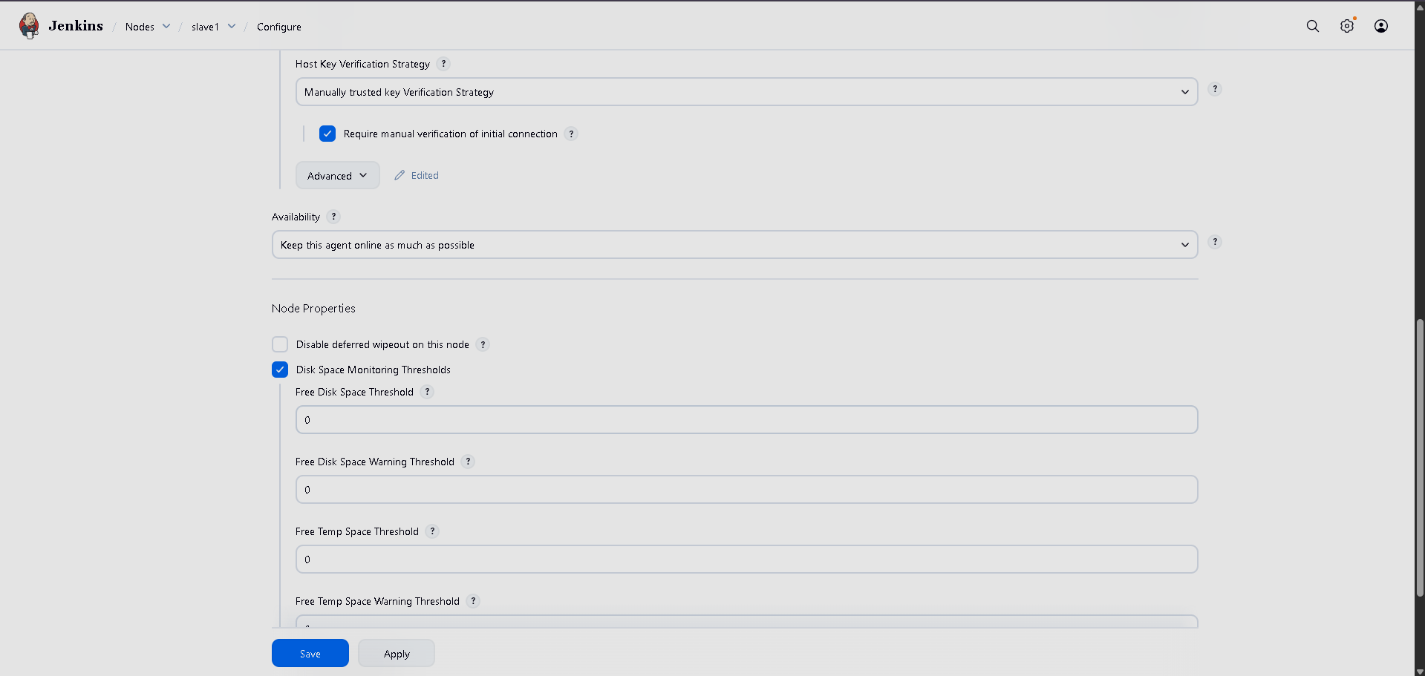

- First Jenkins job to clone git repo, compile, build and copying the WAR file to s3 bucket
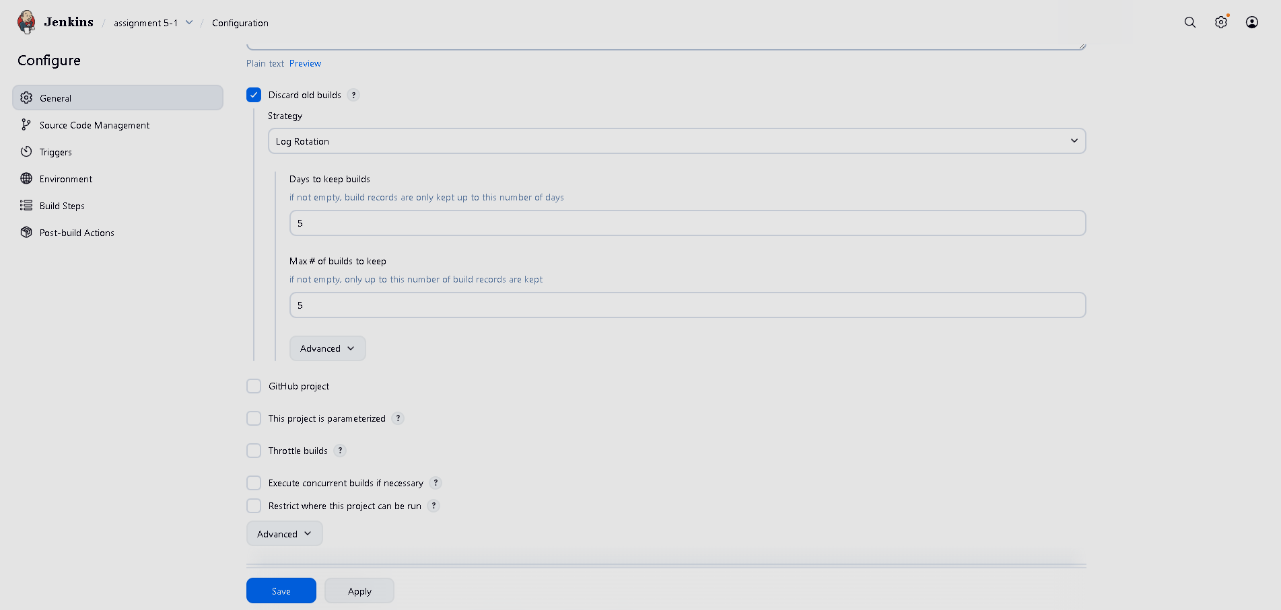
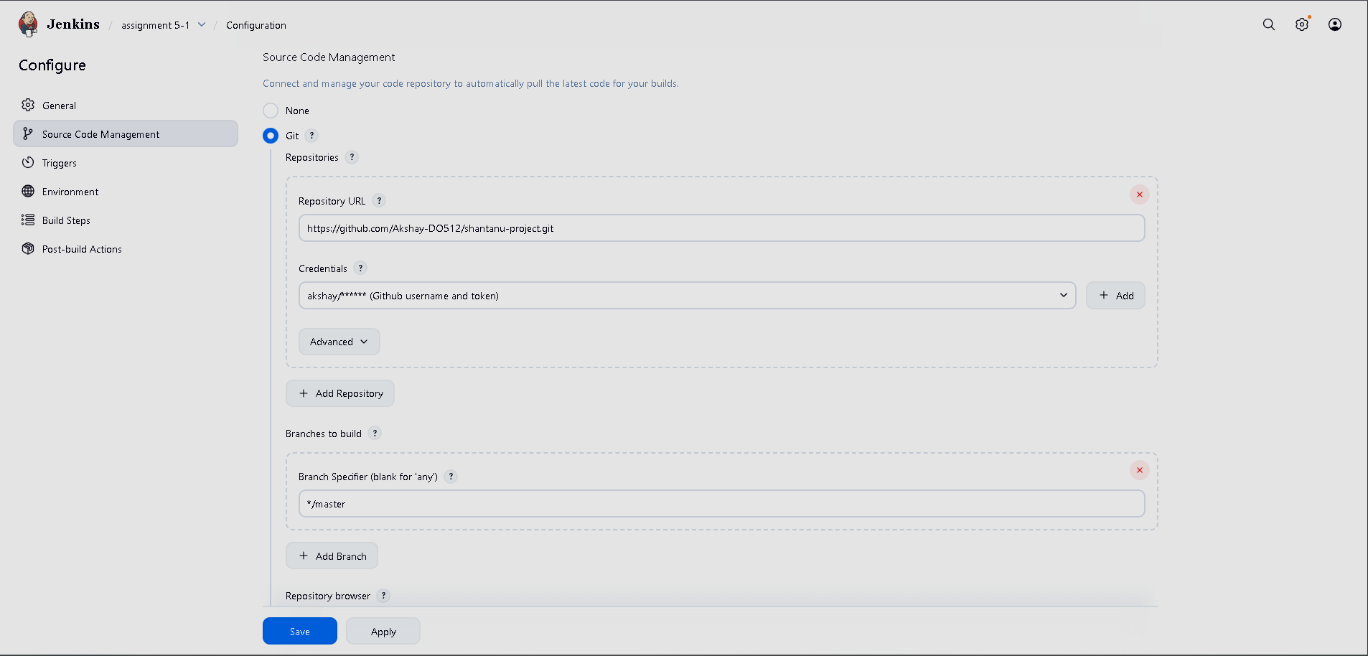
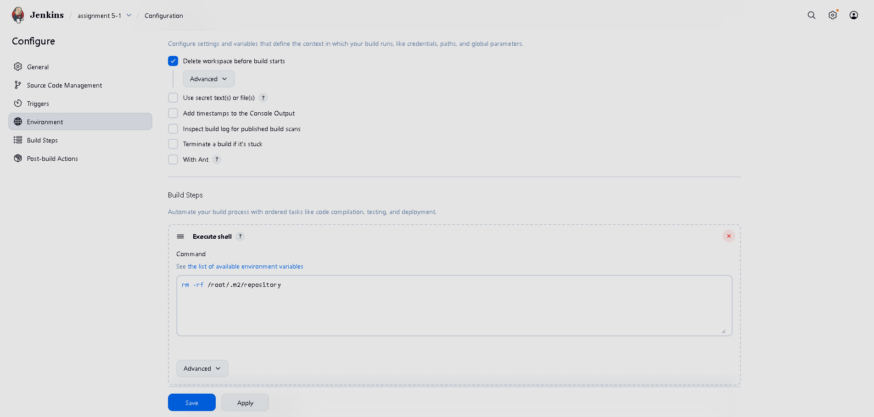
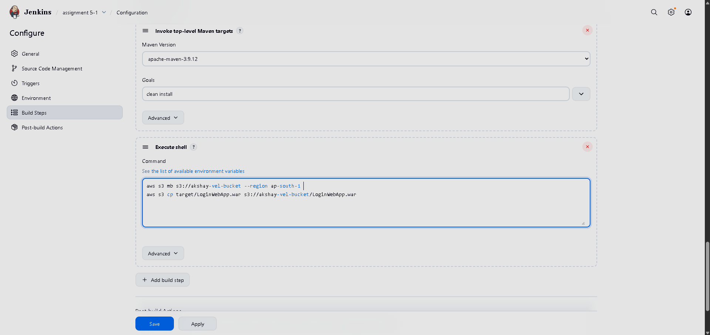

- Second Jenkins job to copy WAR file from s3 bucket and deploy on tomcat server
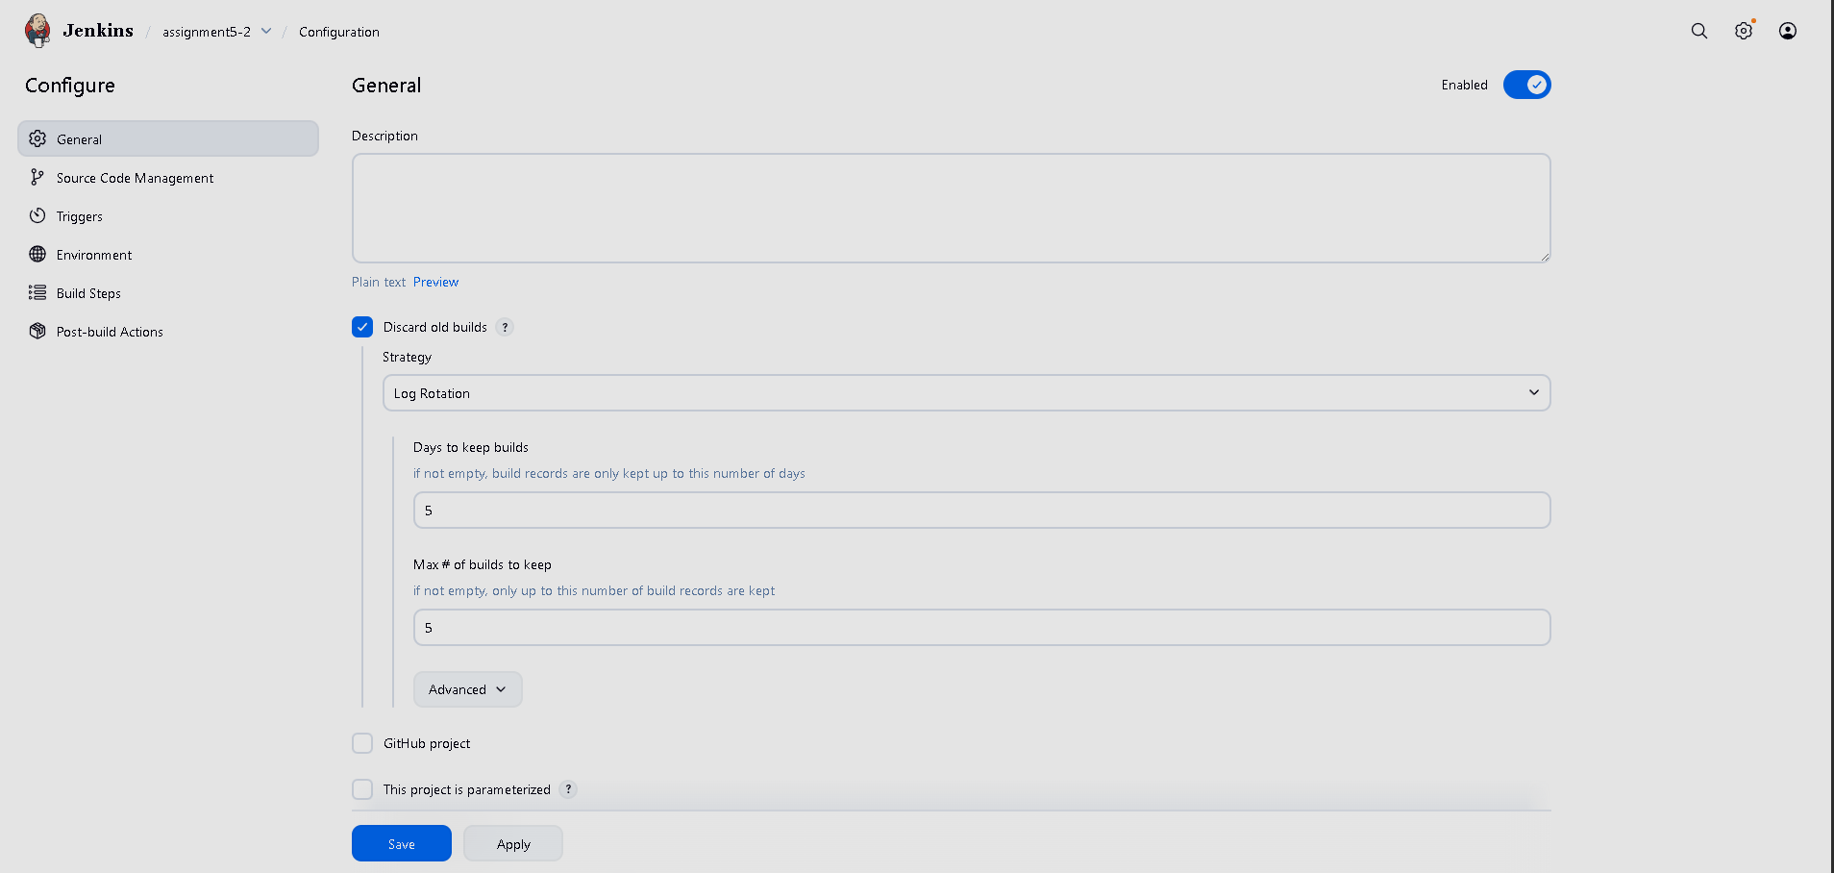
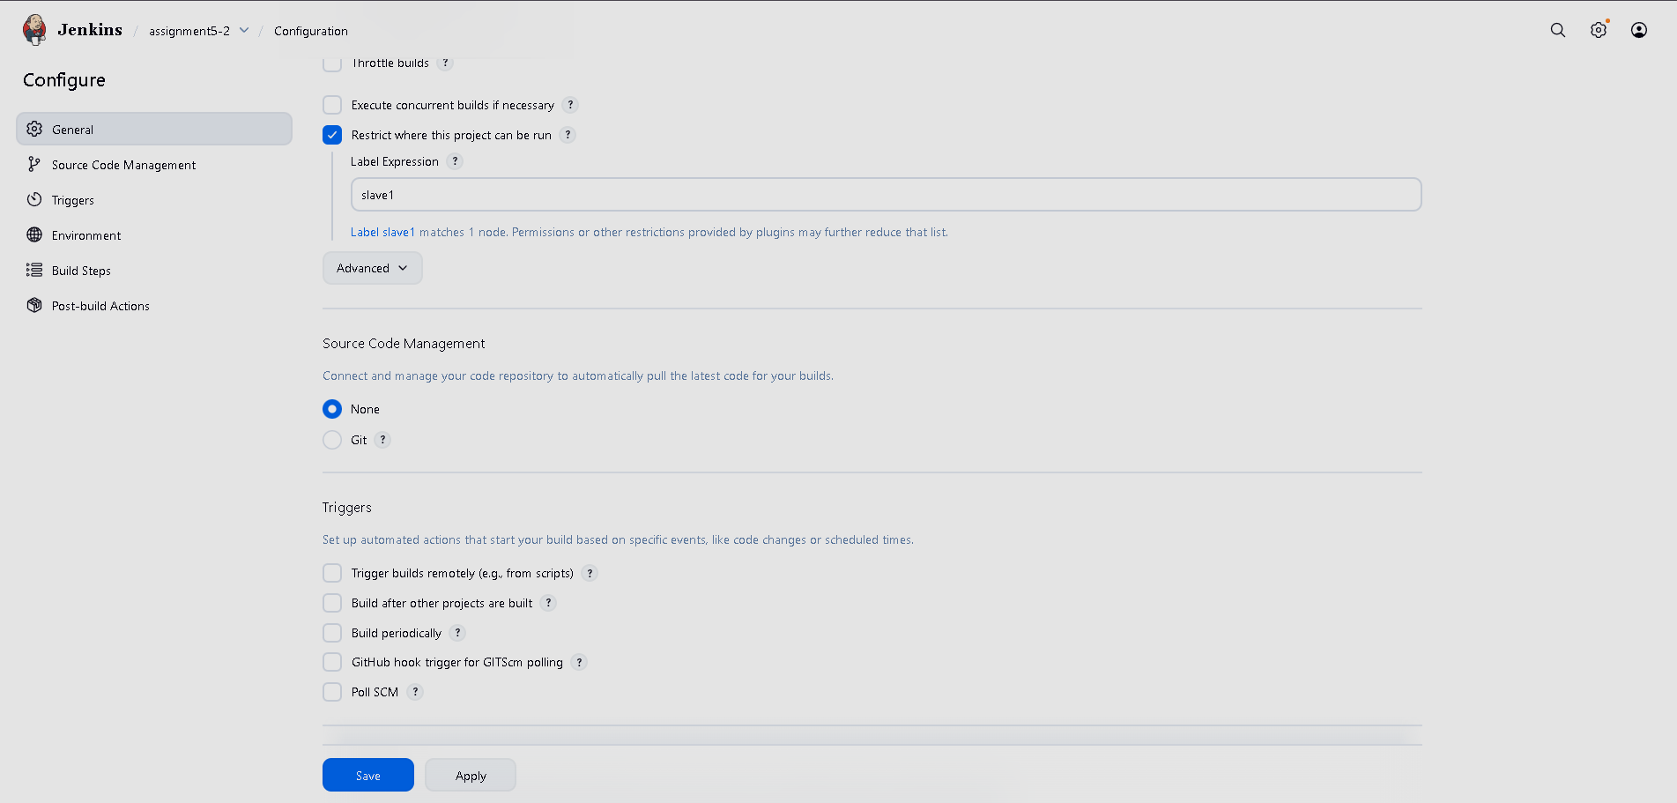
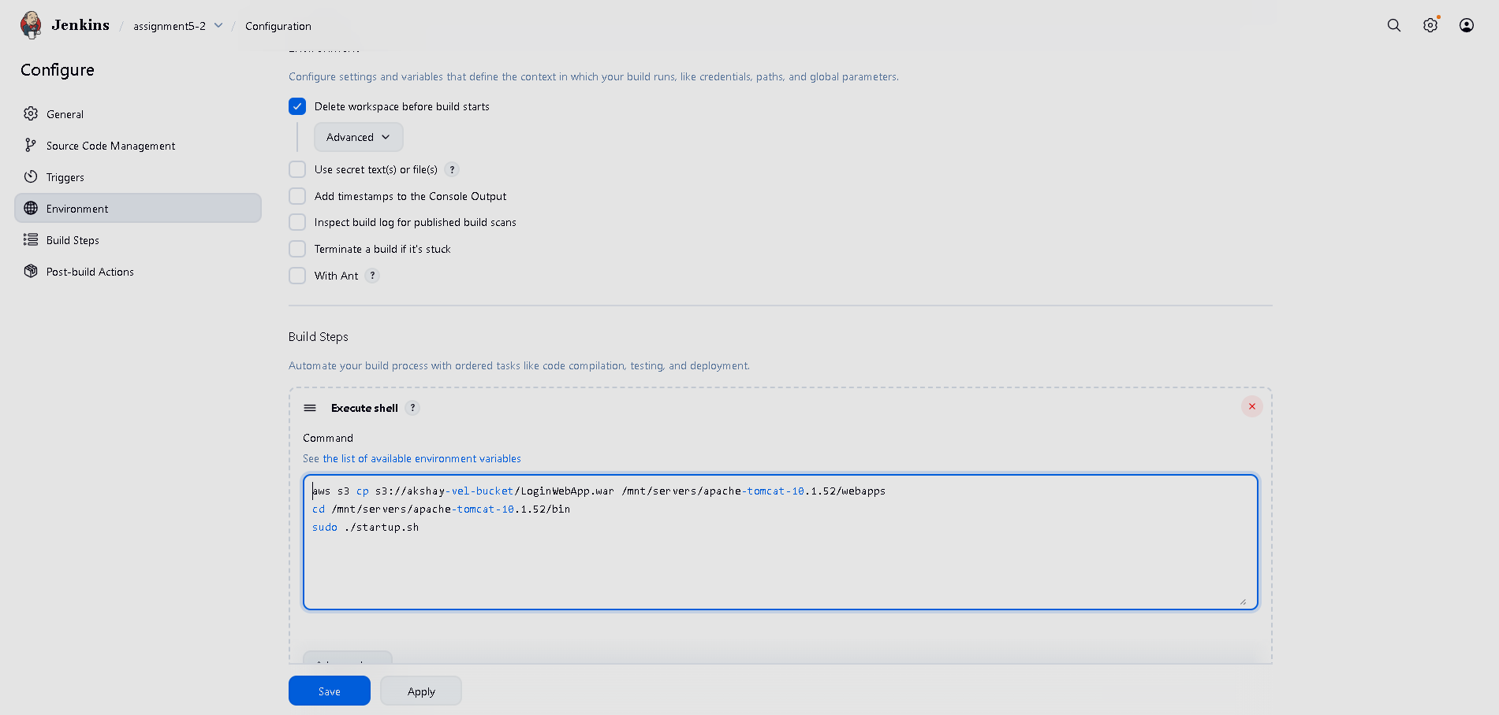

Note: we have to configure AWS CLI first on both the EC2 instances for working with s3 bucking through scripts.

