Assignment-6

Create Jenkins master and slave machine. Configure node/slave with master machine. Clone the git repository and compile, build the war file on slave machine and deploy it on tomcat server on slave machine itself

- Jenkins master and slave machine
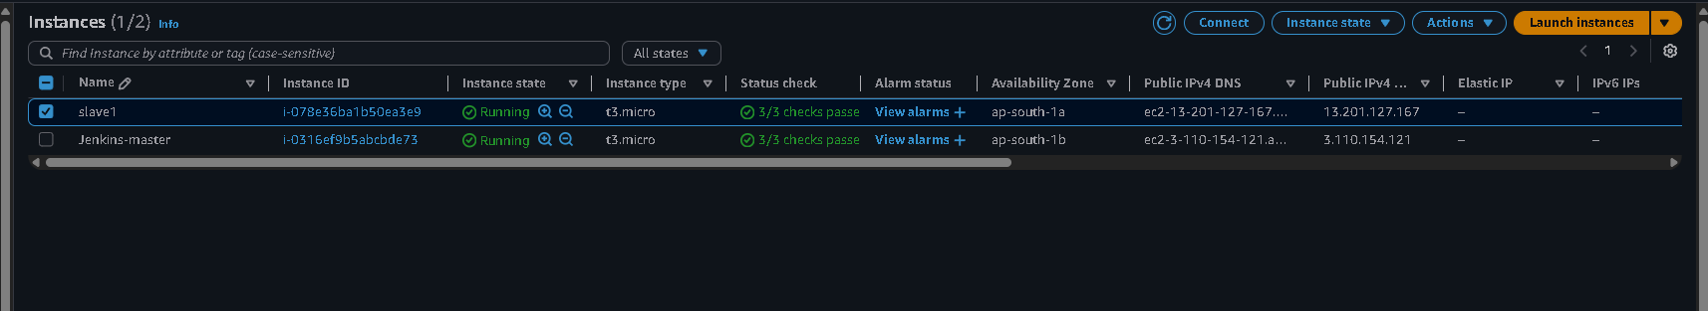

- Configure the slave with master
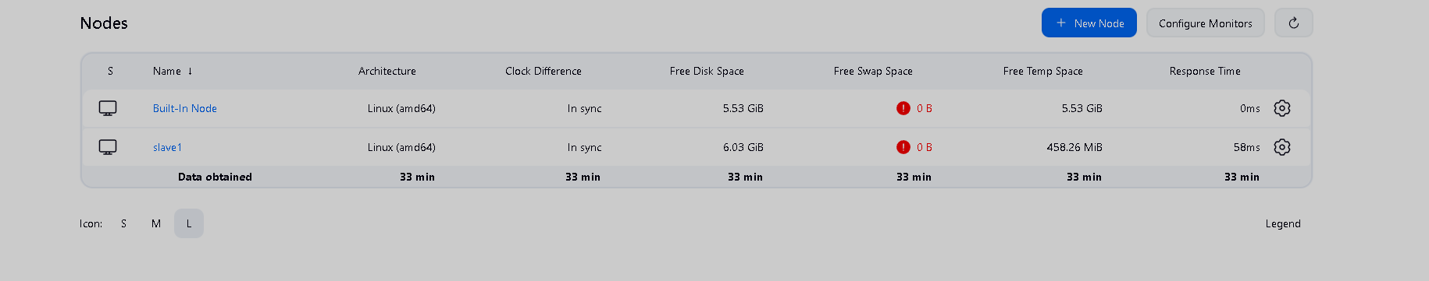
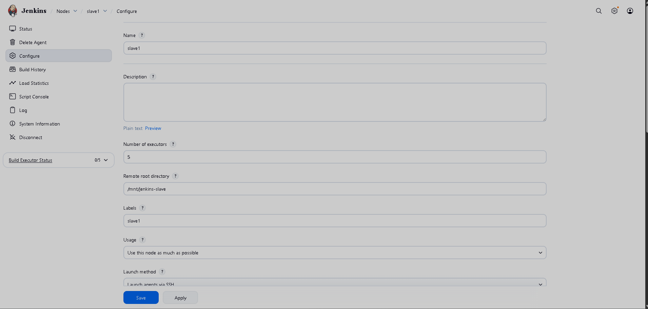
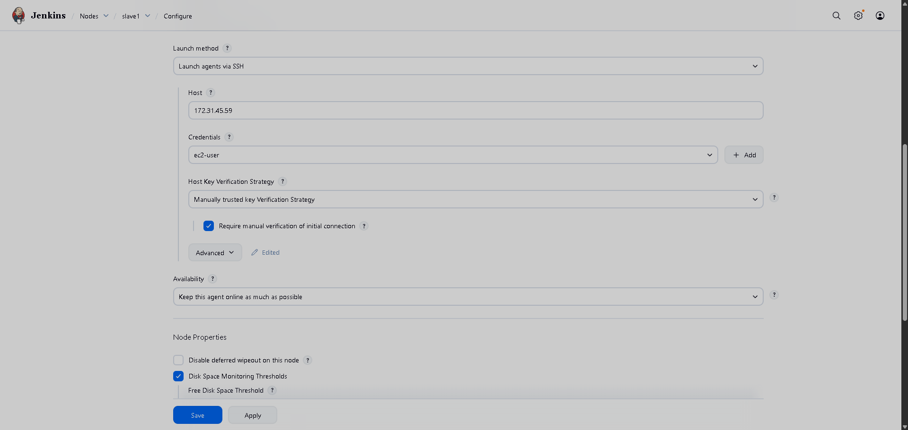

- Jenkins job configuration for building and deploying on slave machine
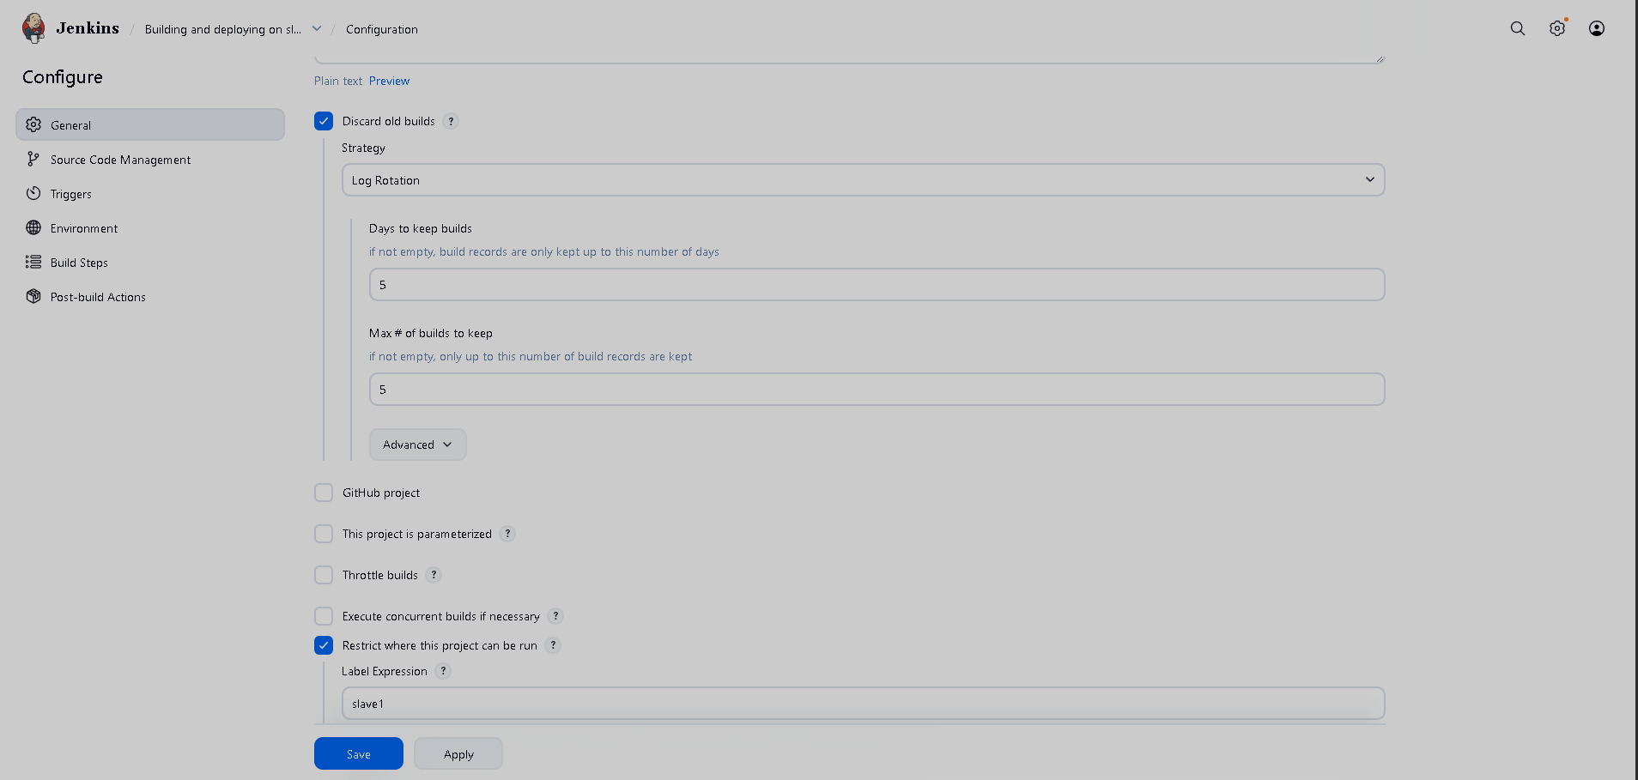
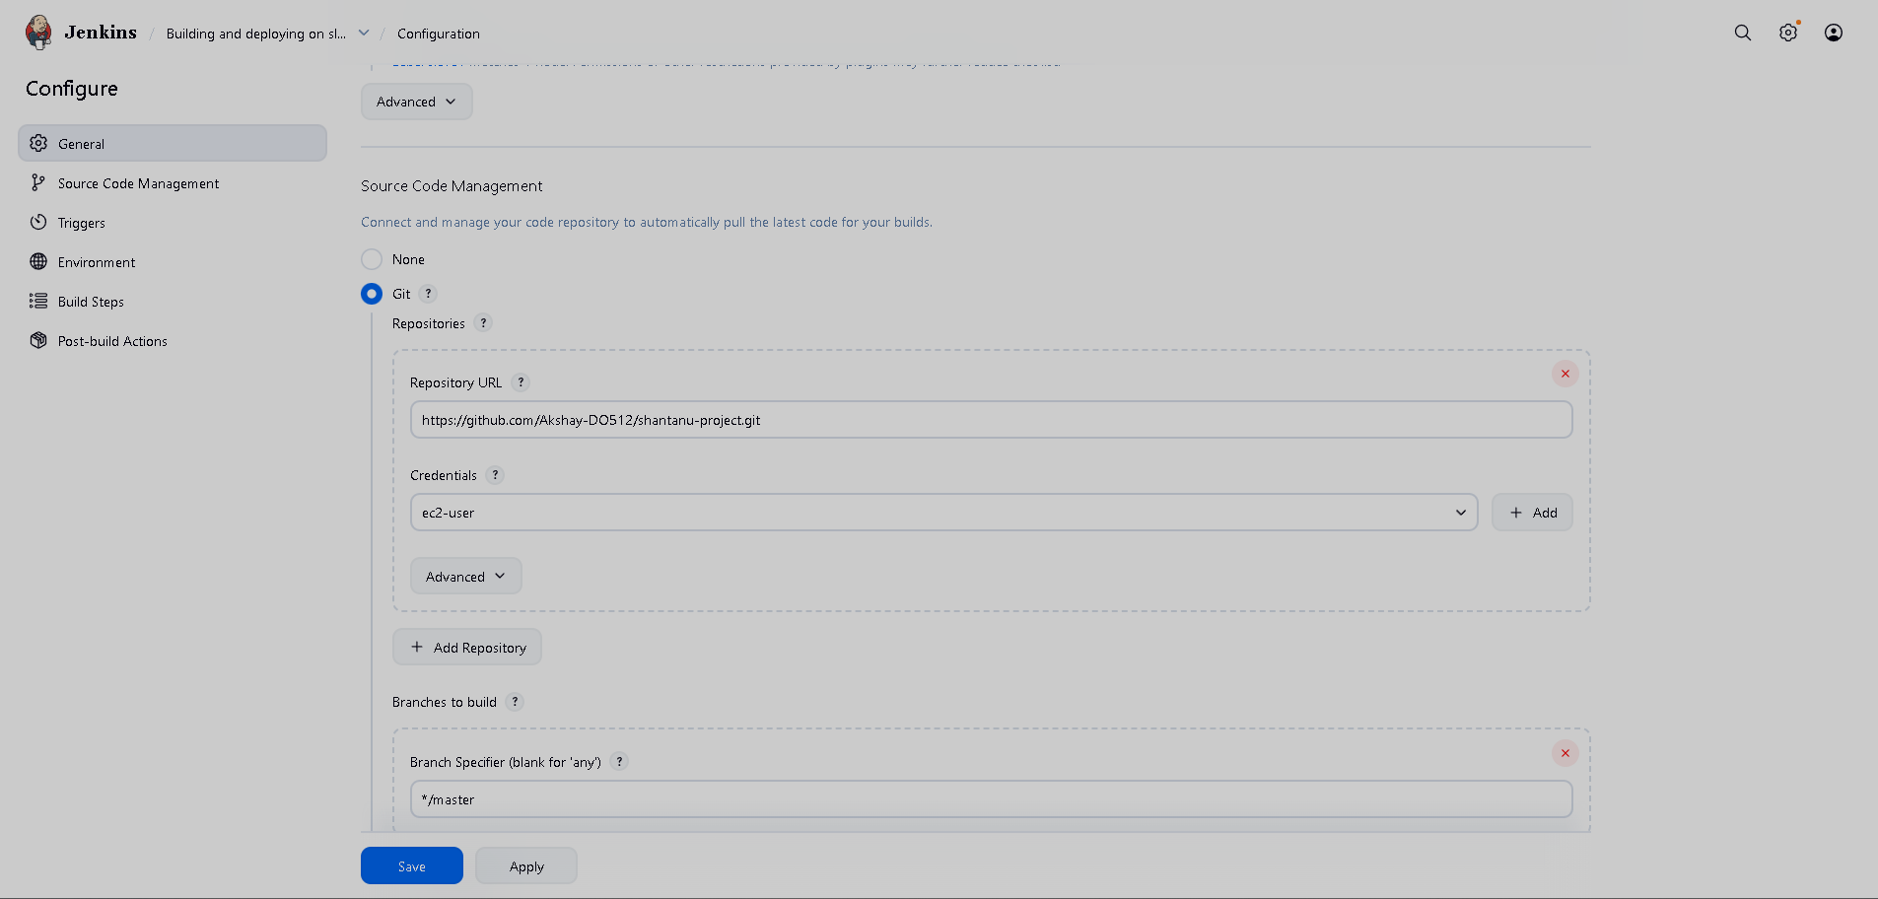
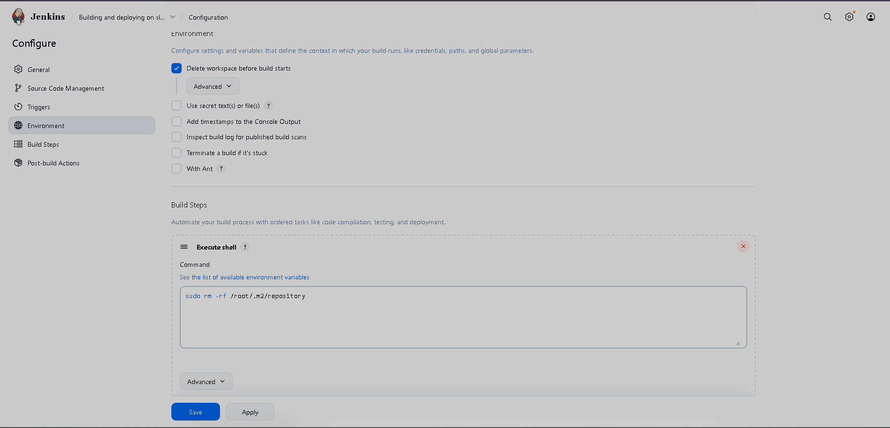
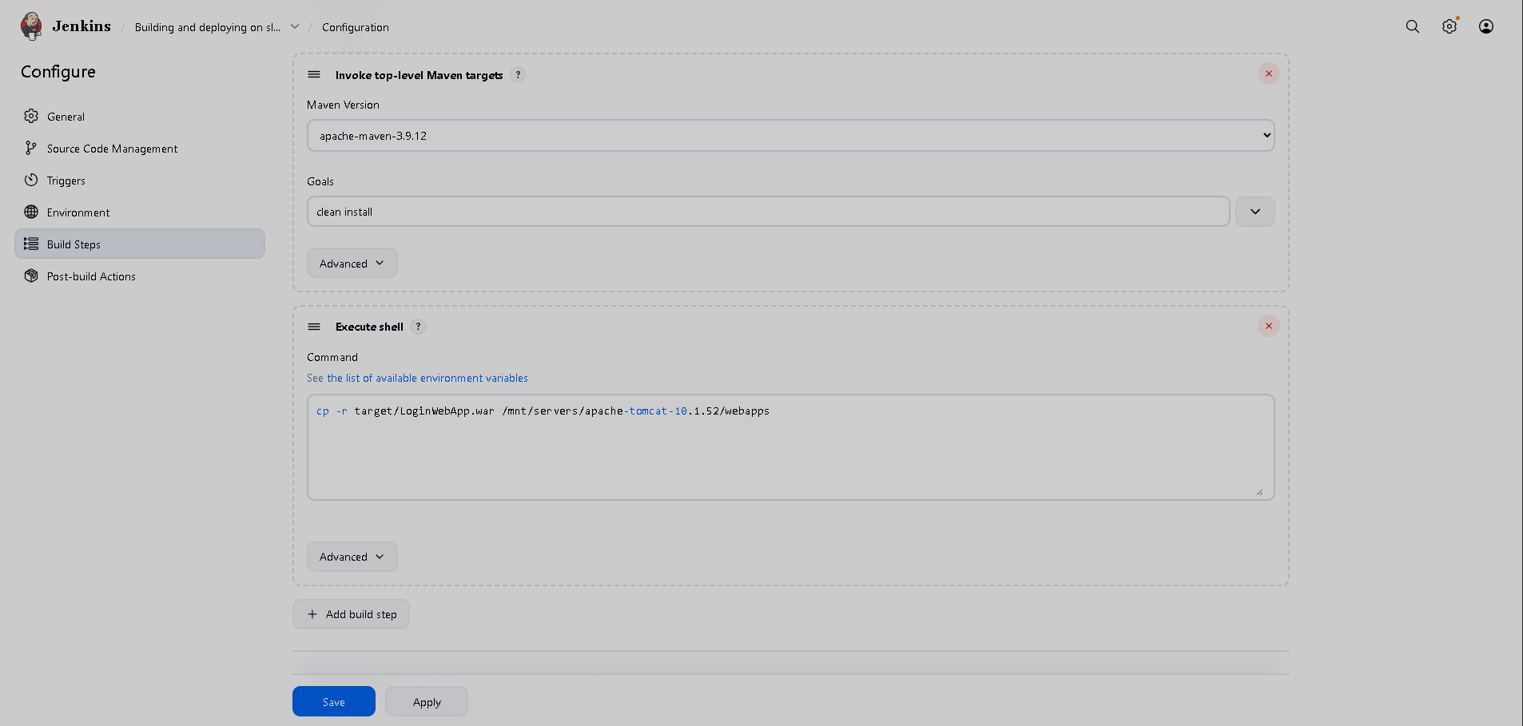

Note: we need to install Java, Maven, Git, Tomcat on slave machine

