**Assignment 1 : Simple SQL Query with a single table with where clause**

Write a query to get a Product list (id, name, unit price) where current products cost

less than $20.

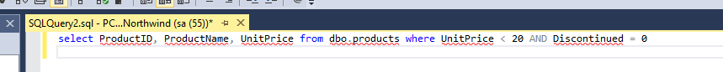

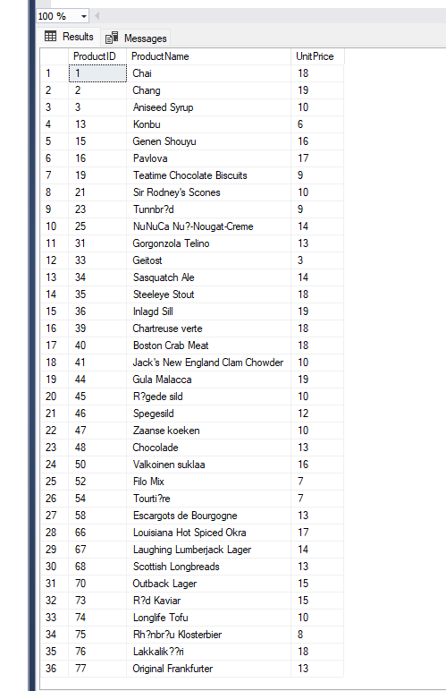

Write a query to get Product list (id, name, unit price) where products cost between

$15 and $25



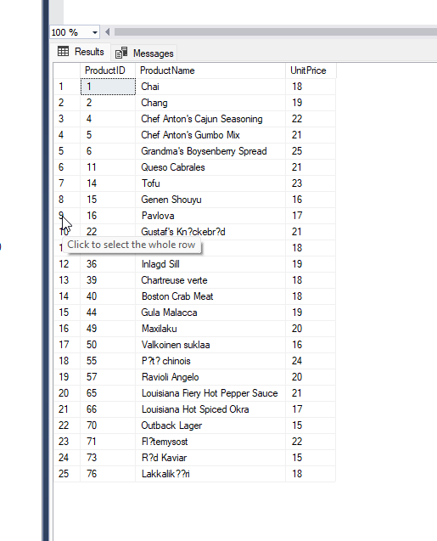

Write a query to get Product list (name, unit price) of above average price.



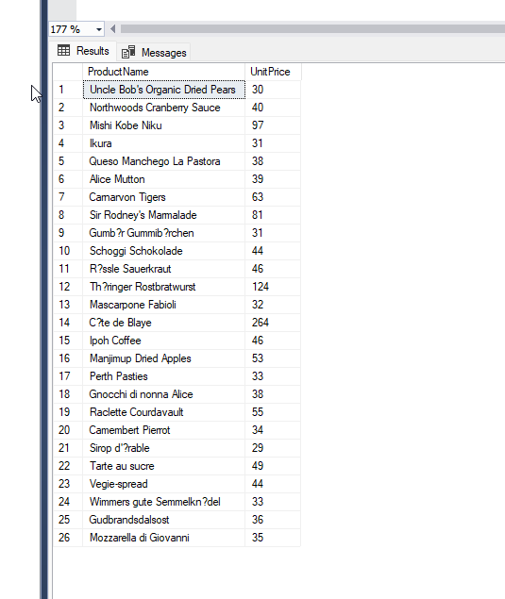

Write a query to get Product list (name, unit price) of ten most expensive products

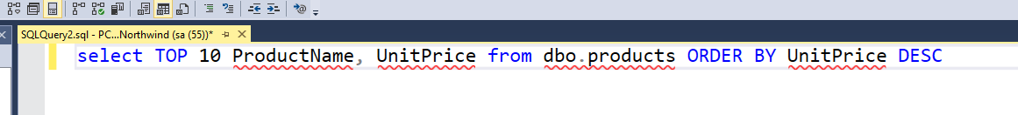

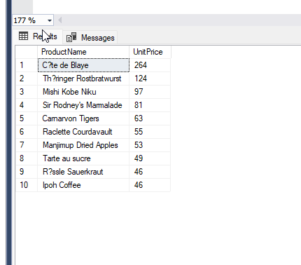

Write a query to count current and discontinued products



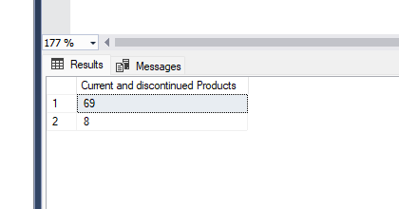

Write a query to get Product list (name, units on order , units in stock) of stock is less

than the quantity on order



