Object Type Classification Using Radar Data

Methodology:
- Dataset Description
The proposed federated learning (FL) method utilizes automotive radar data consisting of object-level measurements captured per frame. Each frame contains up to 10 object samples, and every object is represented by a 7-dimensional feature vector, Xᵢ ∈ R⁷, for i = 1, …, N. The underlying feature components are: [x, y, z, vᵣ, RCS, dᵣ, Δθₑₗₑᵥ] which corresponds to spatial coordinates, radial velocity, radar cross-section, distance rate, and elevation-angle change. The ground-truth category of each object is encoded as a one-hot vector: 𝜰 ∈ {0, 1}⁶ representing the following six radar classes as car, truck/bus, two-wheeler, pedestrian, overridable, underridable.
Additionally, each frame contains an object-presence mask which further categorizes it under obstacle or non-obstacle category: m ∈ {0, 1}ᴺ. Thus, a complete data is defined as the tuple: (X, m, 𝜰) where the radar frame is: X ∈ Rᴺ×⁷, m is the obstacle mask and 𝜰 is the label.
Summary of the Dataset Split:
- Total Dataset Summary: Train=1020298 Valid=343732 Test=114063
- Per-Client Train sizes: [204061, 204061, 204059, 204059, 204058]
- Per-Client Val sizes: [68749, 68748, 68745, 68745, 68745]
----------- Client 0 Summary ----------
Train frames: 204061; Val frames: 68749
Train label counts: {0: 35329, 1: 41732, 2: 48653, 3: 34924, 4: 30524, 5: 12899}
Val label counts: {0: 13193, 1: 13546, 2: 15994, 3: 12835, 4: 9206, 5: 3975}
Train features shape: (204061, 10, 7); labels shape: (204061, 6)
----------- Client 1 Summary ----------
Train frames: 204061; Val frames: 68748
Train label counts: {0: 35329, 1: 41732, 2: 48653, 3: 34924, 4: 30524, 5: 12899}
Val label counts: {0: 13192, 1: 13546, 2: 15994, 3: 12835, 4: 9206, 5: 3975}
Train features shape: (204061, 10, 7); labels shape: (204061, 6)
----------- Client 2 summary ------------
Train frames: 204059; Val frames: 68745
Train label counts: {0: 35328, 1: 41732, 2: 48653, 3: 34924, 4: 30524, 5: 12898}
Val label counts: {0: 13192, 1: 13545, 2: 15994, 3: 12834, 4: 9206, 5: 3974}
Train features shape: (204059, 10, 7); labels shape: (204059, 6)
----------- Client 3 summary -------------
Train frames: 204059; Val frames: 68745
Train label counts: {0: 35328, 1: 41732, 2: 48653, 3: 34924, 4: 30524, 5: 12898}
Val label counts: {0: 13192, 1: 13545, 2: 15994, 3: 12834, 4: 9206, 5: 3974}
Train features shape: (204059, 10, 7); labels shape: (204059, 6)
------------ Client 4 summary -----------
Train frames: 204058; Val frames: 68745
Train label counts: {0: 35328, 1: 41731, 2: 48653, 3: 34924, 4: 30524, 5: 12898}
Val label counts: {0: 13192, 1: 13545, 2: 15994, 3: 12834, 4: 9206, 5: 3974}
Train features shape: (204058, 10, 7); labels shape: (204058, 6)

- Model Architecture
Our proposed FL setup integrates the radar-based object detection data across two model architectures, i.e., DeepLoc and ConfidNet. The ConfidNet uses DeepLoc backbone and augments it with confidence-estimation head for generating the confidence score. Therefore, the final output is the combination of class prediction and confidence estimation.
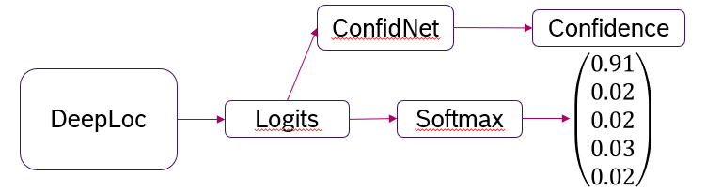

Figure 1: Illustration of Output flow from both Models

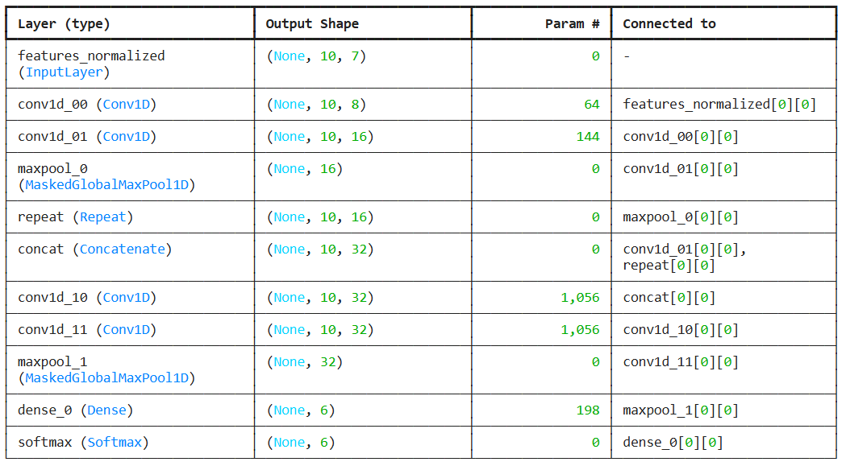
Figure 2: The Architecture of DeepLoc Model in Original Pipeline

Figure 3: The Architecture of DeepLoc Model in Federated Learning Pipeline
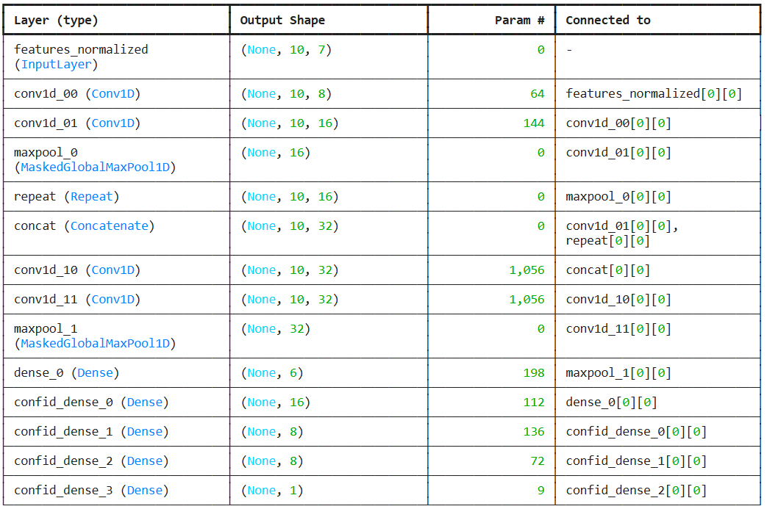
Figure 4: The Architecture of ConfidNet Model in Original Pipeline
Figure 5: The Architecture of ConfidNet Model in Federated Learning Pipeline
- Federated Pipeline
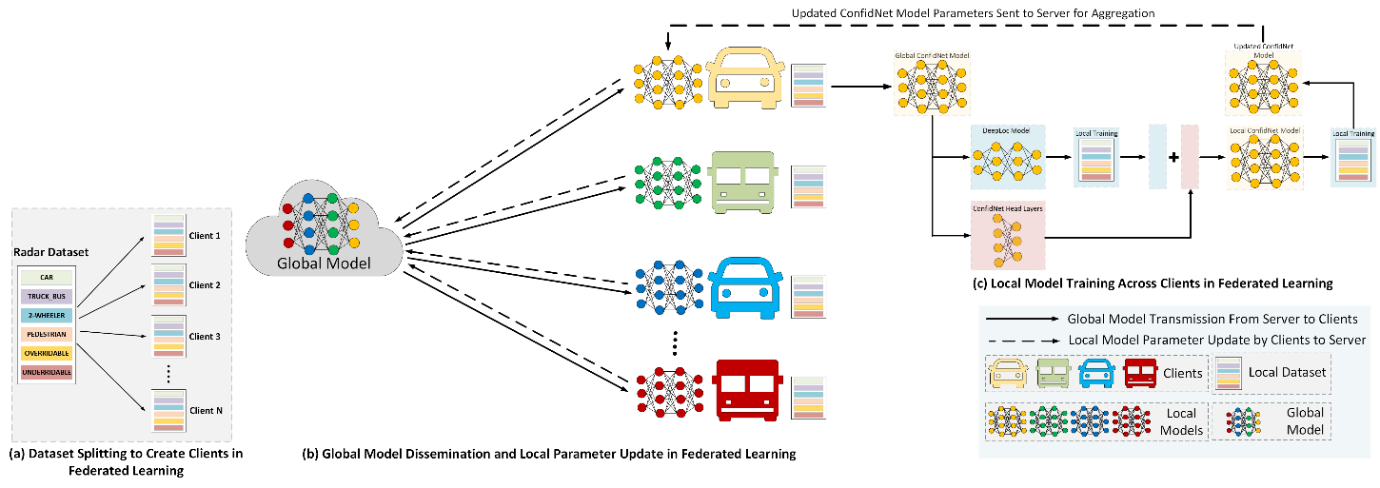
Figure 6: The Architecture of the Radar Based Object Detection using Federated Learning
Our proposed setup integrates the radar-based object detection system with a FL framework that jointly trains a DeepLoc model, as shown in Figure 3, and a ConfidNet model, as shown in Figure 5. The entire dataset is splitted into ‘K’ partitions following stratified sampling with independent and identically distributed clients. The traditional FL framework consists of two major components: the server and the participating clients. The server is responsible for carrying out three operations. First, it performs client selection where the most appropriate clients are allowed to take part into the learning process. Second, it disseminates the global model to each selected client. And finally, it intelligently aggregates the received model updates from all the clients to create an updated global model. Similarly, the client on receiving the global model from the server starts local training on their private dataset. Once training is complete, all the clients send the updated local model parameters to the server. The complete pipeline from receiving the global model to local training and updated parameter sharing to the server and again disseminating the global model is called one training iteration. The entire FL pipeline continues for several iterations until convergence.
Let us consider a scenario where we have ‘K’ clients with their local dataset denoted by:
Dₖ = {(Xᵢ, 𝜰ᵢ, wᵢ)} for i = 1…Nₖ,
where each radar frame Xᵢ ∈ ℝᴹˣᶠ contains M object detections with F features, as shown in Figure 6. The label 𝜰ᵢ ∈ ℝᶜ is a one-hot category vector, and wᵢ is a per-sample weight. Before local training, features are normalized on each client using a global mean and standard deviation (μ, σ) computed by the client. The backbone network is the DeepLoc model, producing logits z = f{θ_{b}}(x) for C classes. A ConfidNet head g{θ_{h}}(·) is attached on top of the final feature layer of DeepLoc, outputting a scalar confidence score s ∈ (0, 1). Thus, the combined output is,
(z, s) = (f{θ_{b}}(x), g{θ_{h}}(f{θ_{b}}^{{L}}(x))),
Where f{θ_{b}}^{{L}}(x) represents the last hidden representation passed to the confidence head. The FL training proceeds in two stages. In the initial global round, the server distributes the DeepLoc backbone parameters θ_{b}⁽⁰⁾ to the selected clients. Each client first optimizes θ_{b}⁽⁰⁾ locally using categorical cross-entropy:
L_{{cls}} = − Σ_{{c=1}}^{{C}} 𝜰_{c} · log(σ(z)_{c})
After this, the ConfidNet head is attached and trained jointly with frozen DeepLoc backbone weights. Confidence monitoring is derived from whether the predicted obstacle category matches the ground-truth obstacle mask. For this, lets consider Oᵢ denoting as an obstacle-mask vector indicating which categories correspond to obstacles.
For a prediction z, we define the predicted class ĉ = argmax_{c}(z_{c}). Then compute:
- Prediction is obstacle (pred_is_obst) = 1 if O_{{ĉ}} = 1, otherwise 0
- Label is obstacle (label_is_obst) = 1 if Σ_{{c=1}}^{{C}} 𝜰_{c} · O_{c} = 1, otherwise 0
The confidence target is: t = 1 if pred_is_obst = label_is_obst, otherwise 0. The ConfidNet is trained using a masked mean-squared error that excludes out-of-distribution (ood) samples:
L_{{conf}} = [ Σ_{{i=1}}^{{Nₖ}} (1 − oodᵢ)(tᵢ − sᵢ)² ] / [ Σ_{{i=1}}^{{Nₖ}} (1 − oodᵢ)]
where oodᵢ = 1 when 𝜰ᵢ is an all-zero label. The model parameter updates follow SGD with an exponential step-decay learning-rate schedule:
η_{e} = η₀ · (η_{f} / η₀)^{{⌊e / T⌋}}, where e is the epoch index.
For each subsequent global rounds r > 1, the server distributes the current global parameters
θ⁽ʳ⁻¹⁾ = (θ_{b}⁽ʳ⁻¹⁾, θ_{h}⁽ʳ⁻¹⁾) to each participating clients. Each client then detaches the head (g{θ_{h}}), updates only the backbone parameters θ_{b} using clients’ local data. After training the DeepLoc model, it reattaches and trains the ConfidNet head. Finally, after completion of this sequential local training, each client returns its updated parameter set θₖ⁽ʳ⁾ to the server. The server performs weighted federated averaging to get the new updated global model:
θ⁽ʳ⁾ = [1 /(Σ_{{k ∈ Sᵣ}} Nₖ)] · Σ_{{k ∈ Sᵣ}} (Nₖ · θₖ⁽ʳ⁾),
where Sᵣ is the set of selected clients in round r. The global model is then evaluated on the test set existing at the server. This process continues until the given number of global rounds is reached or validation loss converges to a threshold loss. Overall, the methodology enables decentralized training of a confidence-aware radar object detector while preserving data privacy and minimizing communication overhead compared to traditional centralized pipeline.
- Experimental Setup
Table 1 summarizes the training hyperparameters used across all FL experiments. We followed standard FL training conventions to balance communication efficiency and model convergence. All clients used identical learning schedules and participated in continuous rounds. We created total 5 clients and adopted ρ = 0.6 to simulate partial participation typical of vehicular networks where vehicles intermittently connect. Three local epochs (E = 3) for both model architectures were sufficient for local convergence while minimizing drift, and T = 25 rounds yielded stable global accuracy without overfitting.
Table 1: The Hyperparameters in Federated Settings
S.No. | Parameter | Value | Description
1. | Total Clients | K=5 | Total number of participating clients
2. | Client Fraction | ρ=0.6 | Selecting 60% clients per round
3. | Total Rounds | r=25 | The number of global aggregation iterations
4. | Batch Size | B=10 | The number of samples in each local batch
5. | Local Epochs | DeepLoc=3  ConfidNet=3 | The number of local training epochs at the client in each round
6. | Optimizer | SGD (β₁=0.9) | The optimizer at the client

The learning rate for DeepLoc is fixed to 1e-5. The code set up uses a custom step-based learning-rate (LR) schedule for the ConfidNet model, constructs a function that provides the LR for each epoch, and initializes an SGD optimizer with momentum=0.9 and Nesterov acceleration, with its learning rate dynamically updated from 0.001 to 0.00001 during training for after local epochs=4. These settings jointly ensured a practical trade-off between communication cost and model stability.

- Results
Local Performance
Table 2: Final Performance of Both the Models (Best) Across Various Clients
S.No. | Client | DeepLoc |  | ConfidNet
S.No. | Client | Train Acc Train Loss | Valid Acc Valid Loss | Train Loss Valid Loss
1 | Client 1 | 98.74 0.0411 | 97.63 0.0152 | 0.0725 0.0724
2 | Client 2 | 97.17 0.0757 | 96.82 0.0864 | 0.7233 0.7227
3 | Client 3 | 99.88 0.0050 | 99.81 0.0015 | 0.0724 0.0724
4 | Client 4 | 96.77 0.1082 | 95.34 0.1641 | 0.0853 0.0744
5 | Client 5 | 95.95 0.1078 | 90.14 0.8089 | 0.0723 0.0914
Global Performance
Table 3: Roundwise Performance of ConfidNet (Global FL Model) Across Test Dataset
Round | Test Loss | Round | Test Loss | Round | Test Loss
1 | 0.1754 | 11 | 0.0975 | 21 | 0.0956
2 | 0.1638 | 12 | 0.1280 | 22 | 0.1246
3 | 0.1327 | 13 | 0.0948 | 23 | 0.1130
4 | 0.1210 | 14 | 0.0945 | 24 | 0.1062
5 | 0.1514 | 15 | 0.0931 | 25 | 0.1012
6 | 0.1548 | 16 | 0.0899
7 | 0.1234 | 17 | 0.0898
8 | 0.1464 | 18 | 0.0865
9 | 0.0951 | 19 | 0.0894
10 | 0.1302 | 20 | 0.0881

- Final Evaluation of Federated ConfidNet Model on Test Data after Post Processing:

- y_true counts: {0: 68136, 1: 7685, 2: 7837, 3: 24832, 4: 4615, 5: 958}
- y_pred counts: {0: 67494, 1: 7217, 2: 21225, 3: 12694, 4: 4753, 5: 680}
"Test Accuracy": 0.8294,
"Macro Avg": {"precision": 0.8252, "recall": 0.7949, "f1-score": 0.7708, "support": 114063},
"Weighted Avg": {"precision": 0.9028, "recall": 0.8294, "f1-score": 0.8397, "support": 114063}

Table 4: Confusion Matrix on Test Dataset
Predicted | Car | Truck/Bus | Two-Wheeler | Pedestrian | Overridable | Underridable
Actual
Car | 63633 | 973 | 3318 | 90 | 60 | 62
Truck/Bus | 1367 | 6244 | 65 | 0 | 0 | 9
Two-Wheeler | 121 | 0 | 7312 | 209 | 195 | 0
Pedestrian | 1977 | 0 | 10375 | 12395 | 84 | 1
Overridable | 158 | 0 | 43 | 0 | 4414 | 0
Underridable | 238 | 0 | 112 | 0 | 0 | 608

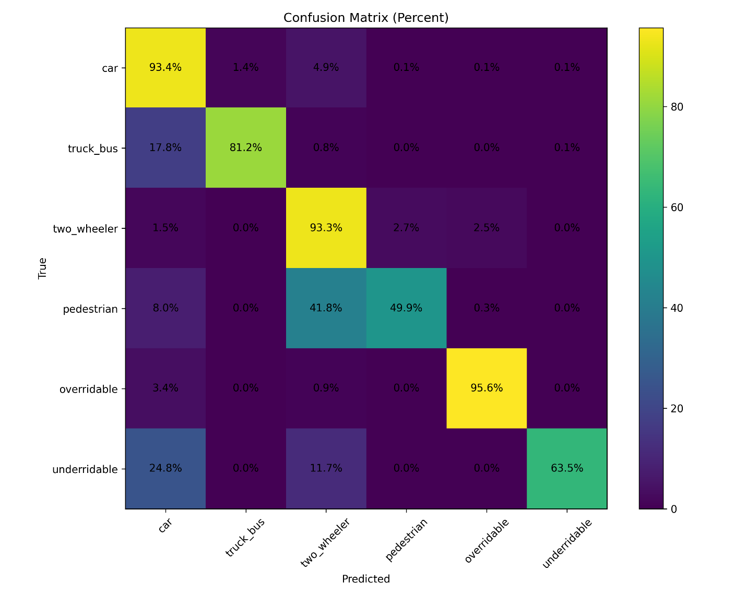
- Classwise Performance:
Test Accuracy: {
"Car": 0.9339,
"Truck/Bus": 0.8124,
"Two-Wheeler": 0.9330,
"Pedestrian": 0.4991,
"Overridable": 0.9564,
"Underridable": 0.6346,
}
"Car": {"precision": 0.9427, "recall": 0.9339, "f1-score": 0.9383, "support": 68136},
"Truck/Bus": {"precision": 0.8651, "recall": 0.8124, "f1-score": 0.8380, "support": 7685},
"Two-Wheeler": {"precision": 0.3444, "recall": 0.9330, "f1-score": 0.5032, "support": 7837},
"Pedestrian": {"precision": 0.9764, "recall": 0.4991, "f1-score": 0.6606, "support": 24832},
"Overridable": {"precision": 0.9286, "recall": 0.9564, "f1-score": 0.9423, "support": 4615},
"Underridable": {"precision": 0.8941, "recall": 0.6346, "f1-score": 0.7423, "support": 958},

- Post Processing Description:
Table 5: The hyperparameters used during the post-processing phase
Parameter | Value | Parameter | Value
batch_size | 1024 | default_category | “overridable”
filter_coeff | 0.97 | default_category_index | 4
init_confidence | 0.5 | threshold = [0.4, 0.45, 0.5, 0.55, 0.6, 0.65, 0.7] | 0.7
default_bias | 0.005 | strategy | “last_certain”

- lowpass_IIR_incl_nan_handling()
Smooths frame-to-frame noise in model outputs and handles missing or invalid frames (NaNs) by not contaminating the filter state - i.e., it keeps last good estimate during gaps. This increases temporal stability, apparent accuracy for tracked objects, and reduces false rapid switches between classes.
- replace_unconfident()
Enforces conservative behavior when the model is unsure: either fall back to a safe default class or reuse the last reliable prediction. This reduces spurious class switches driven by low-confidence model outputs. Therefore 'default' tends to improve precision for the default class (fewer false positives in non-confident frames) but can harm recall of other classes (it will miss some true positives that were low confidence).
In Summary:
- (Model outputs) → feed to
- lowpass_IIR_incl_nan_handling — smooth time series and handle NaNs, → feed to
- softmax — convert filtered activations/logits to probabilities, → feed to
- replace_unconfident — apply confidence thresholding and replace weak prediction
- confusion_matrix calculation

