QuickSight

# Index

Table of Contents

Index 2

QuickSight 3

Definition 3

Use Cases 3

Data Sources 4

SPICE 4

Security 4

Pricing 4

Visualization Types 5

Bar Graphs 5

Histograms 5

Line Graphs 6

Scatter Plots & Heat Maps 6

Pie Graphs & Donut Charts 7

Gauge Charts 7

Tree Maps 8

Pivot Tables 8

KPI 9

Geospatial Charts 9

Word Clouds 10

Alternatives 10

# QuickSight

## Definition

* It is a fast, easy, serverless, cloud-powered business analytics service.
* It allows one to build visualizations, perform ad-hoc analysis, quickly gain insights from data anytime, from any device.

## Use Cases

* Interactive, ad-hoc exploration / visualization of data.
* Create dashboards and KPI’s.
  + A dashboard is a way to publish a read-only screen of data to a larger audience.
* Stories
  + Guided tours through specific views of an analysis.
  + Convey key points, thought process, evolution of an analysis.
* Analyze/ visualize data from:
  + Logs in S3.
  + On-premise databases.
  + AWS (RDS, Redshift, Athena, S3).
  + SaaS applications such as Salesforce.
  + Any JDBC/ ODBC data source.

## Data Sources

* Redshift
* RDS/ Aurora
* Athena
* EC2-based databases
* Files (S3, or on-premise)
  + Excel
  + CSV, TSV
  + Common or extended log format

## SPICE

* It is the compute engine on top of which QuickSight functions.
* It stands for Super-fast, Parallel, In-memory Calculation Engine.
* It uses columnar storage, in-memory, machine code generation.
* It accelerates interactive queries on large datasets.
* Each user is provided with 10 GB of SPICE.
* It is highly available, durable & can scale to hundreds of thousands of users.

## Security

* MFA authentication for user account.
* VPC Connectivity: One can add QuickSight’s IP address range to Database Security Groups.
* Row-level security.
* Private VPC access : Elastic Network Interface, AWS Direct Connect.
* For user management:
  + Users can be defined via IAM, or email signup.
  + Active Directory Integration with QuickSight Enterprise Edition.

## Pricing

* QuickSight has two packages: Standard edition and Enterprise edition.
  + The Enterprise edition comes with security at rest as well as Microsoft AD integration.
* Annual subscription
  + Standard : 9$ per user per month.
  + Enterprise: 18$ per user per month.
* Month-to-month subscription:
  + Standard: 12$ per user per month.
  + Enterprise: 24$ per user per month.
* Additional charges apply if users require more than 10 GB SPICE.

## Visualization Types

### Bar Graphs

* Where we wish to see how data points compare to each other.

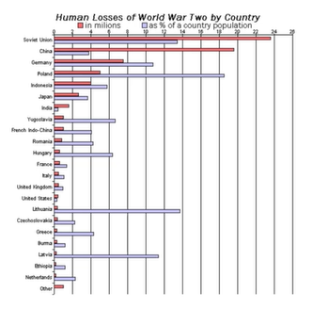

### Histograms

* The data is bucketed into certain ranges before comparison.
* The data points in a certain range are grouped together to form a bar.

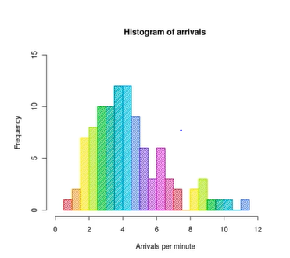

### Line Graphs

* For changes over time to identify trends.

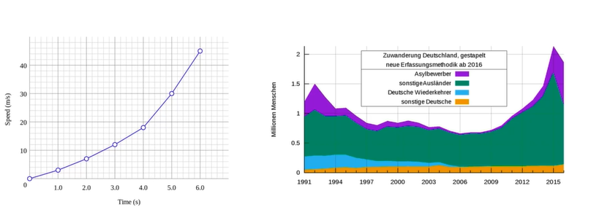

### Scatter Plots & Heat Maps

* For correlation.

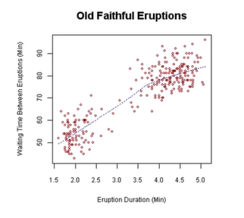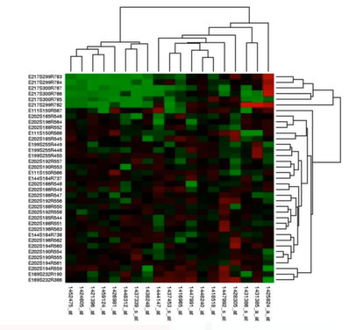

### Pie Graphs & Donut Charts

* For aggregation.
* When the data points add to a whole.

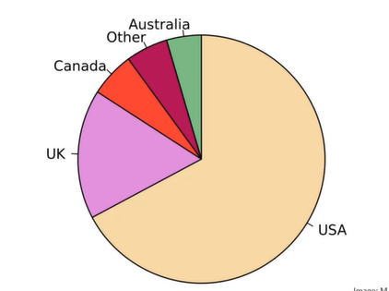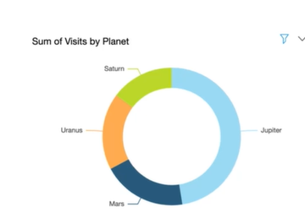

### Gauge Charts

* How much a whole is being utilized.

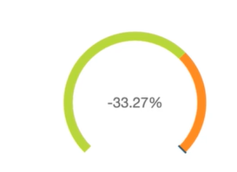

### Tree Maps

* When the data points add to a whole.
* When the data points have a hierarchy.

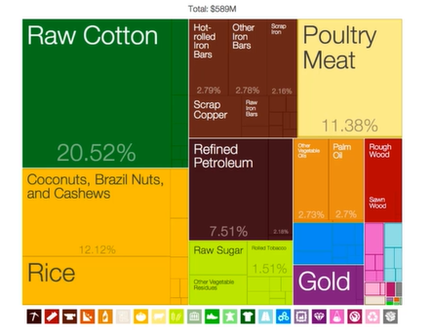

### Pivot Tables

* For tabular data.

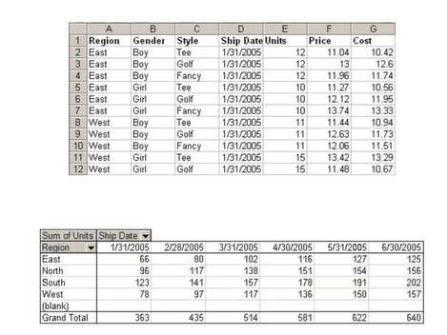

### KPI

* Compare some key value compared to its target value. (Say, progress towards a goal).

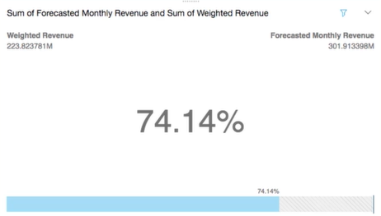

### Geospatial Charts

* When dealing with distribution across a geography.
* The larger the circles, the higher the value.

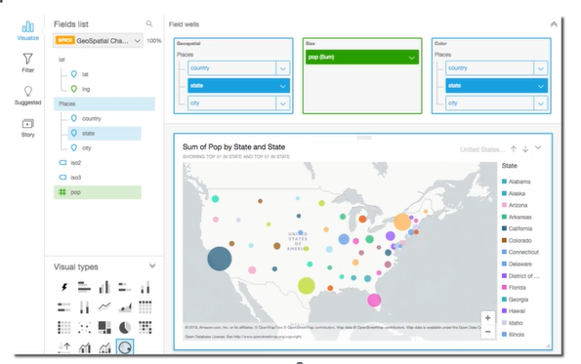

### Word Clouds

* To depict how often a word appears in a given text.
* The larger the font, the higher the frequency.

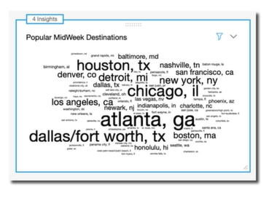

## Alternatives

* Web-based visualization tools.
* Useful when one wishes to publish visualizations outside their own organization.
  + D3.js
  + Chart.js
  + Highchat.js
* Business Intelligence Tools
  + Tableau
  + MicroStrategy.