**ftool(format tool V1.0)for Linux.**

We always use **Linux** alongside **windows OS** and face various issues with our pen-drive in Linux.

We often try to format pen-drive in Linux like (Fedora or Ubuntu) and due to wrong method used we corrupt our device or it becomes write protected and can’t be used until we format it correctly.

So I have developed a tool known as **ftool** which **will format your pen-drives within a minute.**

**Steps to use ftool:-**

1. Download ftool and place it in home directory else you need to switch to respective directory before using ftool.
2. Open terminal and type **su** if you are using **Fedora** else type **sudo su** for **Ubuntu** and enter root password. You can skip this step in **kali** or **Backtrack** because terminal opens with root permission in those OS.
3. Now run the ftool by following command **sh ftool.sh** you will see ftool running on terminal.
4. You will see all devices connected to system your device might be last one in given list.

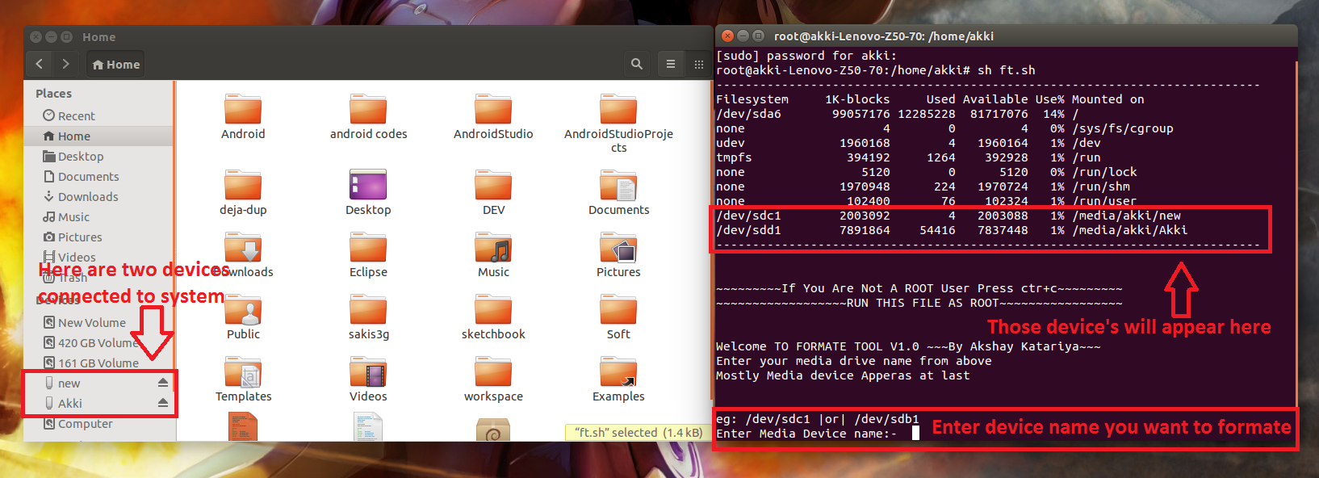

1. Enter device name which you want to format.

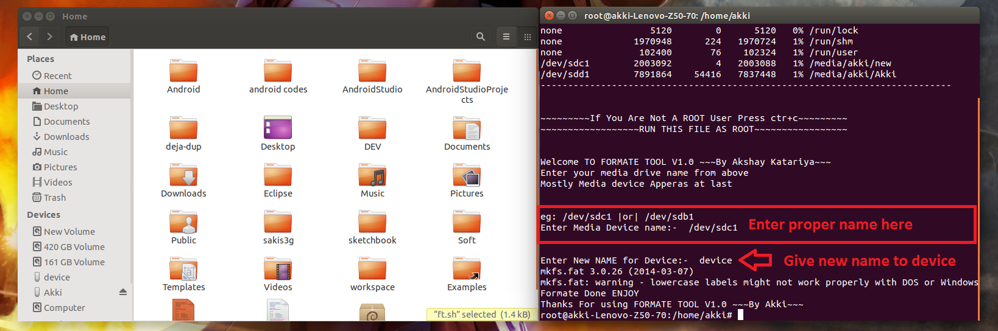

1. Enter new name to device (Don’t give space in between name keep it one word).

Bingo you are done…… ☺

So using ftool you can format any media device easily on any Linux flavor.

If you have used ftool please let me know how it works and please report if any bug.

If you like my work & wish to use any part of my code please take proper permission and give proper credits when you post your work because developing something involves lot of hard work, overcoming the challenges while developing it and patience to develop it, and giving credit is giving tribute to someone’s work.