Name : Miyatra Akshay

Roll no : 23

Enrollment no : 240823062

Division : Z2(x)

Asp_Assignment

Asp_Assignment_q1

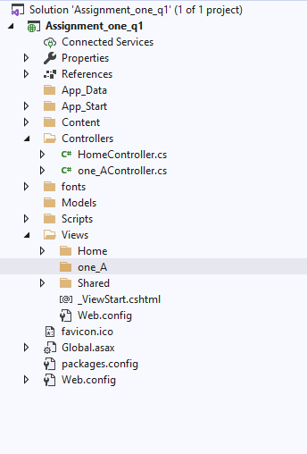

Assignment_one_q2

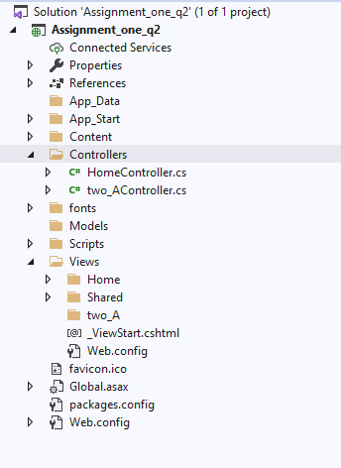

Assignment_one_q3

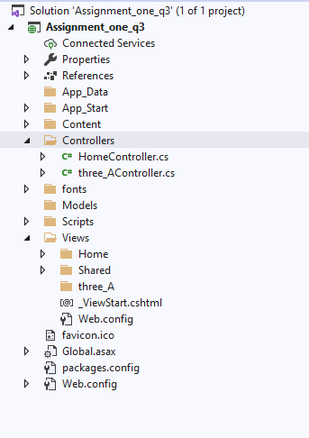

Assignment_one_q4

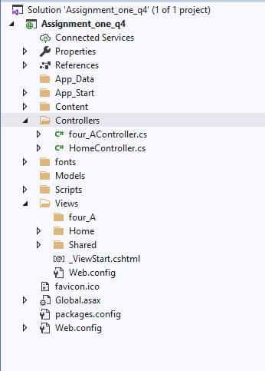

Assignment_one_q5

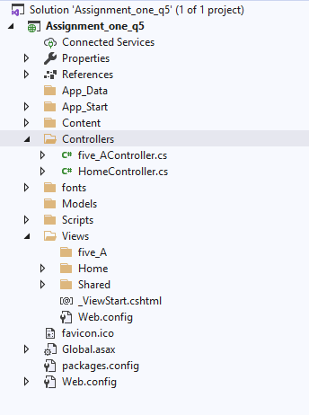

Assignment_one_q6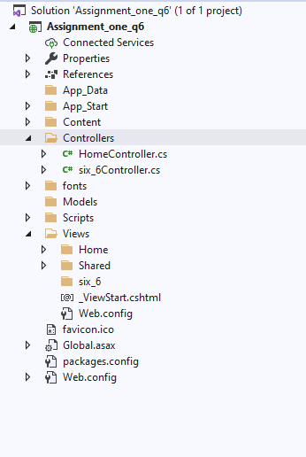

Assignment_one_q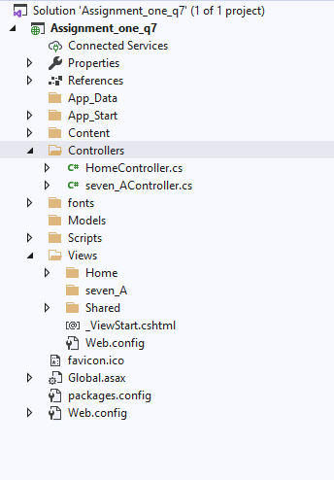7

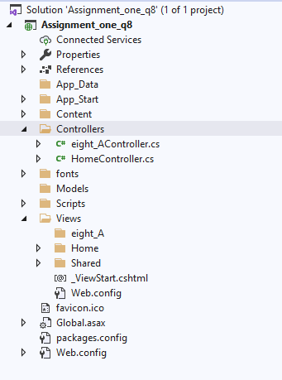

Assignment_one_q8

Assignment_one_q9

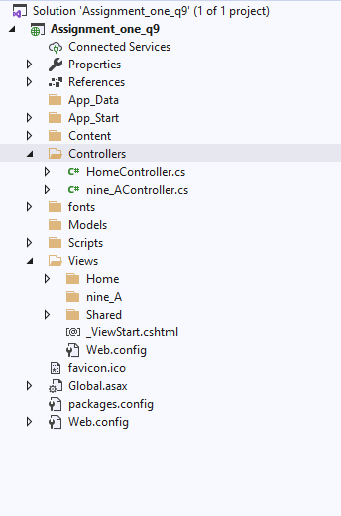

Assignment_one_q10

